**02808:校门外的树**

def cs02808():  
 l, m = map(int, input().split())  
 lst = [True] * (l + 1)  
 for i in range(m):  
 x, y = map(int, input().split())  
 for j in range(x, y + 1):  
 lst[j] = False  
 print(lst.count(True))

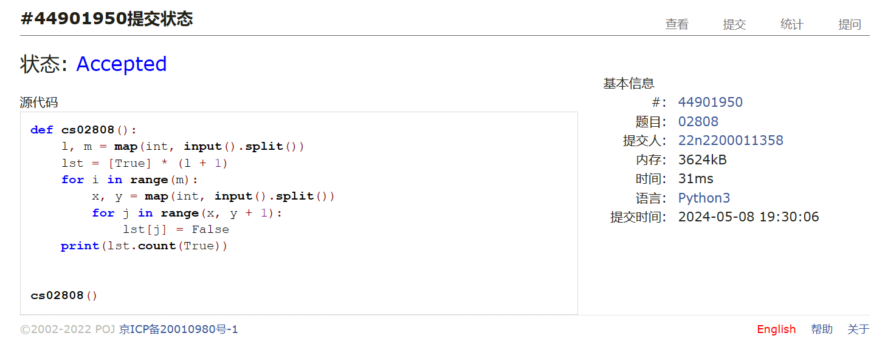

## 20449:是否被5整除

def cs20449():  
 ipt = input()  
 ans = ""  
 for i in range(len(ipt)):  
 if int(ipt[:i + 1], 2) % 5:  
 ans += "0"  
 else:  
 ans += "1"  
 print(ans)

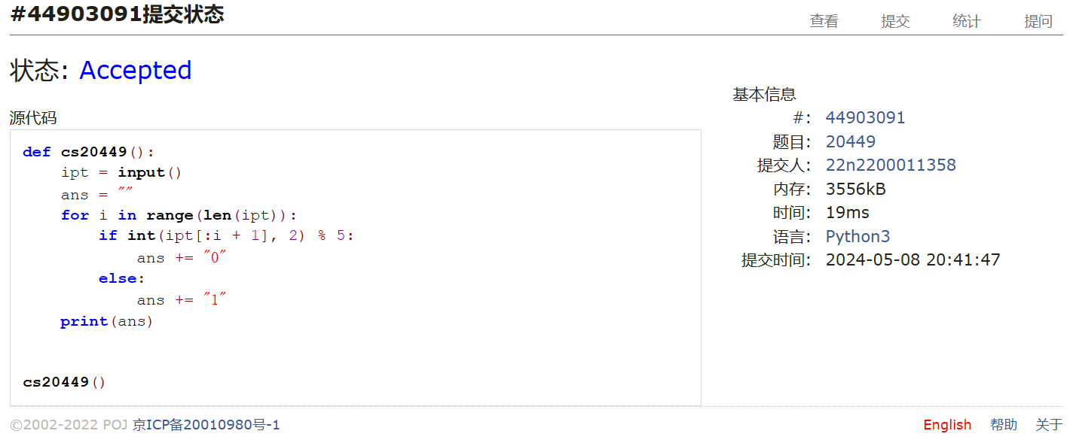

## 01258:Agri-Net

def cs01258():  
 try:  
 while True:  
 n = int(input())  
 a = []  
 flag = [[True] * n] * n  
 past = [0]  
 ans = 0  
 for i in range(n):  
 a.append(list(map(int, input().split())))  
 for i in range(n - 1):  
 mn = 100001  
 for j in past:  
 for k in range(n):  
 if flag[j][k] and j - k and a[j][k] < mn:  
 jj, kk, mn = j, k, a[j][k]  
 flag[jj][kk], flag[kk][jj] = False, False  
 ans += mn  
 past.append(kk)  
 print(ans)  
 except:  
 pass

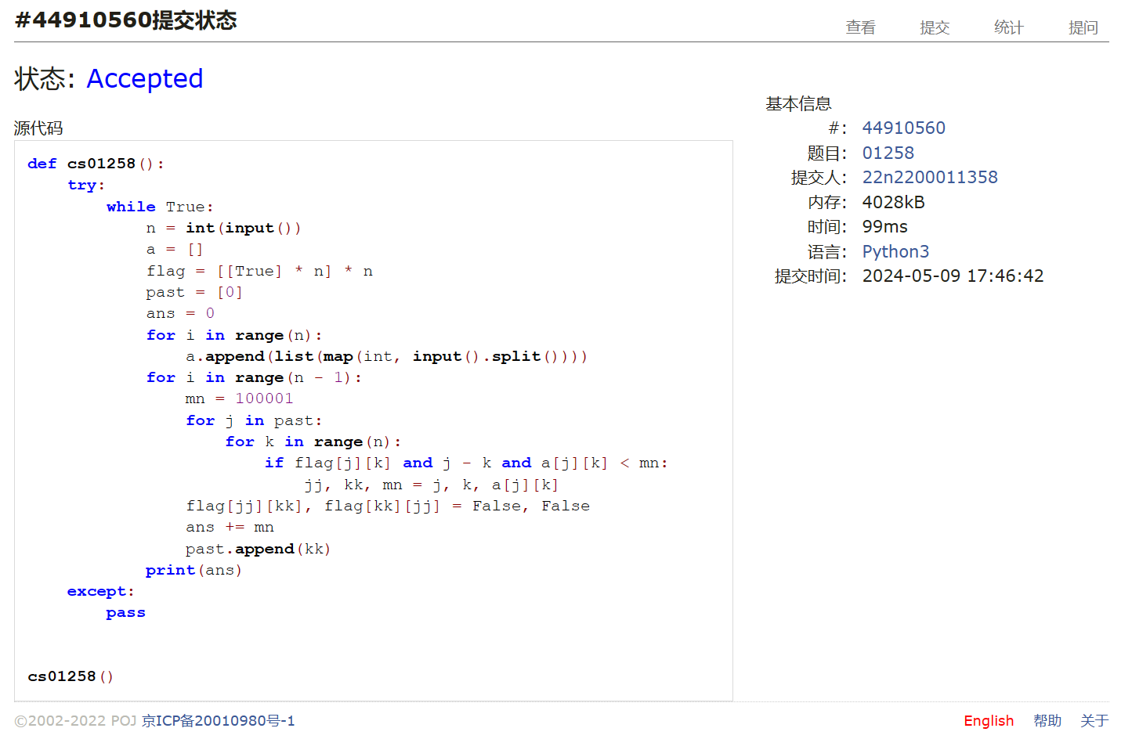

## 27635:判断无向图是否连通有无回路(同23163)

def cs27635():  
 n, m = map(int, input().split())  
 dct1 = {i: [] for i in range(n)}  
 flag = [True for i in range(n)]  
 for i in range(m):  
 u, v = map(int, input().split())  
 dct1[u].append(v)  
 dct1[v].append(u)  
  
 def go1(i):  
 flag[i] = False  
 for j in dct1[i]:  
 if flag[j]:  
 go1(j)  
  
 go1(0)  
 if True in flag:  
 print("connected:no")  
 else:  
 print("connected:yes")  
 flag = [True for i in range(n)]  
  
 def go2(ii, tmp):  
 if flag[ii]:  
 flag[ii] = False  
 for j in dct1[ii]:  
 if flag[j]:  
 go2(j, tmp + [j])  
 elif len(tmp) > 1 and j == tmp[-2]:  
 pass  
 else:  
 print("loop:yes")  
 exit()  
  
 for i in range(n):  
 go2(i, [i])  
 print("loop:no")

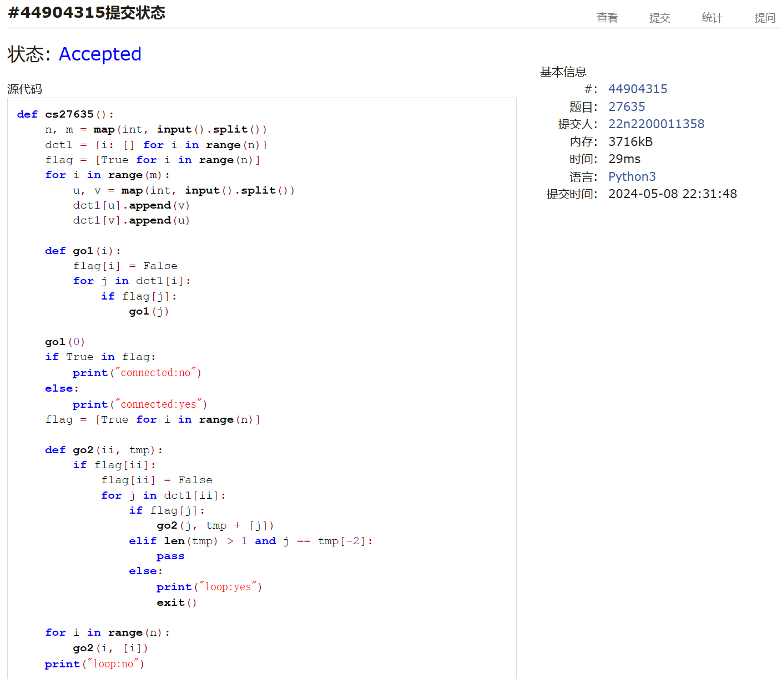

## 27947:动态中位数

def cs27947():  
 import heapq  
 for i in range(int(input())):  
 ipt = list(map(int, input().split()))  
 flag = 1  
 lft, rt, ans = [], [], []  
 md = ipt[0]  
 f = 0  
 for j in ipt:  
 if j <= md:  
 heapq.heappush(lft, -j)  
 f += 1  
 else:  
 heapq.heappush(rt, j)  
 f -= 1  
 if f > 1:  
 heapq.heappush(rt, -heapq.heappop(lft))  
 f -= 2  
 elif f < 0:  
 heapq.heappush(lft, -heapq.heappop(rt))  
 f += 2  
 md = -lft[0]  
 if f % 2:  
 ans.append(md)  
 flag += 1  
 print(len(ans))  
 for j in ans[:-1]:  
 print(j, end=" ")  
 print(ans[-1])

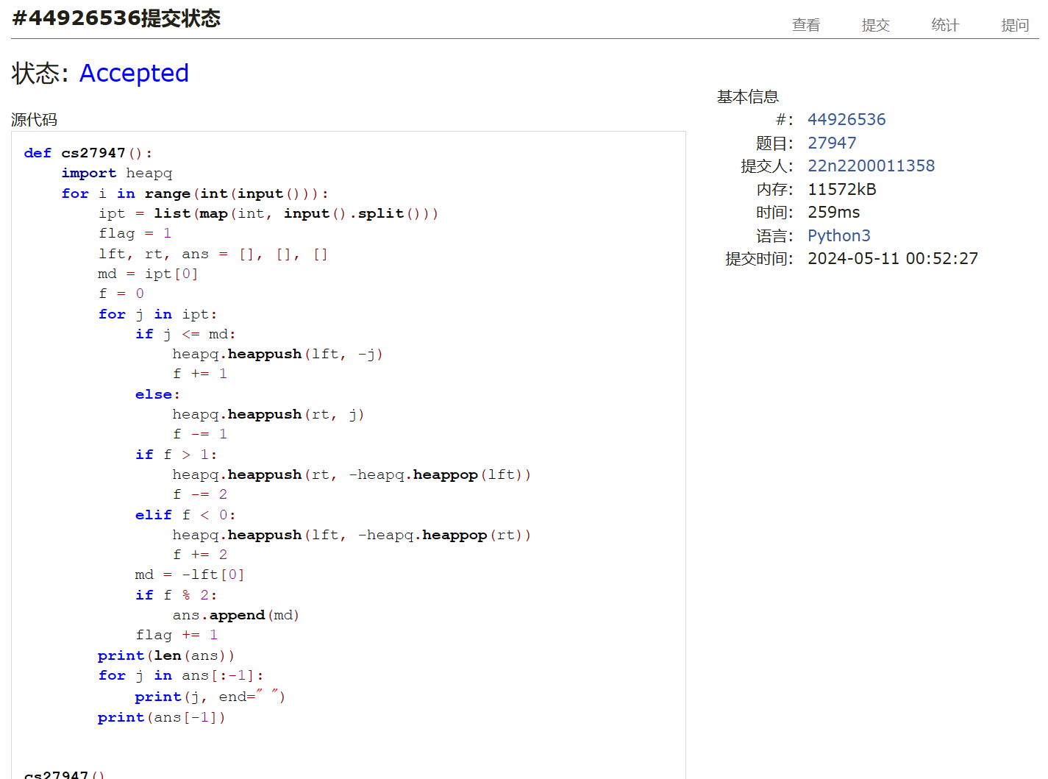

## 28190:奶牛排队

def cs28190():  
 n = int(input())  
 a = [int(input()) for _ in range(n)]  
 lft, rt = [n] * n, [-1] * n  
 ans = 0  
 lst1, lst2 = [], []  
 for i in range(n):  
 while lst1 and a[lst1[-1]] < a[i]:  
 lst1.pop()  
 if lst1:  
 rt[i] = lst1[-1]  
 lst1.append(i)  
 while lst2 and a[lst2[-1]] > a[n - 1 - i]:  
 lst2.pop()  
 if lst2:  
 lft[n - 1 - i] = lst2[-1]  
 lst2.append(n - 1 - i)  
 for i in range(n):  
 for j in range(lft[i] - 1, i, -1):  
 if rt[j] < i:  
 ans = max(ans, j - i + 1)  
 break  
 if ans > 1:  
 print(ans)  
 else:  
 print(0)

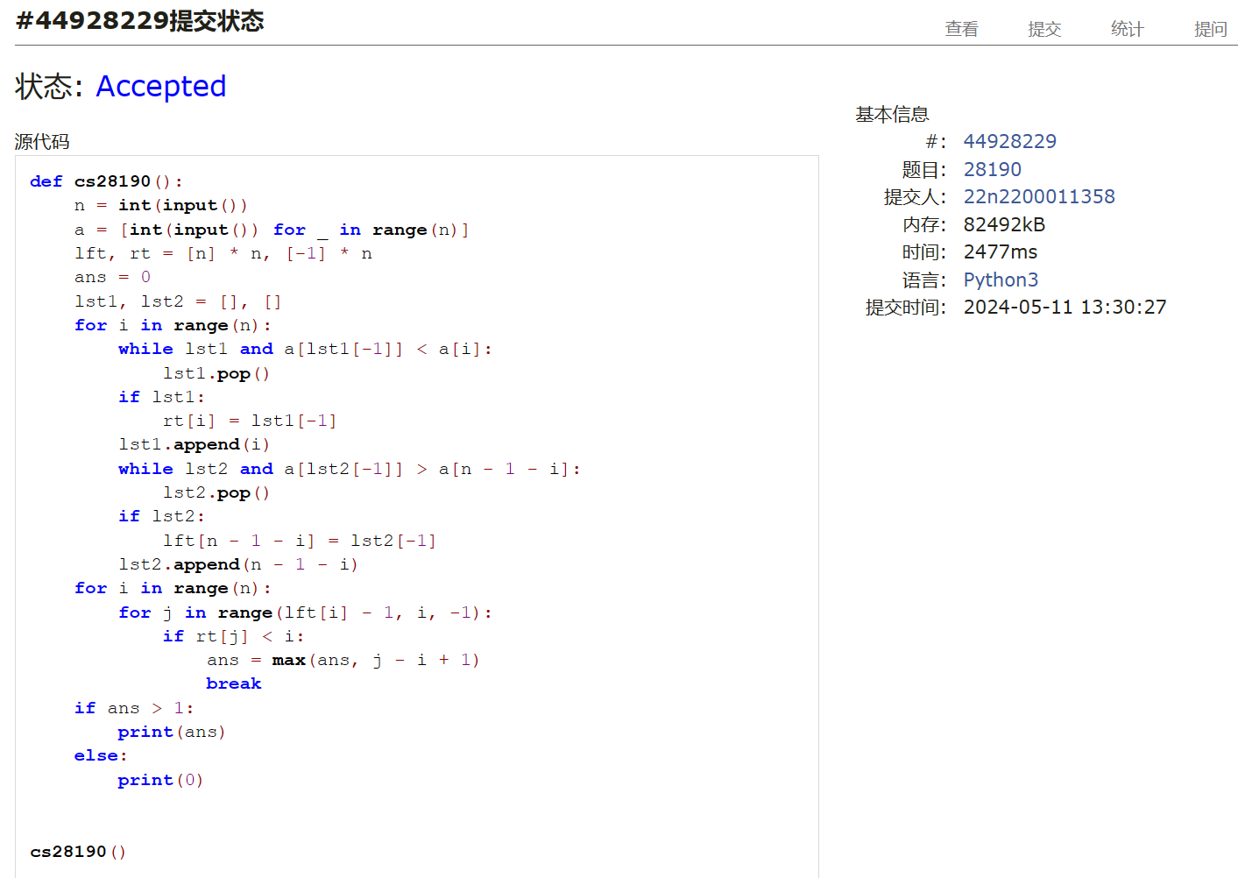

总结：2小时AC4。T1T2超出我的能力了。动态中位数改测试数据前，我写的O（n2）还能过，改数据之后我是看题解才明白这两题算法思路的。