**22485:升空的焰火，从侧面看**

def cs22485():  
 from _collections import deque  
 n = int(input())  
 dct = {}  
 for i in range(n):  
 dct[i + 1] = list(map(int, input().split()))  
 lst = deque([1])  
 tmp = deque([])  
 ans = ""  
 while lst:  
 ans += str(lst[-1]) + " "  
 while lst:  
 for i in dct[lst.popleft()]:  
 if i > -1:  
 tmp.append(i)  
 lst = tmp  
 tmp = deque([])  
 print(ans[:-1])

## 28203:【模板】单调栈

def cs28203():  
 n = int(input())  
 a = list(map(int, input().split()))  
 ans = [0 for i in range(n)]  
 lst = []  
 for i in range(n):  
 if not lst or a[i] <= a[lst[-1]]:  
 lst.append(i)  
 else:  
 while lst and a[i] > a[lst[-1]]:  
 ans[lst.pop()] = i + 1  
 lst.append(i)  
 for i in ans[:-1]:  
 print(i, end=" ")  
 print(ans[-1])

## 

## 09202:舰队、海域出击！

def cs09202():  
 for _ in range(int(input())):  
 n, m = map(int, input().split())  
 dct = {i: [] for i in range(n)}  
 for _ in range(m):  
 a, b = map(int, input().split())  
 dct[a - 1].append(b - 1)  
 flag0 = [True for _ in range(n)]  
 flag = [True for _ in range(n)]  
  
 def go(k):  
 for i in dct[k]:  
 if not ans[0] and flag0[i]:  
 if flag[i]:  
 flag[i] = False  
 go(i)  
 else:  
 print("Yes")  
 ans[0] = True  
 break  
 flag0[k] = False  
  
 ans = [False]  
 for j in range(n):  
 if flag0[j]:  
 go(j)  
 if ans[0]:  
 break  
 if not ans[0]:  
 print("No")

## 07735:道路

def cs07735():  
 import heapq  
 k = int(input())  
 n = int(input())  
 r = int(input())  
 dct = {i: [] for i in range(n)}  
 for _ in range(r):  
 s, d, l, t = map(int, input().split())  
 dct[s - 1].append((l, t, d - 1))  
 pq = [(0, 0, 0)]  
 while pq:  
 ll, tt, dd = heapq.heappop(pq)  
 if dd == n - 1:  
 print(ll)  
 exit()  
 else:  
 for i in dct[dd]:  
 if tt + i[1] <= k:  
 heapq.heappush(pq, (ll + i[0], tt + i[1], i[2]))  
 print(-1)

## 

## 01182:食物链

def cs01182():  
 n, k = map(int, input().split())  
 ans = 0  
 dct = {}  
 for _ in range(k):  
 tag, x, y = map(int, input().split())  
 if x > n or y > n or x == y and tag == 2:  
 ans += 1  
 else:  
 xx, yy = 0, 0  
 while x in dct:  
 xx = (xx + dct[x][1]) % 3  
 x = dct[x][0]  
 while y in dct:  
 yy = (yy + dct[y][1]) % 3  
 y = dct[y][0]  
 if x != y:  
 dct[y] = (x, (xx - yy + tag + 2) % 3)  
 elif (xx - yy + tag + 2) % 3:  
 ans += 1  
 print(ans)

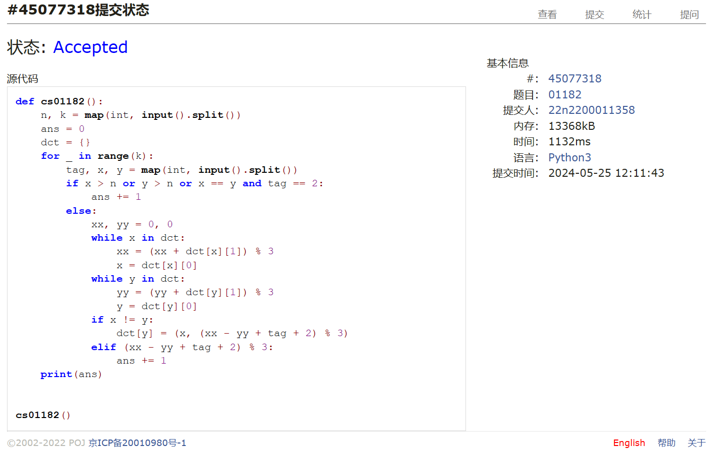

总结：道路和月度开销做得灰头土脸，月度开销后来是看题解了，实在想不到二分。其他还过得去。预祝自己机考顺利吧