**FINAL YEAR PROJECT**

**AY2023**

**TECHNICAL DESIGN DOCUMENT**

**[GAME TITLE/LOGO HERE]**

**[STUDIO NAME/LOGO HERE]**

**Ang Sheng Heng (210352F)**

**Randall Soh (210495D)**

**Member 3 (Admin No 3)**

**Member 4 (Admin No 4)**

**… …**

**Member N (Admin No N)**

TABLE OF CONTENTS

1.0. Software Architecture 3

2.0. Class Diagrams 4

3.0. Conventions 5

3.1. Coding standards 5

3.2. Directory Structure 5

3.3. File Naming Convention 5

4.0. Features 6

4.1. Collision Detection 6

4.2. AI State Machines 6

4.3. Etc 6

5.0. Installation Manual 6

5.1. Build steps 6

5.2. Installation steps 6

5.3. Hardware and software requirements 6

# Software Architecture

Describe using diagrams what are the engines, libraries you use and how they are interlinked with your game

This image is for sample purposes:

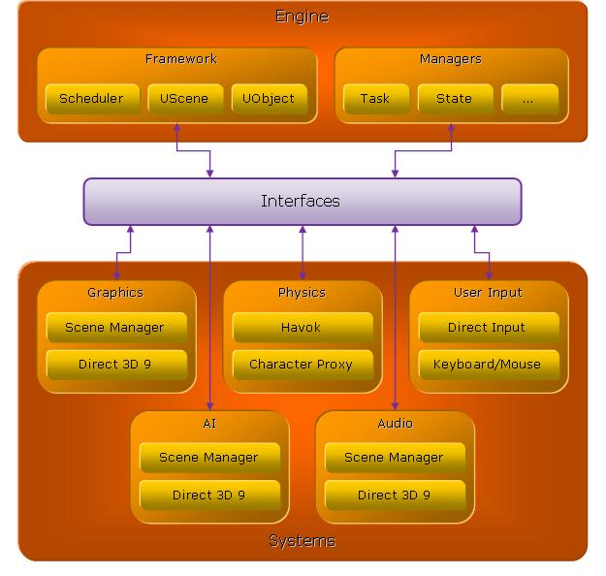

Image Ref: <https://software.intel.com/sites/default/files/7948.jpg>

# Class Diagrams

This image is for sample purposes:

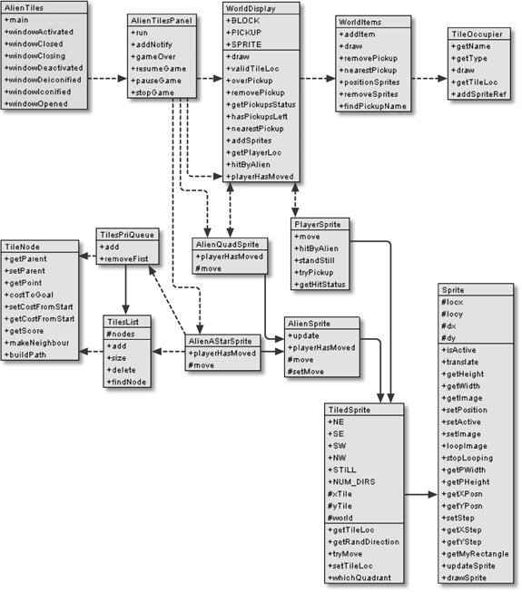

# Conventions

## Coding standards

Description of how your coding conventions such as all classes begins with letter ‘C’ (e.g: CBullet), all member variable name in a class begin with ‘m’ (e.g: mScore)

## Directory Structure

Explain in diagrams the directory structure of your project

## File Naming Convention

List down all the source codes and its file naming convention

# Features

The following are samples of features done. Describe any algorithm or method (especially those difficult to understand).

**NPC Dialogues interaction**

Variable description:

Each NPC Characters have a Dialogues List which consists of DialogueChoice Array List. In the DialogueChoice Array, it consists of the Player Response string and NPC Response string array so it gives the player options to choose the responses they want to go for.

Code: (Recursion)

Everytime we interact with the NPC, we have to construct the widget UI which first call the UpdateDialogueText function, after that we just need to call the UpdateDialogueText function when pressing the interact button. First iteration, the currentDialogueTalkingIdx has to be incremented so that it will return false because it is started from -1 and check to see whether it is more than the size of the NPC Response string array, then we can increment the currentDialogueIdx. A variable called ChoiceDone helps to indicate if there are more than 1 response choice for the player and whether it is selected. If true, we loop the function again and reset the dialogue text. If the DialogueChoice Array list length is less than 2, it will skip the creation of the 2 widget UI and do the loop instead. We store the dialogue text that is supposed to be printed out into a variable. We set a timer loop to increment the index and capture that character element and append it to the variable. After the dialogue text has been fully appended, it will stop the loop until the player call the function with the updated variable again to do the necessary checking.

**Inventory**

**Interaction (General)**

**Map**

**Quest System**

## Collision Detection

## AI State Machines

Mobiro AI

Follow

Idle:

## Etc

# Installation Manual

Describe the some of the following information clearly:

## Build steps

## Installation steps

## Hardware and software requirements