西南大学教师职业能力测评团体报告

单位：

人数：

**基本情况**

1.性别

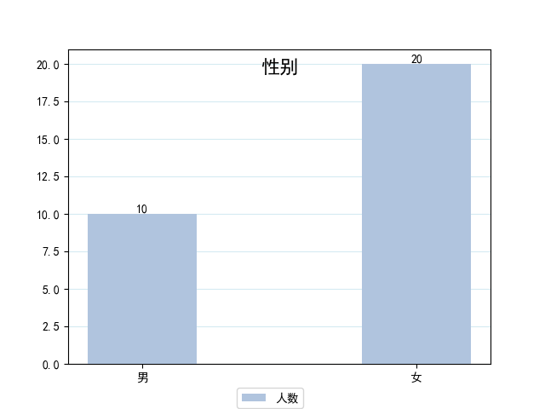

2.年龄

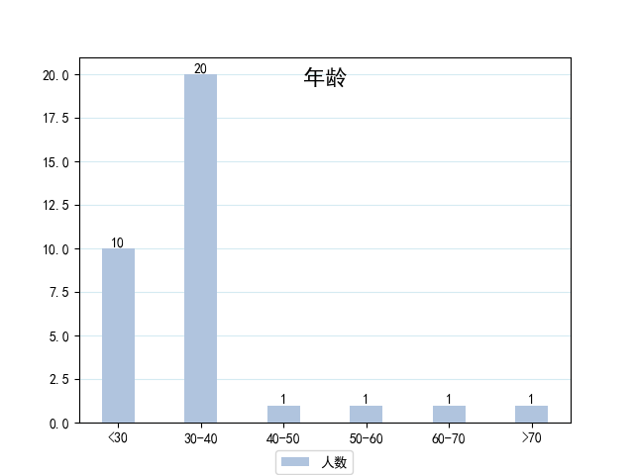

2.教龄

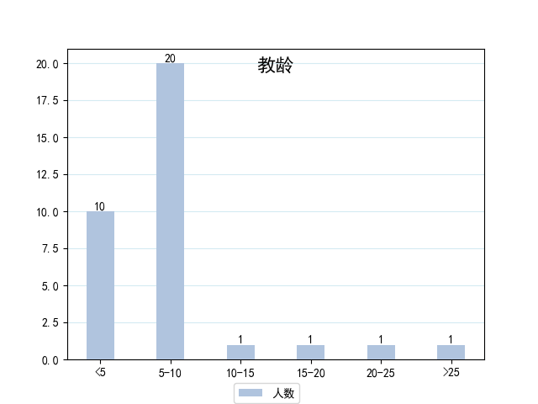

4.学历

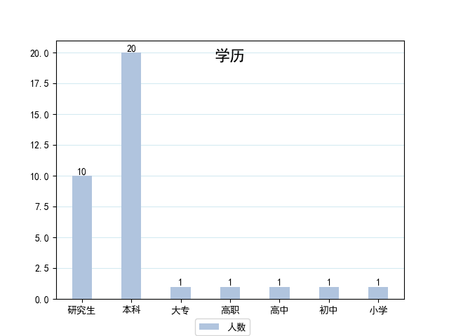

5.职称

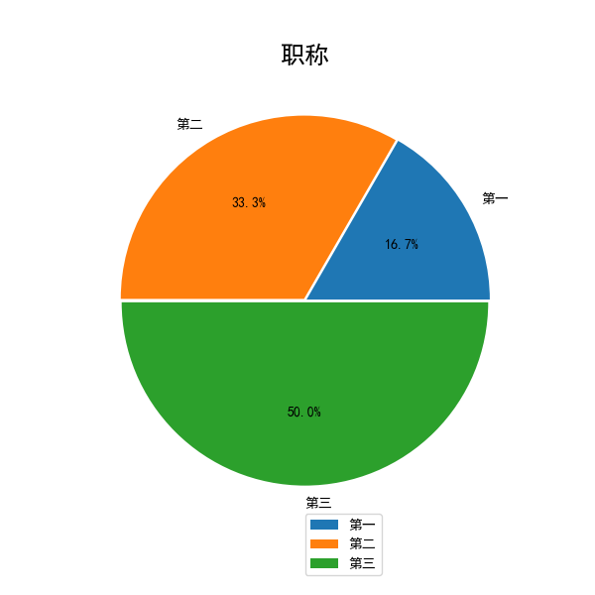

6.岗位分布



**测评结果**

1.工作疲劳

(1) 总体情况

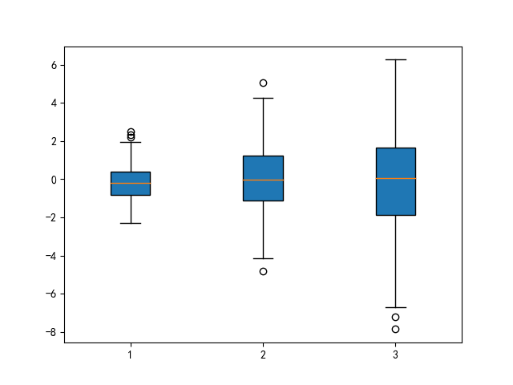

|  |  |  |  |  |  |  |  |  |
| --- | --- | --- | --- | --- | --- | --- | --- | --- |
| **平均得分** |  | **各维度平均分** | **情绪衰竭成就感低落玩世不恭** | | | | | |
| **水平** |  |  |  | | | | | |
| **解释** |  |

(2) 差异分析

① 性别差异

|  |  |  |  |
| --- | --- | --- | --- |
| **性别** | **平均得分** | **水平** | **解释** |
| **男** |  |  |  |
| **女** |  |  |  |

② 年龄差异

|  |  |  |  |
| --- | --- | --- | --- |
| **age** | **平均得分** | **水平** | **解释** |
| **<30** |  |  |  |
| **>70** |  |  |  |

③ 教龄差异

|  |  |  |  |
| --- | --- | --- | --- |
| **teac_age** | **平均得分** | **水平** | **解释** |
| **5** |  |  |  |
| **>25** |  |  |  |

2.幸福感

(1) 总体情况

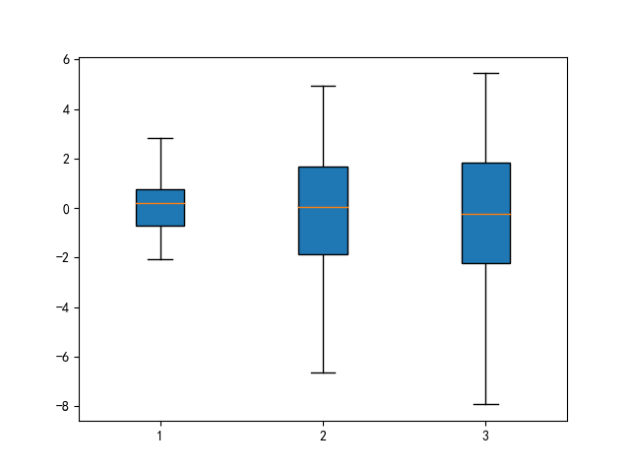

|  |  |  |  |  |  |  |
| --- | --- | --- | --- | --- | --- | --- |
|  | **平均得分** | **水平** | **解释** | | | |
| **总分** |  |  |  | | | |
| **对健康的担心** |  |
| **精力** |  |
| **对生活的满足和兴趣** |  |
| **忧郁或愉快的心境** |  |
| **对情感和行为的控制** |  |
| **松弛与紧张** |  |

(2) 差异分析

① 性别差异

|  |  |  |  |  |  |  |  |  |
| --- | --- | --- | --- | --- | --- | --- | --- | --- |
| **性别** |  | **总分** | **对健康的担心** | **精力** | **对生活的满足和兴趣** | **忧郁或愉快的心境** | **对情感和行为的控制** | **松弛与紧张** |
| **男** |  |  |  |  |  |  |  |  |
| **女** |  |  |  |  |  |  |  |  |

② 年龄差异

|  |  |  |  |  |  |  |  |  |
| --- | --- | --- | --- | --- | --- | --- | --- | --- |
| **age** |  | **总分** | **对健康的担心** | **精力** | **对生活的满足和兴趣** | **忧郁或愉快的心境** | **对情感和行为的控制** | **松弛与紧张** |
| **<30** |  |  |  |  |  |  |  |  |
| **>70** |  |  |  |  |  |  |  |  |

③ 教龄差异

|  |  |  |  |  |  |  |  |  |
| --- | --- | --- | --- | --- | --- | --- | --- | --- |
| **teac_age** |  | **总分** | **对健康的担心** | **精力** | **对生活的满足和兴趣** | **忧郁或愉快的心境** | **对情感和行为的控制** | **松弛与紧张** |
| **5** |  |  |  |  |  |  |  |  |
| **>25** |  |  |  |  |  |  |  |  |

3.压力情况

(1) 总体情况

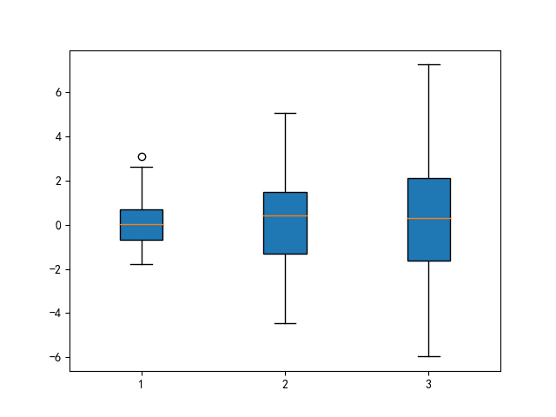

|  |  |  |  |  |  |  |
| --- | --- | --- | --- | --- | --- | --- |
|  | **平均得分** | **水平** | **解释** | | | |
| **总分** |  |  |  | | | |
| **紧张感** |  |
| **失控感** |  |

(2) 差异分析

① 性别差异

|  |  |  |  |  |
| --- | --- | --- | --- | --- |
| **性别** |  | **总分** | **紧张感** | **失控感** |
| **男** |  |  |  |  |
| **女** |  |  |  |  |

② 年龄差异

|  |  |  |  |  |
| --- | --- | --- | --- | --- |
| **age** |  | **总分** | **紧张感** | **失控感** |
| **<30** |  |  |  |  |
| **>70** |  |  |  |  |

③ 教龄差异

|  |  |  |  |  |
| --- | --- | --- | --- | --- |
| **teac_age** |  | **总分** | **紧张感** | **失控感** |
| **5** |  |  |  |  |
| **>25** |  |  |  |  |

4.心理状况

(1) 总体情况

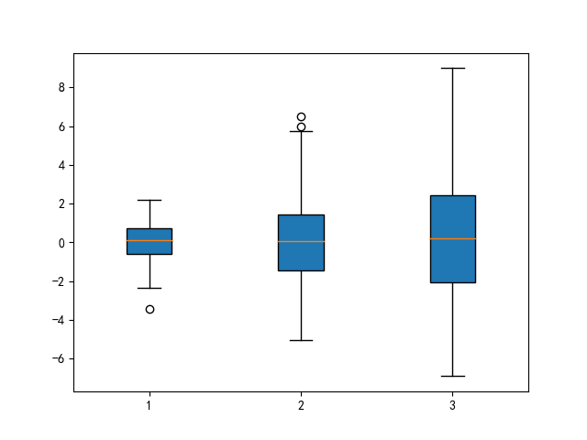

|  |  |  |  |  |  |  |
| --- | --- | --- | --- | --- | --- | --- |
|  | **平均得分** | **水平** | **解释** | | | |
| **总分** |  |  |  | | | |
| **躯体化** |  |
| **强迫** |  |
| **人际关系敏感** |  |
| **抑郁** |  |
| **焦虑** |  |
| **敌对** |  |
| **恐怖** |  |
| **偏执** |  |
| **精神病性** |  |

(2) 差异分析

① 性别差异

|  |  |  |  |  |  |  |  |  |  |  |  |
| --- | --- | --- | --- | --- | --- | --- | --- | --- | --- | --- | --- |
| **性别** |  | **总分** | **躯体化** | **强迫** | **人际关系敏感** | **抑郁** | **焦虑** | **敌对** | **恐怖** | **偏执** | **精神病性** |
| **男** |  |  |  |  |  |  |  |  |  |  |  |
| **女** |  |  |  |  |  |  |  |  |  |  |  |

② 年龄差异

|  |  |  |  |  |  |  |  |  |  |  |  |
| --- | --- | --- | --- | --- | --- | --- | --- | --- | --- | --- | --- |
| **age** |  | **总分** | **躯体化** | **强迫** | **人际关系敏感** | **抑郁** | **焦虑** | **敌对** | **恐怖** | **偏执** | **精神病性** |
| **<30** |  |  |  |  |  |  |  |  |  |  |  |
| **>70** |  |  |  |  |  |  |  |  |  |  |  |

③ 教龄差异

|  |  |  |  |  |  |  |  |  |  |  |  |
| --- | --- | --- | --- | --- | --- | --- | --- | --- | --- | --- | --- |
| **teac_age** |  | **总分** | **躯体化** | **强迫** | **人际关系敏感** | **抑郁** | **焦虑** | **敌对** | **恐怖** | **偏执** | **精神病性** |
| **5** |  |  |  |  |  |  |  |  |  |  |  |
| **>25** |  |  |  |  |  |  |  |  |  |  |  |

-------------------------报告结束-------------------------