A+ Computer Science ROCK DROPPING ACTOR Lab Value - 110

Lab Goal : This lab was designed to teach you more about the GridWorld case study and more about the methods of the Actor class.

Lab Description : Make a new actor that only moves across a row and drops rocks. The actor should move across the row and drop a rock each time it moves to a new location.
Files Needed ::
RockDroppingActor.java
RockDroppingActorRunner.java
GridWorld project

Sample Output :
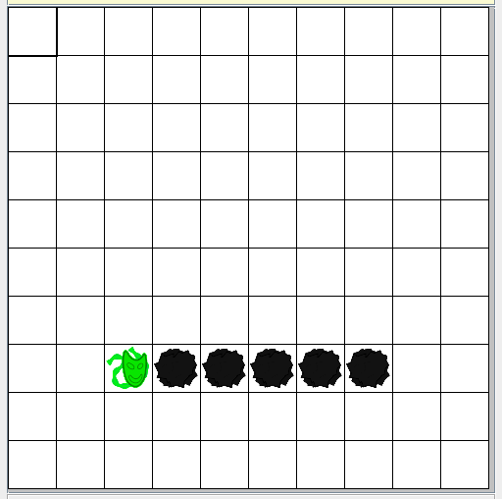
Image Information
You can create an image for any class you create in GridWorld.
The image must have the exact same name as the class. Case matters!
Save the image in the same folder as the class.

public class FlyingActor .....
FlyingActor.gif

The best size for an image would be 48X48.

To make your own image for the MoveLeftActor class, you would have to name the image MoveLeftActor.gif and save the image in the same folder as the MoveLeftActor class.

