Feature Plan

**IMPORTANT NOTES:**

1. The 3-dot button on the top right corner of the navigation bar is a development feature. It will be replaced with a user profile icon and a floating action menu (for account related actions) later.
2. Buttons will be added in the Administration page for admins to create & manage hotspots.
3. Buttons will be added in the Administration page for admins to view check-in history for users and venues.
4. Registration code field will be created to allow for registering managers and admins.
5. Menu will be added with the Google Maps components to toggle showing hotspots and check-in history.
6. Google login and registration will be integrated later.

## USER

### User Home page

* Header
  + The header shortens itself when the user scrolls down.
  + The “tall” header also consists of a background picture.
  + The button on the top left of the “tall” header, helps the user access the login/signup and account information.
  + The button on the top right of the “tall” header, helps the person to switch to their respective role of user, manager, admin.
  + The header mainly includes two navigation tabs.
    - Check in: Navigates to check-in code input bar.
    - Map: Navigates to the map portion of the page.
* Main body
  + Welcomes with the name of the user.
  + Check-in input bar, with placeholder text: “Check-in code” and a prominent submit button.
  + Map
    - Shows location history of user’s check-ins.
    - Indicates what areas are active hotspots.
* Footer
  + Social media icons
  + Contact info, mission statement
  + Disclaimer stuff

### User Account page

* Header
  + The header disappears when the user scrolls down.
  + The “tall” header also consists of a background picture.
  + The button on the top left of the “tall” header, helps the user access the login/signup and account information.
  + The button on the top right of the “tall” header, helps the person to switch to their respective role of user, manager, admin.
  + The header mainly includes two navigation tabs.
    - Check in: Navigates to check-in code input bar.
    - Map: Navigates to the map portion of the page.
* Accounts details
  + Edit details button, this enables the editing mode to change certain details which are permitted.
  + Search bar to find certain details for the user’s reference.
  + Details Column and Last updated column have sorting features, to arrange according to the user’s preference.
  + Details like USER ID, role, email, first name, last name, etc are listed.
  + Check-in Timeline
    - Proper listed history of each and every place the user has visited.
* Footer
  + Social media icons
  + Contact info, mission statement
  + Disclaimer stuff

## **Manager/Venue Home Page**

* Header Bar:
  + Logo at the top
  + Navigation bar icon at the top-left
    - Clicking on the navigation bar icon draws the navigation bar from the left, which contains Home, Account, Sign-up and Log-in options in the menu.
  + Options icon at the top-right
    - Clicking on the options button shows a drop-down menu which helps the person to switch to their respective role of user, manager or admin.
* Heading: It contains the name of the venue
* The body of the page consists of
  + Check-In History Table: It shows the recent check-in made by the users.
    - Contains a search option if the manager wants to look for a particular information.
    - Contains relevant information to check-ins, such as User ID, Name, Date and Time.
    - Indicates if any checked-in visitor has recently been to a hotspot area or not.
    - Rows per page option to allow the manager to preview the number of check-ins according to liking.
* Footer
  + Social media icons
  + Contact info, mission statement
  + Disclaimer stuff

## **Manager/Venue Account Page**

* Header Bar (SAME AS THAT OF Manager/Venue Home Page)
* Top of the body of the page consists of two options, Account and Venue, to choose from.
  + Choosing either option navigates the manager to the relevant part of the page.
  + Account Details: Contains the information related to the manager such as:
    - User ID, Role (Manager), Name, Date of Birth, Gender etc.
  + Venue Details: Contains the information related to the venue such as:
    - Venue ID, Venue Name, Location details such as Longitude, Latitude, Radius.
  + Edit detail option at the top of both Account Detail and Venue Details tables to manage information.
* Footer
  + Social media icons
  + Contact info, mission statement
  + Disclaimer stuff

**Sketch for Manager/Venue Home Page**

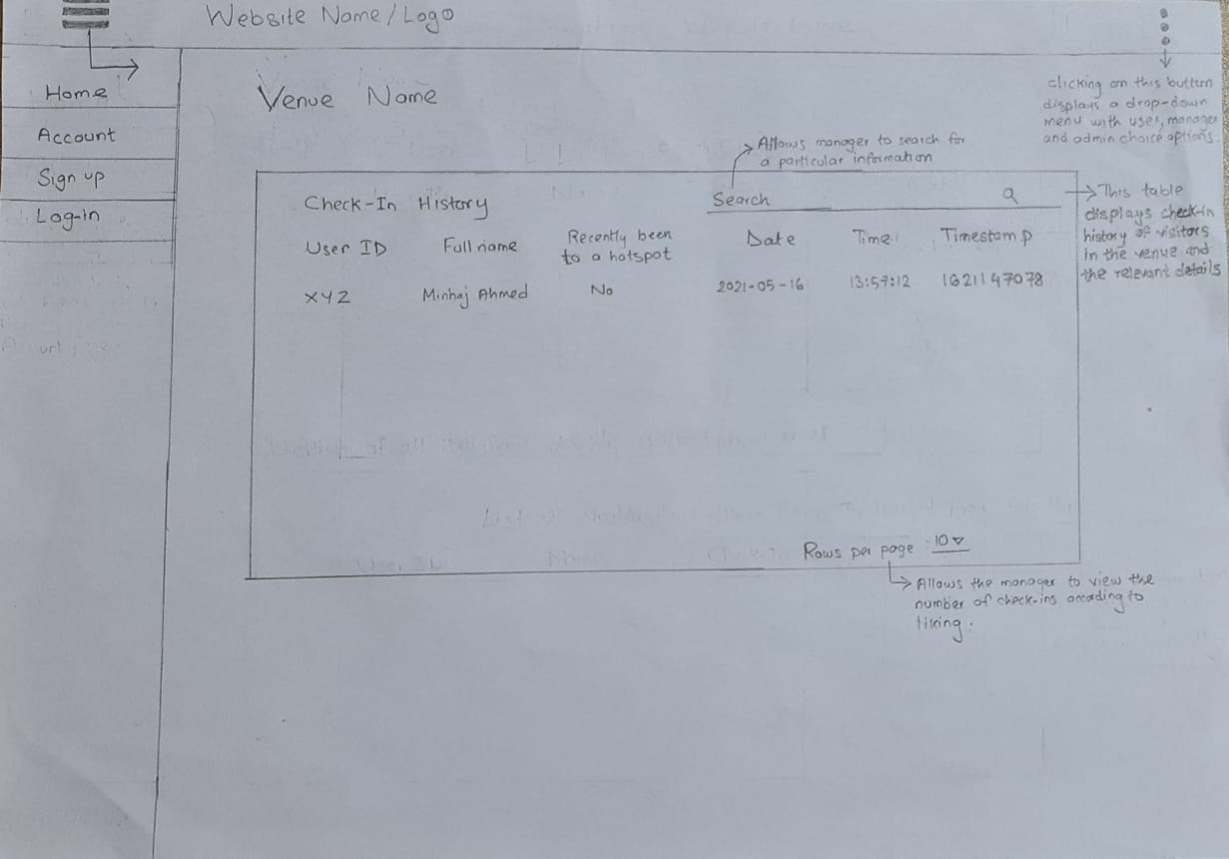

**Sketch for Manager/Venue Account Page**

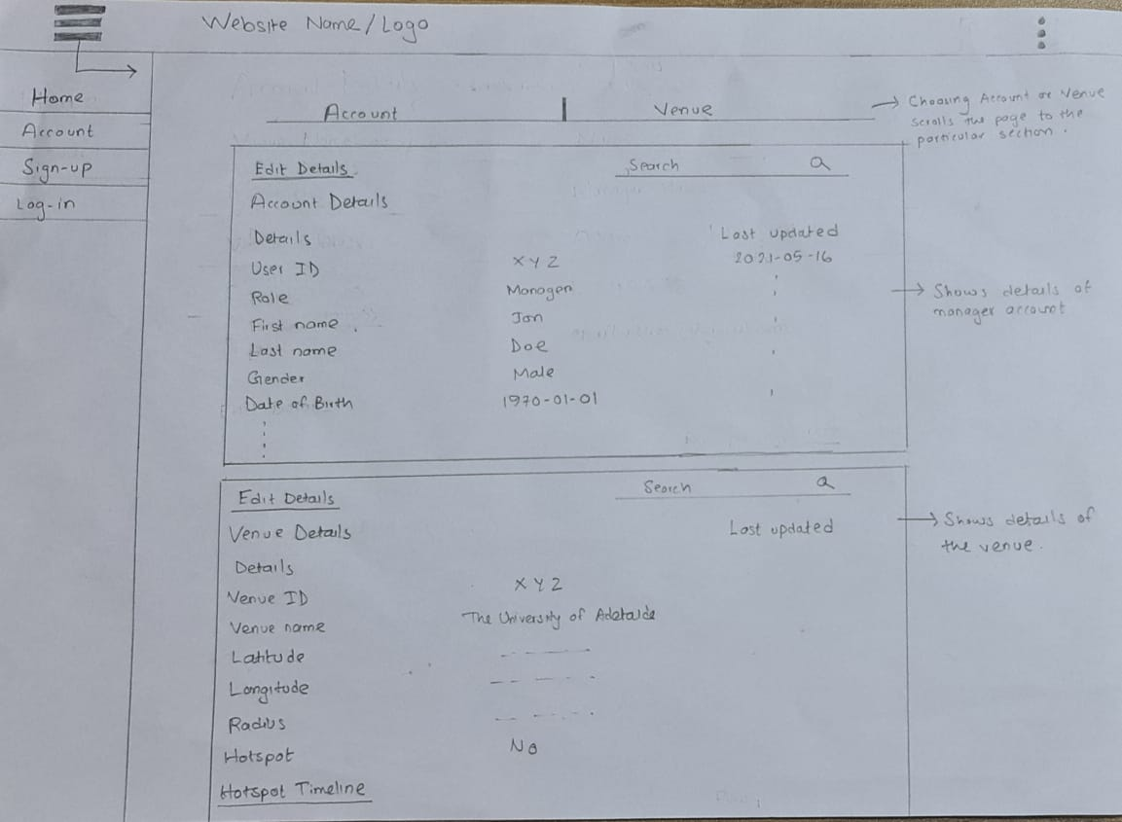

Login Page

*Head Bar*

         Burger button(left): List other pages’ option

         Users switch button(right): List the users classification

         Home button: Back to the home pages

         Consistent across all pages

*Background picture*

         Provide a suitable login atmosphere

*Sign in area*

## **Accept users input the login information**

### **Given the option to hide or show the password**

### **Given the option to reset the inputs**

## **Allow users store the login history**

## **Provide option to redirect to signup page**

*Footer*

## **The public social media icons**

## **The developers**

Sign up Page

*Head Bar*

*Burger button(left): List other pages’ option*

*Users switch button(right): List the users classification*

*Home button: Back to the home pages*

*Consistent across all pages*

*Background picture*

*Provide a suitable login atmosphere*

*Sign up area*

*List the sign-up information required*

                     First name

                     Last name

                     Phone number

                     Email

                     Password

Confirm password

Gender

Date of birth

Address & Address(optional)

Suburb

Postcode

         Provide option to redirect to login page

*Footer*

*The public social media icons*

*The developers*

Integration of Features into Website

The following features describe the interaction between the corresponding page and the users.

Login

Burger button

Located in the header, there is a list which can be displayed by clicking the burger button which shows the different button which can link to different pages.

Home page

Located in the header, It will directly back to the home page.

Users change

Located in the header, it will show a list of different types of users by clicking it.

Sign in area

Recover

Located in the sign in area that provides users can reset the password content by clicking on it.

Remember me

Located in the  sign in area that users can keep their information until next time by checking it.

Sign in

Located in the sign in area that would create the access request to the system if the information inputted is correct by clicking it.

Create an account

Located in the sign in area that provides the option to new users who can directly switch pages to sign up page by clicking it.

Connect social media

         Located in a footer that provides users with social media.

Sign up

Burger button

Located in the header, there is a list which can be displayed by clicking the burger button which shows the different button which can link to different pages.

Home page

Located in the header, It will directly back to the home page.

Users change

Located in the header, it will show a list of different types of users by clicking it.

         Sign up area

                     Gender

Located in the sign up area, it provides users with the option to choose from the drop-down menu by clicking the triangle.

Date of birth

Located in the sign up area, it provides users with the option to pick the date from the calendar by clicking the text area.

         Submit

Located in the sign up area, users' information will be stored in the database by clicking the submit button.

Sign in instead

Located in the sign up area, it allows users to log in the account immediately after sign up, which will switch to the login page.

Connect social media

         Located in a footer that provides users with social media.

Site design

Picture 1

Picture 2