## Identify the names and format of the 3 biggest files. Can you come up with a command to generate a numerically ordered list of 3 biggest files? (hint: try using the **wc**command)

**Step 1**; I navigate to Desktop using cd command, and then to the folder HW. As for some reason, my default settings don’t show me the path, but to check where I am, I use pwd (Print Working Directory) command.

**Step 2**; I then use the wc -c which displays count of bytes present in a file. Then by using the find command, to find all (\*) file names, in the current directory (.) that end with “.jpg”. I then insert the and command |, and sort it numeric.

**Step 3**; Here is a screenshot of the bottom 3 files, which are the largest.

## Some of the image files are empty, a sign of error in the data processing or corruption. Generate a list of empty photo filenames to facilitate their later replacement easier? (hint: look up **find**)

Step 1; I use the same command as last, but ad the -size 0 to find files which have a size of zero. Another way would be to use the -empty command (wc -c $(find . name "\*.jpg" -empty)

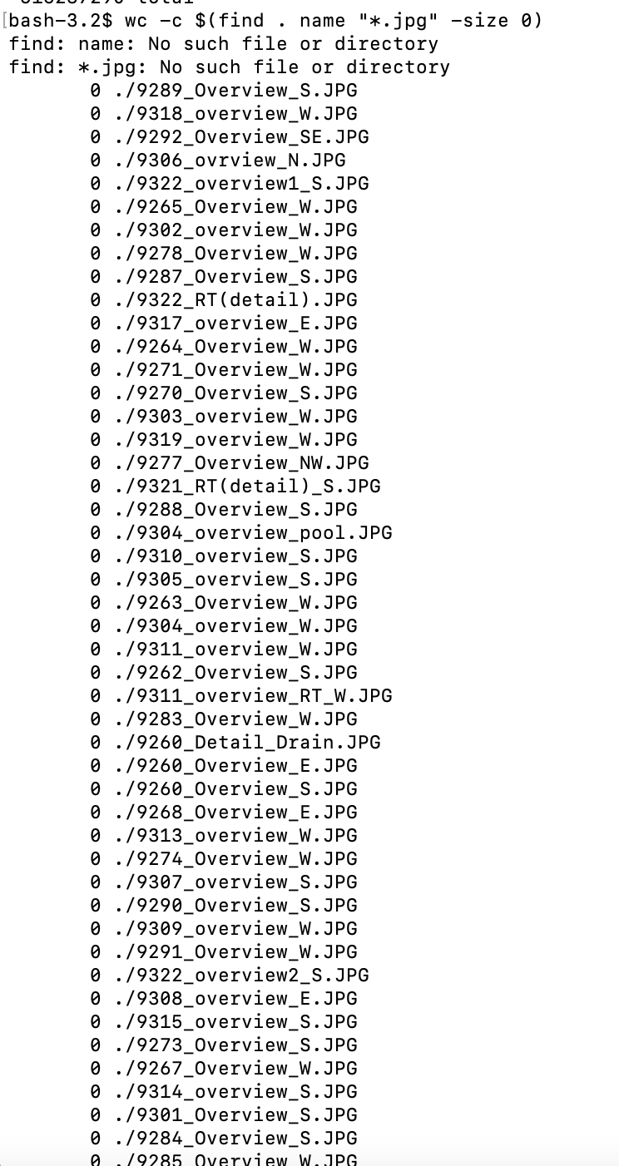

## CHALLENGE (Easy to Medium): Write a shell script called emptyfiles.sh that takes the name of a directory and generates a list of empty photo filenames (remember to pick up all extensions) . So that, for example, running $ bash emptyfiles.sh Downloads/badphotos produces a list of empty file filenames either in the terminal or in an external textfile. Can you eliminate the ./ notation at the start of the filename?

## CHALLENGE (Advanced): Imagine you have a directory [goodphotos/](https://sciencedata.dk/shared/16112a12cc9f57ef697d4502448a3e60?download" \t "_blank) (same password as above) with original non-zero-length files sitting at the same level as the current directory. How would you write a loop to replace the zero-length files?