W4: Start with R

**DESCRIPTION**

For this assignment, please answer the following three questions showing your code and results and then take a particular screenshot of your working environment. You can upload here (to Brightspace) the code and the URL to the screenshot OR submit everything to Github and submit here a single link to your repository.

1) Use R to figure out how many elements in the vector below are greater than 2.

rooms <- c(1, 2, 1, 3, 1, NA, 3, 1, 3, 2, 1, NA, 1, 8, 3, 1, 4, NA, 1, 3, 1, 2, 1, 7, 1, NA)

2) What **type** of data is in the 'rooms' vector?

To check the type of data I use the function ‘class’

3) What is the result of running the **median()**function on the above 'rooms' vector?

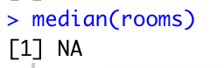

As the vector contains NA values, the function is not able to calculate it.

To do this you should remove those by adding the na.rm (rm = remove)

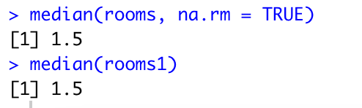

At the end I just check if its right by trying the median function on room1

4) Submit the following image to Github: Inside your R Project (.Rproj), install the 'tidyverse' package and use the download.file() and read_csv() function to read the SAFI_clean.csv dataset into your R project as 'interviews' digital object (see instructions in https://datacarpentry.org/r-socialsci/setup.html and 'Starting with Data' section). Take a screenshot of your RStudio interface showing

a) the line of code you used to create the object,

b) the 'interviews' object in the Environment, and

c) the file structure of your **R project** in the bottom right "Files" pane.

Save the screenshot as an image and put it in your **AUID_lastname_firstname** repository inside our Github organisation (github.com/Digital-Methods-HASS) or equivalent. Place **here**the URL leading to the screenshot in your repository.