ENSF-381: Full Stack Web Development Laboratory
Lab03

Section:

Group information:
Name 1 (UCID#): Fadi Salman (30240957)
Name 2 (UCID#)

GitHub Link:

Exercise 1 Output Screenshot:

Exercise 2 Output:

Screenshot from step 6:
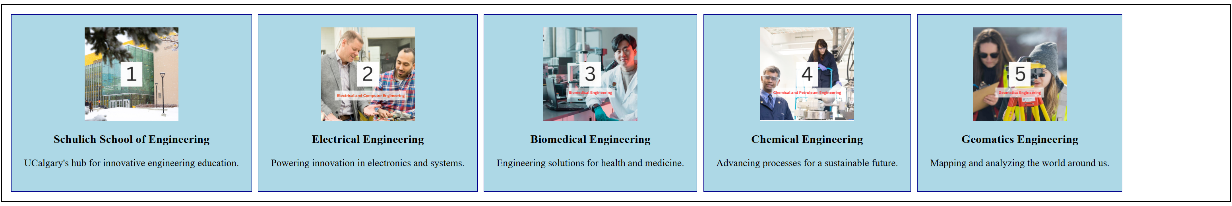

Screenshot from step 8:
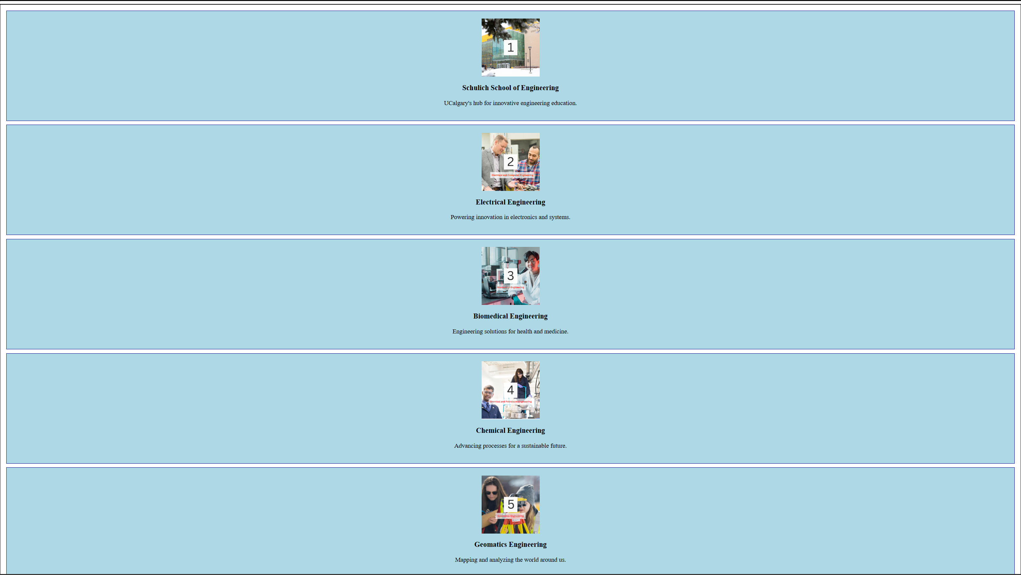
Two Screenshots from step 9:

flex-direction: row-reverse


flex-direction: column-reverse
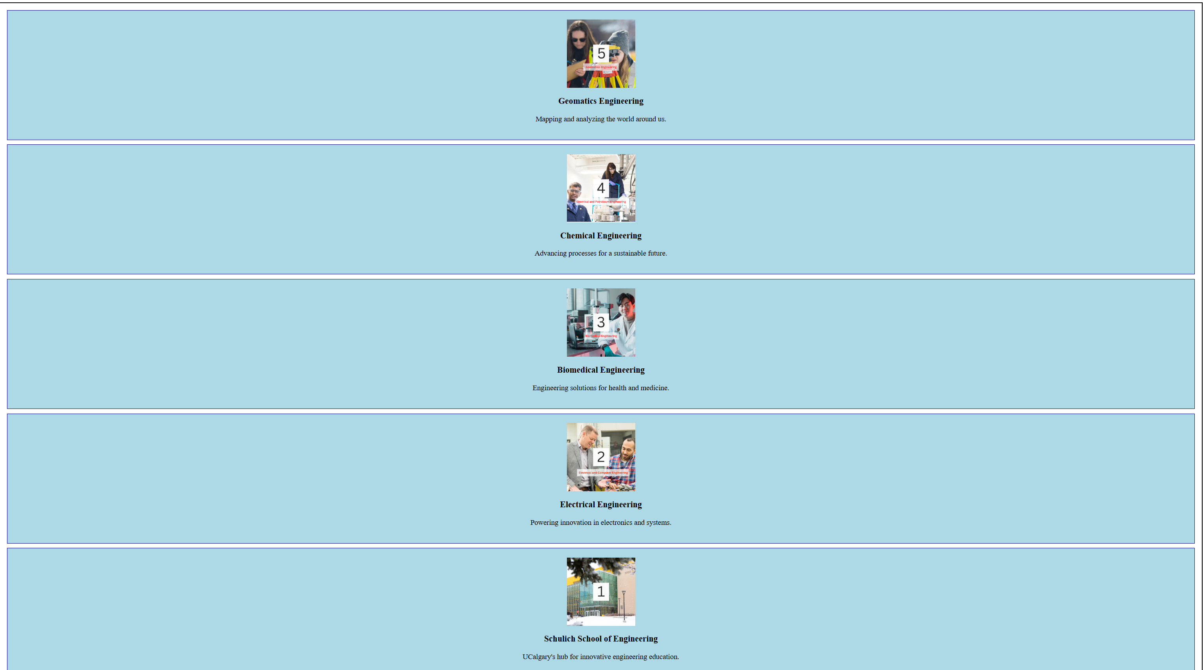

Screenshot from step 12:
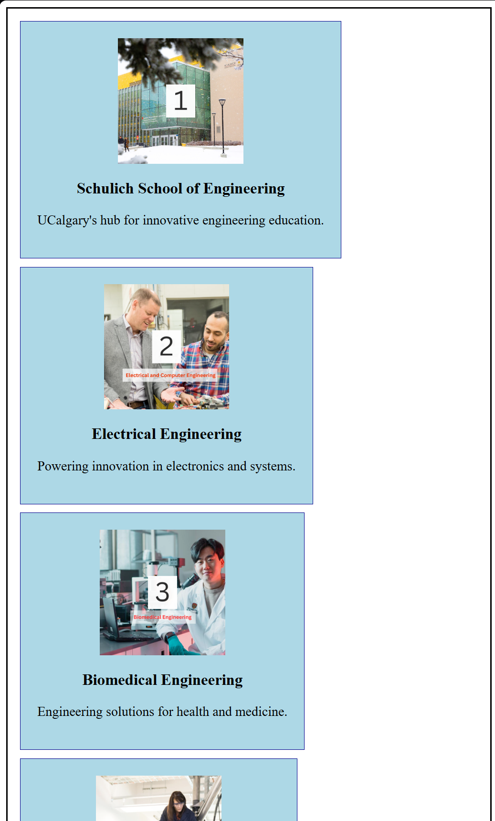

Screenshot from step 14:
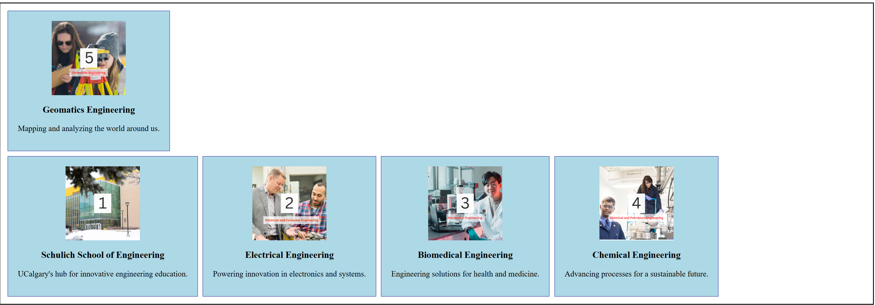

Screenshot from step 16:

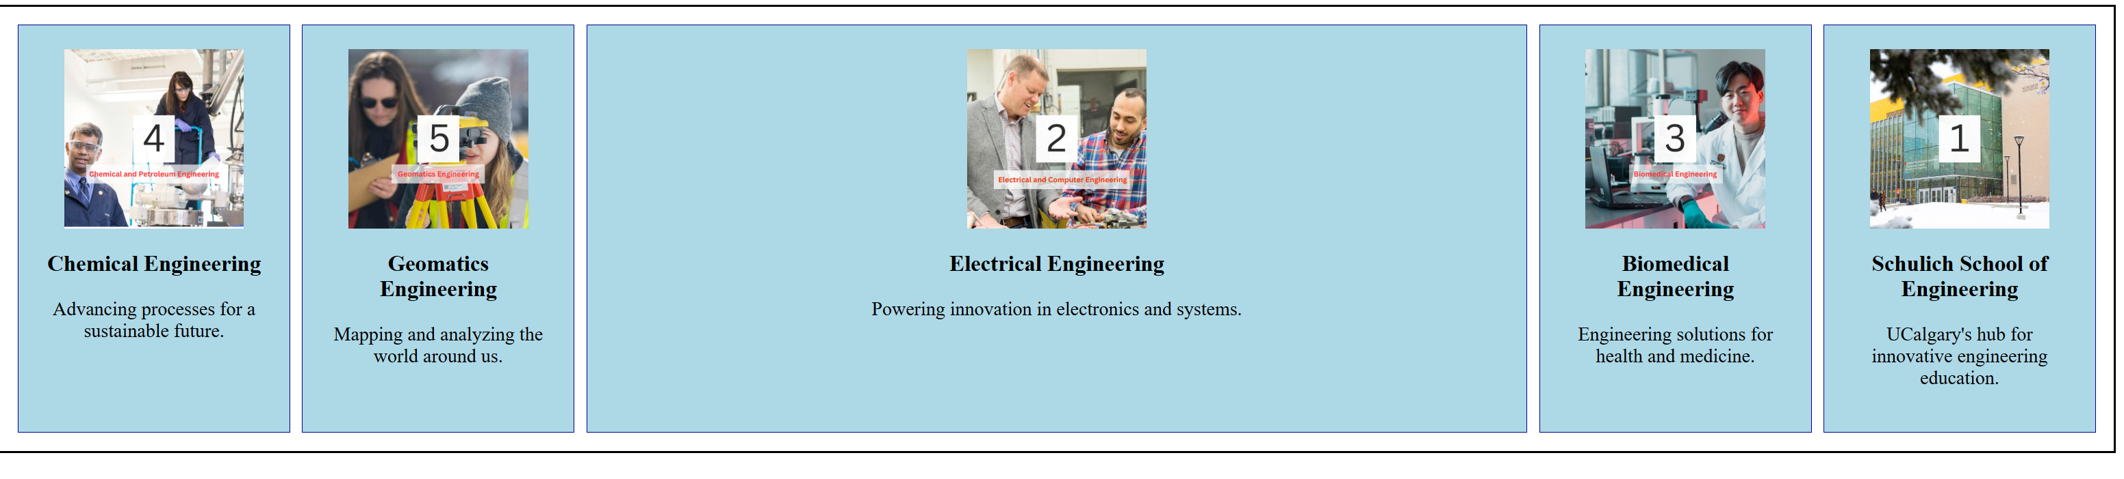

Exercise 3 Output Screenshot:

