Contents

1. Run pss\e in pythonwin at: 2

2. Run pss\e in python at visual studio code (vc): 2

3. Install numpy 4

4. PSS\E automation using python script: 4

5. Get branch flow and bus numbers of the branches 6

# 1. Run pss\e in pythonwin at:

C:\Users\HUANJ\AppData\Roaming\Microsoft\Windows\Start Menu\Programs\Python 3.9

**References:**

1. PSSE Tutorial #11 : AC Contingency Analysis (ACCC analysis) in PSSE | N-1 Contingency Analysis PSSE

https://www.youtube.com/watch?v=2dk30WXqUiA&t=77s

1. How to Use Command Line Interface (CLI) in PSS/E Software

https://www.youtube.com/watch?v=QVzcBnPBo1M

1. Lecture: 01 PSS/E Automation using Python script (*.py, *.pyc, or *.pyw) or Response file (*.idv)

https://www.youtube.com/watch?v=l2K2TS-wTlA

1. chrome-extension://efaidnbmnnnibpcajpcglclefindmkaj/https://www.engr.colostate.edu/ECE461/FA13/LAB3/LAB3.pdf
2. Import PSSE into your Python script:

<https://www.youtube.com/watch?v=nHrAAnCSYqU>

# 2. Run pss\e in python at visual studio code (vc):



1. Download and install vc
2. Install python extension in vc
3. A screenshot of a computer

   Description automatically generated with medium confidence



1. Select python interpreter which was installed by PSSE. The location of the interpreter can be found as follows:



Click “Control”+”Shift”+”P” to select python interpreter.

1. Open the python code and run it:



# 3. Install numpy

1. Open PSS®E 35.5 Command Prompt
2. Type the following:

**py -3.9 -m** pip install numpy

Note 3.9 is the python package installed along with the installation of PSSE. The above command will install numpy under python 3.9 instead of other python interpreters. The following command fails to install numpy in the designated python: pip install numpy. It installs numpy in the default python version 3.10.10.

# 4. PSS\E automation using python script:

1. Open PSSE and start recording



1. Enter script name, like ‘first_script.py’

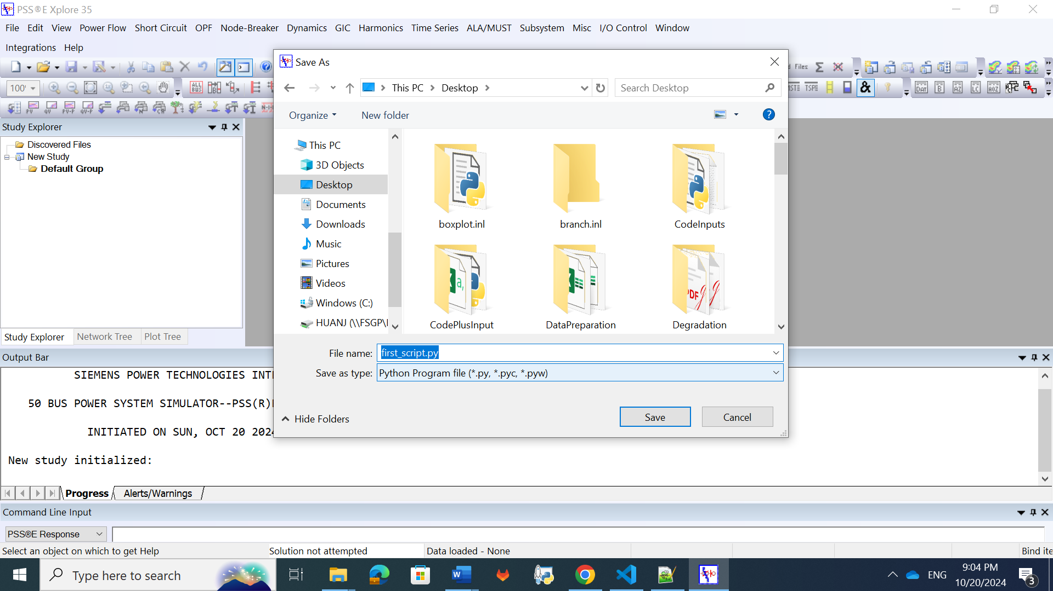

1. Open .sav file.

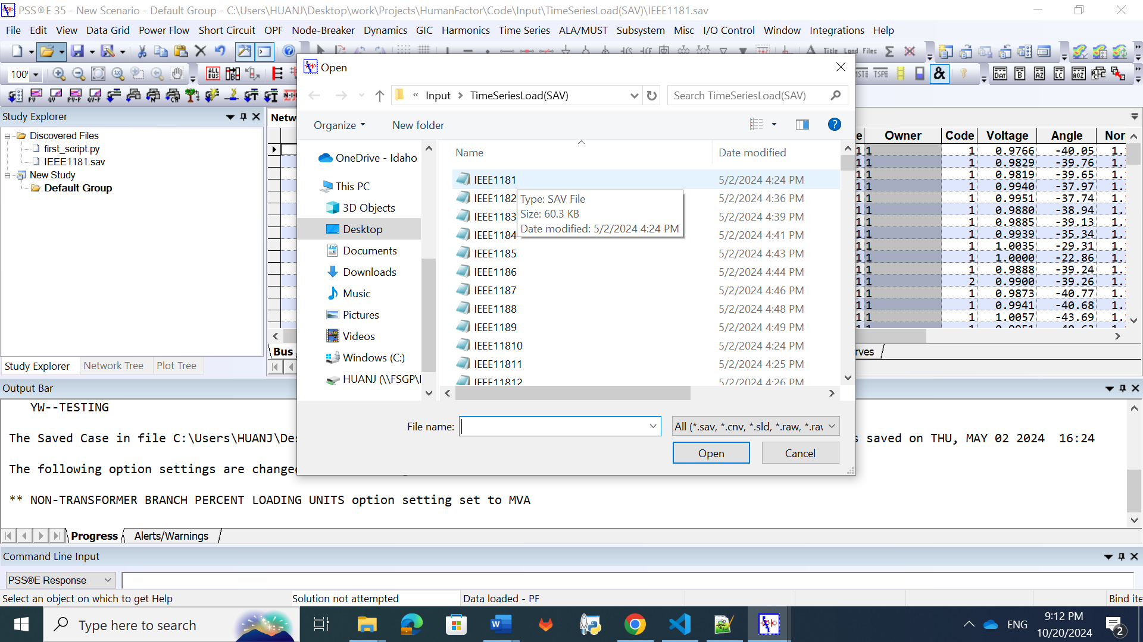



1. perform all steps manually in the GUI
2. Stop Recording



1. Run the automation python script ‘first_script.py’



# 5. Get branch flow and bus numbers of the branches

<https://psspy.org/psse-help-forum/answers/146/revisions/>

https://psspy.org/psse-help-forum/question/4127/how-to-get-branch-power-flow-and-their-bus-numbers/