1. Responsive for phone(change width)

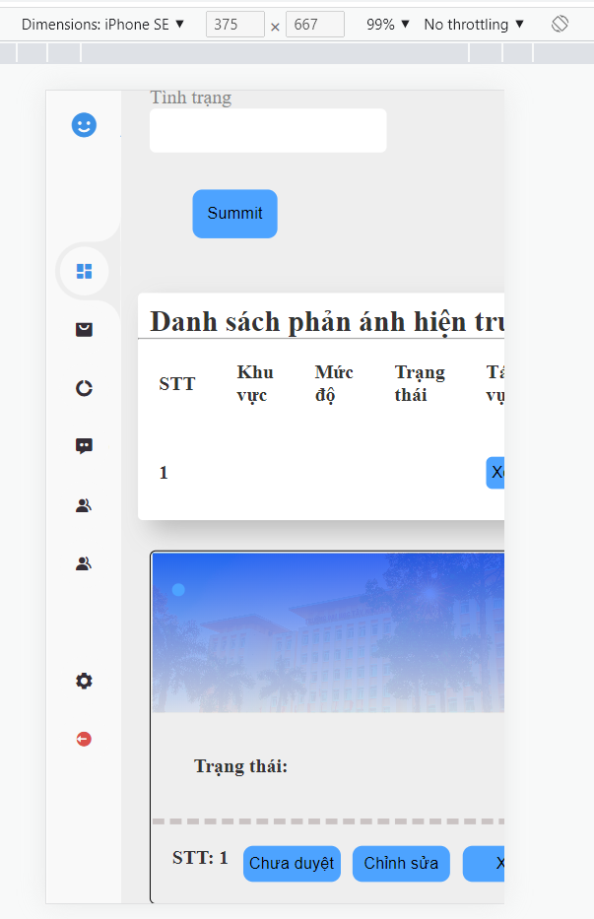

1. Hide item (responsive)

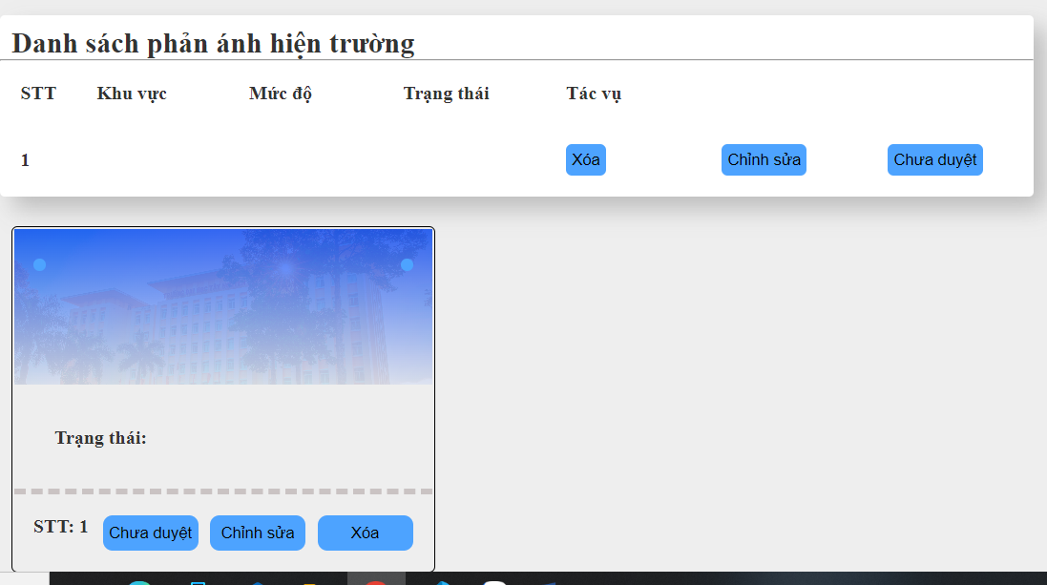

1. Login, nofitication

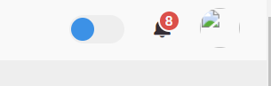

1. Change current status

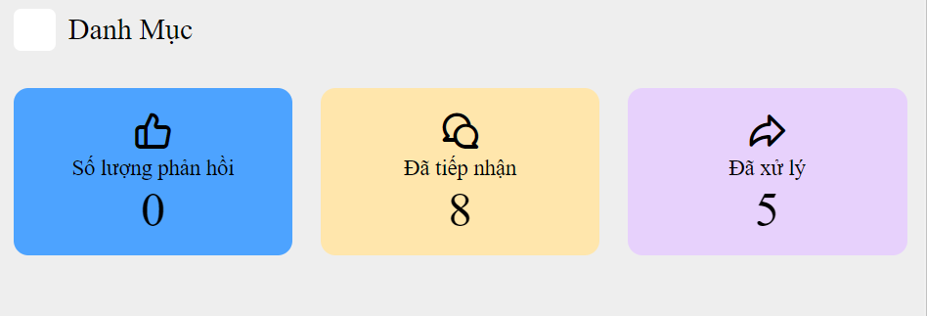

1. Change js-onclick from word to box (include the word) / DONE

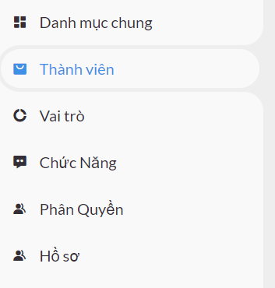

1. Complete orther pages

