# Home Task for Software Engineer (Student Position) - OP Analyzer

## Objective

Create a service that performs an analysis over a specific data source. The implementation should be completed step by step as described below.

## Step 1: Basic API Implementation

Develop an API with the following functionality:

### Function Definition

string[] Analyze(string dataSourceName)

### Behavior

- Input: A parameter called `dataSourceName` (string).

- Output: A list of strings.

### Requirements

The API should support the following data sources:

1. Stackoverflow  
 - When the input `dataSourceName` is `"Stackoverflow"`, fetch data from:   
 `https://api.stackexchange.com/2.2/tags/highcharts/faq?site=stackoverflow`   
 - Extract the titles of the returned items and return them as the result.

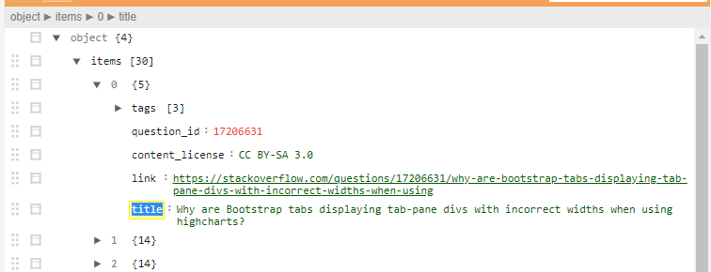

2. Github  
 - When the input `dataSourceName` is `"Github"`, fetch data from:   
 `https://api.github.com/repos/highcharts/highcharts/commits`   
 - Extract the commit messages from the returned data and return them as the result.

## Step 2: Extend the API for Analysis Flow

Enhance the API to support running predefined analysis flows on the data.

### Updated Function Definition

string[] Analyze(string dataSourceName, long analysisFlowId)

### Behavior

- Input:   
 1. `dataSourceName` (string): Name of the data source.   
 2. `analysisFlowId` (long): ID of the analysis flow to execute.   
  
- Output: A list of strings after applying the analysis flow.

### Analysis Flow

An analysis flow contains predefined steps. Each step processes the data sequentially. For example:  
  
Analysis Flow (ID: 1)  
{  
 "Id": 1,  
 "Steps": [  
 {  
 "Name": "Remove short items",  
 "Description": "Remove items with less than 5 characters"  
 },  
 {  
 "Name": "Remove spaces",  
 "Description": "Remove spaces from items"  
 }  
 ]  
}

### Expected Behavior

The API should:   
 - Run the analysis from Step 1 based on the `dataSourceName`.   
 - Apply the steps of the provided analysis flow (e.g., filter items based on the flow's logic).   
 - Return the processed data as the result.