**Accuracy/Loss progression per epochs**

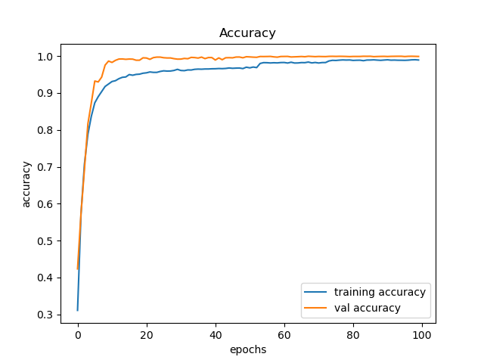

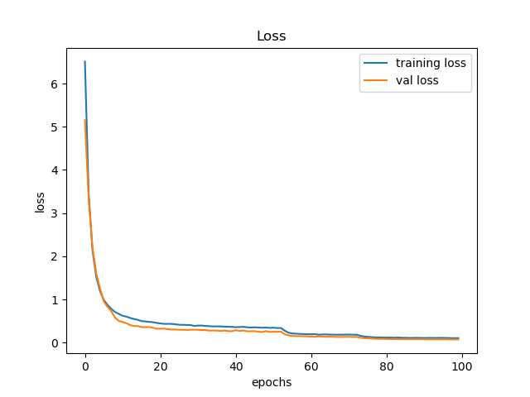

As we can see, we have very ideal graphs of increasing accuracy and decreasing loss for both train and validation sets.

**Overall, we achieve ~98.5% accuracy in all sets (train, validation, test).**

In practice this model will accompany a segmentation model which will segment the traffic sign and send as input to get prediction of the meaning of the sign (preferably it will take multiple pictures to reduce risk of action upon mistake).

**Subset of Correct predictions (total of 169 out of 12,450)**

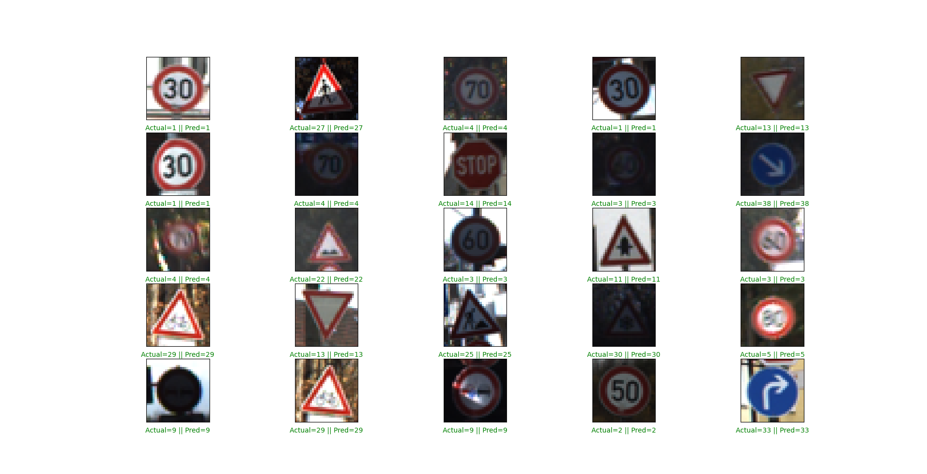

**Subset of wrong predictions (total of 169 out of 12,619)**

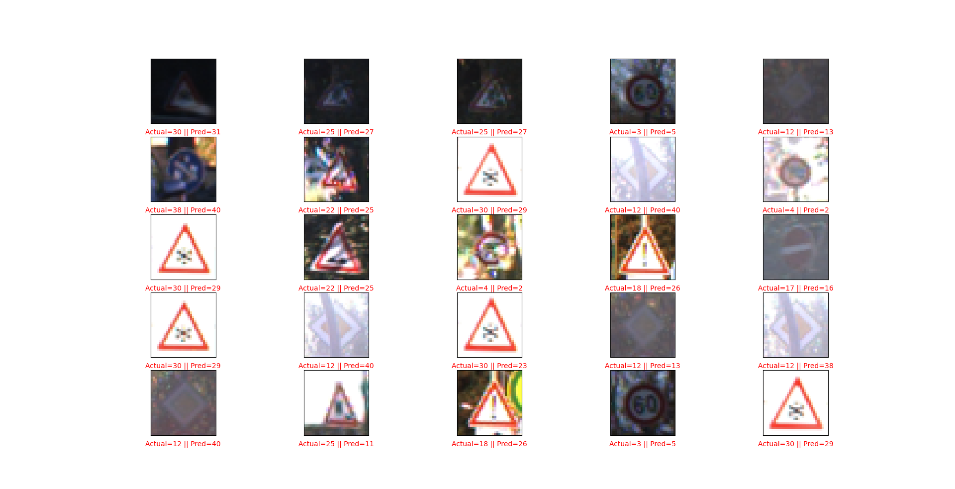

As can be seen in this subset, most of the errors happen on the same problematic labels (which will be clearer later in the classification report), in some cases I believe even a human will mistake due to bad lighting or out of focus images.

**Accuracy display**

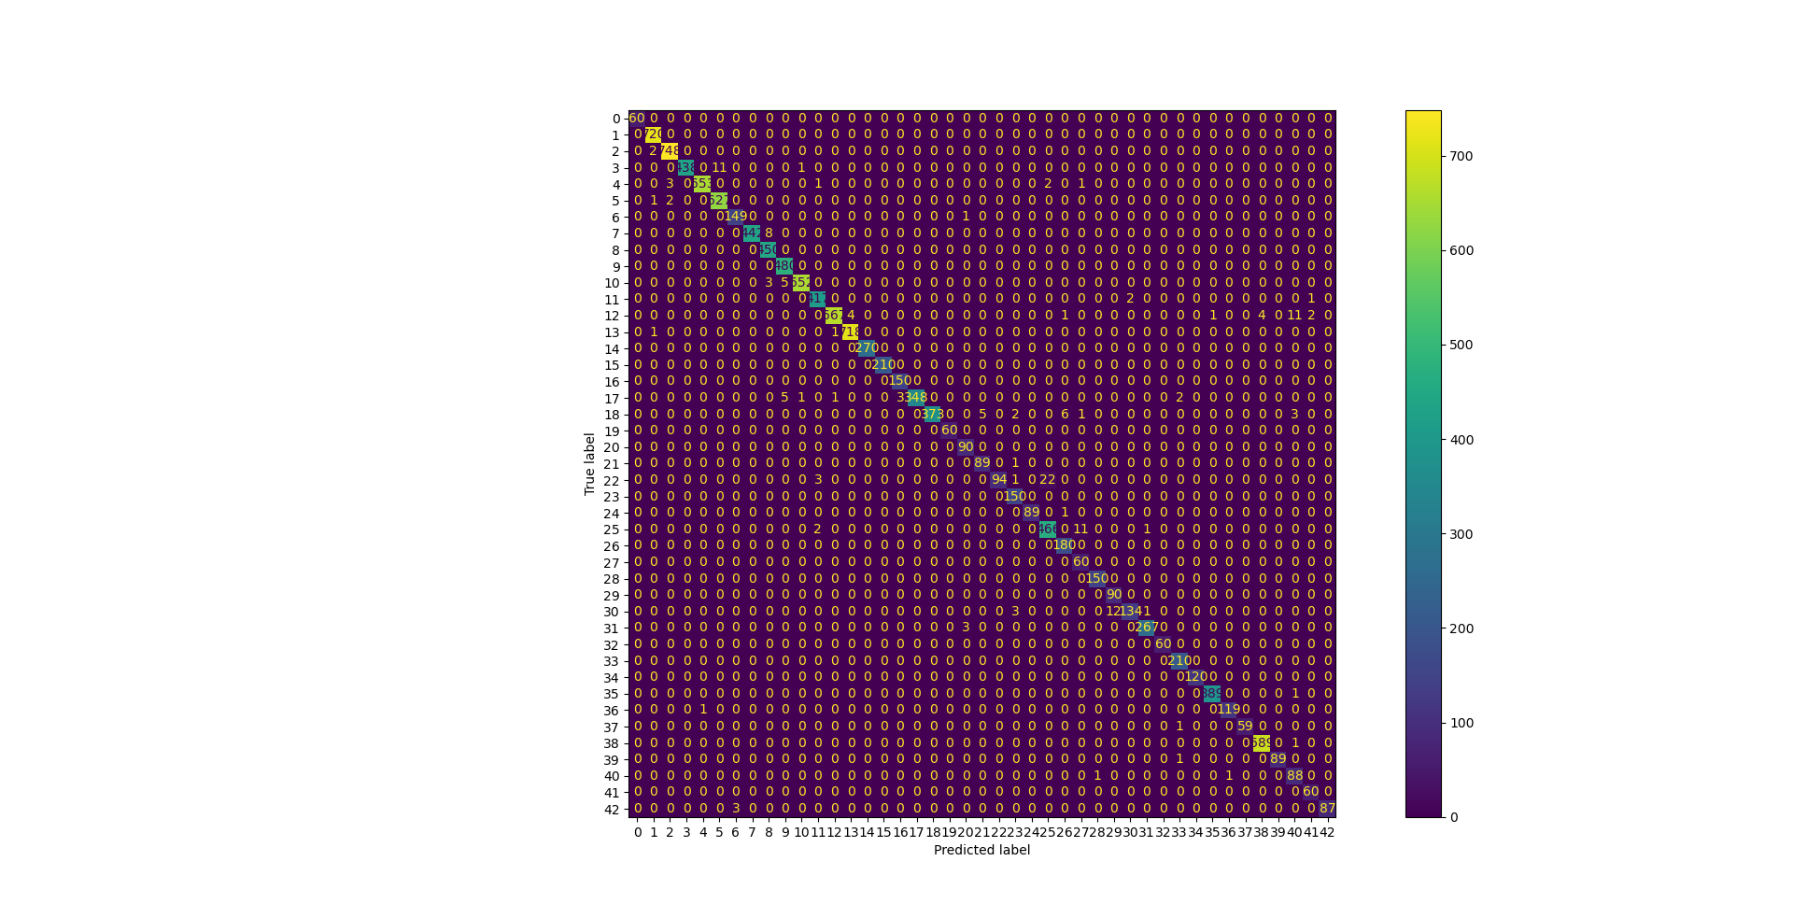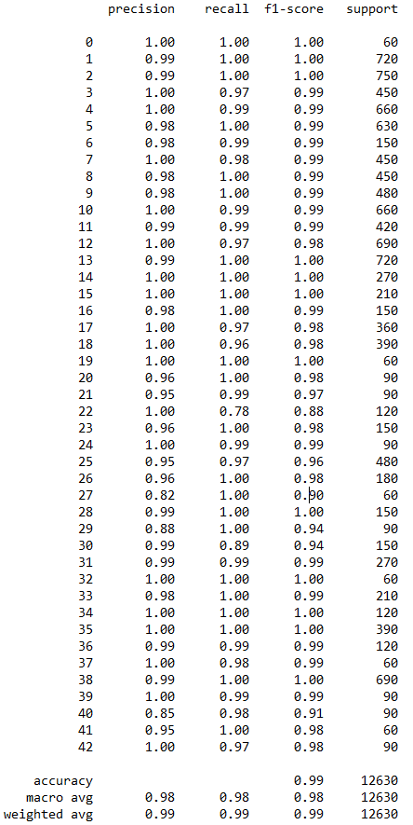

As seen in the classification report, my model achieves very high accuracy, recall and F1 score over all different labels despite the imbalance of them with the lowest accuracy being 82% for the label 27.