Final Project – Deepfake detection
Names: Almog Asher (ID 322417916), Idan Yehuda (ID 207016270)
Question 2:
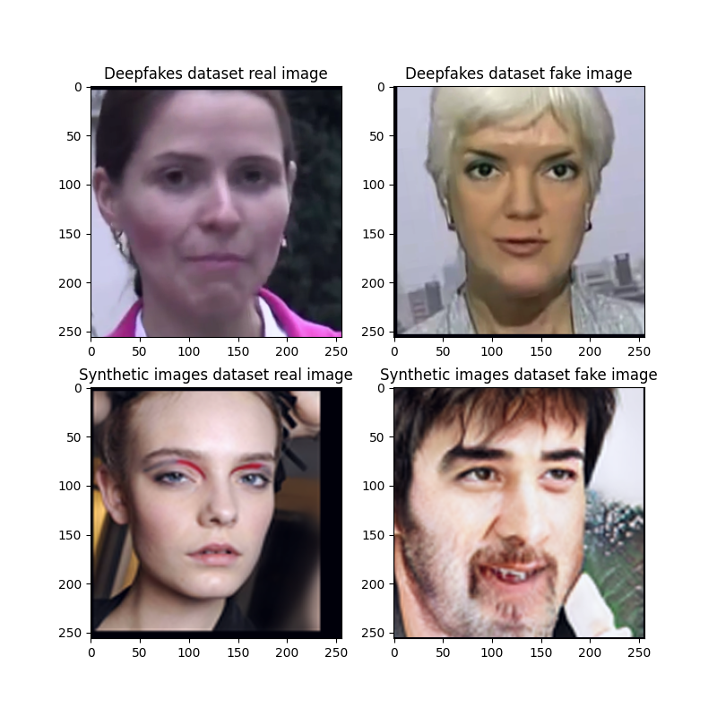

Question 7:
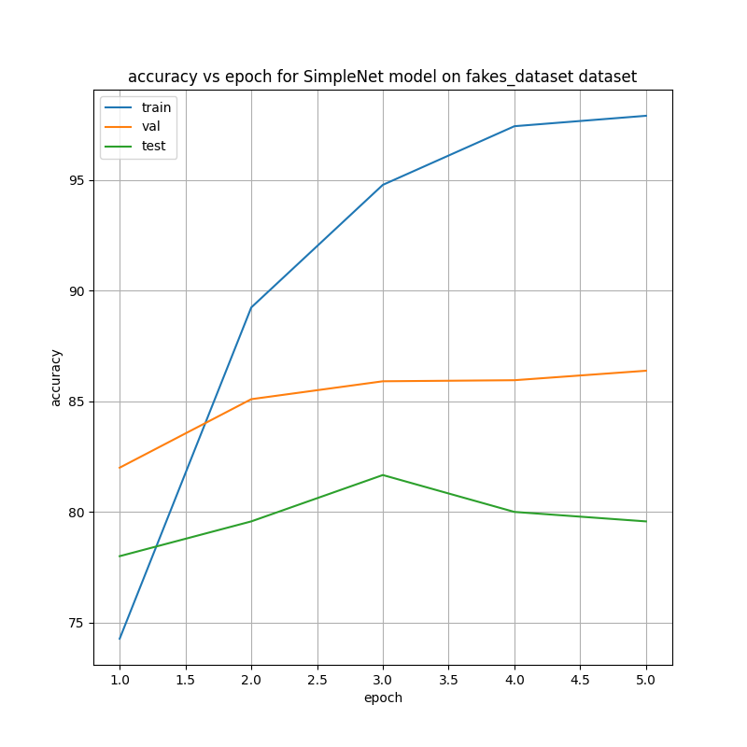

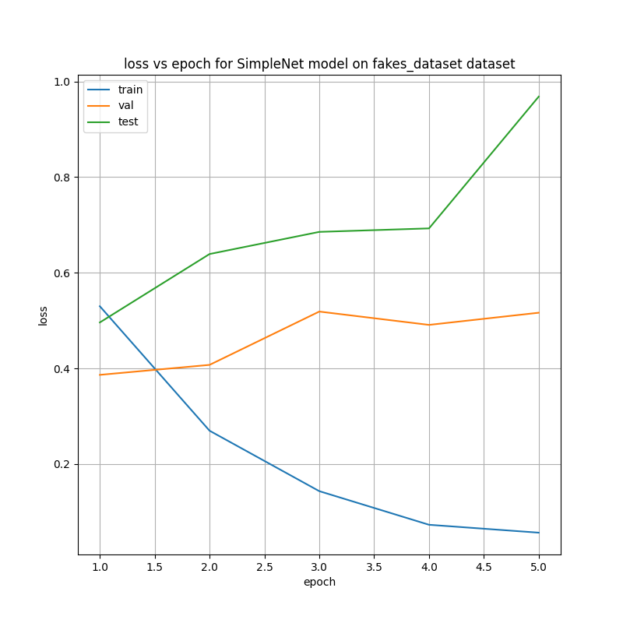

Question 8:
86.38% validation accuracy that resulted in 79.57% test accuracy.
Question 9:
The fake: real ratio is 1:2 – 1400 real images and 700 fake ones.
Question 10:
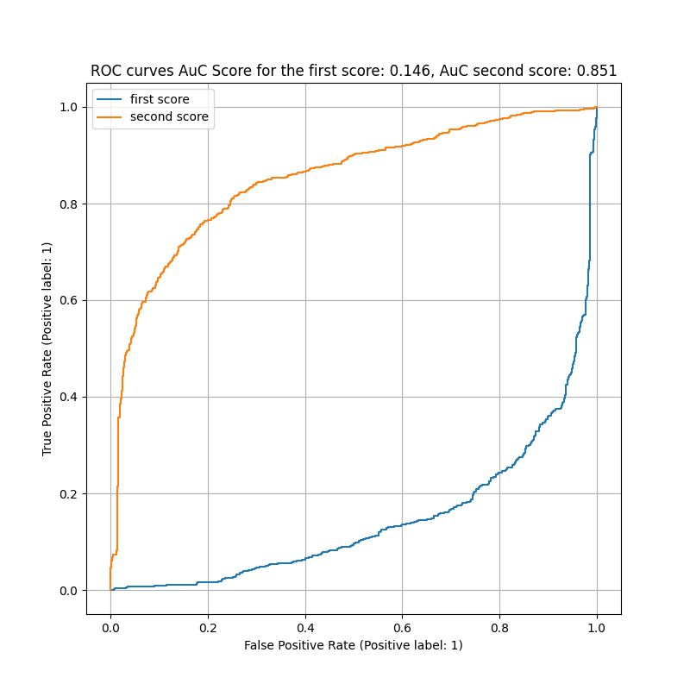
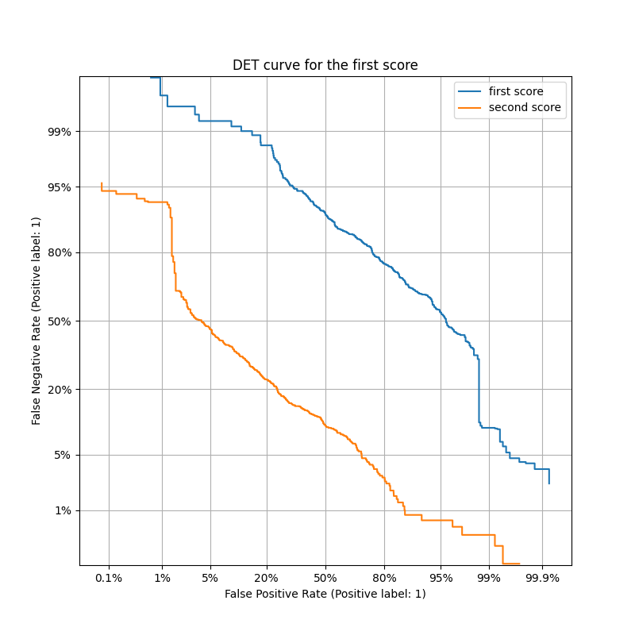
Question 11:
Since A uses the score for real images and B uses the score for a fake image, the two curves should just be the complement to 1 of each other, and that’s why $AUC_{A}=1-AUC_{B}$.
Question 13:
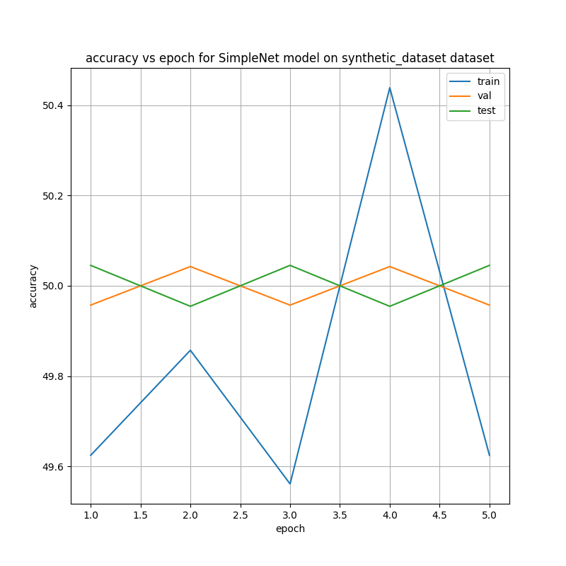
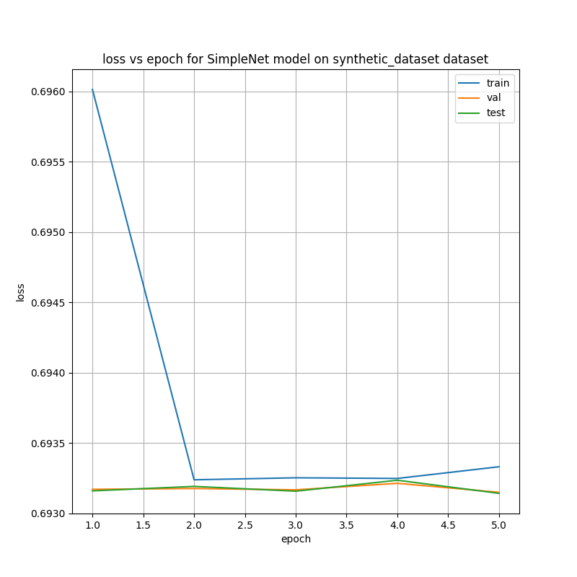

Question 14:
50.04% validation accuracy that resulted in 50.04% test accuracy.
Question 15:
The ratio is almost 1:1, as there are 551 real images and 552 fake ones.
Question 16:
One that always predicts 0 as it can’t separate the two classes.
Question 17:
Yes, the fake faces in the deepfake dataset are much easier to detect with the human eye. The fake images are usually not smooth and there seem to be artifacts of the swap in the face’s skin.
Question 18:
Xception was pre-trained on ImageNet, to classify images into 1000 different categories.
Question 19:
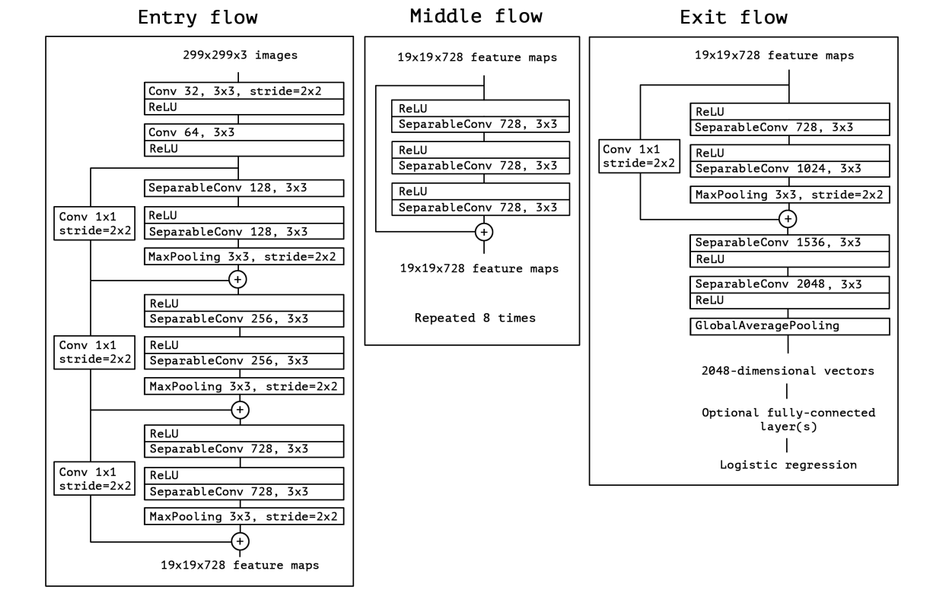

Question 21:
The input to the FC layer is a 2048 elements vector.
Question 24:
We added: $256⋅\left(1000+1\right)+64⋅\left(256+1\right)+2⋅\left(64+1\right)=272,834 parameters$

Question 26:
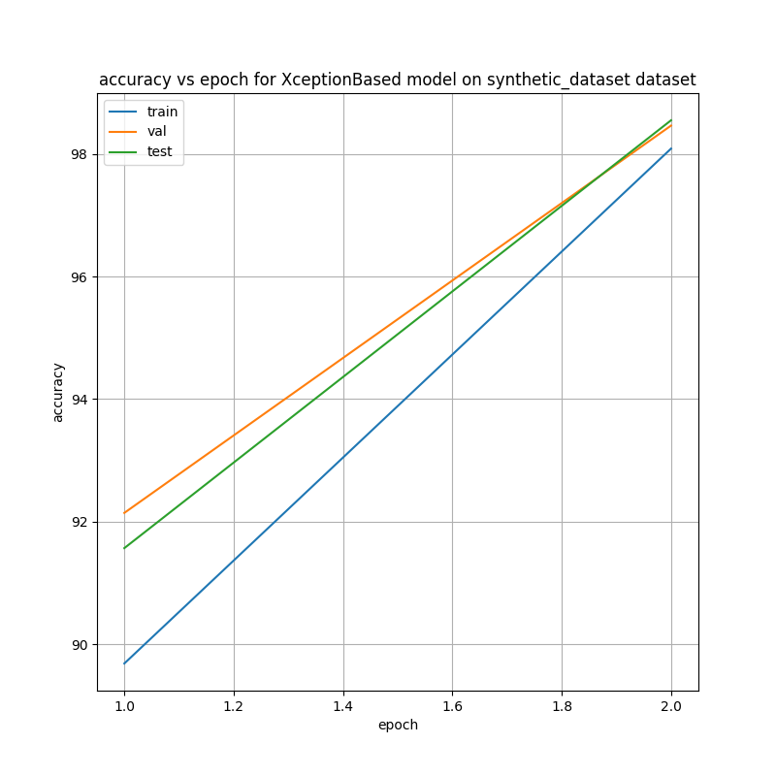
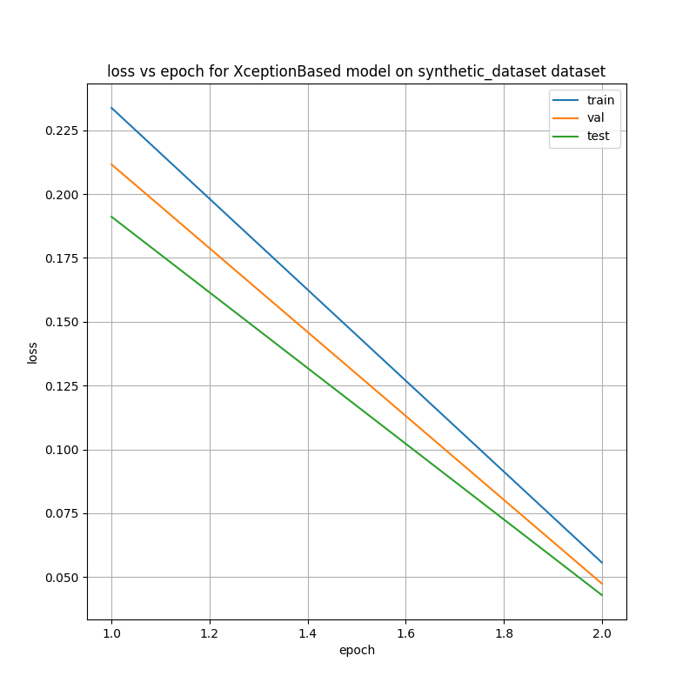

Question 27:
98.46% validation accuracy that resulted in 98.55% test accuracy.
Question 28:
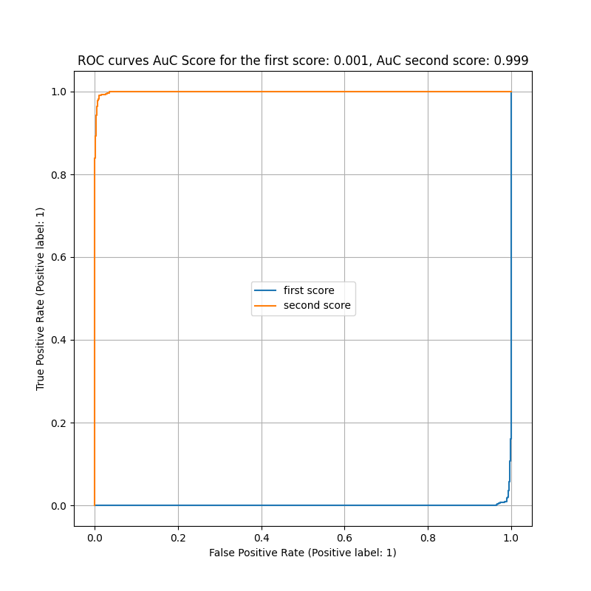

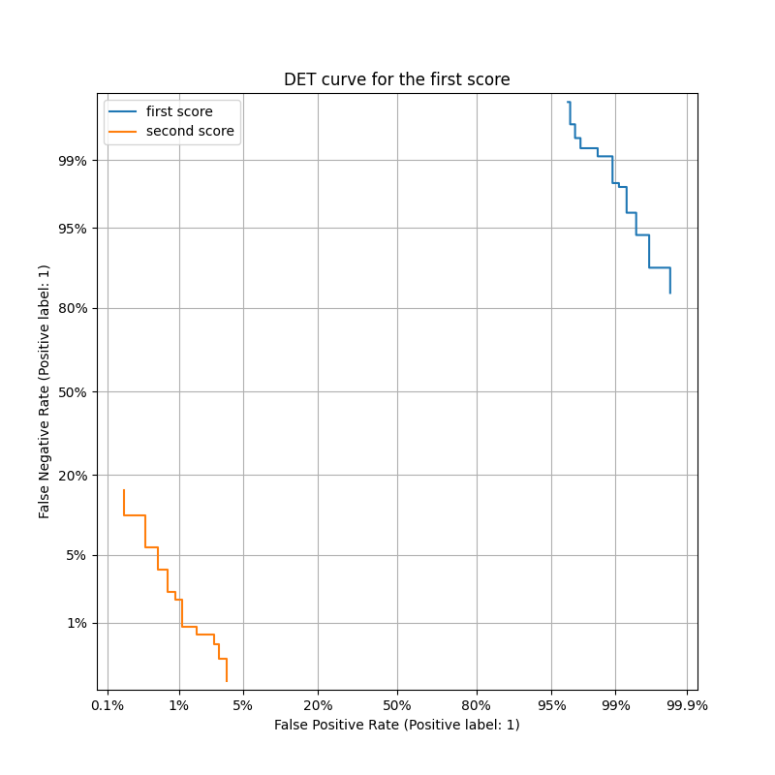

Question 29
Given an image, saliency maps show how much each pixel affects the score for each possible class. A pixel gets a higher value in the map when the class scroe is more sensitive to a change in this pixel’s value. You can use this map to visualize the importance of pixels in the image and get a better understanding of the model’s behavior.
The Vanilla-gradient saliency map method is computing an importance score based on the gradient of the class output score with respect to this specific pixel’s value.
That’s basically a first order approximation of the contribution of this pixel’s valueto the output class score.
Question 30:
Grad-CAM is a method to visualize regions in an image that contributes most to the class output score.
Given an image of size $HxWxC$, we forward-pass it through a CNN and obtain the output scores per class $y_{1}, ..y_{C}$.
We then pick the feature maps of a convolution layer, usually the last, and we denote them by $A^{k}$ of size $H^{l}xW^{l}$
For each class $c in \{1, 2, ..C\}$, we compute a weight for each feature map using the average gradient of the class score with respect to each of the feature map’s elements:
$$α_{k}^{c}=\frac{1}{H^{l}W^{l}}\sum_{i,j}{\frac{∂y_{c}}{∂A_{i,j}^{k}}}$$
We then compute a Grad-CAM map using a weighted average of the feature maps:
$$L_{c}=ReLU\left(\sum_{k}{α_{k}^{c}}A^{k}\right)$$
Feature maps are weighed according to their average contribution to the score (first order approximation using the gradient).
The ReLU function ensures that only regions that positively contribute to this class’s score are visualized.
And finally upsample this output map from $H^{l}xW^{l}$ to $HxW$.

