SkillBridgeSL Mini Project Report
Nov 1, 2026 · @Iddamalgoda

1. Introduction
SkillBridgeSL is a web application that helps Sri Lankan students plan the road from school to a real career, and I built it as my EC4307 Web Application Development mini project.
Why I built it. Deciding what to do after O/Ls is confusing. You have to pick an A/L stream, work out which careers that stream leads to, find which universities offer the degree, and still understand what the job needs later on. All of that information exists, but it is spread over university websites, UGC pages, forums and word of mouth. I wanted one place where a student can look at a career, see the education route behind it, and then turn it into a plan they can actually follow and tick off.
What I wanted it to be. Not just a page of information. The main part of the system is a personal roadmap: a student builds a path for a career they like, and the site breaks it into milestones and small tasks that they can edit, search, update and delete as their plans change. I also added Sinhala next to English, because a lot of students are more comfortable reading in Sinhala.

2. What the website does
The site has two sides: a public side for exploring careers and universities, and a private side where a logged-in student manages their own roadmap.
Public pages
- Home – introduction and quick links to everything else.
- Careers – a directory of careers with search, and a detail page for each one: overview, skills needed, salary range, education route, a step-by-step roadmap, related universities and the future outlook.
- Universities – a directory of state and non-state institutions with detail pages covering faculties, academics, campus photos and admission information.
- About and Contact – the contact form saves each message into the database.
- English / Sinhala switch on every page.
Student pages (after login)
- Register / Login – account creation and sign-in.
- Build Your Path – a step-by-step wizard. The student picks a career, their current stage (O/L, A/L and so on), stream, district and budget, and the site generates a roadmap with milestones and tasks.
- My Path – the main CRUD page. It lists all saved roadmaps, shows the milestones and tasks of the active one, and lets the student search, filter, sort, edit and delete them.
- Account – update profile details and change password.
The main entity. Everything in the CRUD side revolves around the career path: one user has many paths, a path has many milestones, and a milestone has many tasks. Finishing tasks updates the completion percentage automatically, and completing milestones unlocks achievement badges.

3. Technologies used
I split the project into a separate frontend, backend and database so each part has one job.
Layer | Technology | What I used it for
Frontend | Next.js 16 (App Router), React 19, TypeScript | Pages, routing, forms, and the API routes that sit between the browser and the backend
Frontend | Tailwind CSS 4 and my own CSS files | Layout, the glass-style design, responsive behaviour
Frontend | next-intl | English and Sinhala text (messages/en.json, messages/si.json)
Frontend | lucide-react, Radix / shadcn | Icons and a few basic UI parts
Backend | Java 25, Spring Boot 3.5 | REST API
Backend | Spring Data JPA (Hibernate) | Reading and writing the database through entities and repositories
Backend | Spring Security with JWT (jjwt) | Login, access tokens, refresh tokens, protecting the student endpoints
Backend | Jakarta Validation | Server-side validation of every request
Backend | springdoc OpenAPI | Swagger page to try the API
Database | PostgreSQL 17 | Persistent storage
Database | Flyway | Versioned SQL migrations (database/migrations, V1 to V10)
Testing | Vitest, Playwright, axe-core, Spring Boot Test | Unit tests, browser tests, accessibility checks, API integration tests
Tools | Git and GitHub, Maven, npm | Version control and builds

4. System architecture
I split the system into three layers so the screens, the business rules and the data are not mixed together. The Next.js app serves the pages and also has its own API routes, which pass requests on to the Spring Boot API with the student's login token. This keeps tokens in HttpOnly cookies, so JavaScript in the page never touches them.
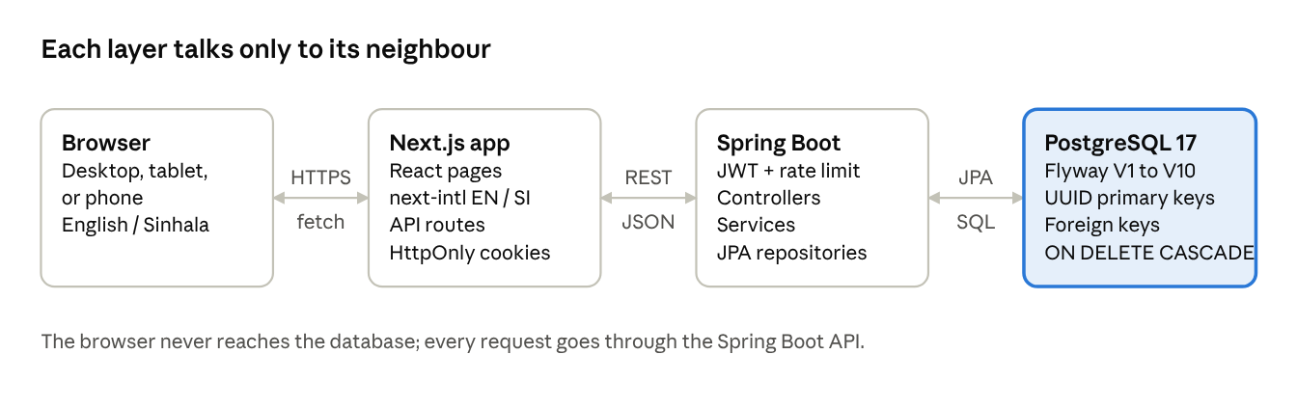
system architecture · 4 layers
In the backend each request goes controller, service, repository. Controllers only handle HTTP and validation, services hold the rules (for example recalculating progress), and repositories talk to PostgreSQL through JPA.

5. Database design
The database is PostgreSQL, and every table is created by a numbered Flyway migration in database/migrations (V1 to V10), so anyone can rebuild it from scratch. Primary keys are UUIDs, relationships use foreign keys, and updated_at columns are filled by a database trigger.
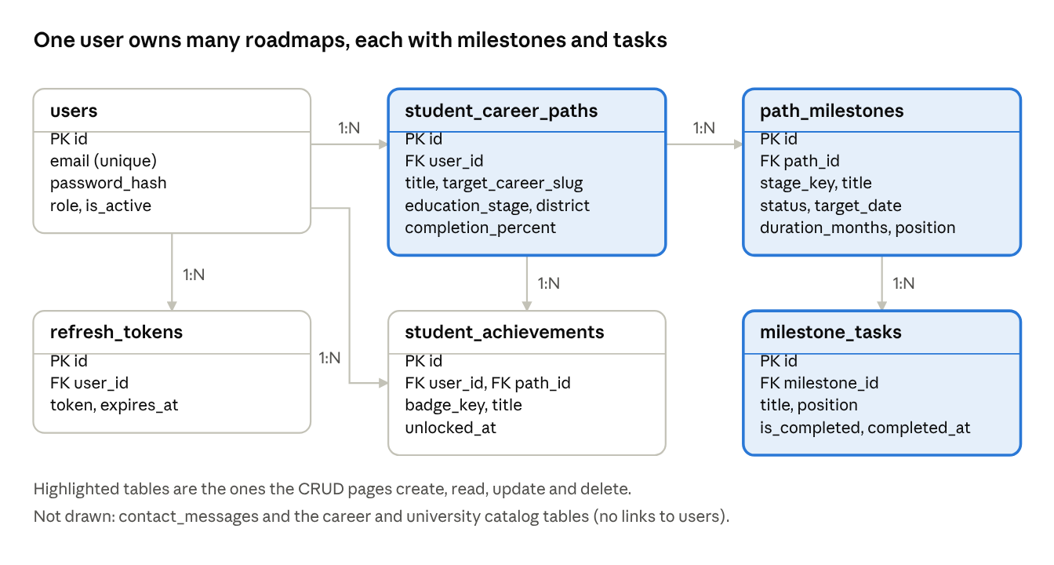
ER diagram · 6 core tables
A user has many roadmaps (student_career_paths), a roadmap has many milestones, and a milestone has many tasks. The foreign keys from roadmap to milestone to task are ON DELETE CASCADE, so deleting a roadmap cleans up everything under it. Badges are kept in student_achievements; if a roadmap is deleted the badge stays with the user (ON DELETE SET NULL).
Tables
Table | Purpose | Key columns and constraints
users | Student accounts | email unique, password_hash (BCrypt), role, is_active
refresh_tokens | Login sessions that can be rotated and revoked | FK user_id, token unique, expires_at, rotated_at
student_career_paths | A student's roadmap (main entity) | FK user_id, title, target_career_slug, education_stage, district, budget_tier, completion_percent, notes
path_milestones | Steps in a roadmap | FK path_id, stage_key, title, status, target_date, duration_months, position
milestone_tasks | Checklist items in a milestone | FK milestone_id, title, is_completed, completed_at, position, resource_url, notes
student_achievements | Badges earned | FK user_id, FK path_id, badge_key, unique on (user, badge, path)
contact_messages | Messages from the contact form | name, email, topic, message, created_at
career_catalog, career_profiles | Career list and detail content | slug primary key, catalog_data and profile_data as JSONB with a check that it is an object
university_catalog, university_profiles | University list and detail content | slug primary key, institution_type limited to Government or Non-state by a CHECK
Design choices. Dates use DATE, timestamps use TIMESTAMPTZ, and flags use BOOLEAN. I added indexes on the columns I filter by most (user, active path, position, status). The career and university pages hold a lot of descriptive content that differs from one entry to the next, so I stored that part as JSONB next to a few normal columns (slug, title, type) instead of making dozens of narrow tables.

6. CRUD operations
The entity I built the CRUD around is the career path and the milestones and tasks inside it. All of it is saved in PostgreSQL for a logged-in student, and every query is checked against the logged-in user, so nobody can read or change another student's roadmap.
Operation | What the student does (page) | API call
Create | Finishes the Build Your Path wizard to save a new roadmap | POST /paths
Create | Clicks "Add Custom Milestone" and fills the form (stage, title, duration, date) | POST /paths/{id}/milestones
Create | Types a new task inside a milestone | POST /paths/milestones/{id}/tasks
Read | Opens My Path: list of roadmaps, active roadmap, milestones, tasks, progress | GET /paths, GET /paths/active, GET /paths/{id}
Read | Searches, filters and sorts the milestones of a roadmap | done on the page with the loaded data
Read | Sees earned badges | GET /paths/achievements
Update | Edits the roadmap name, stream, district, notes, active flag | PATCH /paths/{id}
Update | Edits a milestone (title, description, status, date, duration) | PATCH /paths/milestones/{id}
Update | Ticks or unticks a task | PATCH /paths/tasks/{id}
Delete | Deletes a whole roadmap after confirming | DELETE /paths/{id}
Delete | Deletes a milestone after confirming | DELETE /paths/milestones/{id}
Delete | Deletes a task after confirming | DELETE /paths/tasks/{id}
Search, filter and sort. On My Path there is a search box that matches milestone titles, descriptions and task names. The status filter has All, Pending, In Progress and Completed, there is a filter by stage, and the sort can be by roadmap order, target date, duration or status. The page shows how many milestones match, for example "3 of 8".
Safe delete. Nothing is deleted on the first click. A confirmation window opens and names what will be removed. Deleting a roadmap also deletes its milestones and tasks through the foreign keys (ON DELETE CASCADE), so no orphan rows are left.
Automatic progress. When a task is ticked, the backend recalculates the milestone status and the roadmap's completion percentage. When progress reaches certain points, a badge is saved for the student.
Guests. A visitor who is not logged in can still try the builder. Their roadmap is kept in the browser (localStorage) and is copied into the database when they log in.

7. Validation and error handling
I validate in two places, because checks in the browser can always be skipped by someone calling the API directly.
In the browser. Forms check the fields before sending: required fields, a valid email, password length, a valid date and a positive duration. Errors appear next to the field in red, in the language the student is using, and a message is not shown until the field has something wrong with it.
On the server. Every request body is checked with Jakarta Validation before it reaches the service:
- Register: names up to 100 characters, a valid email, password 8 to 72 characters with at least one letter and one number.
- Contact form: topic must be one of the allowed values, message 10 to 4000 characters.
- Roadmap and milestone requests: title 3 to 255 characters, status limited to Pending / In Progress / Completed, duration between 1 and 120 months, task titles not blank.
- A duplicate email at registration gives a clear "email already exists" error.
Error format. A single GlobalExceptionHandler turns every failure into the same JSON shape with a code (VALIDATION_FAILED, NOT_FOUND, and so on) and the list of fields that failed. The frontend translates those codes into messages. Stack traces are never sent to the browser.
Stability. Trying to open or edit someone else's roadmap returns "not found", not their data. Login and register are rate limited. If the backend is not running, the pages show a normal message instead of crashing, and the roadmap tools fall back to the browser copy.
I also wrote automated tests for this: backend integration tests (bad input returns 400, other users get 404) and Playwright browser tests for the login, features and language switching.

8. UI/UX and responsiveness
I wanted the site to feel friendly rather than like a government form, so it uses a soft, glass-style look with a warm gold background, big headings and plenty of white space. The colours, spacing and fonts are defined once as design tokens in tokens.css, and the pages share the same components (buttons, cards, form fields, page headers), so everything looks consistent.
- Navigation: the same top bar on every page with Careers, Universities, Build Your Path, My Path, and the login or account link. On a phone it turns into a menu panel.
- Mobile support: the layouts collapse from multiple columns to one on small screens, and I tested the pages at desktop, tablet and phone widths with Playwright.
- Language: a switch in the header changes the whole interface between English and Sinhala. All text lives in en.json and si.json.
- Feedback: loading skeletons, empty states (for example "no milestones match your search"), confirmation windows before deleting and clear error messages.
- Accessibility: labelled form fields, keyboard-friendly controls, and automated axe checks in the tests.

9. How to run it
You need JDK 25, Maven 3.9+, Node.js 22+ and PostgreSQL 17.
- Create the database in psql:
CREATE ROLE skillbridge WITH LOGIN PASSWORD 'skillbridge_secret';
CREATE DATABASE skillbridgesl OWNER skillbridge;
- Start the backend. From the backend folder run mvn spring-boot:run -Dspring-boot.run.profiles=local. Flyway creates all the tables automatically from database/migrations on the first start. The API is at http://localhost:8080/api and the Swagger page is at /api/swagger-ui.html.
- Start the frontend. From the frontend folder run npm install and then npm run dev, and open http://localhost:3000.
- Or use the helper script. ./run-local.sh in the project root starts both.
- Tests. mvn -f backend/pom.xml test for the backend, npm --prefix frontend test for unit tests and npm --prefix frontend run test:e2e for the browser tests.
To try the CRUD part: register an account, open Build Your Path and save a roadmap, then go to My Path to add, edit, search and delete milestones and tasks.

10. Screenshots
Insert your own screenshots here (take them from the running site so they match what you demo):
- Home page
- Careers directory and one career detail page
- Universities directory and one university page
- Register and login (include one with a validation error showing)
- Build Your Path wizard
- My Path with milestones, plus the search / filter / sort bar
- Add Milestone and Edit Milestone windows
- Delete confirmation window
- The same page in Sinhala and on a phone-width screen

11. Challenges and conclusion
Challenges. The hardest part was keeping three layers in step: the Next.js pages, the Spring Boot API and the database. A small change, like adding a task, needed a database column or rule, a backend endpoint, a Next.js route and the page itself. Login was the other big one. I wanted tokens that are safe in the browser, so the access token is short-lived and the refresh token lives in an HttpOnly cookie that is rotated on every use. Getting Sinhala text to fit the same layouts as English also took several rounds of CSS fixes. Late in the project I found that adding and deleting tasks were only saved in the browser, so I added proper backend endpoints for them and tests to match.
What I learned. Designing the tables first and writing them as Flyway migrations kept the database and code in agreement. Validating on the server as well as in the browser, and returning one consistent error format, made the frontend much simpler. Writing tests early saved time when I changed things later.
Possible improvements. An admin page to edit the career and university data (it is currently loaded from migrations and data files), email reminders for milestone dates, and a way to share a roadmap with a parent or teacher.
Conclusion. SkillBridgeSL gives a student one place to explore careers and universities and to turn that into a plan they can edit and track. It meets the mini project requirements with full CRUD on persistent data, search, filter and sort, validation on both sides, a relational database design, a responsive bilingual interface and documentation.

