* 结果确定方式：
* 
* http://wiki.mbalib.com/wiki/随机森林
* 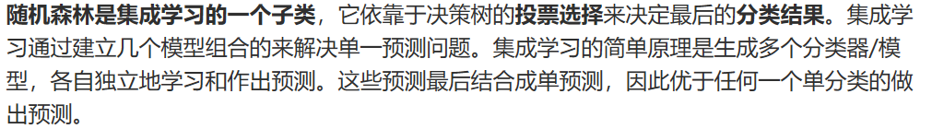
* http://www.360doc.com/content/18/0409/19/44507361_744246388.shtml
* **算法实现**
* 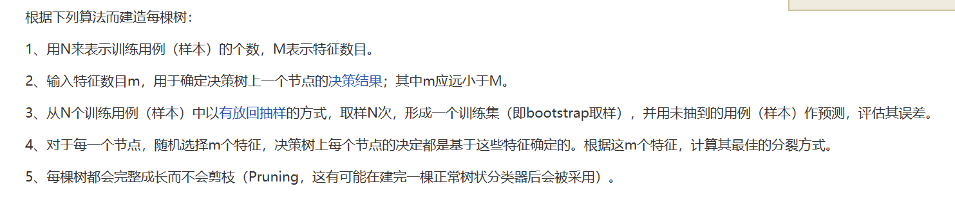
* 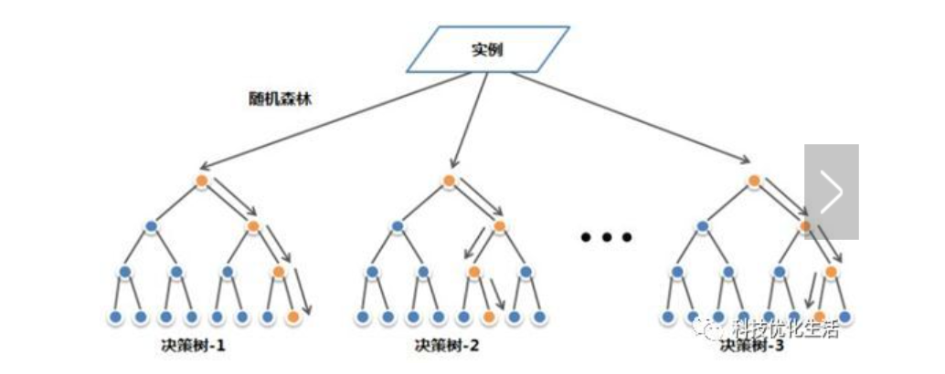
* **影响性能的因素**
* 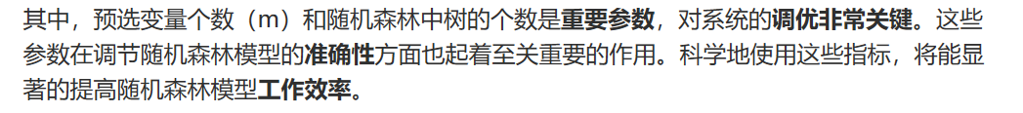
* 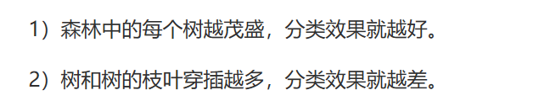
* 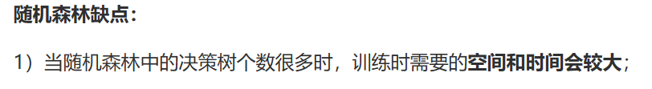
* [**http://www.360doc.com/content/18/0409/19/44507361_744246388.shtml**](http://www.360doc.com/content/18/0409/19/44507361_744246388.shtml)
* **随机森林的随机选取**
* 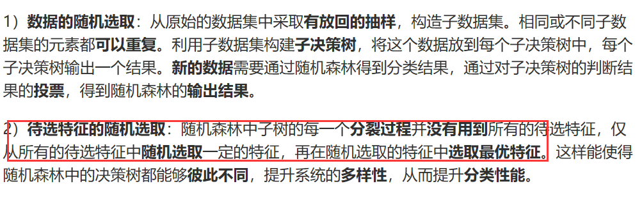
* 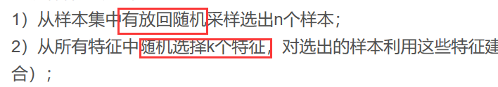
* **https://blog.csdn.net/y0367/article/details/51501780**
* **参数调优**



**一、特征数量**

* 
* 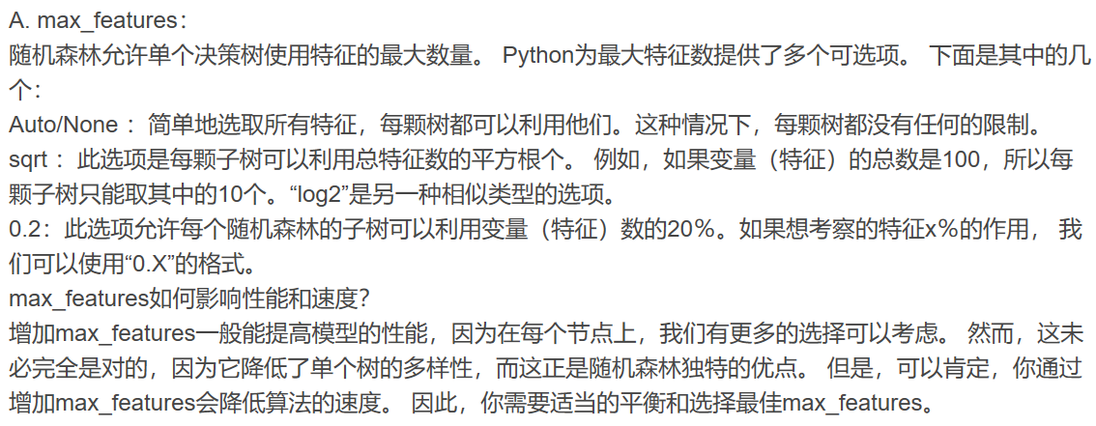
* [**https://blog.csdn.net/y0367/article/details/51501780**](https://blog.csdn.net/y0367/article/details/51501780)
* 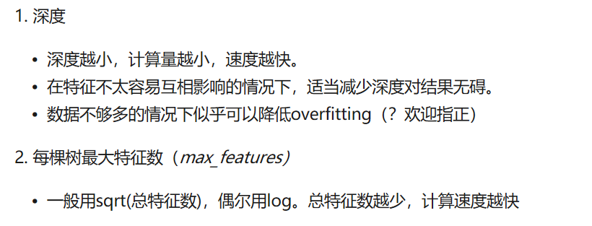
* [**https://www.zhihu.com/question/36511737?from=profile_question_card**](https://www.zhihu.com/question/36511737?from=profile_question_card)**（知乎）**
* 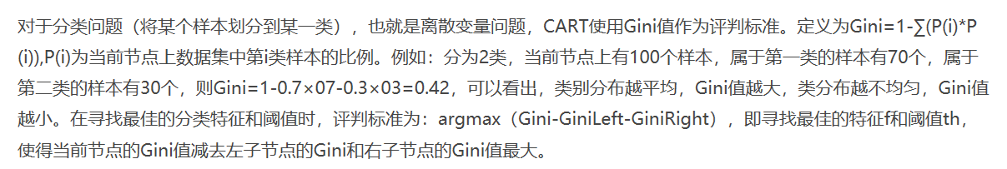
* **https://blog.csdn.net/findsd1989/article/details/46388961**

**二、评估方式**

* 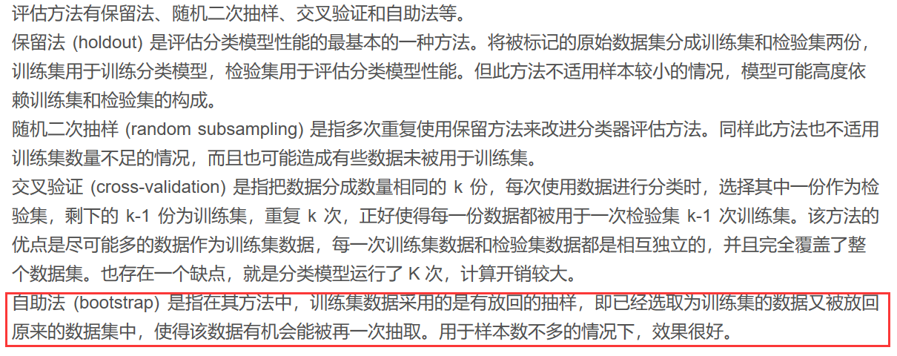
* [**https://blog.csdn.net/y0367/article/details/51501780**](https://blog.csdn.net/y0367/article/details/51501780) **！！！**

**三、子树及叶子节点数等**

* 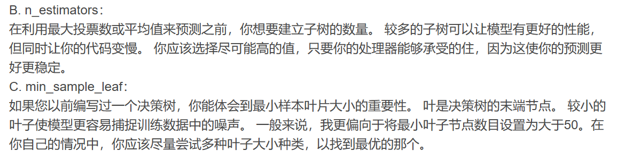
* **https://blog.csdn.net/y0367/article/details/51501780**
* 
* 
* 
* **https://www.cnblogs.com/gczr/p/7141712.html**
* **python中的模块，可以了解**
* 
* [**https://www.sogou.com/tx?query=sklearn&hdq=sogou-site-c91e3483cf4f9005-1002&ekv=3&ie=utf8&**](https://www.sogou.com/tx?query=sklearn&hdq=sogou-site-c91e3483cf4f9005-1002&ekv=3&ie=utf8&)

**四、选取步骤**

* 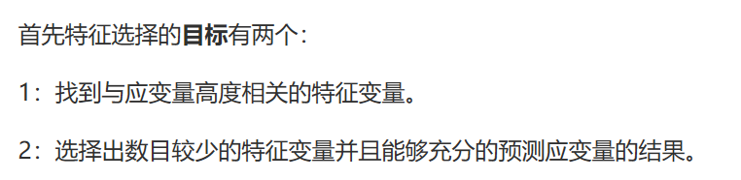
* 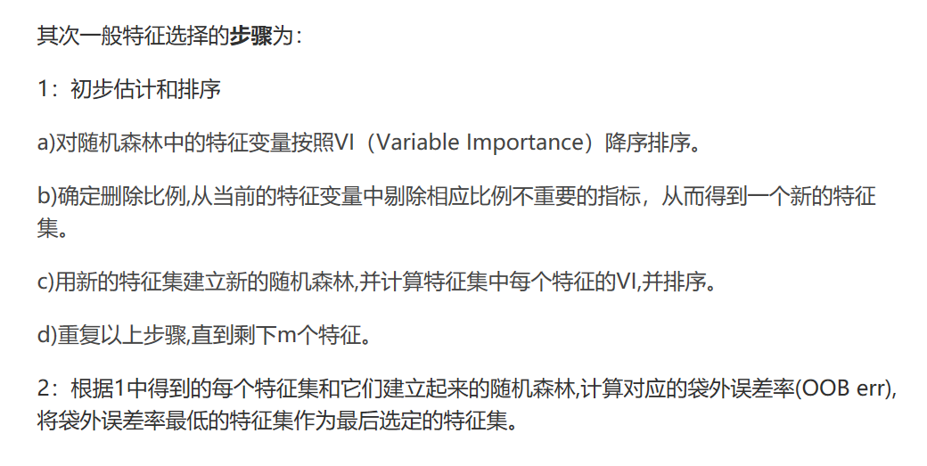
* [**http://www.360doc.com/content/13/1206/09/13528701_334877080.shtml**](http://www.360doc.com/content/13/1206/09/13528701_334877080.shtml)
* 基于随机森林的特征选择算法
* <https://blog.csdn.net/smf0504/article/details/51939064>
* 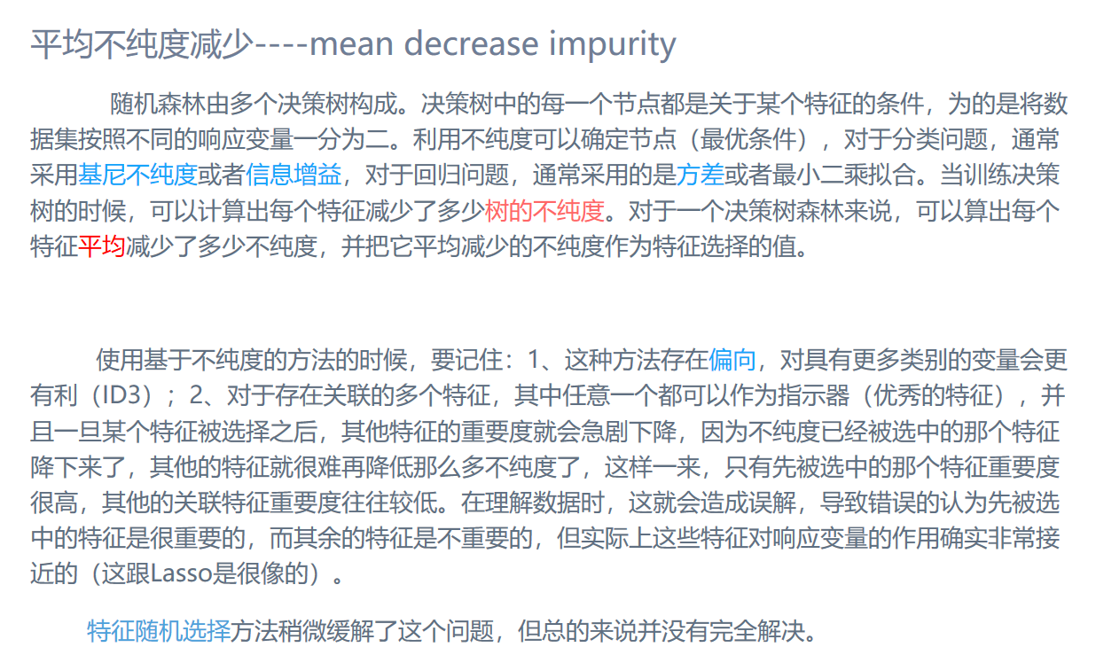
* 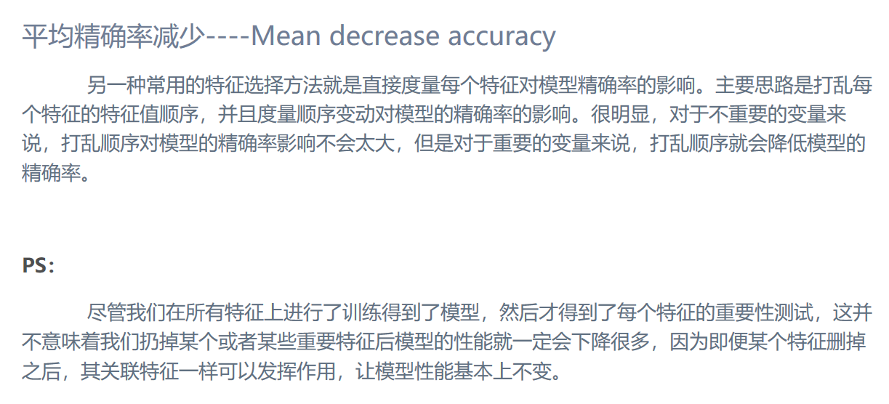
* <https://blog.csdn.net/keepreder/article/details/47277517>
* 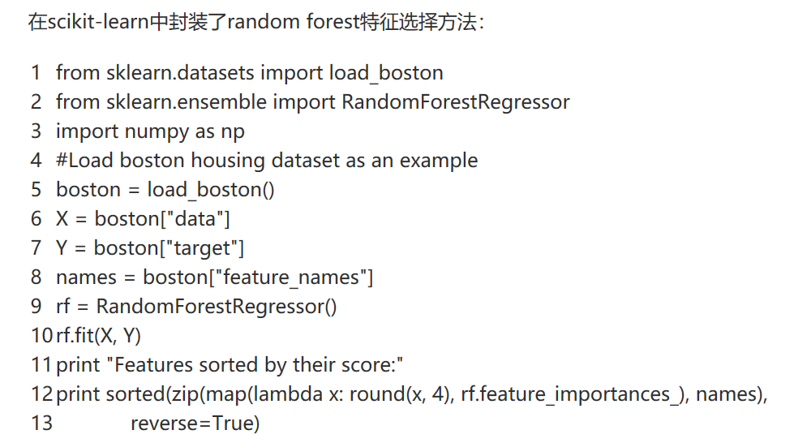
* 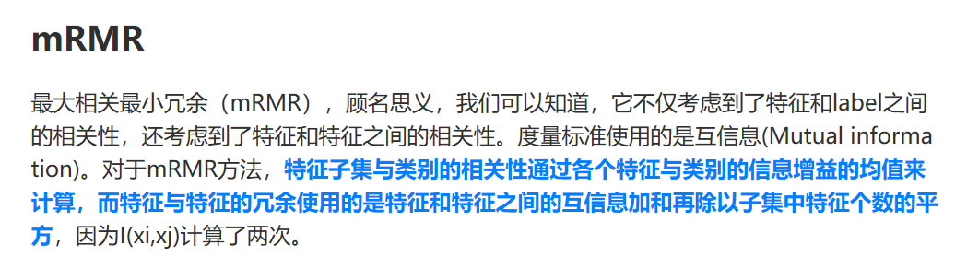
* 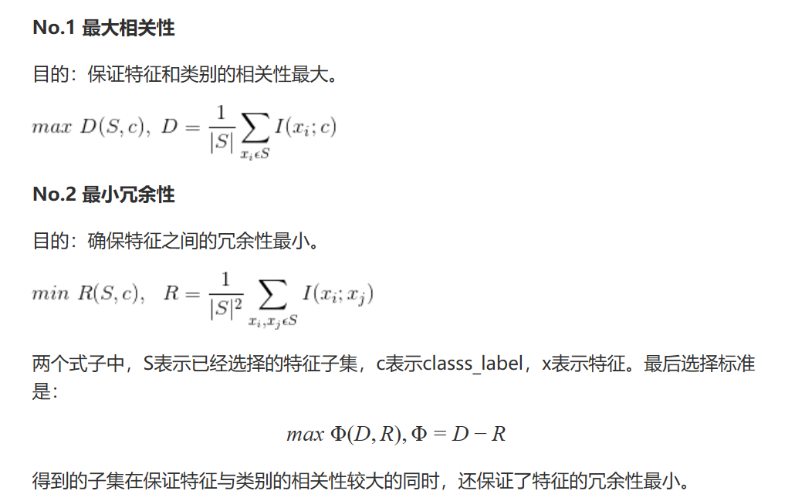
* http://www.360doc.com/content/17/0829/13/15077656_683003157.shtml