# 评测指标

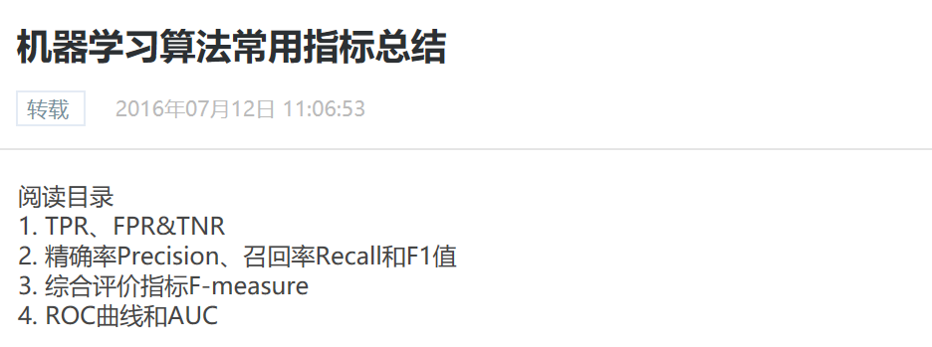

* <https://blog.csdn.net/abcd1f2/article/details/51887148>

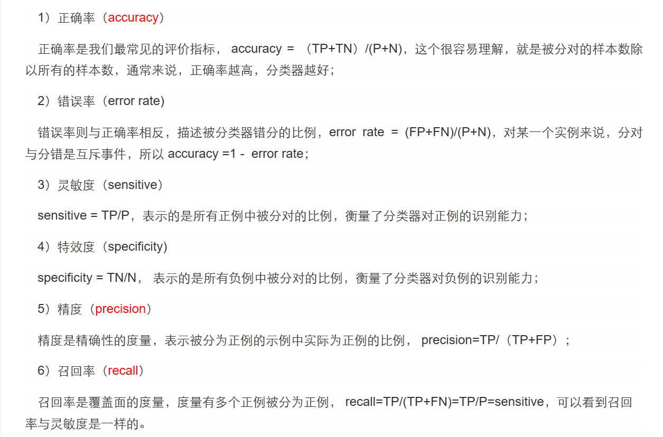



* <https://blog.csdn.net/hermito/article/details/51076728>



https://www.cnblogs.com/zhaokui/p/ml-metric.html