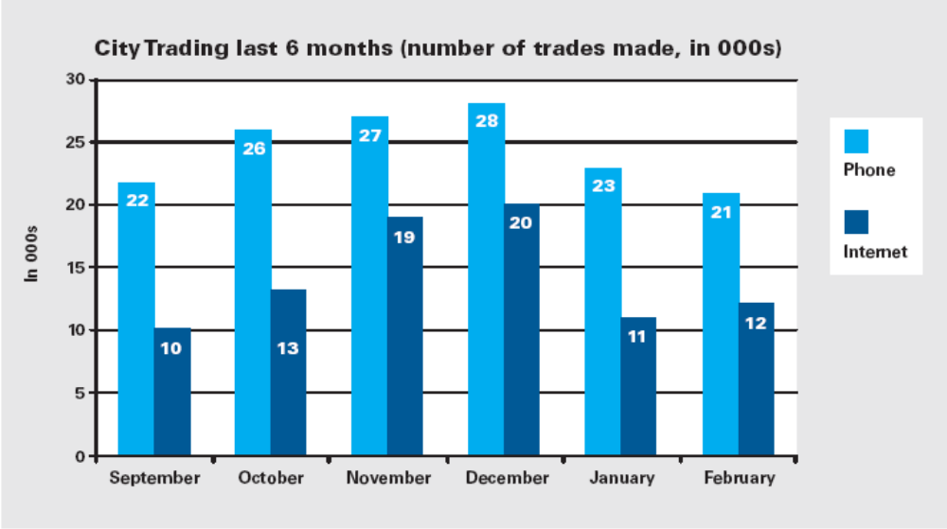
Ex1. Between which two months was there the greatest change in the number of Internet trades made?
A) September and October
B) October and November
C) November and December
D) December and January
E) January and February

Ex2. In September, approximately what proportion of the total number of trades was made up of Internet trades?
- 25% B) 31% C) 34% D) 37% E) 43%

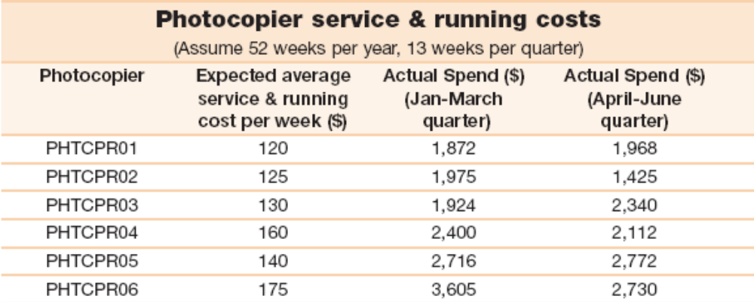
1. By how much have the actual service and running costs for Photocopier PHTCPR06 exceeded those for Photocopier PHTCPR05 so far this year?
A) $847 B) $876 C) $898 D) $913 E) $925

2. On which photocopier is there the least amount of budget left to spend this year?
A) Photocopier A B) Photocopier B C) Photocopier C D) Photocopier D E) Photocopier E

3. By what proportion should the service and running costs for Photocopier PHTCPR05 be increased next year if the actual spend recorded between January and June is a true reflection of service and running costs?
A) 38.9% B) 43.6% C) 48.7% D) 50.8% E) 53.3%

4. By how much is the annual spend on Photocopier PHTCPR01 likely to exceed that of Photocopier PHTCPR02 if the current spend recorded between January and June is a true reflection of actual service and running costs?
A) $740 B) $820 C) $880 D) $960 E) $1,120

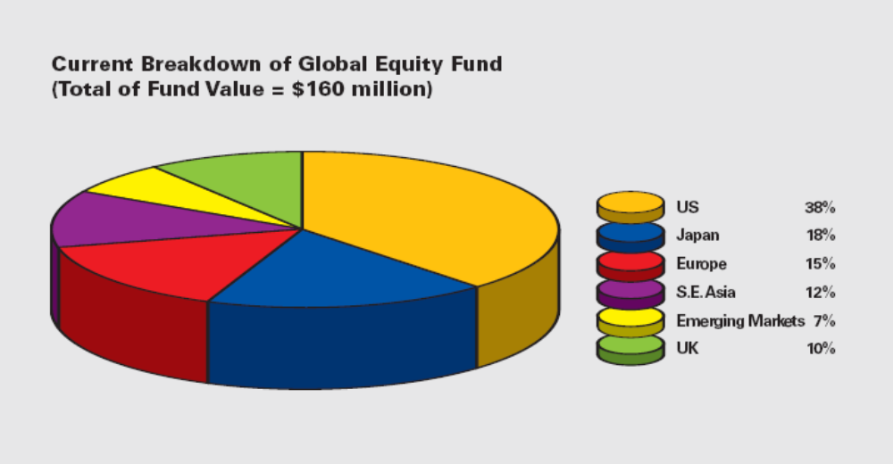
5. What is the value of the Japanese holding in the Fund?
A) $24.0 million B) $28.8 million C) $32.8 million D) $44.8 million E) $60.8 million

6. Which of the following combinations of holdings has a value of $40 million?
A) Emerging Markets & S .E .Asia
B) Emerging Markets & UK
C) Europe & Japan
D) Europe & S. E. Asia
E) Europe & UK

7. By how much do the value of the holdings in the US and Japan exceed that of the value of all the other holdings combined?
A) $16.4 million B) $18.8 million C) $19.2 million D) $22.8 million E) $26.4 million

8. Last year, the value of the S. E. Asia holding was 10% less than what it is now. What was the value of the S. E. Asia holding last year?
A) $17.28 million B) $17.45 million C) $17.96 million
D) $18.48 million E) $19.05 million

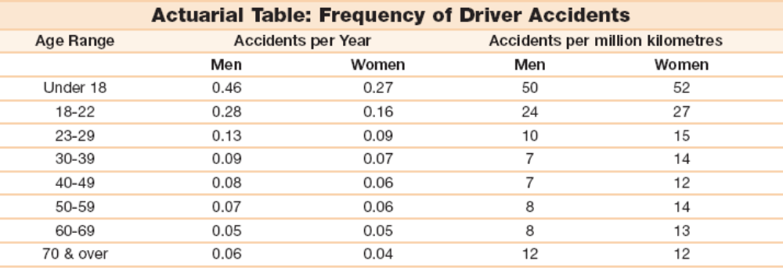
9. In terms of kilometers driven, for which age range is the proportional difference between the number of accidents for men and women the greatest?
A) 30-39 B) 40-49 C) 50-59 D) 60-69 E) 70 & over

10. How many more accidents in a year will a group of a thousand 18-22 year old men be likely to have compared with a group of a thousand 18-22 year old women?
A) 60 B) 80 C) 110 D) 120 E) 150

11. In terms of accidents per year, to what extent do women aged 40-49 have fewer accidents than men aged 23-29?
A) 47% less B) 49% less C) 54% less D) 58% less E) 65% less

12. How many kilometers approximately does the average 18-22 year old woman drive per year?
A) 4,884 km B) 4,929 km C) 5,246 km D) 5,624 km E) 5,926 km
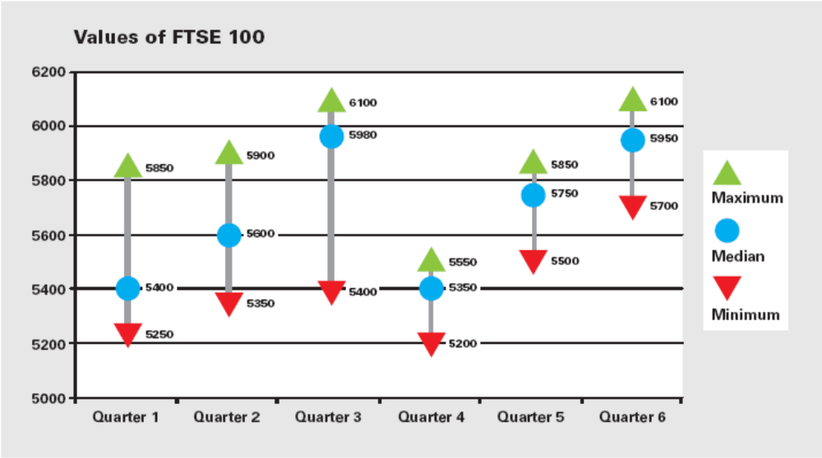
13. Which quarter saw the greatest range in the value of the FTSE 100?
A) Quarter 1 B) Quarter 2 C) Quarter 3 D) Quarter 4 E) Quarter5

14. Between which two quarters was there the smallest proportional change in the median value of the FTSE 100?
A) Quarter 1 to Quarter 2 B) Quarter 2 to Quarter 3 C) Quarter 3 to Quarter 4
D) Quarter 4 to Quarter 5 E) Quarter 5 to Quarter 6

15. If in Quarter 7, the minimum value of the FTSE 100 increases by 15% but the maximum value increases by 20%, what will the difference be between the minimum and maximum value for that quarter?
A) 745 B) 755 C) 760 D) 765 E) 775

16. The median value of the FTSE 100 is expected to increase by 3% per quarter for the next 4 quarters, what will the median value be in Quarter 10?
A) 6,656 B) 6,683 C) 6,697 D) 6,714 E) 6,725

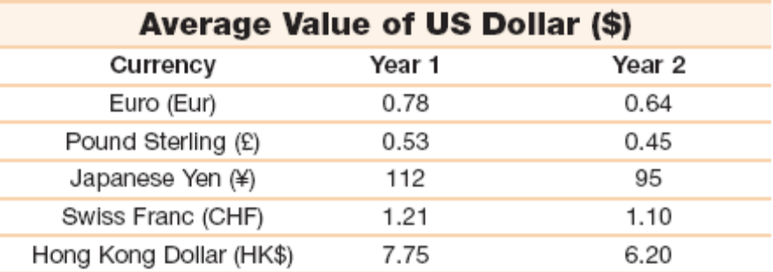
17. How much was a Japanese Yen worth in US dollars in Year 1?
A) $0.0009 B) $0.0089 C) $0.011 D) $0.089 E) $0.105

18. How much more ￡Sterling could have been purchased with 2000 US Dollars in Year 1 compared to Year 2?
A) ￡145 B) ￡150 C) ￡155 D) ￡160 E) ￡165

19. Between Year 1 and Year 2, the value of the Swiss Franc in relation to the US dollar, moved:
A) Down 9.1% B) Down 8.3% C) Down 1.7% D) Up 8.3% E) Up 9.1%

20. In Year 1, US$200 was used to purchase a holding of Euros. What would the value of this holding be if exchanged for HK$ in Year 2?
A) HK$ 1,313 B) HK$ 1,412 C) HK$ 1,511 D) HK$ 1,610 E) HK$ 1,709

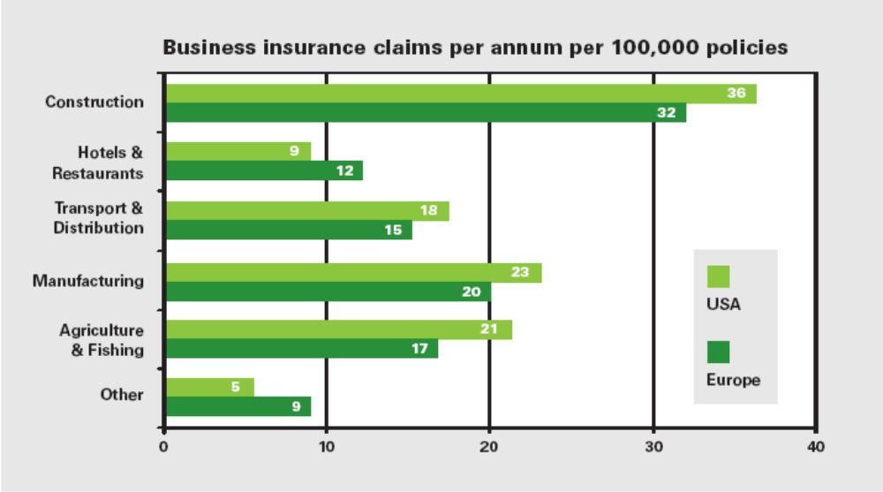
21. Assuming there were 1,250,000 insurance policies issued annually in Europe to cover the Manufacturing sector, how many claims would be expected per year?
A) 250 B) 400 C) 500 D) 550 E) 600

22. Comparing the USA with Europe, which business sector has the most similar number of claims on a proportional basis?
A) Construction B) Hotels & Restaurants C) Transport & Distribution
D) Manufacturing E) Agriculture & Fishing

23. There are on average 6 times as many claims made per annum in the USA compared to Europe in the Transport & Distribution sector. How many more policies are issued in the US compared to Europe in this sector?
A) 3.3 times as many B) 4 times as many C) 4.3 times as many
D) 5.0 times as many E) 5.5 times as many

24. Last year there were 630 claims made in the USA against policies written out in the Agriculture & Fishing sector. How many policies were issued that year for that sector?
A) 2,670,000 B) 3,000,000 C) 4,330,000 D) 5,000,000 E) 6,300,000

KEY:

Ex1D Ex2B
1A 2E 3D 4C 5B 6E 7C 8A 9A 10D 11C 12E
13C 14E 15D 16C 17B 18D 19E 20C 21A 22A 23D 24B

