现在越来越多的外资企业（包括若干投行、商业银行、industry的MT program等）已经把笔试（online test或者现场笔试）纳入应聘程序，而其中很多公司的test用题源于一家名为SHL的机构。
那么，这家名为SHL的公司出的题目到底是些什么东东?它由缘何得到如此多跨国企业的亲睐呢？
今天，让HIALL团队与您来共同来剖析一下SHL的出题风格！

一般来说SHL类型test的分两部分：numerical test和verbal test。这里我们分别来探讨。

第一部分：verbal test
所谓verbal test（verbal：口头的），就是给出一段100~200多字的短文，然后让你根据文章意思，判断题干信息正确与否，主要考察应聘者的英语阅读能力和逻辑判断能力。
verbal test 一般会分为TEST1 和TEST2 ，每个TEST都会有两篇PASSAGE。我们来剖析一下真题：

The verbal questions which follow are multiple choice. For each question, you are given several possible answers. When you have selected your answer, click in the appropriate circle.
…………………… verbal test一般都会遵从的要求

下面我们来分别看一看TEST1和TEST2

TEST1
In this test you are given two passages, each of which is followed by several statements. Your task is to evaluate the statements in the light of the information or opinions contained in the passage and to select your answer according to these rules.
（1）If you think the statement is patently true or follows logically given the information or opinions contained in the passage
Click on A
（2）If the statement is patently untrue or the opposite follows logically, given the information or opinions contained in the passage
Click on B
（3）If you cannot say whether the statement is true or untrue or follows logically without further information
Click on C
……………………TEST1的具体要求

PASSAGE 1:
the big economic difference between nuclear and fossil fuelled power stations is that nuclear reactions are more expensive to build and decommission, but cheaper to run. so disputes over the relative efficiency of the two systems revove not just around the prices of coal and uranium today and tomorow, but also around the way in which future income should be compared with current income.
Question:
(1) The main difference between nuclear and fossil-fuelled power stations is an economic one.
(2) The price of coal is not relevant to discussions about the efficiency of nuclear reactors.
(3) If nuclear reactors were cheaper to build and decommission than fossil fuelled power stations, they would definitely have the economic advantage.

PASSAGE2（哈哈，地方不够，今天就不说PASSAGE2）

TEST2
In this test you are required to evaluate each statement in the light of the passage. Read through the passage and evaluate the statements according to the rules.
(1) TRUE: If the statement follows logically from the information or opinions contained in the passage
Click on A
(2) FALSE: If the statement is obviously false from the information or opinions contained in the passage
Click on B
(3) If you CANNOT SAY whether the statement is true or false without further information
Click on C

…………………………TEST2的具体要求

PASSAGE1:
Many organizations find it beneficial to employ over the summer. permanent staff often wish to take their holidays over this period. Fouture more,it is not companies to experience peak workloads in the summer and so require extra staff. summer employment also attracts students who may return as well qualified recruits to an organization when they have completed their education.
(1)It is possible that permanent staff who are on holiday can have their work carried out by students.
(2) Students in summer employment are given the same paid holiday benefit as permanent staff.
(3) Students are subject to the organization's standard disciplinary and grievance procedures.
(4) Some companies have more work to do in summer when students are available for vacation work.

PASSAGE2（哈哈，地方不够，今天就不说PASSAGE2）

第二部分：numerical test

所谓numerical test（numerical:数字的），就是给出一张图或表，然后让你根据题干，提取有用的信息进行简单或复杂的计算，主要目的（个人以为）是考察你的基本运算，经济学常识和sense，以及迅速从纷繁复杂的大量信息里提取有价值信息的能力（换句话说，就是眼睛要快，手要快，脑子更要快）。
numerical test也会分为TEST1和TEST2。下面我们来看真题：

Numerical Example Questions Introduction
The numerical questions which follow are multiple choice. For each question, you are given several possible answers. When you have selected your answer, click in the appropriate circle.
…………………… numerical test要遵循的要求
TEST1
In this test you have to use facts and figures presented in statistical tables to answer the questions. In each question you are given either five or ten options from which to choose. One, and only one, of the options is correct in each case. Note that for questions that have 10 options you may have to click on more than one letter to indicate your answer.
For some numerical tests of this nature you may be provided with a calculator - for some you may be required to work without one. You may try the following questions with or without the use of a calculator - as you wish. In addition at your assessment, you may be provided with rough paper for your working out.
……………………TEST1的具体要求

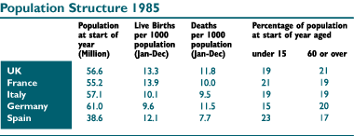

(1) Which country had the highest number of people aged 60 or over at the start of 1985?
(a) UK France (b) Italy (c) Germany (d) Spain

(2) How many live births occurred in 1985 in Spain and Italy together (to the nearest 1,000)?
(a) 104,000 (b) 840,000 (c) 1,044,000 (d) 8,400,000 (e) 10,440,000

(3) What was the net effect on the UK population of the live birth and death rates in 1985?
(a) Decrease of 66,700 (b)Increase of 84,900 (d)Increase of 85,270 (e)Increase of 752,780 (f)Cannot say

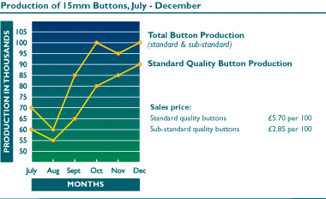
(4) What percentage of the total 15mm button production was classed as sub-standard in September?
(a) 10.5% (b)13% (c)15% (d)17.5% (e)20%
(f)23.5% (g)25% (h)27.5% (i)28% (j)30.5%

(5) By how much did the total sales value of November's button production vary from October's?

(a) ?8.50 (Decrease) (b) ?42.50 (Decrease) (c)?85.00 (Increase) (d)?27.50 (Decrease)
(e)No change

(6) What was the loss in potential sales revenue attributable to the production of sub-standard (as opposed to standard) buttons over the 6 month period?
(a) ?13.75 (b)?27.50 (c)?,137.50 (d)?,280.00 (e)?,275.00

TEST2
In this test you have to use facts and figures presented in statistical tables to answer the questions. In each question you are given five answers to choose from. One, and only one, of the options is correct in each case. If necessary use a sheet of rough paper for your working out.
The numerical questions which follow are multiple choice. For each question, you are given several possible answers. When you have selected your answer, click in the appropriate circle.
……………………TEST2的具体要求

最后，要注意的是时间问题，因为SHL对回答每个TEST都有的规定是：
see how many questions you can answer in 5 minutes, remembering you should work accurately as well as quickly.

附：
（一）采用shl试题的公司概略
Mars ICI Unilever 高露洁 汇丰银行 恒生银行 渣打银行 德勒 KMPG 瑞安集团
（二）具体介绍：
1. 毕马威KPMG、安永E&Y
Paper Test
毕马威的笔试采用的是SHL的试题，分为verbal和number两个部分，时间有限，一般做不完，主要考察英文阅读能力、逻辑能力、数字能力和准确率。在这一关80%的人，无法进入下一轮。
安永的笔试主要是写作文，考察英文表达能力，每年的题型都有变化。
其他流程参见普华永道。
2． 德勤DTT
On-line test
在线提交简历后，会收到一个在线测试的链接，类似于心理测试，100道题左右，有时间限制；隔几天后，会收到一个在线英文测试，是SHL的试题，与毕马威的verbal有些类似。
Goup Discussion

写在最后：
不知道您看完这些题目有些什么感觉呢？欢迎大家和HAILL的专家团队交流、探讨！我们会给大家提供尽可能最详细的咨询。

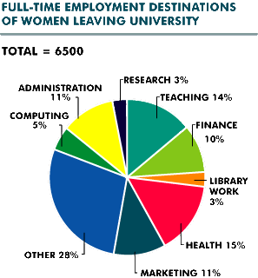
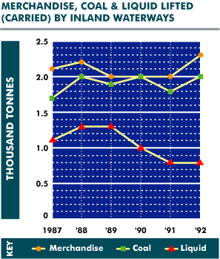
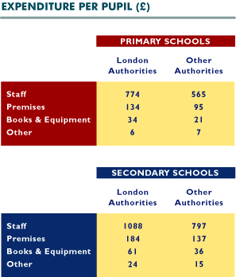
What percentage of women leaving university went into finance and administration?
10%
11%
14%
20%
21%
How many thousand tonnes of liquids were lifted in 1989?
1.3
1.5
1.9
2.0
None of these
How much more per pupil do London authorities spend on staff in secondary schools than in primary schools?
£209
£219
£232
£291
£314
Which one area of employment is least popular among female university leavers?
Cannot say
Computing
Library Work
Marketing
Research
How much more coal was lifted in 1992 than in 1987?
How much more than "other" authorities do London authorities spend per secondary pupil on premises?
0.1 thousand tonnes
0.2 thousand tonnes
0.3 thousand tonnes
1.3 thousand tonnes
2.0 thousand tonnes
£39
£47
£184
£137
£291
Which was the most popular area of work chosen by women leaving university?
How many thousand tonnes of merchandise and liquids were lifted in 1991?
Administration
Finance
Health
Sales
Teaching
1.9
2.2
2.8
2.9
3.0
What is the total cost to London authorities per secondary school pupil?
£688
£948
£985
£1,357
£1,427
Into which two areas of employment did a combined 19% of female university leavers go?
Admin & Computing
Health & Research
Marketing & Admin
Teaching & Computing
Teaching & Library
In which year was most merchandise carried?
On what do "other" authorities spend 13.8% of their total outlay per primary school pupil?
1988
1989
1990
1991
1992
Books & Equipment
Premises
Staff
Other
Cannot say
How many women went into teaching when they left university?
140
650
870
910
None of these
In 1988 how much more merchandise than liquids was lifted?
0.2 thousand tonnes
0.9 thousand tonnes
1.0 thousand tonnes
1.1 thousand tonnes
2.2 thousand tonnes
What is the total expenditure for a primary school in London with 320 pupils?
£300,360
£303,360
£330,306
£330,360
£360,303
How many more women went into computing than into research?
120
135
195
325
None of these
How much more liquid was carried in 1989 than in 1992?
0.5 thousand tonnes
0.8 thousand tonnes
1.3 thousand tonnes
1.5 thousand tonnes
1.8 thousand tonnes
What is the difference in total cost to London authorities between one secondary pupil and one primary pupil?
£260
£314
£409
£948
None of these
How many women went into computing and administration?
940
1040
1100
1140
None of these
In which year was an equal tonnage of merchandise and coal carried?
1987
1988
1990
1991
1992
Approximately what proportion of the total amount spent per primary pupil by "other" authorities is on books and equipment?
1%
3%
10%
12%
17%
24% of female university leavers go into
Finance, Research & Admin
Finance, Teaching & Research
Health, Computing & Research
Marketing, Finance & Computing
Teaching, Research & Admin
----------------------------------------------------------------------------------------------------------------------
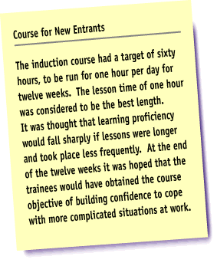
The course lasted twelve weeks.
True
False
Cannot Say
A lesson time of two hours was considered to be the best length.
True
False
Cannot Say
A target of ninety hours was set for the course.
True
False
Cannot Say
These courses are beneficial to the entire population.
True
False
Cannot Say
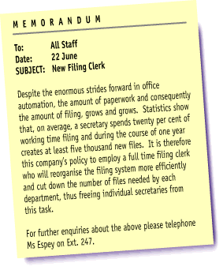
This memo should be distributed to all staff.
True
False
Cannot Say
Statistics show that, on average, a secretary spends a third of working time filing.
True
False
Cannot Say
Ms Espey should be contacted with further enquiries.
True
False
Cannot Say
All firms should employ a full time filing clerk.
True
False
Cannot Say
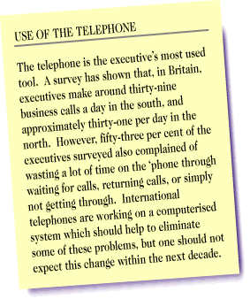
According to the survey, executives in the north make around thirty-nine business calls a day.
True
False
Cannot Say
The telephone will always be the executive's most used tool.
True
False
Cannot Say
Over half of the executives in the survey said that they waste a lot of time on the telephone.
True
False
Cannot Say
Telephones are often misused.
True
False
Cannot Say

Visitors sometimes get out of their car to look more closely at the animals.
True
False
Cannot Say
Accidents have occurred when visitors wind down their windows to take photographs.
"Danger" signs are placed every fifty yards around the park.
True
False
Cannot Say
True
False
Cannot Say
The general public should be banned from safari parks.
True
False
Cannot Say
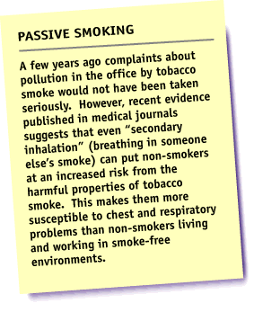
In the past, complaints about tobacco smoke pollution would have been treated seriously.
True
False
Cannot Say
"Secondary inhalation" is breathing in another's smoke.
True
False
Cannot Say
Medical journals have proposed that smoking should be banned from offices.
True
False
Cannot Say
Smokers have an increased risk of heart disease.
True
False
Cannot Say

Wise parents should praise their child's drawings.
True
False
Cannot Say
Teachers and parents should avoid talking to each other.
True
False
Cannot Say
All children watch television.
True
False
Cannot Say
All children should go to play school.
True
False
Cannot Say
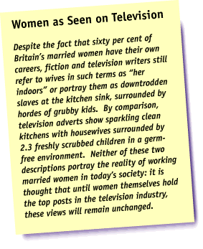
Sixty per cent of Britain's married women have their own careers.
True
False
Cannot Say
Television writers never refer to wives as "her indoors".
True
False
Cannot Say
Women hold all the top posts in the television industry.
True
False
Cannot Say
The National Statistics show that most couples have 2.3 children.
True
False
Cannot Say

