  - Downloading Quartus
- Go to the Intel FPGA Download Page
  - https://www.intel.com/content/www/us/en/software-kit/849770/intel-quartus-prime-lite-edition-design-software-version-24-1-for-windows.html
- Choose the Correct Version
  - Select version 24.1(Latest) from the drop-down menu.
  - Please verify that you have selected the following parameters. FPGA Development < Quartus Prime Lite < 24.1 (Latest) < Windows
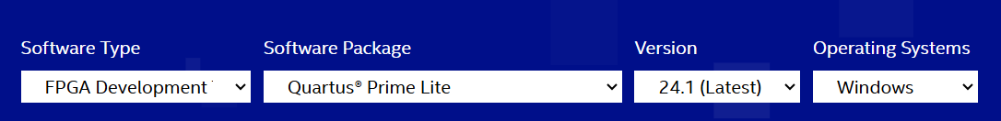
  - Once satisfied, press the download button below and accept the legal disclaimer when prompted.
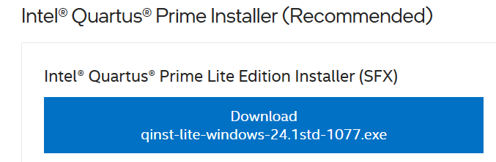
  - Your zip file will now be downloaded, open the folder to begin the setup process. If your file has not downloaded, please click the link to redownload the zip folder.
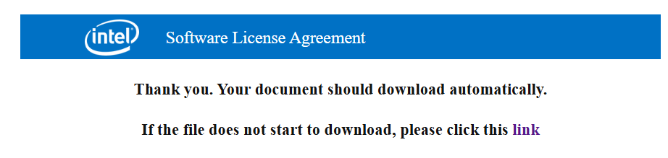
  - Check off the following components.
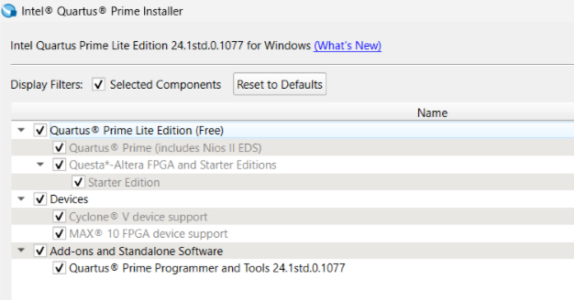
  - Select the Intel License Agreement and click Download and Install. This installation will take a while to complete. Please be patient.
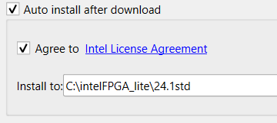
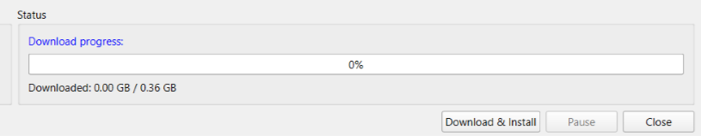
  - Once the download and installation are complete, close the window and open up Quartus. You should see a screen that looks like this:
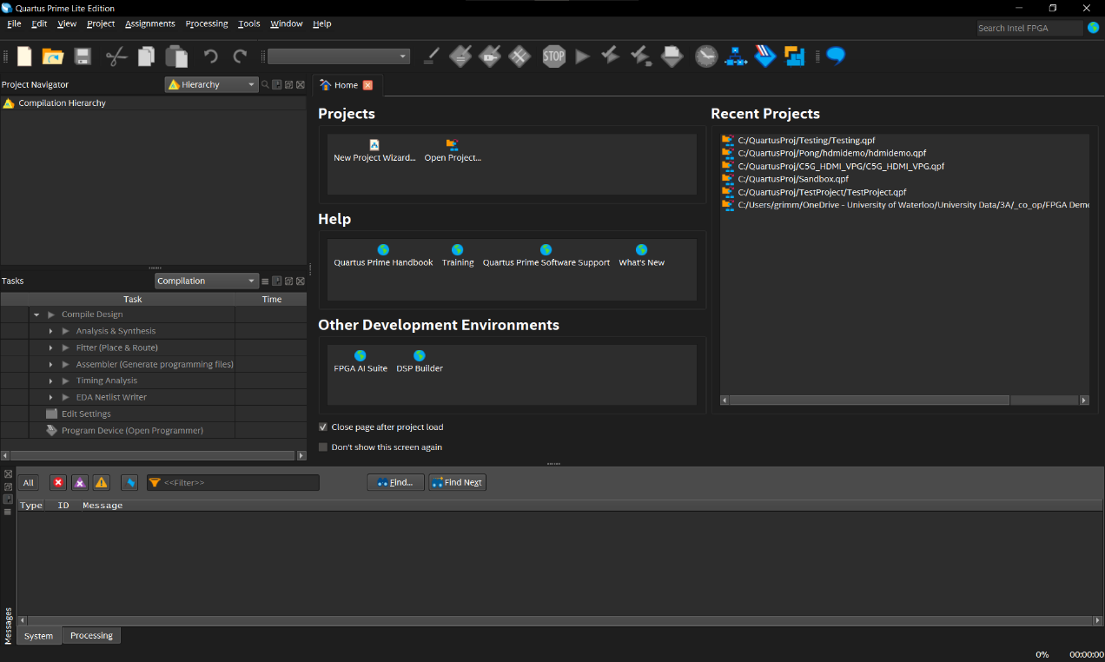

Driver Installation
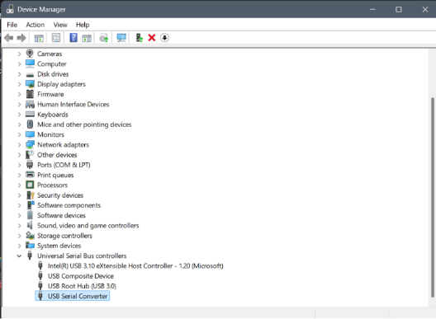
For Quartus to detect your FPGA, you will need to install the USB-Blaster drivers. Your FPGA will need to be plugged into power, as well as your computer to do this. MAKE SURE THAT THE USB-B END OF YOUR CABLE IS PLUGGED INTO THE PORT ON YOUR FPGA LABELED AS “USB-Blaster” (The one that is closest to the edge of the board). To do this, navigate to Device Manager. The FPGA will be labeled as either an unknown device, or something like USB Serial Converter (you can figure out which device corresponds by unplugging and plugging in the FPGA and seeing which device appears and reappears).
Double click on the device and navigate to the driver tab. Click on “Update Driver”
.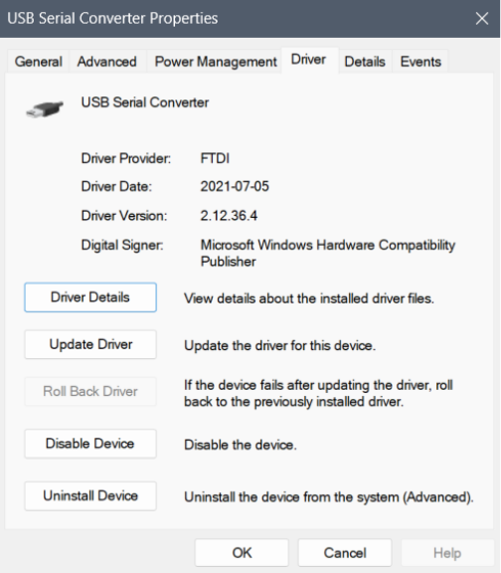
Click on “Browse my computer for drivers”
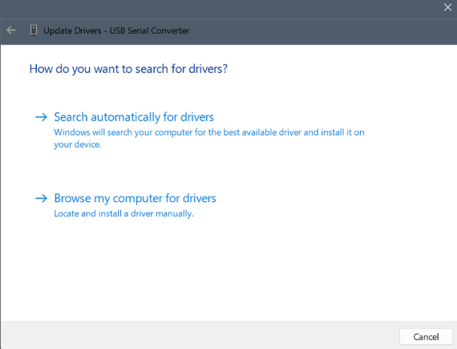
Click on “Let me pick from a list of available drivers on my computer”.
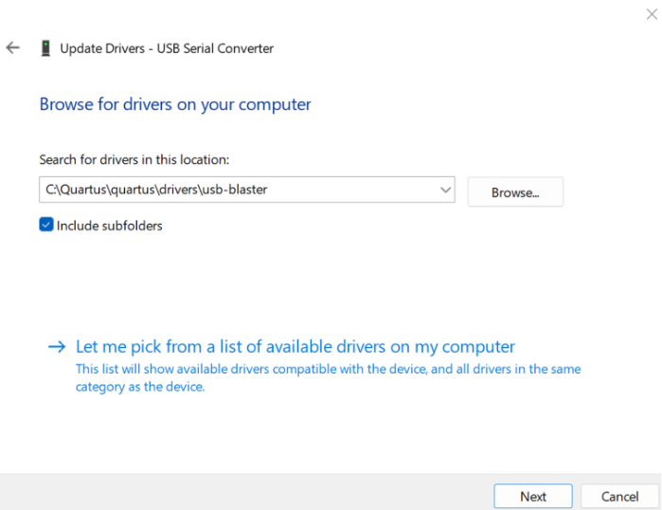
Click “Browse” and navigate to quartus\drivers\usb-blaster or intel_fgpa\quartus\drivers\usb-blaster or something similar. The file you are looking for is usb-blaster. Click OK.

Driver troubleshooting:
If you’re unable to update the drivers using the previously mentioned approach you can try the following approaches to see if that works.
Alternative 1:
Instead of just selecting the folder, you can select the file directly. Similar to the previous step, we need to get to the usb-blaster folder and then follow the path usb-blaster >> x64 >> .inf file (there should only be one file and that’s the one which should be selected) and just select that file.
Alternative 2:
It’s also possible to install the driver package online using the following link and its respective instructions https://www.terasic.com.tw/wiki/Windows_encountered_a_problem_installing_the_drivers_for_your_device
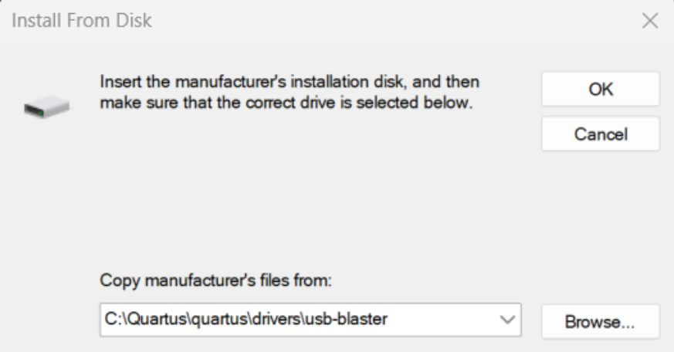
Select “Altera USB-Blaster" and click Next.
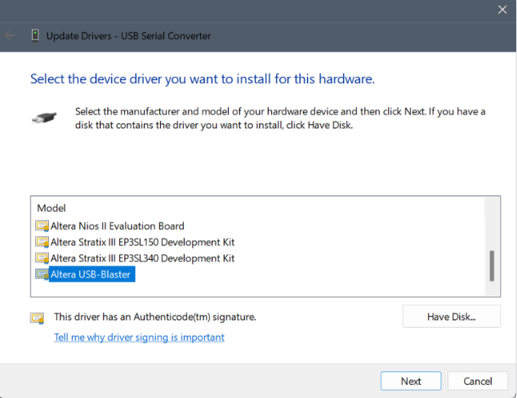
The drivers should now be installed.

