https://github.com/  
GitGui визуализирует процесс (работы с git)  
GitBash работа с консолью (код)  
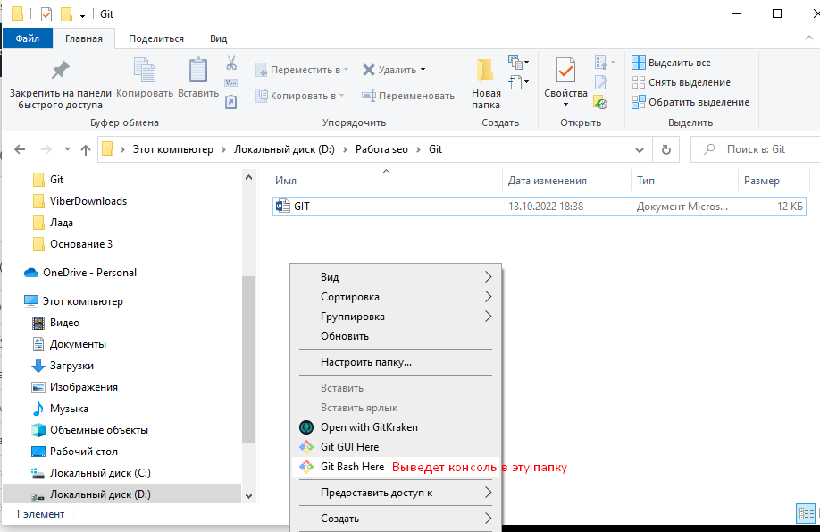  
  
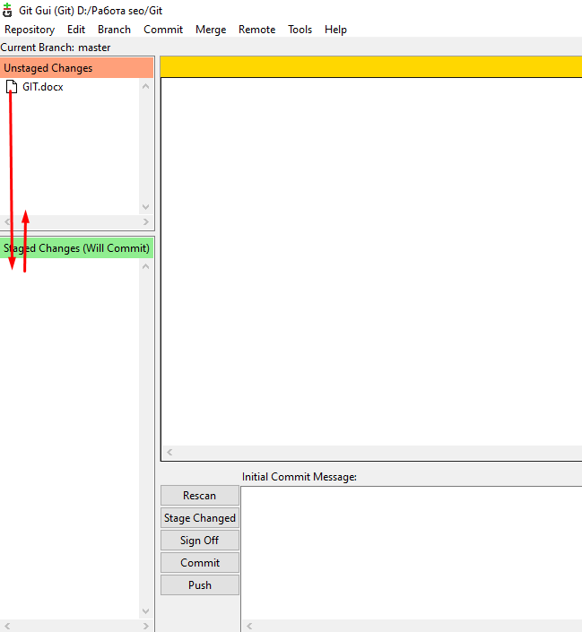

Git руководство <https://git-scm.com/book/ru/v2>  
<https://www.youtube.com/watch?v=zZBiln_2FhM>  
  
[https://www.atlassian.com/ru/git/tutorials/what-is-git#:~:text=Git%20%E2%80%94%20%D1%81%D0%B8%D1%81%D1%82%D0%B5%D0%BC%D0%B0%20%D1%83%D0%BF%D1%80%D0%B0%D0%B2%D0%BB%D0%B5%D0%BD%D0%B8%D1%8F%20%D0%B2%D0%B5%D1%80%D1%81%D0%B8%D1%8F%D0%BC%D0%B8%20%D1%81,%D1%81%D0%B0%D0%BC%D0%B0%20%D0%BF%D0%BE%20%D1%81%D0%B5%D0%B1%D0%B5%20%D1%8F%D0%B2%D0%BB%D1%8F%D0%B5%D1%82%D1%81%D1%8F%20%D1%80%D0%B5%D0%BF%D0%BE%D0%B7%D0%B8%D1%82%D0%BE%D1%80%D0%B8%D0%B5%D0%BC](https://www.atlassian.com/ru/git/tutorials/what-is-git#:~:text=Git%20%E2%80%94%20%D1%81%D0%B8%D1%81%D1%82%D0%B5%D0%BC%D0%B0%20%D1%83%D0%BF%D1%80%D0%B0%D0%B2%D0%BB%D0%B5%D0%BD%D0%B8%D1%8F%20%D0%B2%D0%B5%D1%80%D1%81%D0%B8%D1%8F%D0%BC%D0%B8%20%D1%81,%D1%81%D0%B0%D0%BC%D0%B0%20%D0%BF%D0%BE%20%D1%81%D0%B5%D0%B1%D0).