**Best website design firm in Bengaluru**

**Our website pricing starts from ₹85,000 onwards to find exact quotation use below button.**

 Get Exact Quotation 

**Join 500+ happy customers from Bengaluru.**

#### Currently we only work with private limited and public limited companies

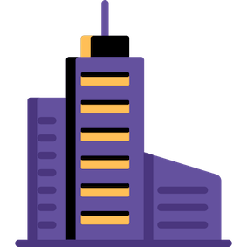

### Private Limited



### Public Limited

#### We are specialist in business websites

#### What we don't do



### E-Commerce



### Portal Website

#### What we do



### Business Website

#### Key benefits you get by choosing us.



## Convenience

Our expert web designers build high-quality custom designs to make your website stand-out among your competitors.



## Support

We have dedicated team of experts which give best inputs and suggestions according to the latest design trends always keep in touch with you during and after the project.



## Trust

We ensured high-quality visual graphics across the website. keeping all our commitments and completing projects with 100% satisfaction.

#### Frequently Asked Questions

#### Which technology we use?



### Wordpress

#### How much time it takes?

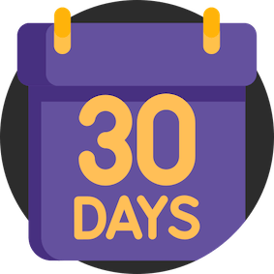

### Min. 30 Days

#### Process we follow to deliver your website.

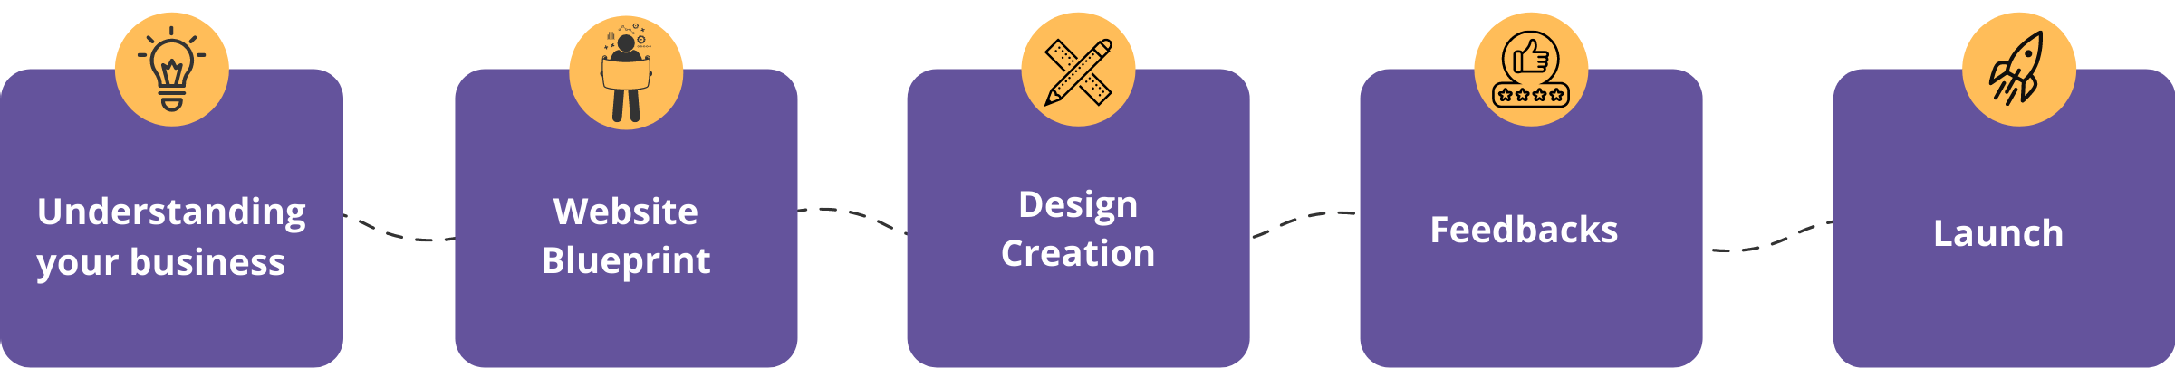

#### 100% Happy Customers | 7+ Years of experience | 500+ Projects Completed

Our team draws **onboard industry experience**to create the most rewarding outcome for our client.

## **Benefits of Using Our Best CRM System for Small Business or Other Business**

**Best CRM System for Small Business Company and other parts are playing a crucial role for companies and our daily lives in a variety of ways. CRM (Customer Relationship Management) software allows storing customer information and interactions. The Wingshield Customer Relationship Management (CRM) software is a multi-channel integrated solution that includes marketing and sales support as well as Customer Relationship Management.**

The **[Wingshield's](https://thewingshield.com/)** CRM (Customer Relationship Management) solution helps in the strengthening of present customer connections, the identification of prospective leads, and the recovering of former clients. You can save, organize, and manage customer data all in one spot with the CRM app.

Small and medium-sized businesses may benefit from our CRM, which is no longer just for multinational corporations with enormous consumer databases.

We are confident in our CRM software's ability to maintain customers and increase customer communication quality. Wingshield Customer Relationship Management Software integrates all customer information and automates in **business management software**. Telephonic calls, chatbots, and email are just a few of the communication methods available in our CRM software. CRM software may help companies in improving customer responsiveness and preserving customer connections. We're delighted that our whole CRM software is focused on helping clients achieve business excellence by satisfying their needs.

One of the most efficient management tools you may have is a CRM framework that keeps track of your work progress and automates performance. Our CRM **products management system** offer improved customer service and greater business relationships, to mention a few benefits. The Wingshield's Customer Relationship Management helps our clients boost profits, gross profit, and customer happiness by providing customized solutions and services. We help our clients with service inquiries, sales, customer service, customer acquisition, grievance management, and account management.

## **Enhances the efficiency of internal communication**

CRM leads to more efficient and effective internal communication within the company. One of the various advantages of a CRM platform is its ability to share customer data across teams, enabling you to work as a team and improve the customer experience. Each employee could be available for questions of customers regarding their product or service.

## **CRM is a Scalability-Ready Tool**

If a company is to survive, it must have a growing customer base that acknowledges the value proposition it offers. Because each encounter requires a unique time commitment, it becomes increasingly difficult to satisfy individual demands on a personal level as the number of consumers rises. This software is a scalable solution that can be customized to nearly any budget and will only expand as the firm expands, ensuring that all requirements are satisfied.

## **Easy Integration with Other Software**

Various business management solutions, such as accounting, project management, and data processing software, desktop apps, and online services, can easily integrate with CRMs.

Because you can correlate your customer information with all of your other business operations, you can get a more complete and holistic picture. Customer email and social media notifications can be managed, prioritized, and reacted to in real-time thanks to an easy connection with email and social media activity. By turning your emails into a conversion funnel and better managing your email campaigns, you can now convert more leads from email.

## **Better Customer Service**

Although modern CRM software has various functions, it was designed to reinforce business-to-business relations, and this is still its main purpose. A customer relationship management system (CRM) integrates all of your contacts and collects significant customer data such as demographics, purchase history, and previous communications across all channels, making it easily accessible to anybody in your organization that needs it. This ensures that your workers have access to all they need to know about the client and can provide a better customer experience, which improves customer satisfaction.

## **Everything You Need is One Place**

To be effective, customer relationship management must be centralized. The information collected must be accessible to anyone who needs it. It’s works like a **store management system,** where everything you need finds in a one place. Everyone can be on the same page with a CRM system since everyone has access to the same information. Workers can be more productive of this since they can focus more on addressing the requirements of current and potential customers.



## **Increased Sales**

It works like **sales management software**, in which boost your sales activities. A CRM system may help you optimize key tasks, improve your sales process, and monitor all of your sales data in one central spot, significantly boosting sales and productivity. A CRM helps to create a step-by-step sales strategy that your workers can trust and that you can easily tweak when problems arise.

## **Higher Productivity and Efficiency**

CRM software makes use of marketing automation technology, which accelerates time-consuming tasks like drip campaigns and allows your employees to focus on things that only people can do, such as content development. It can also verify that no tasks are missed (e.g., all-important emails are always sent to the right people). A CRM can also provide you with a dashboard that shows you how well your business processes are performing and where they could be modified.

## **Uprooting of Data in an Easy Way**

We're not just talking about consumer data there; we're also talking about sales reports and other analytics that might help your company figure out what's working. Managing customer relationships allows individuals to see how they're doing without needing to spend as much time collecting data, resulting in an environment where changes can be made nearly instantly.

## **Increased Revenue and Retention**

By integrating CRM software for your business, you may improve customer retention rates, which will lead in more sales for your company.

# ****Web Design & Web Development Company in  Bangalore****

Welcome to Sunsys Technologies India Pvt Ltd commenced in the year 2006, we are one among the top **web design and development company in Bangalore** that offers comprehensive **web design** & development services, web hosting services, and web maintenance services.

We have served 750+ clients across the world for more than 14 years with creative and utmost technology services. A small team of 10 dedicated and hardworking employees to offer best-in-class services to our customers and now we have a great team of creative but practical people.

We strive to escalate your business realistically with our hard work and expertise in website development, web application development, mobile app development, and so on. We are a complete **Website development company in Bangalore, India**.

## **Web design and development company in Bangalore**

We work with all the latest technologies to make your **website design** compelling and both mobile and SEO friendly. Since there are several ranking factors in the digital world, our experienced and cultivated team understands the efforts you have made to grow your business and work in a collaborative manner to offer best custom and e-commerce website design services in Bangalore.

With some of the most experienced and **creative website designers in Bangalore**, we leave no stone unturned to design a responsive website that works equally on both android and iOS. Since website designing is not child play, we along with our motivated team check everything from the user’s perspective as UI & UX. Sunsys is a leading web design company in Bangalore that takes care of your website with all essential aspects of SEO, Designing and Development as well. Our passionate and experienced designers & developers do more than just website development.

We analyze your business and let you know the best way to reach the top of the industry. With a proven track record in providing high-end web development, portal development in both Windows and Linux platforms, we are the best **website development agency in Bangalore** that offers 360° solutions to all custom and WordPress websites in a cost-effective manner.

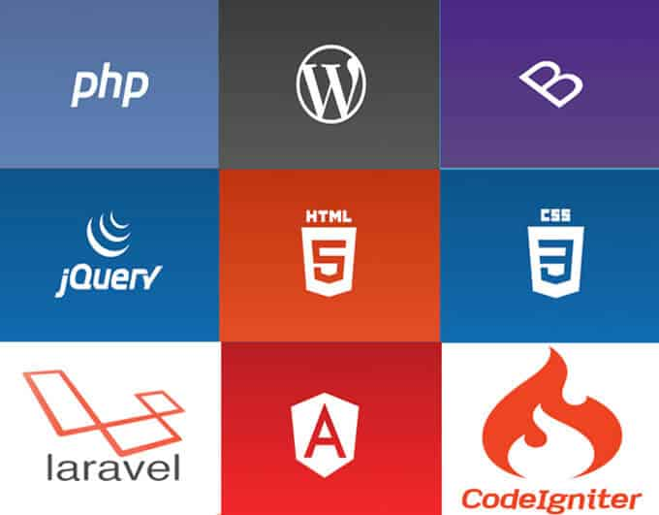

Our team works with the latest technologies in the field of website designing and development like HTML, CSS, JavaScript, Laravel, WordPress, and other languages to add a database, Email setup, and user authentication. We do everything that escalates your business and results in better business outcomes. As the best SEO Services Agency in Bangalore.

we are committed to providing all types of marketing services, such as Google PPC, Social Media Marketing, and everything that ensures sustained growth of your business along with ours. To ensure your brand visibility we come up with high-end digital marketing solutions and with our hard work and prestige experience, we ensure your #1 rank on the search engine.

We are a team of innovators that stay creative 24/7 and thrive for customer satisfaction. We understand your needs and the value of your time, therefore we deliver our project under strict timelines. We have been serving international and domestic clients with the sole purpose to earn their trust with our time efficiency and quality of services. Our values are what ensure our presence as the **best website designing & development company in Bangalore, India**.

## Our Services

We, Sunsys Technologies, offer a wide range of services with comprehensive solutions for all your website design and development needs. Here is all that we do to grow your business and make your presence in this everchanging online & offline market.

Web Designing  
**Web Designing**  
We provide compelling, creative, user and SEO-friendly website designs. Our expert web designers work with the latest technologies to offer the best custom and E-commerce website designing.  
[Read More](https://www.sunsys.in/website-design-company-bangalore/)

  
**Domain Registration**  
Registering a domain name for your business can be really exhausting and time taking but we can do it instantly in a cost-effective way with our proven experience and set your business ready to go online.

[Read More](https://www.sunsys.in/domain-registration-company-bangalore/)

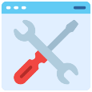  
**Website Maintenance**  
Besides designing and development, we nurture your business online and take care of everything that makes your business grow faster

[Read More](https://www.sunsys.in/website-maintenance-company-bangalore/)

Web Hosting  
**Web Hosting**  
We provide compelling, creative, user and SEO friendly website designs. Our expert web designers work with the latest technologies to offer the best custom and E-commerce website designing

[**Read More**](https://www.sunsys.in/website-hosting-company-bangalore/)

Website Development  
**Website Development**  
Every business needs development, whether it’s stable or progressive and Sunsys Technologies offer best-in-class website development at an affordable price.

[**Read More**](https://www.sunsys.in/)

  
**CMS Development**  
Needs of a website keep changing from design to content on the website. We provide inclusive CMS development services to give you ease of content publication

[**Read More**](https://www.sunsys.in/cms-development-company-bangalore/)

  
**Linux hosting**  
We are a leading name in Linux hosting service provider in Bangalore, we offer affordable and tailored Linux hosting services to all Window and Framework-based websites.

[**Read More**](https://www.sunsys.in/linux-hosting-company-bangalore/)

  
**Data Base**  
With our US and India based dedicated services, we provide affordable database services to store your data somewhere in the clouds.

[**Read More**](https://www.sunsys.in/database-development-company-bangalore/)

  
**Digital marketing**  
Our high-end digital marketing services ensure your astonishing growth in the ever-changing online market and set your business online.

[**Read More**](https://www.sunsys.in/digital-marketing-company-bangalore/)

  
**Portal Development**  
Planning to address a specific community or group? We also offer portal development services project information on site from various sources.

[**Read More**](https://www.sunsys.in/web-portal-development-company-bangalore/)

  
**Search Engine Optimization**  
SEO is called the backbone of the business. With professional SEO executives and business analysts, we provide the most effective SEO services in Bangalore.

[**Read More**](https://www.sunsys.in/seo-company-bangalore/)

  
**Ecommerce web development**

This digital era has made everyone to adapt the digital world of business. If you have an offline business then you must have an online business to reach more customers.

[**Read More**](https://www.sunsys.in/ecommerce-website-development-company-bangalore/)

## **Who We Are**

Hello! We’re Sunsys Technologies (India) Pvt. Ltd., empowering people and industry by establishing their business online. Established in 2006, we are the best Website Design & Development Company in Bangalore.

**Our area of services goes through**

* Custom & E-commerce website design and development
* Digital marketing
* web and mobile app development
* website hosting, domain registration
* search engine optimization
* Ecommerce web development

With a supersonic team of expert SEO executives, web designers in Bangalore and web developers, we make sure your business grows faster than you think.



Sunsys Technologies is a family of innovators and creative thinkers, and our team members hold extensive experience in their domain as they have reached here after successful completion of employment with successful startups, and multinational corporations to E-commerce companies. We design, develop and market your business online to turn your imaginations into innovation.

We are more than just a website design, development or digital marketing company instead we are a team whom you can expect nothing less than perfection. We believe in developing new ideas, planning, rethinking, improving, and finally execution of our innovative ideas for client’s success. In this growing digital world you can have more [**benefits of website for business**](https://www.sunsys.in/blog/10-benefits-website-for-business/). We focus on every detail and leave the irrelevant information to maintain the highest level of proficiency in every service. We’re a website design company in Bangalore providing best-in-class services all around the world. We’re the digital experience  
of your dreams

### **Vision**

Customer satisfaction through professional service   reap the trust of worldwide clients.

### **Mission**

To clearly understand our client’s needs, provide the most effective solution and celebrate success.

### **Profile**

Our young experienced team of professionals continuously focuses on good quality and value for money.

## **Areas What We Serve**

These are the ways we usually engage with our customers. While these are basic ways of interaction, we also provide tailored solutions to your business needs. We Listen: Sunsys Technologies takes communication as the only way to understand the client’s requirements. And this is an essential part of our business strategy that compiles with in depth business research, analyses, online consultation, usability, and mainly creative suggestion sessions. We listen to your needs, analyze your business and then come up with the most innovative ideas to ensure your growth.

We Plan and Improve: This mainly includes studying your business, research, business plan, project outline, web design, development, user experience, UX & UI, content planning, website response, SEO factors and most importantly rethinking and improving the same. We Execute and Grow: In this section we will design, develop and set your business online. Our final procedure includes, plan, design, development, testing, improvement, launching and, of course, establishment and marketing. Once we are done, then we maintain your business online

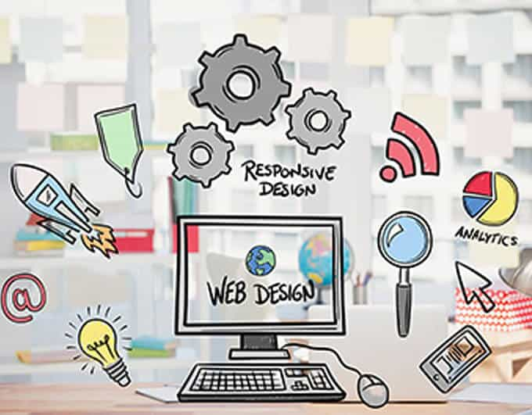

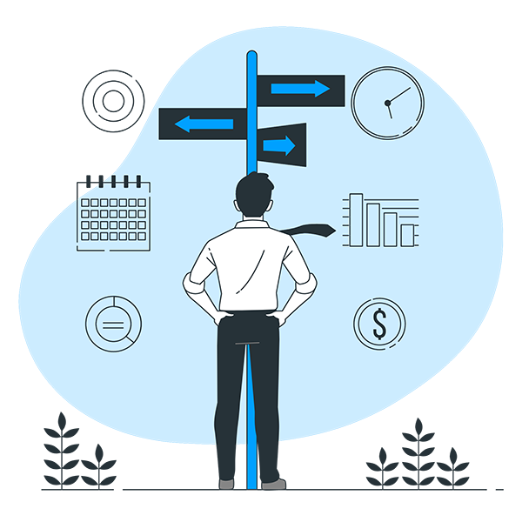

## **Why Choose Sunsys Technologies?**

Wide Range of Services: Our organization offers best website design, development, SEO, Web hosting and various other types of services to establish your business.

* **Comprehensive Solutions**: We deal with nearly all aspects of web designing & development and digital marketing.
* **Dedicated Team:** A great and enthusiastic team is dedicated to delivering the project under strict timelines.
* **Time Efficiency:** We value your time and efforts you’ve made thus we make sure the project delivers before the given timeline.
* **Innovative Creation:** Our young and passionate web designers and developers offer one over one compelling and engaging [**responsive website designs**](https://www.sunsys.in/responsive-web-design-services/).
* **Great Customer Support:** To achieve the utmost customer satisfaction,we stay connected with the customer 24X7.

## **Our Portfolio**

We are one among the most leading Website Design Companies in Bangalore renowned for the most creative and innovative website designs and development services. Our experienced and skillful website designers in Bangalore have successfully designed and developed over 10,000 projects to ensure the powerful creation of growth. We provide our designers and developers with all the latest technologies in web designing and development to give them a window to show the most creative side of their brain. We have been designing powerful and user friendly websites for the growing companies for more than a decade. Here are a few of our recent works.

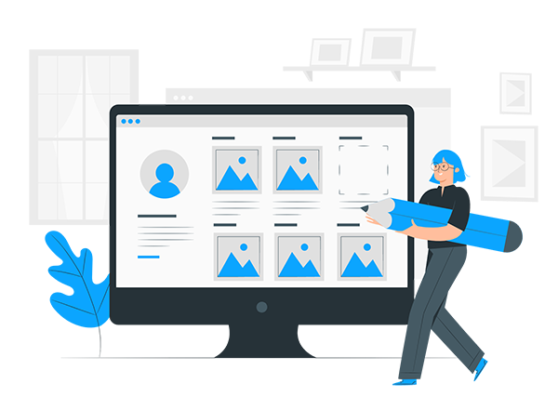

## **Our Clients**

From small businesses to multinational corporations, we have worked with various companies serving in different domains and communities as IT, Education, Healthcare, Food, Travel, and so on. We designed and developed the most engaging and powerful websites to display their business online. From establishment to online marketing we have done everything to lock their success.  Here are a few of our most reputed clients.

## Website Development

Our team of proficient website developers uses the latest technologies to provide responsive website designs for small as well as large enterprises.

Process

## Website Development

Let us create user-engaging business websites & dynamic web applications to promote your business and enhance your customer reach.

1Conception & Initiation

## Understanding your Business

In this phase, we research about the problem your business is tackling and come up with the best software solution that best suits your niche. Here we define the project at a broader level to avoid any further confusion about the process.

2Definition & Planning

## Developing a Strategy

We create a simple draft that everyone can follow and typically set a timeline that is realistic and attainable. To ensure that the work is on track we establish baselines or performance measures and the objectives, deliverables, and key milestones are clearly defined.

3Project Implementation

## Executing the plan

We make sure that the project is executed as planned and we update you regarding the progress and the outcome that can be expected in every step. We hold status meetings every day to keep up-to-date with the project status.

4Performance Monitoring

## Our support

After the completion of the project, we take your feedback seriously and make the necessary modifications according to your requirements. Since we believe in building a long-term relationship, our customer satisfaction is the highest priority.

## Mobile Application

We have the best mobile application developers who use their solid expertise in mobile application development to create practical and seamless experiences on any device.

Process

## Mobile Application

Use the best of mobile technology to provide a user-friendly and secure platform for your customers to browse your products & services.

1Conception & Initiation

## Understanding your Business

In this phase, we research about the problem your business is tackling and come up with the best software solution that best suits your niche. Here we define the project at a broader level to avoid any further confusion about the process.

2Definition & Planning

## Developing a Strategy

We create a simple draft that everyone can follow and typically set a timeline that is realistic and attainable. To ensure that the work is on track we establish baselines or performance measures and the objectives, deliverables, and key milestones are clearly defined.

3Project Implementation

## Executing the plan

We make sure that the project is executed as planned and we update you regarding the progress and the outcome that can be expected in every step. We hold status meetings every day to keep up-to-date with the project status.

4Performance Monitoring

## Our support

After the completion of the project, we take your feedback seriously and make the necessary modifications according to your requirements. Since we believe in building a long-term relationship, our customer satisfaction is the highest priority.

## Software Solutions

Our team of expert software developers creates cutting-edge software solutions to offer your customers the best software experience.

Process

## Software Solutions

We help organizations get the most out of the latest technology with our Software Solutions

1Conception & Initiation

## Understanding your Business

In this phase, we research about the problem your business is tackling and come up with the best software solution that best suits your niche. Here we define the project at a broader level to avoid any further confusion about the process.

2Definition & Planning

## Developing a Strategy

We create a simple draft that everyone can follow and typically set a timeline that is realistic and attainable. To ensure that the work is on track we establish baselines or performance measures and the objectives, deliverables, and key milestones are clearly defined.

3Project Implementation

## Executing the plan

We make sure that the project is executed as planned and we update you regarding the progress and the outcome that can be expected in every step. We hold status meetings every day to keep up-to-date with the project status.

4Performance Monitoring

## Our support

After the completion of the project, we take your feedback seriously and make the necessary modifications according to your requirements. Since we believe in building a long-term relationship, our customer satisfaction is the highest priority.

## Search Engine Optimization

Let us boost your organic search rankings the legit way by tapping new geographies and reaching out to the global audience with our proven SEO strategies.

Process

## Search Engine Optimization

Our SEO experts help businesses build high-quality niche backlinks and gradually climb to the top of Google rankings.

1Conception & Initiation

## Understanding your Business

In this phase, we research about the problem your business is tackling and come up with Digital Marketing Strategies that best suit your niche. Here we define the project at a broader level to avoid any further confusion about the process.

2Definition & Planning

## Developing a Strategy

We create a simple draft about what needs to be done so that everyone can follow the plan and set a timeline that is realistic and attainable. To ensure that the work is on track we establish baselines or performance measures and the objectives, deliverables, and key milestones are clearly defined.

3Project Implementation

## Executing the plan

We make sure that the project is executed as planned and we update you regarding the progress and the outcome that can be expected in every step. We hold meetings every day to keep up-to-date with the project status.

4Performance Monitoring

## Our support

After the completion of the project, we take your feedback seriously and make the necessary modifications according to your requirements. Since we believe in building a long-term relationship, our customer satisfaction is the highest priority.

## Social media marketing

We offer custom social media marketing service plans so that you can build brand awareness across various social media platforms.

Process

## Social media marketing

We help you generate leads from social media platforms like Facebook, LinkedIn, Instagram, and more.

1Conception & Initiation

## Understanding your Business

In this phase, we research about the problem your business is tackling and come up with Digital Marketing Strategies that best suit your niche. Here we define the project at a broader level to avoid any further confusion about the process.

2Definition & Planning

## Developing a Strategy

We create a simple draft about what needs to be done so that everyone can follow the plan and set a timeline that is realistic and attainable. To ensure that the work is on track we establish baselines or performance measures and the objectives, deliverables, and key milestones are clearly defined.

3Project Implementation

## Executing the plan

We make sure that the project is executed as planned and we update you regarding the progress and the outcome that can be expected in every step. We hold meetings every day to keep up-to-date with the project status.

4Performance Monitoring

## Our support

After the completion of the project, we take your feedback seriously and make the necessary modifications according to your requirements. Since we believe in building a long-term relationship, our customer satisfaction is the highest priority.

## Paid Search Advertising

We promote your products and services with Google Ads, YouTube ads, Linkedin Ads, Google product listing ads, and Facebook ads and get your message out to a wide audience looking for your product and services.

Process

## Paid Search Advertising

With customized ads, we help you target users based on demographics, interests, and behavior and also re-target visitors who are interested in your product & services.

1Conception & Initiation

## Understanding your Business

In this phase, we research about the problem your business is tackling and come up with Digital Marketing Strategies that best suit your niche. Here we define the project at a broader level to avoid any further confusion about the process.

2Definition & Planning

## Developing a Strategy

We create a simple draft about what needs to be done so that everyone can follow the plan and set a timeline that is realistic and attainable. To ensure that the work is on track we establish baselines or performance measures and the objectives, deliverables, and key milestones are clearly defined.

3Project Implementation

## Executing the plan

We make sure that the project is executed as planned and we update you regarding the progress and the outcome that can be expected in every step. We hold meetings every day to keep up-to-date with the project status.

4Performance Monitoring

## Our support

After the completion of the project, we take your feedback seriously and make the necessary modifications according to your requirements. Since we believe in building a long-term relationship, our customer satisfaction is the highest priority.