# CS 255 System Design Document Template

## UML Diagrams

### UML Use Case Diagram

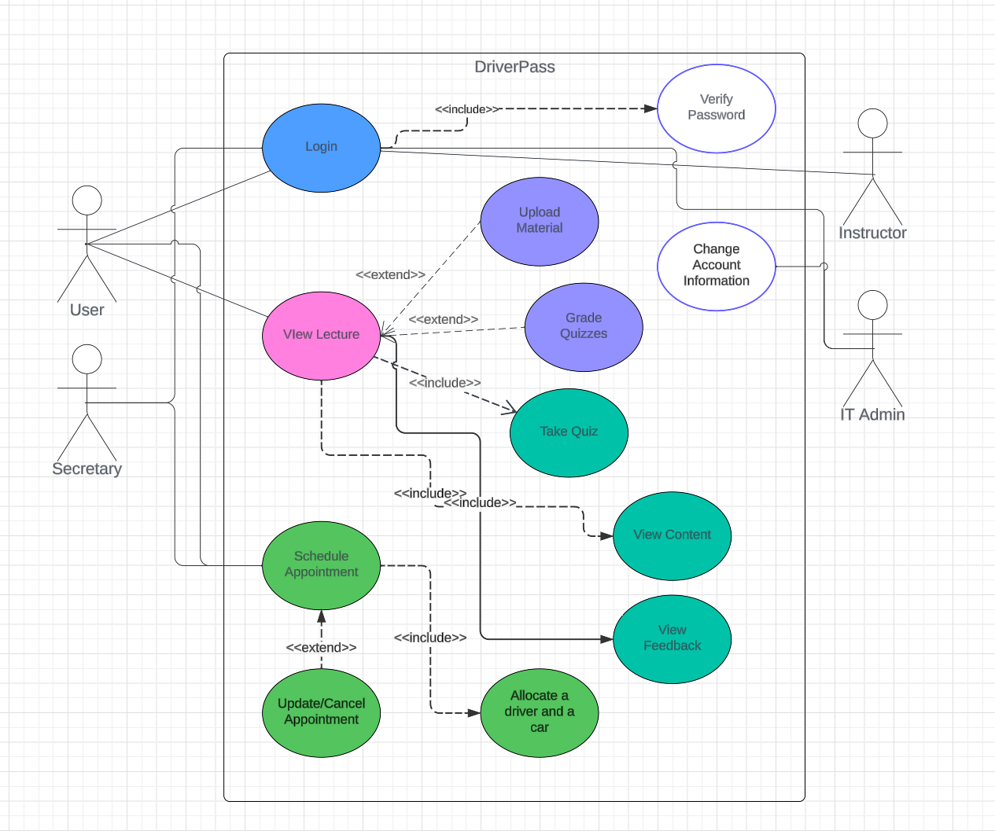

### UML Activity Diagrams

### *Image Image*

### UML Sequence Diagram

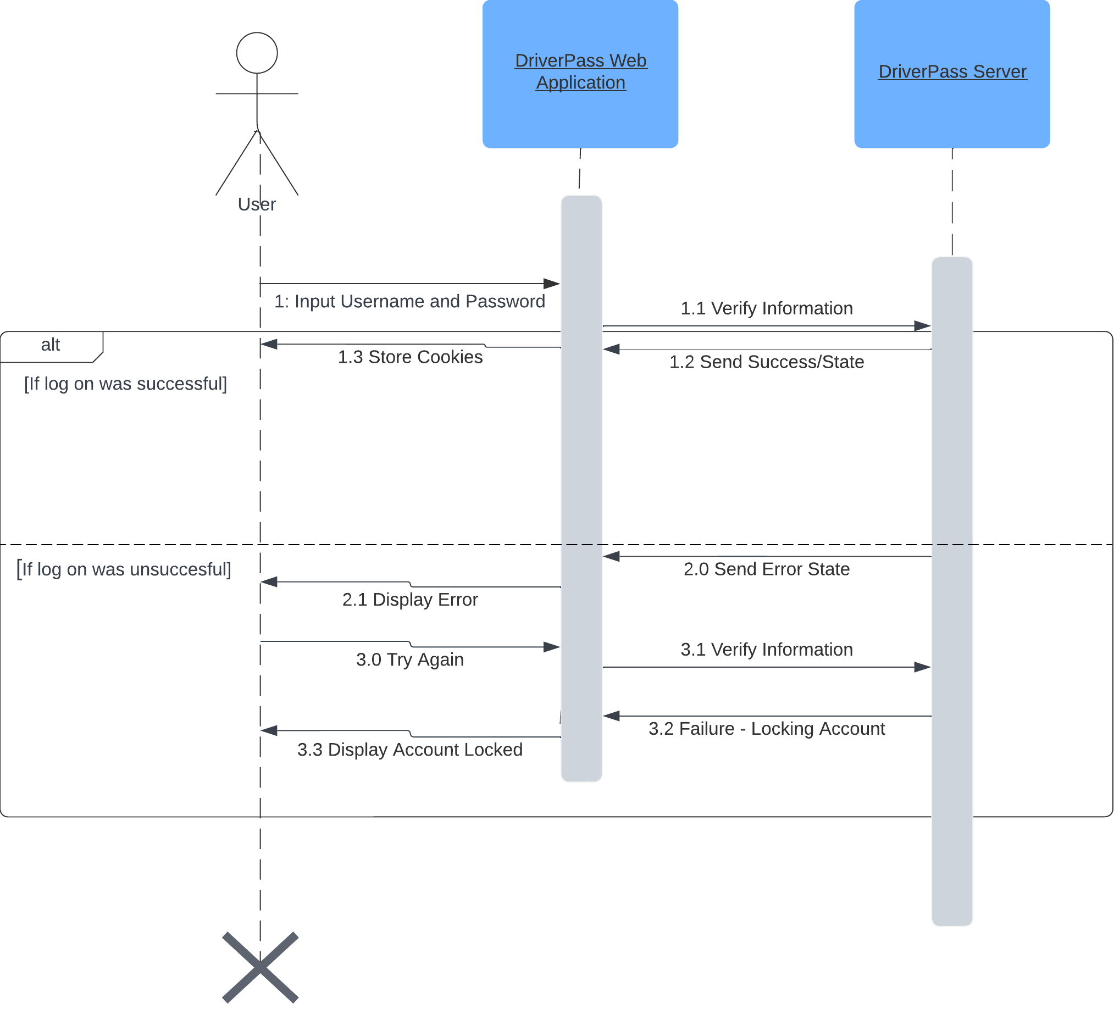

### UML Class Diagram

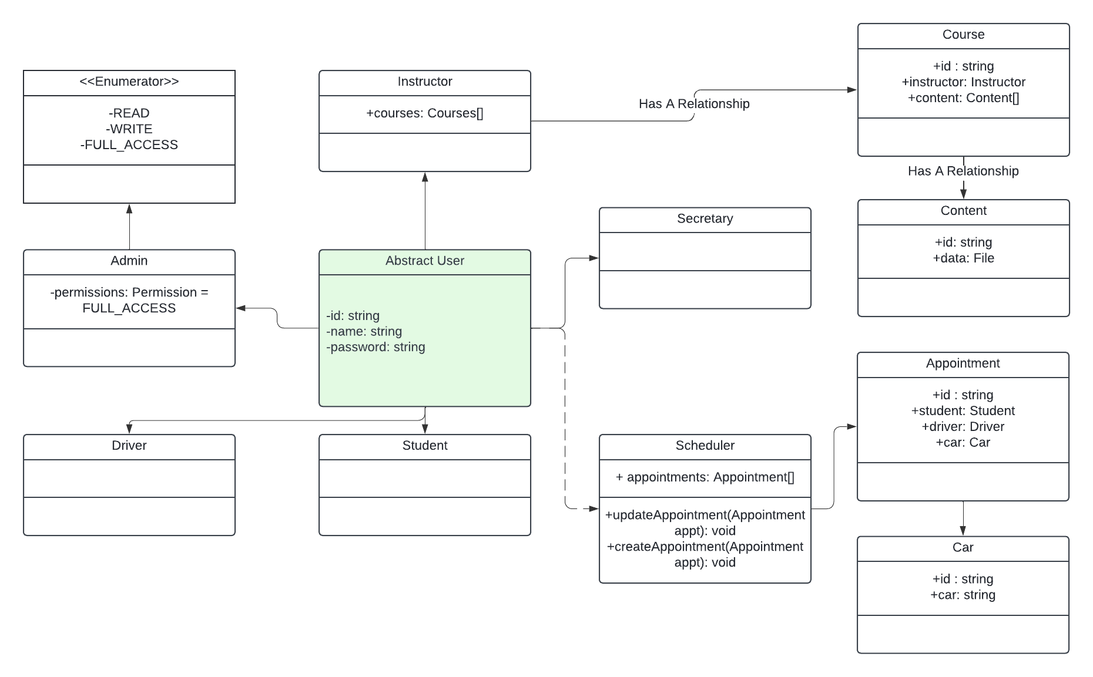

## Technical Requirements

The technical requirements of the DriverPass system are software running on Linux and on cloud, as the DriverPass team does not want to deal with the security. The DriverPass system should operate under a web app system that allows all actors to log in and interact with various parts. The architecture of the system does not matter, ARM64 / 80x86 should not interfere with any of the options depending on the language the system is developed on such as Java. The system should be able to handle various requests from varying parts of the United States, such as West, Central and East.