PIZZA SALES SQL QUERIES

- KPIs

- Total Revenue :
SELECT SUM(total_price) AS TotalRevenue FROM pizza_sales;
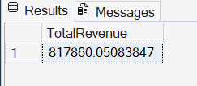

- Average Order Value :
SELECT SUM(total_price)/COUNT(DISTINCT order_id) AS AvgOrderValue FROM pizza_sales;
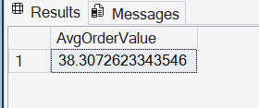

- Total Pizzas Sold :
SELECT SUM(quantity) AS TotalPizzasSold FROM pizza_sales;
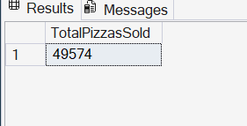

- Total Orders :
SELECT COUNT(DISTINCT order_id) AS TotalOrders FROM pizza_sales;
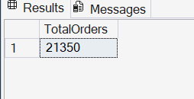

- Average Pizzas Per Order :
SELECT
CAST(
SUM(quantity) * 1.0/COUNT(DISTINCT order_id)
AS DECIMAL(10,2)
) AS AvgPizzasPerOrder
FROM pizza_sales;
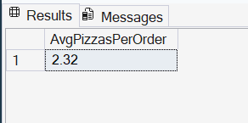

- Daily Trend For Total Orders

SELECT DATENAME(DW,order_date) AS OrderDay,COUNT(DISTINCT order_id) AS TotalOrders
FROM pizza_sales
GROUP BY DATENAME(DW,order_date),DATEPART(DW,order_date)
ORDER BY DATEPART(DW,order_date);

Output:

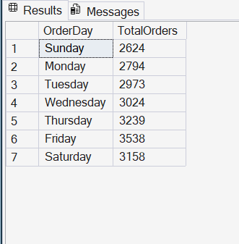

C. Hourly Trend For Total Orders

SELECT DATEPART(HOUR,order_time) AS OrderHour,COUNT(DISTINCT order_id) AS TotalOrders
FROM pizza_sales
GROUP BY DATEPART(HOUR,order_time)
ORDER BY OrderHour;

Output:

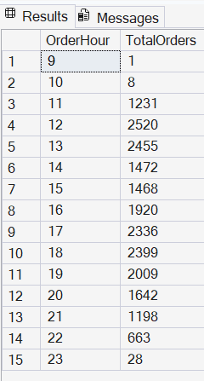

D. % of Sales by Pizza Category :

-- 1.Approach - Window function
SELECT
pizza_category,SUM(total_price) AS TotalSales,
CAST(
SUM(total_price)*100.0/SUM(SUM(total_price)) OVER()
AS DECIMAL(10,2)
) AS SalesPercentage
FROM pizza_sales
GROUP BY pizza_category;

-- 2.Approach - Subquery
SELECT
pizza_category,
SUM(total_price) AS TotalSales,
CAST(
SUM(total_price)*100.0/(SELECT SUM(total_price)FROM pizza_sales)
AS DECIMAL(10,2)
) AS SalesPercentage
FROM pizza_sales
GROUP BY pizza_category

Output:

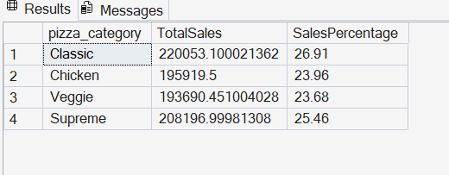

E. % of Sales by Pizza Size :
-- 1.Approach - Window function
SELECT
pizza_size,
CAST(SUM(total_price) AS DECIMAL(10,2)) AS TotalSales,
CAST(
SUM(total_price)*100.0/SUM(SUM(total_price)) OVER()
AS DECIMAL(10,2)
) AS SalesPercentage
FROM pizza_sales
GROUP BY pizza_size
ORDER BY SalesPercentage DESC;

-- 2.Approach - Subquery
SELECT
pizza_size,
CAST(SUM(total_price) AS DECIMAL(10,2)) AS TotalSales,
CAST(
SUM(total_price)*100.0/(SELECT SUM(total_price)FROM pizza_sales)
AS DECIMAL(10,2)
) AS SalesPercentage
FROM pizza_sales
GROUP BY pizza_size
ORDER BY SalesPercentage DESC;

Output:

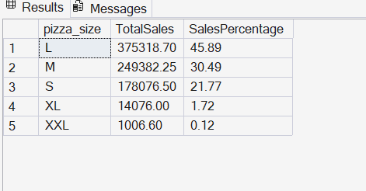

F. Total Pizzas Sold by Pizza Category :

SELECT
pizza_category,
SUM(quantity) AS TotalPizzasSold
FROM pizza_sales
GROUP BY pizza_category
ORDER BY TotalPizzasSold DESC

Output:
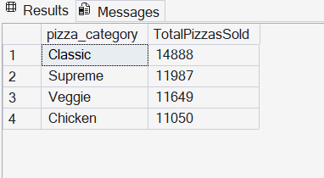

G. Top 5 Best Sellers by Total Pizzas Sold :
SELECT TOP 5
pizza_name,
SUM(quantity) AS TotalPizzasSold
FROM pizza_sales
GROUP BY pizza_name
ORDER BY TotalPizzasSold DESC ;

Output:
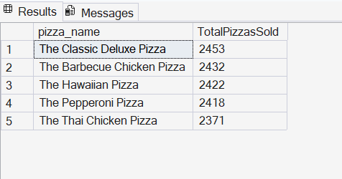

H. Bottom 5 Best Sellers by Total Pizzas Sold :

SELECT TOP 5
pizza_name,
SUM(quantity) AS TotalPizzasSold
FROM pizza_sales
GROUP BY pizza_name
ORDER BY TotalPizzasSold ASC ;

Output:

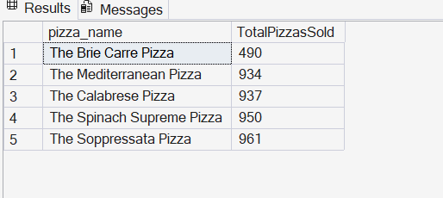

NOTE :
If you want to apply the Month, Quarter, Week filters to the above queries you can use the WHERE clause.
Follow some of below examples :
SELECT
DATENAME(DW, order_date) AS OrderDay,
COUNT(DISTINCT order_id) AS TotalOrders
FROM pizza_sales
WHERE MONTH(order_date) = 1
GROUP BY DATENAME(DW, order_date)

*Here MONTH(order_date) = 1 indicates that the output is for the month of January. MONTH(order_date) = 4 indicates output for the Month of April.

SELECT
DATENAME(DW, order_date) AS OrderDay,
COUNT(DISTINCT order_id) AS TotalOrders
FROM pizza_sales
WHERE DATEPART(QUARTER, order_date) = 1
GROUP BY DATENAME(DW, order_date)

*Here DATEPART(QUARTER, order_date) = 1 indicates that the output is for the Quarter 1
DATEPART(QUARTER, order_date) = 3 means that the output is for the Quarter 3

