**CMSC203 Assignment 0**

Class: CMSC203 CRN XXXX

Program: Assignment 0

Instructor: Alla Web

Summary of Description: Introduction assignment; installation and setup.

Due Date: 06/02/2025

Integrity Pledge: I pledge that I have completed the programming assignment independently.

I have not copied the code from a student or any source.

**Complete the following five parts of Assignment 0. Name your file as FirstInitialLastName_Assignment0.docx**

**Part1: Setup GitHub:** Provide the screen shots of your GitHub account with Assignment 0 file is uploaded on GitHub:

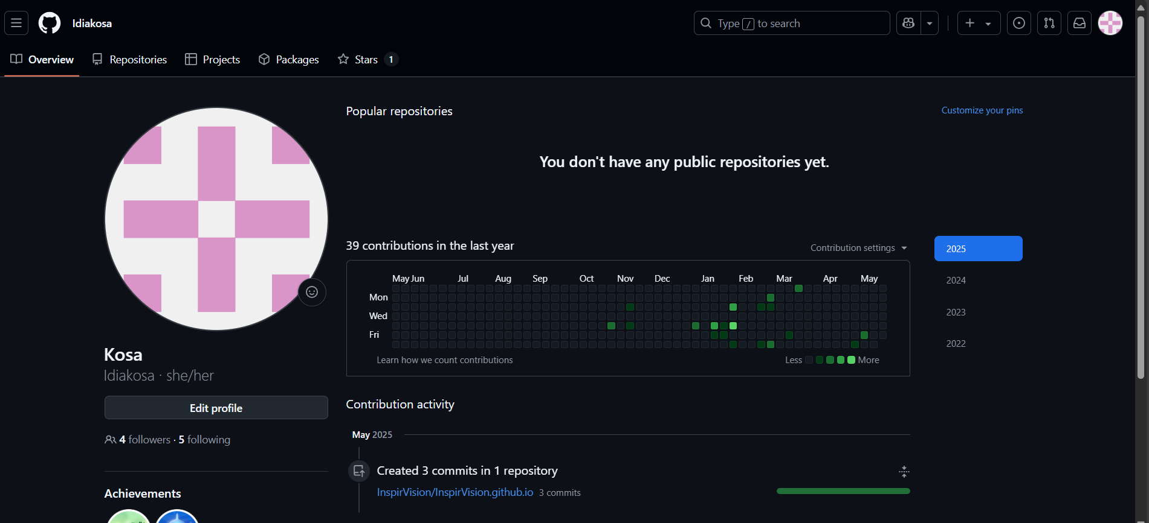

## 

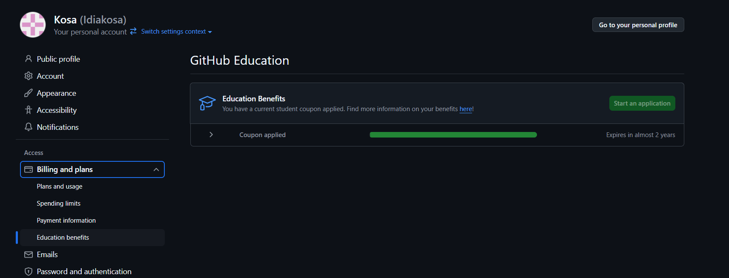

**(assignment 0 file uploaded upon completion)^**

**Part 2 -Install JDK, Test java Application from Command Line**

Provide the screen shots from Step 1 and 2 here:

## 

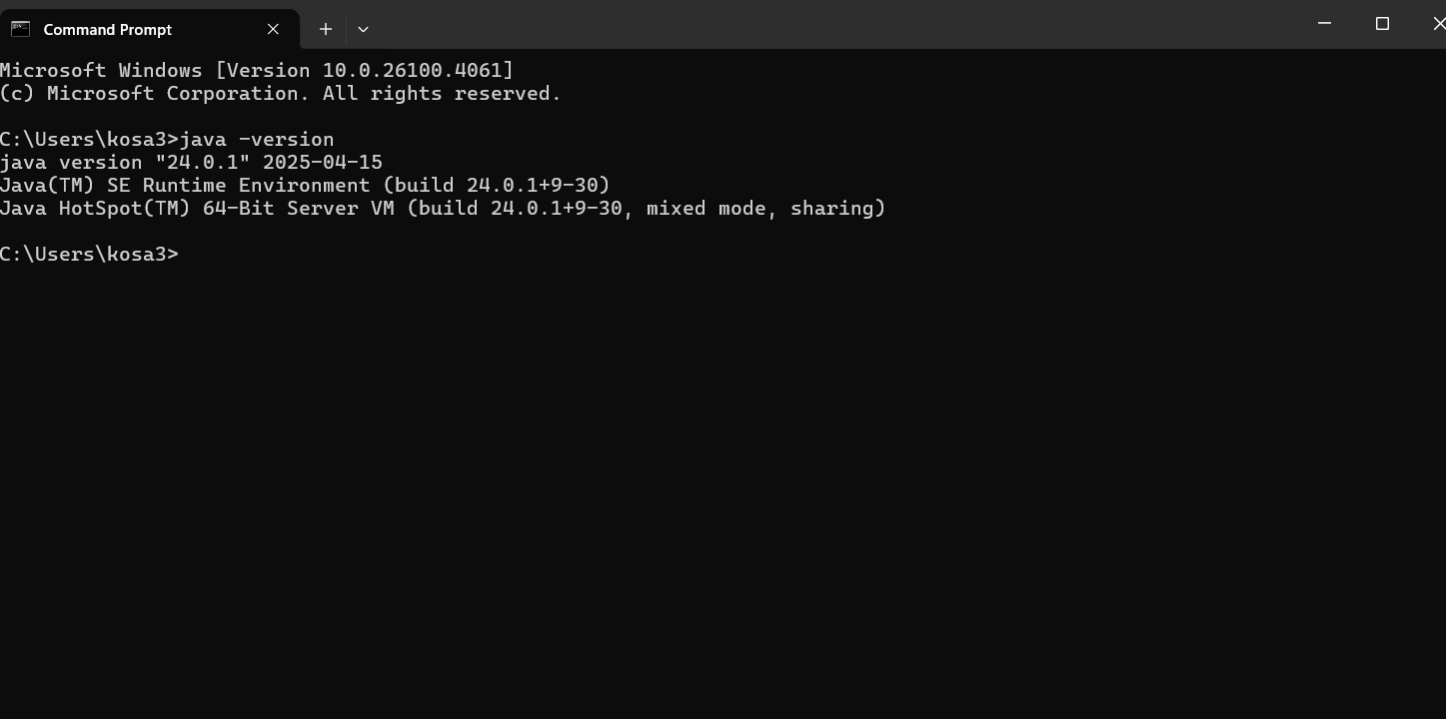

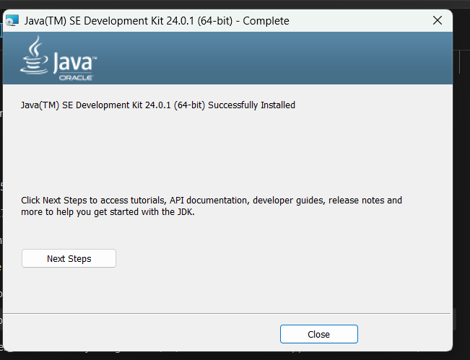

**Part 3 - Install Eclipse, Test Eclipse Java Application**

Provide the screen shots from Step 1 and 2 here:

## 

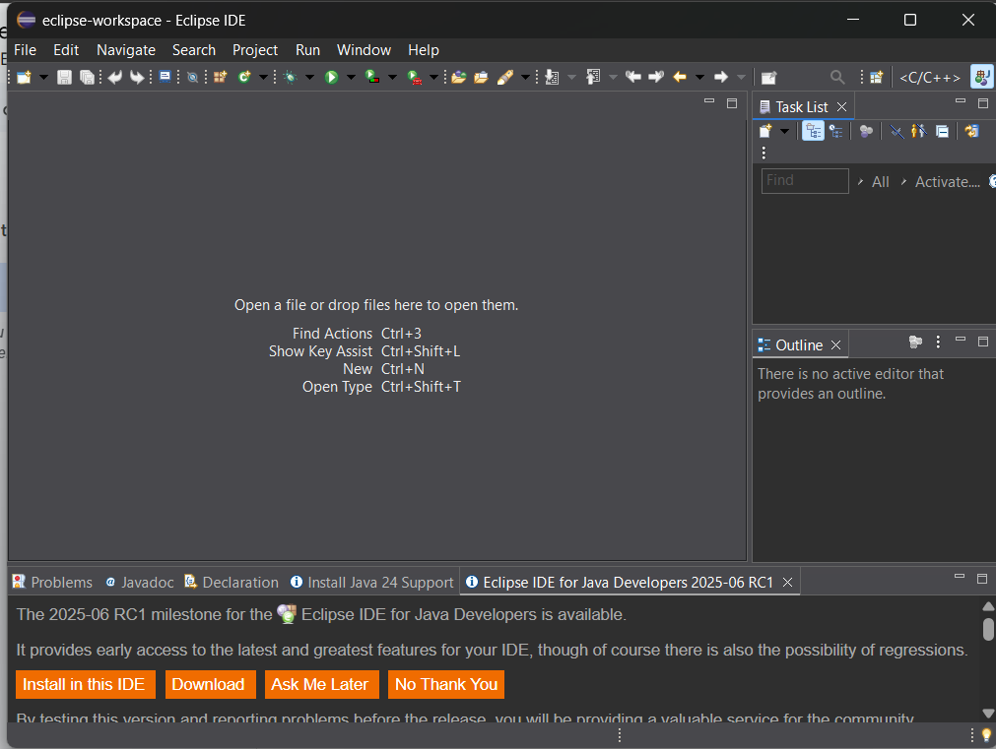

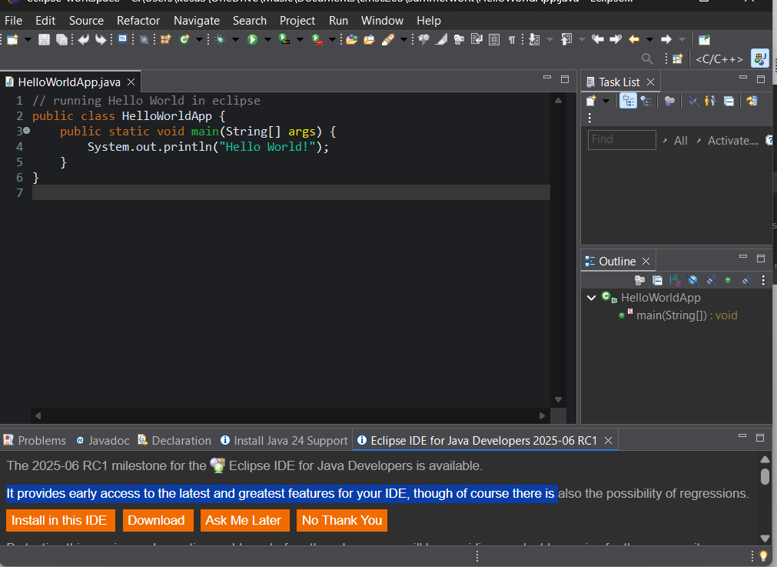

**Part 4 - Install, Setup, Test Junit Program.**

Provide the screen shots showing:

a. Eclipse with working JUnit Test example

b. Project screenshot

c. Running example screenshot

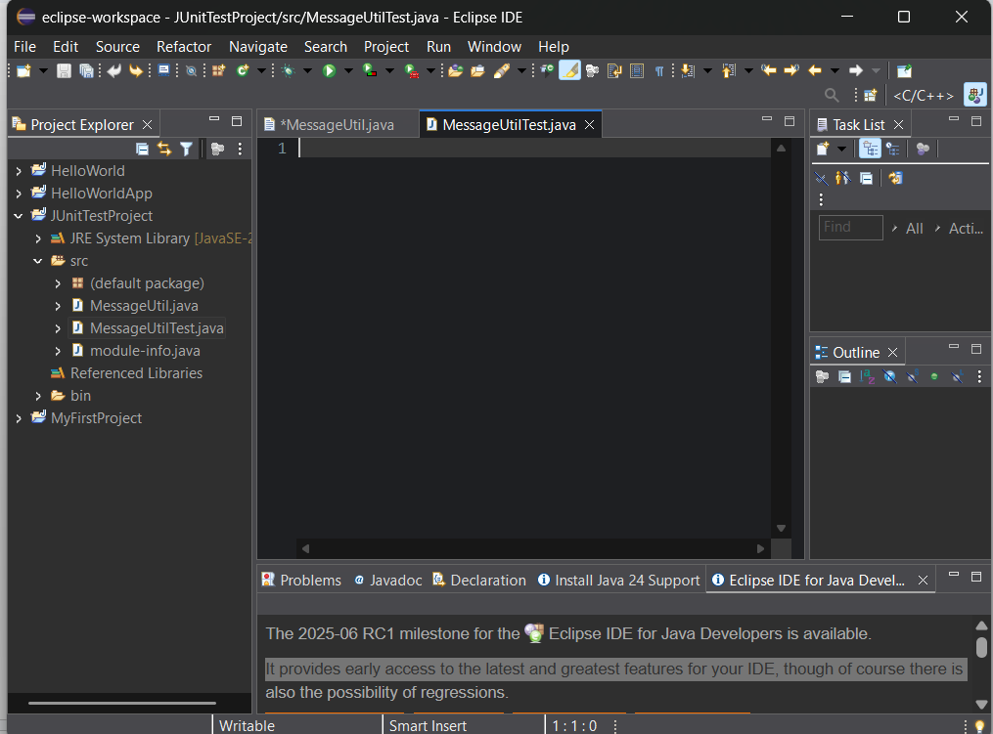

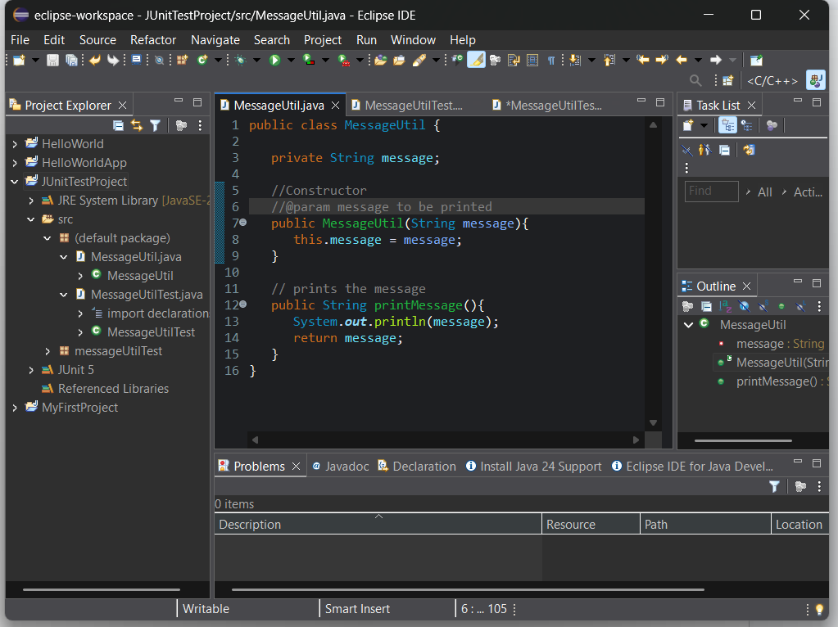

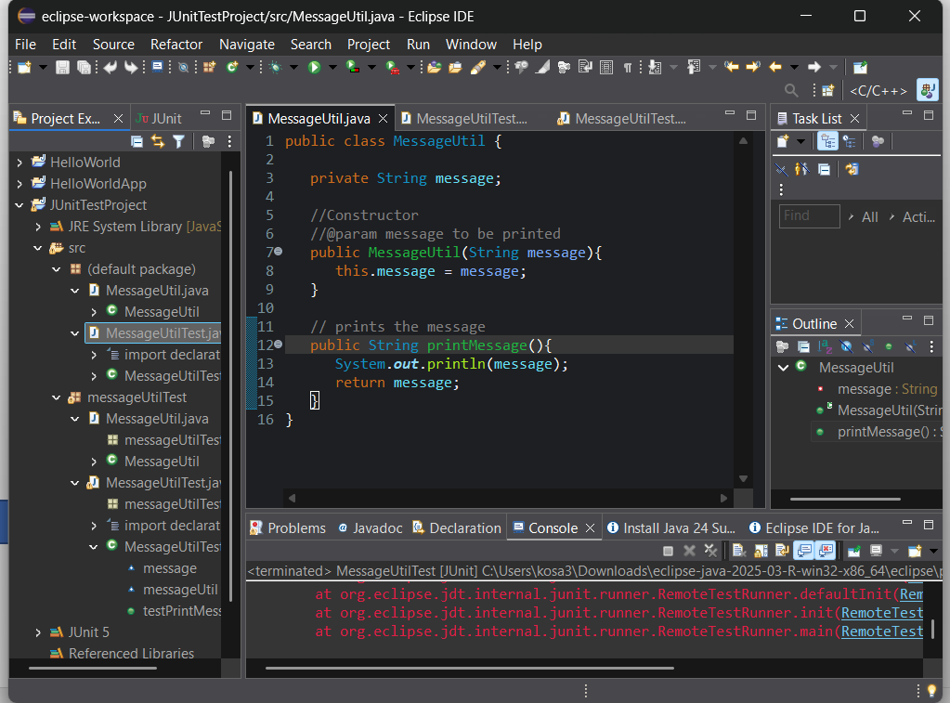

**Part 5 - Install, Setup, and Test JavaFX Application.**

Provide the screen shots showing:

a. JavaFX Project screenshot

b. Running example screenshot

c. Java Source Code File

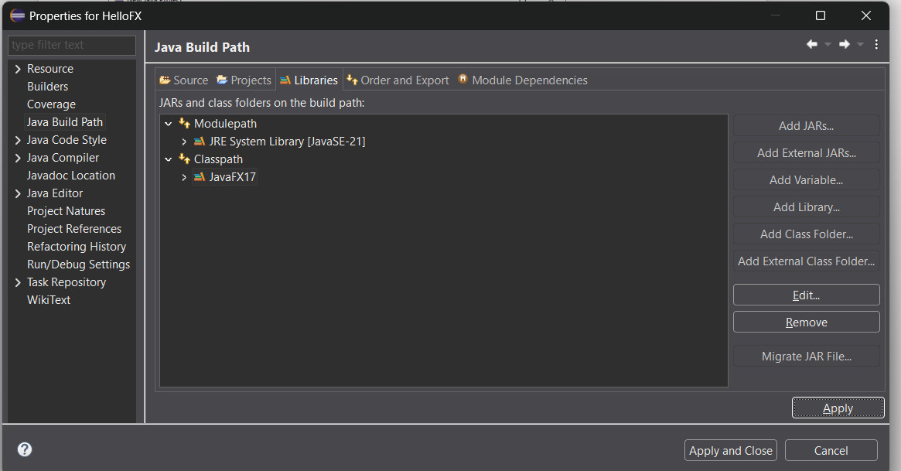

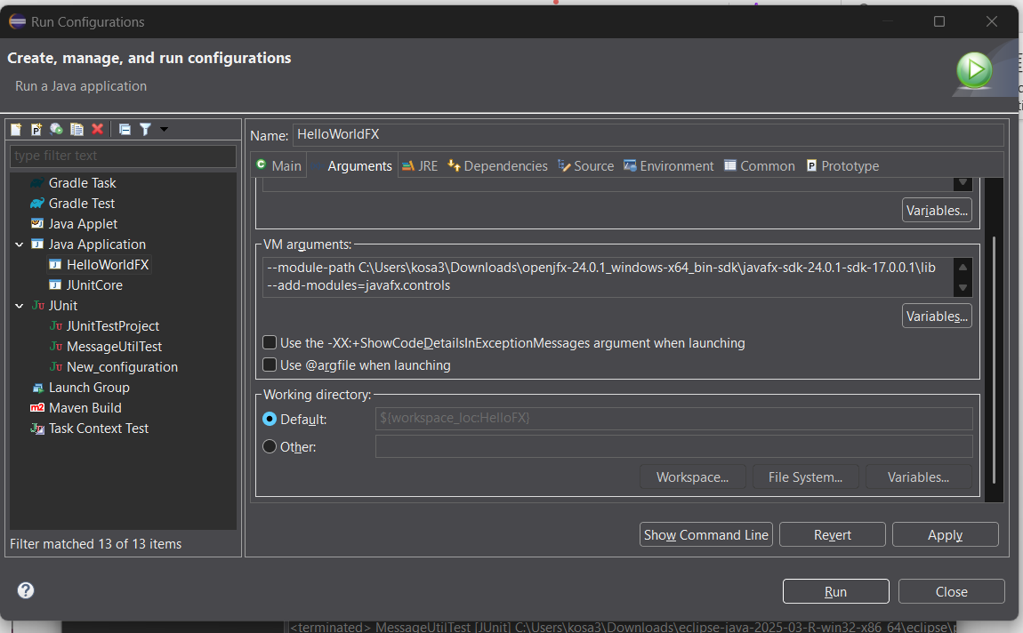

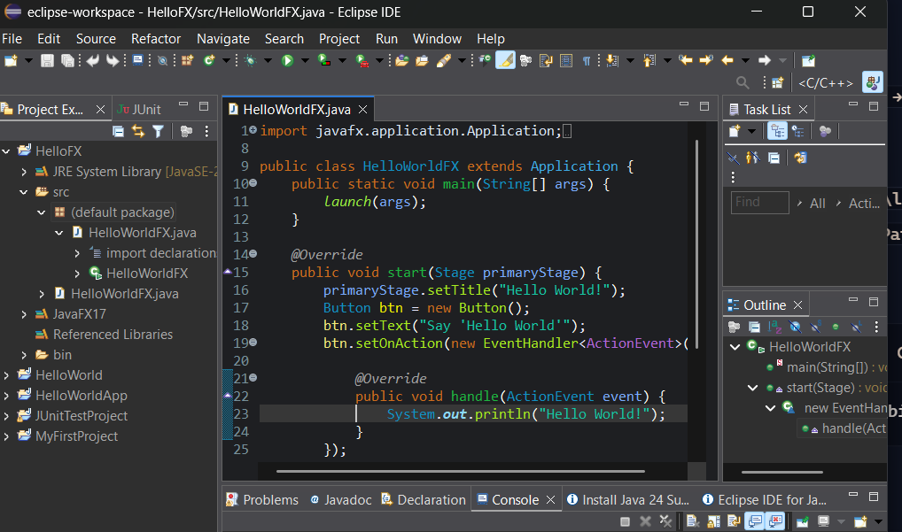

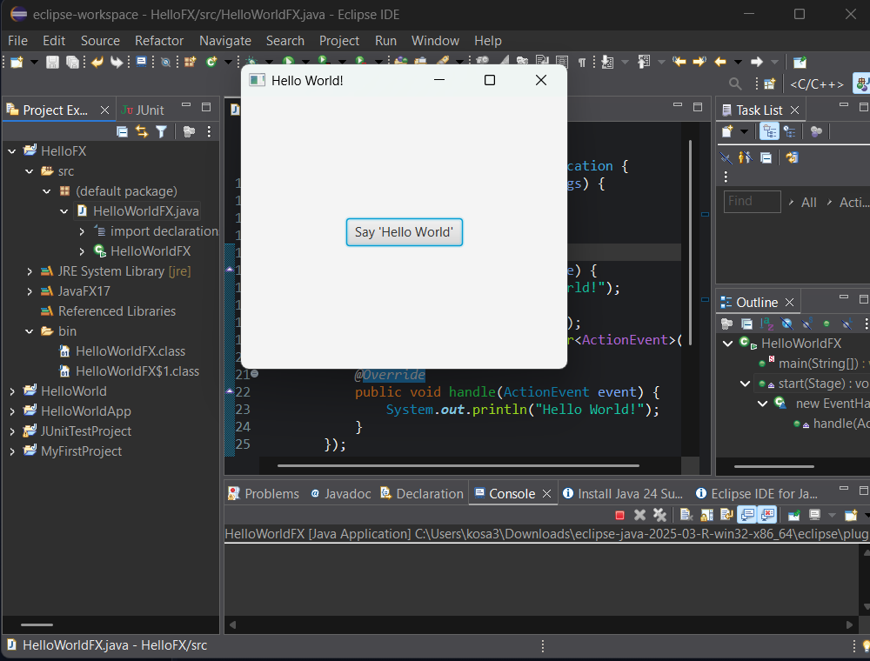

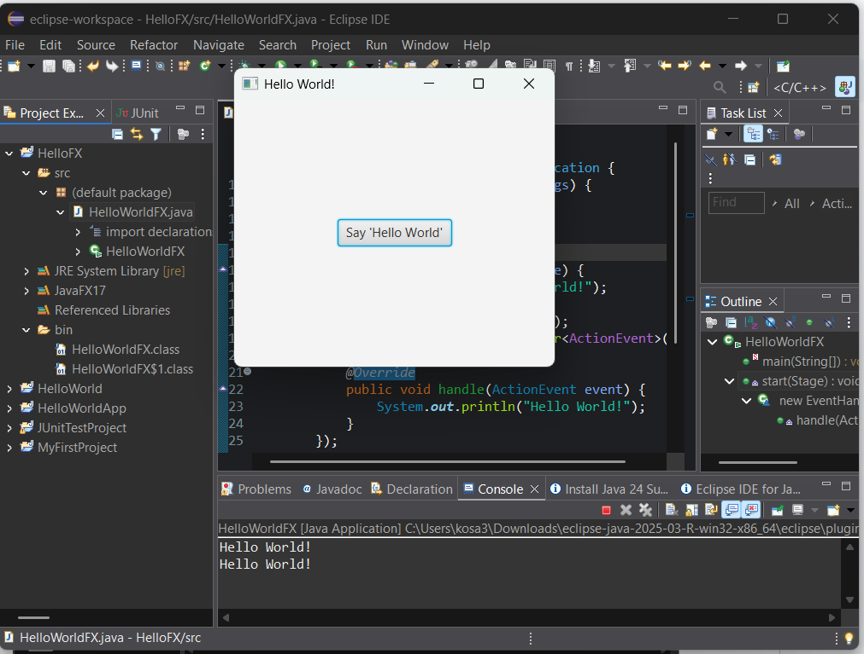

**Lessons Learned** <Provide answers to the questions listed below>**:**

Write about your Learning Experience, highlighting your lessons learned and learning experience from working on this assignment.

What have you learned?

* I learned how to better use Eclipse for different Java versions and JUtils. I feel like I learned how the eclipse ide works better and I can get more accustomed to it.

What did you struggle with?

I struggled with installing the right jdk because I originally completed assignment 1 before week 0 was posted and it said to install the most current version of java for setup so I had jdk 24 set up on my computer and when I needed JavaFX17 for the second section, I spent an hour or two completing all the setup with the wrong java version so when I tried to run I was met with errors. I eventually figured it out and installed and setup the correct version.

What parts of this assignment were you successful with, and what parts (if any) were you not successful with?

I was successful with the eclipse installation and setup, and I successfully completed all parts of it although I have a question regarding retrieving the source files after saving them. For me, it’s really hard to find them in file explorer despite it saying it will save ein a folder I just can’t seem to find the source codes.

Provide any additional resources/links/videos you used to while working on this assignment.

**Check List:** <Provide answers to the column Y/N or N/A >**:**

| **#** |  | **Y/N** | **Comments** |
| --- | --- | --- | --- |
| 1. | **Assignment files:** |  |  |
|  | · FirstInitialLastName_Assignment0.docx/pdf | **Yes** |  |
|  | · Source java files | **Yes** |  |
| 2. | **Program compiles** | **Yes** |  |
| 3. | **Program runs with desired outputs related to a Test Plan** | **Yes** |  |
| 4. | **Documentation file: Screenshots of** |  |  |
|  | · Part1: Setup GitHub | **Yes** |  |
|  | · Part 2 -Install JDK, Test java Application from Command Line | **Yes** |  |
|  | · Part 3 - Install Eclipse, Test Eclipse Java Application | **Yes** |  |
|  | · Part 4 - Install, Setup, Test Junit Program | **Yes** |  |
|  | · Part 5 - Install, Setup, and Test JavaFX Application. | **Yes** |  |
|  | · Lessons Learned | **Yes** |  |
|  | · Checklist is completed and included in the Documentation | **Yes** |  |