JF04-1 to JFo4-5

JFo4-1:

Exercise 1, Part 1:

N/A

Exercise 1, Part 2:

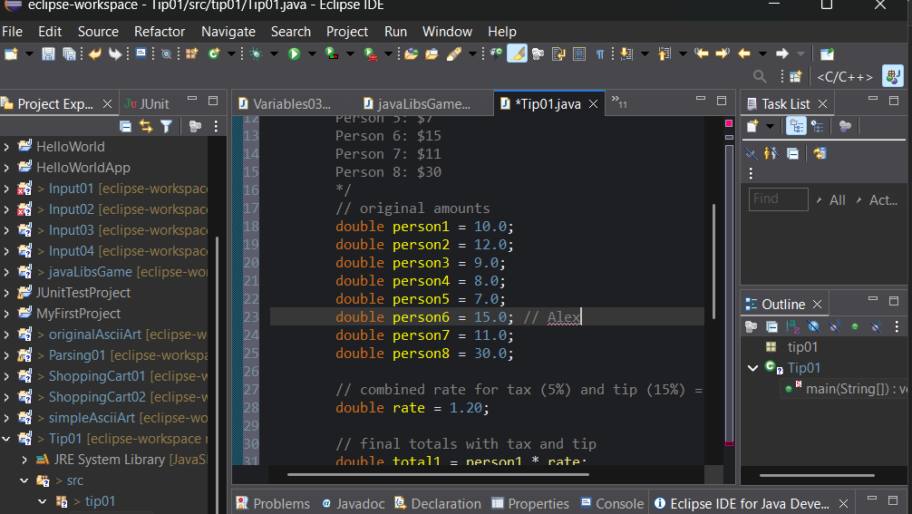

Exercise 1, Part 3:

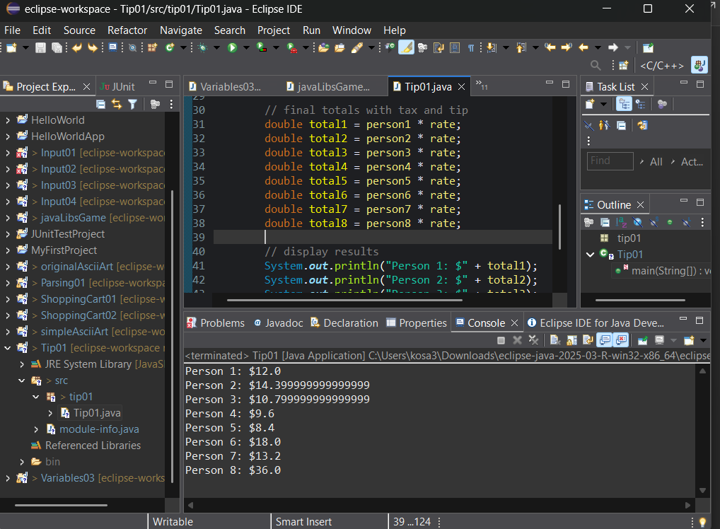

Exercise 2, Part 1

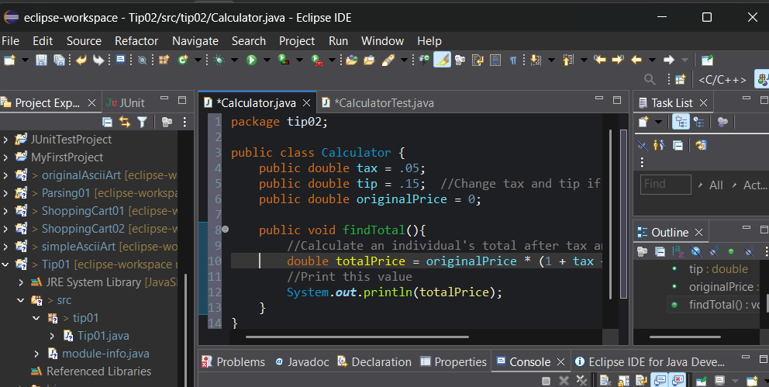

Exercise 2, Part 2:

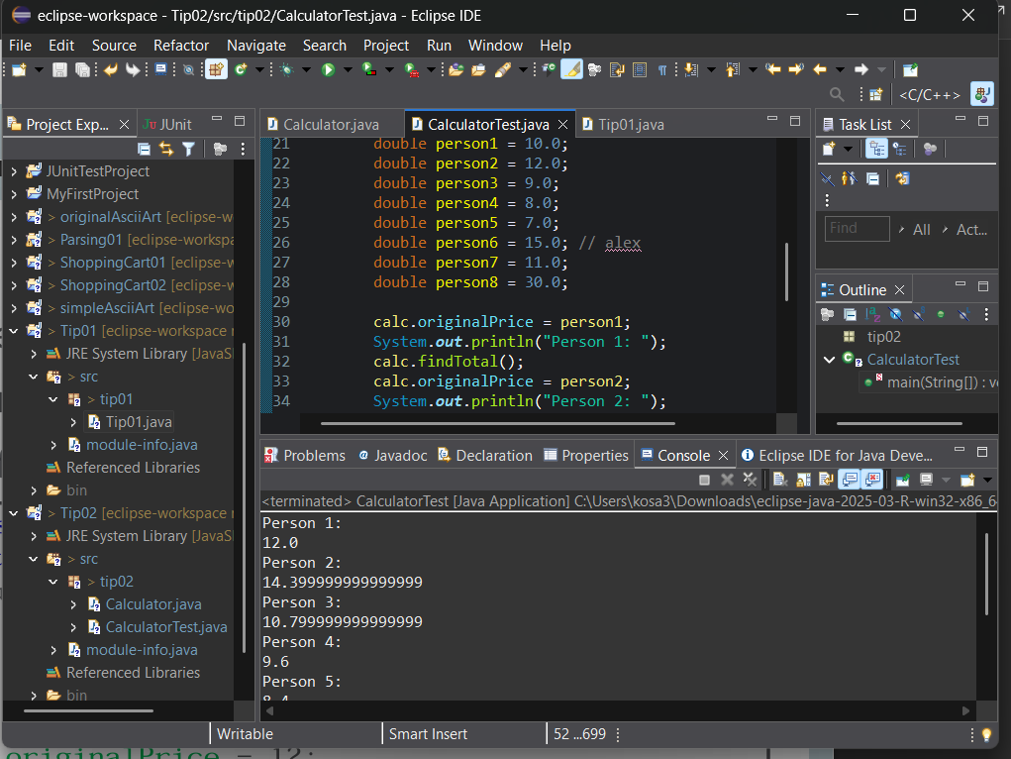

Exercise 3, Part 1:

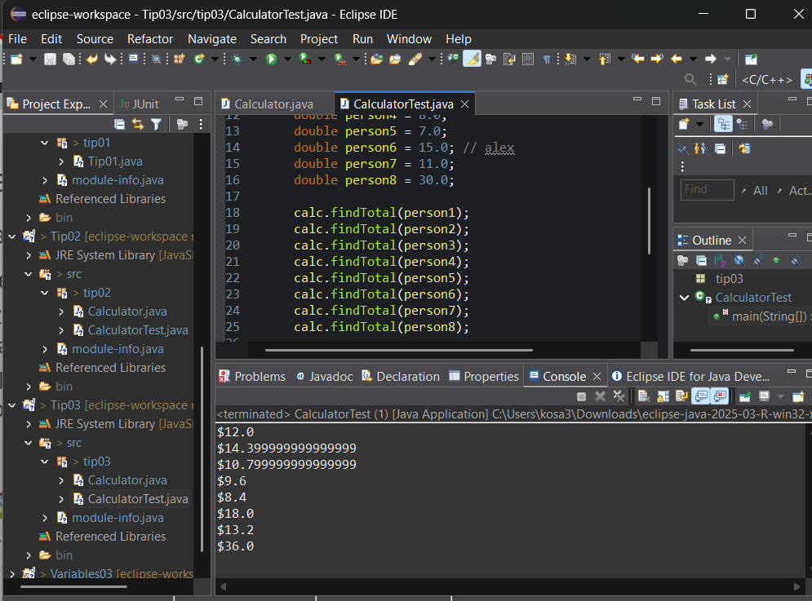

Exercise 3, Part 2:

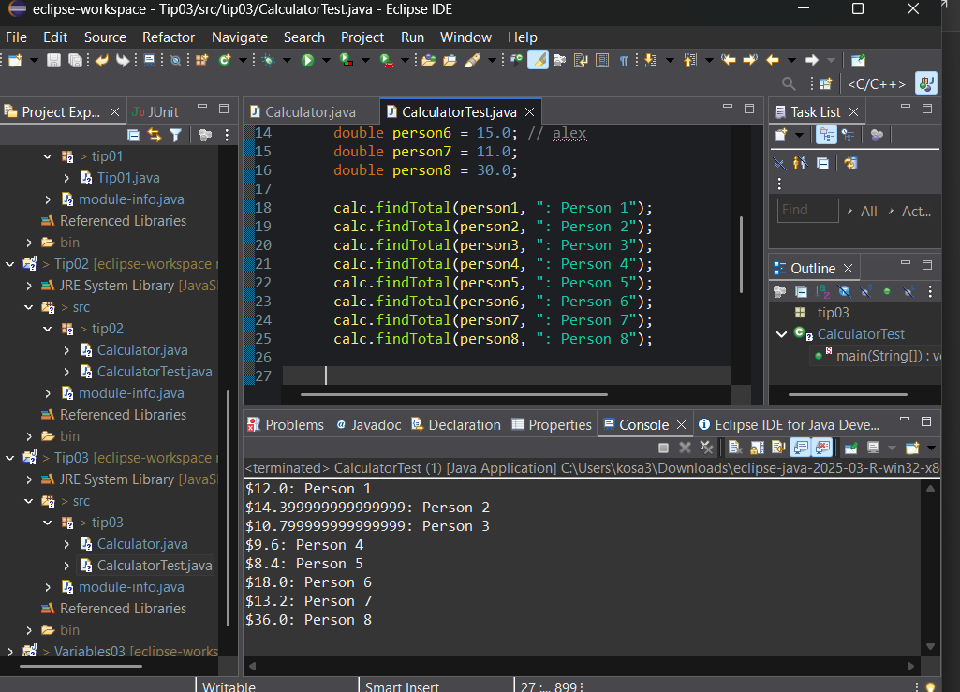

Exercise 4, Part 1:

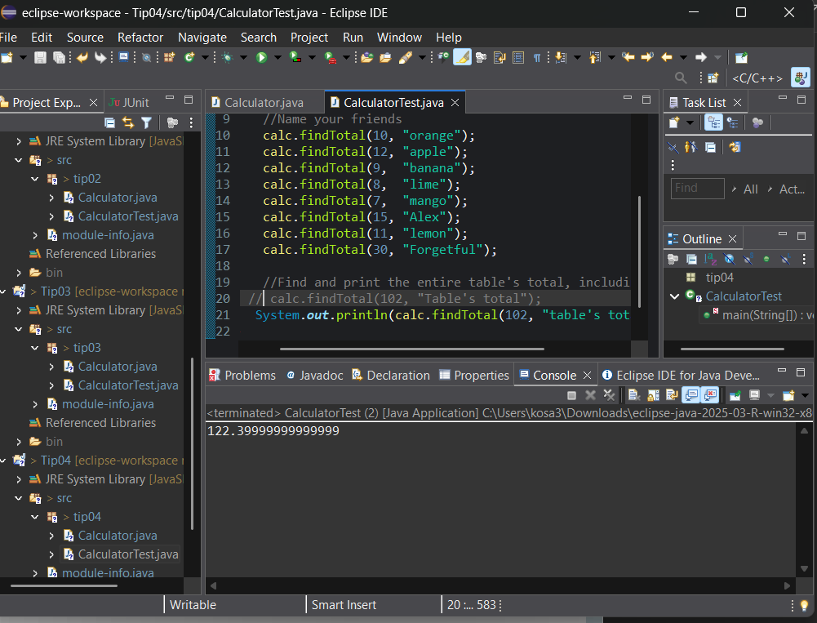

Exercise 4, Part 2:

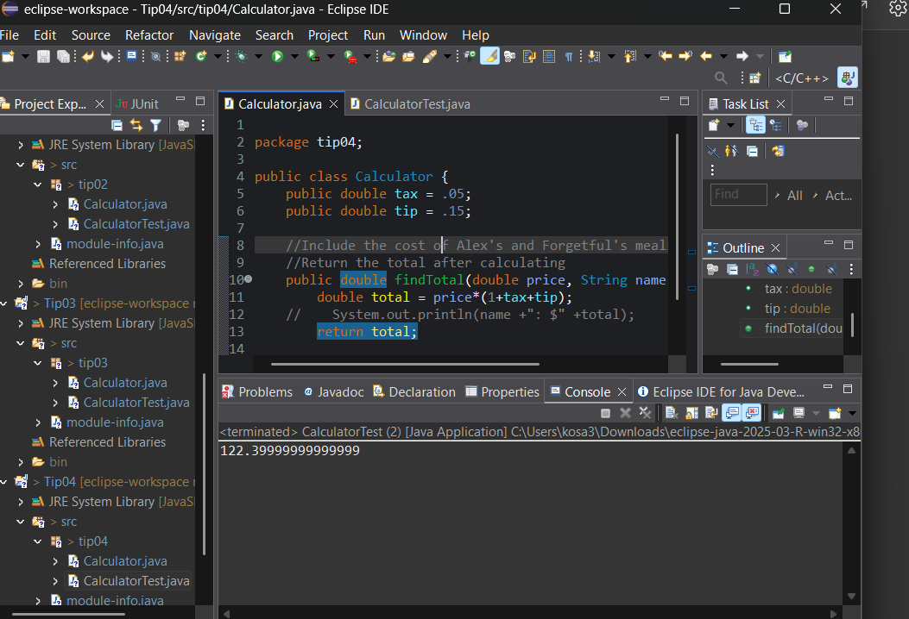

JFo4-2:

Exercise 1:

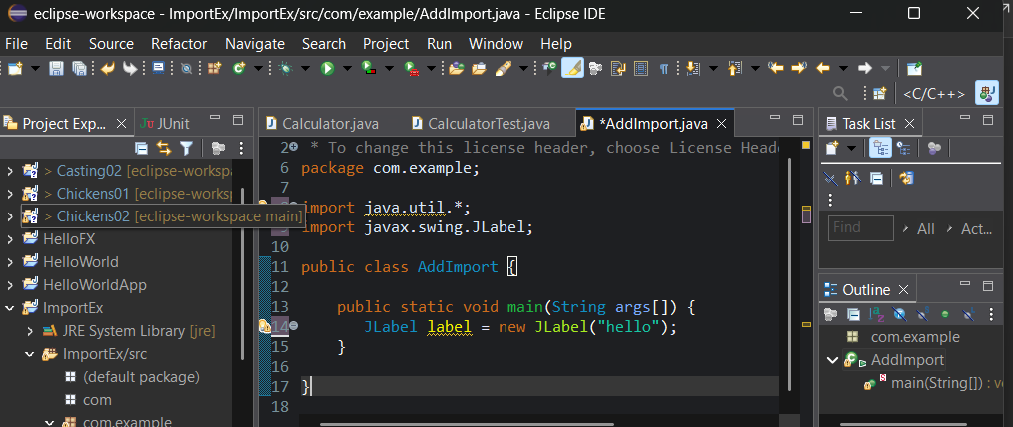

JFo4-3:

Exercise 1, Part 1:

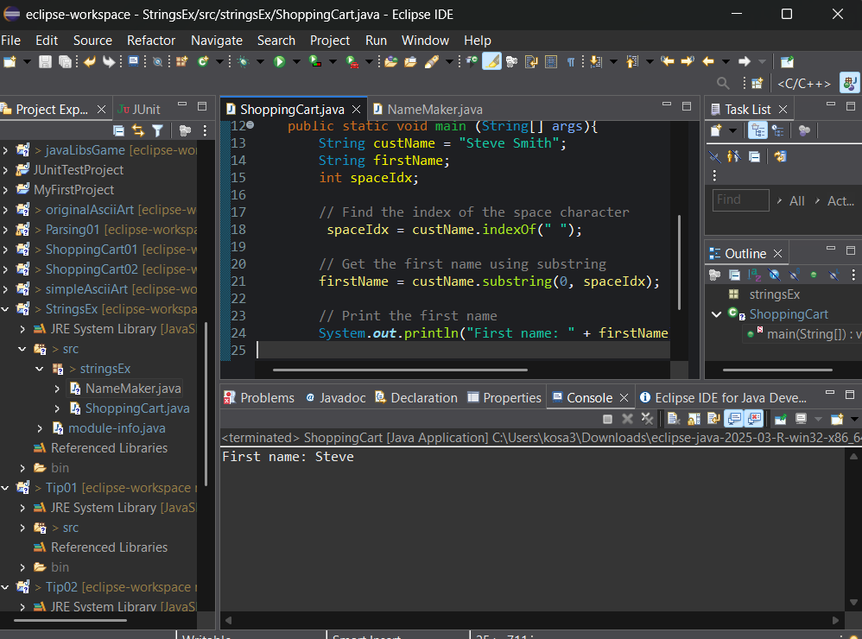

Exercise 1, Part 2:

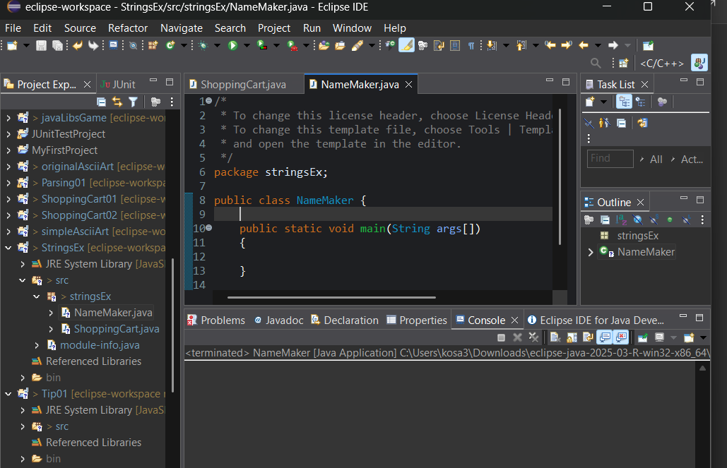

Exercise 2:

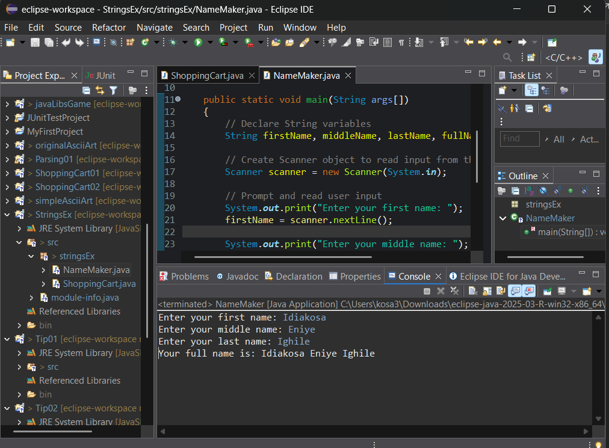

I think the string concat operator is preferable for this scenario just because it's much easier to write.

JFo4-4:

Exercise 1:

\*Heads

Heads

Tails

Tails\*

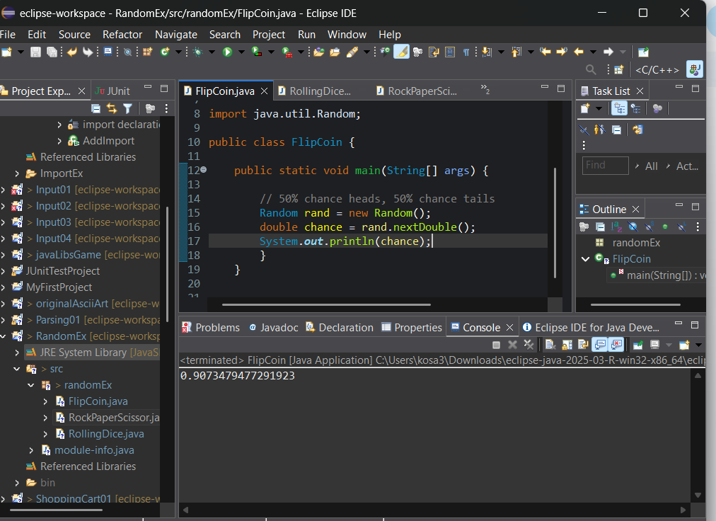

Exercise 2:

\*Rock

Rock

Scissors

Rock

Paper

scissors\*

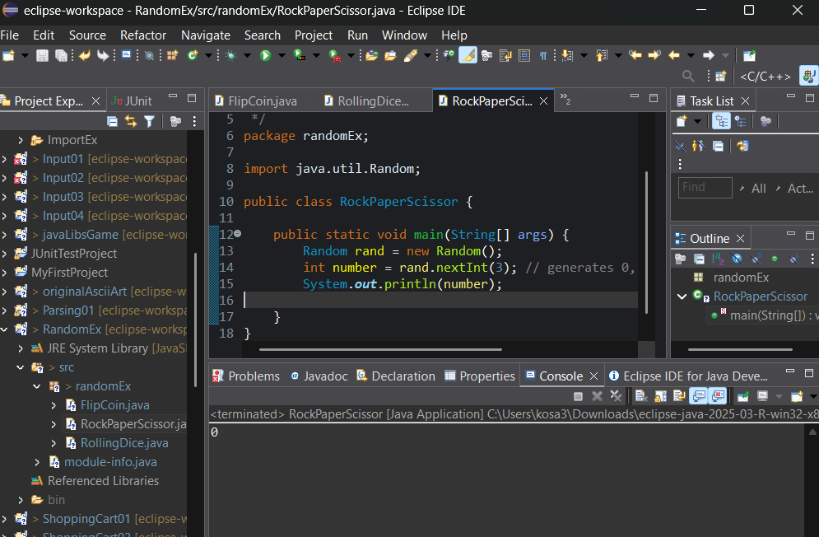

JFo4-5:

Exercise 1:

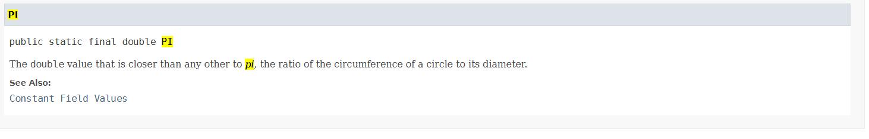

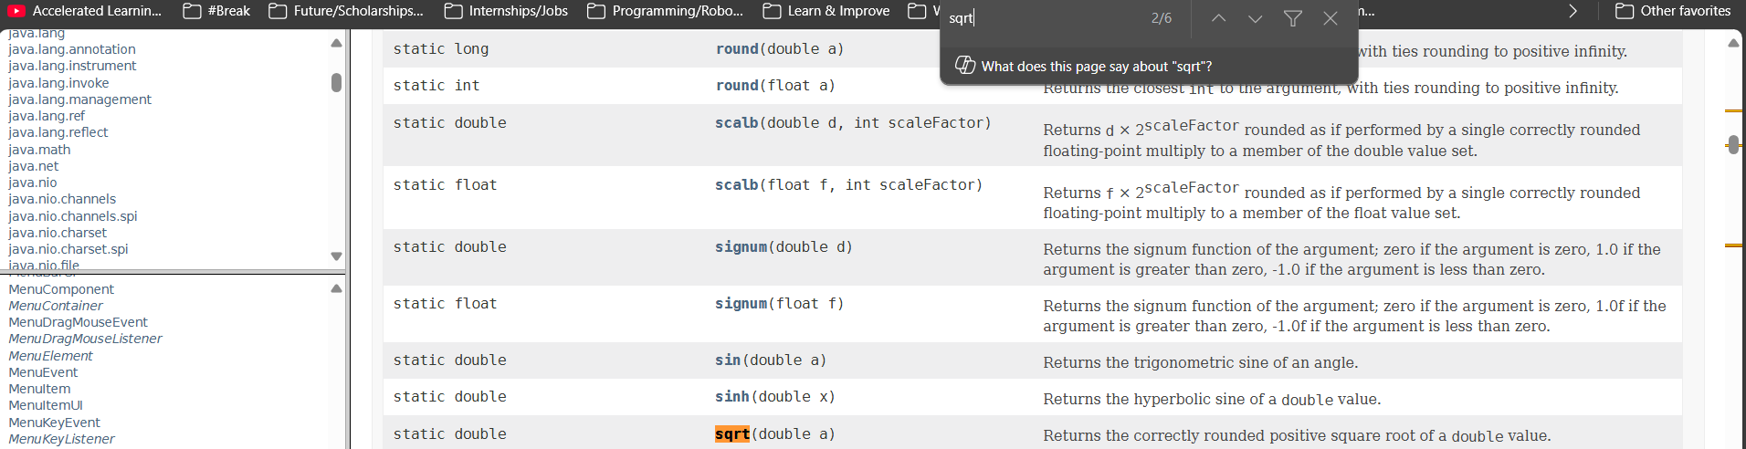

Exercise 2:

Results - 1.23, 9.0, -5, 5

Exercise 3:

What expression would replace negative ages with 0?

int age = Math.max(age, 0);

What expression would limit the maximum age to 40

int age = Math.min(age, 40);

Exercise 4:

