JFo7-1 to JFo7-6

JFo7-1:

Exercise 1:

N/A

Exercise 2:

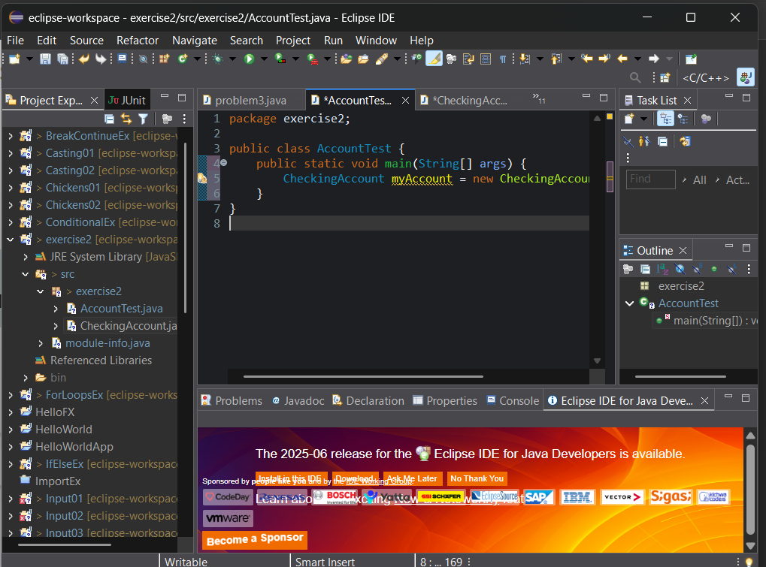

Exercise 3:

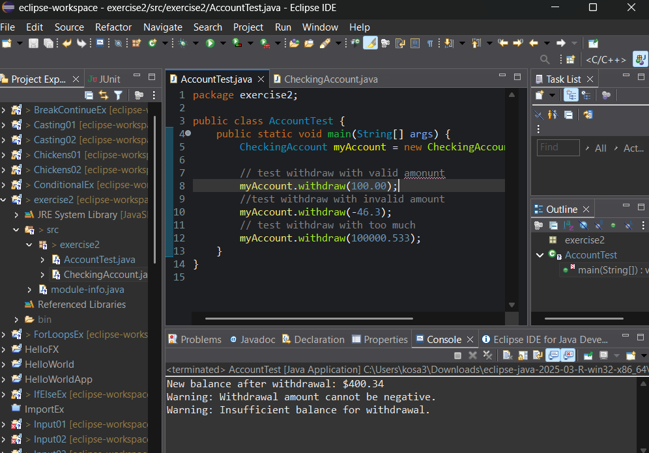

Exercise 4:

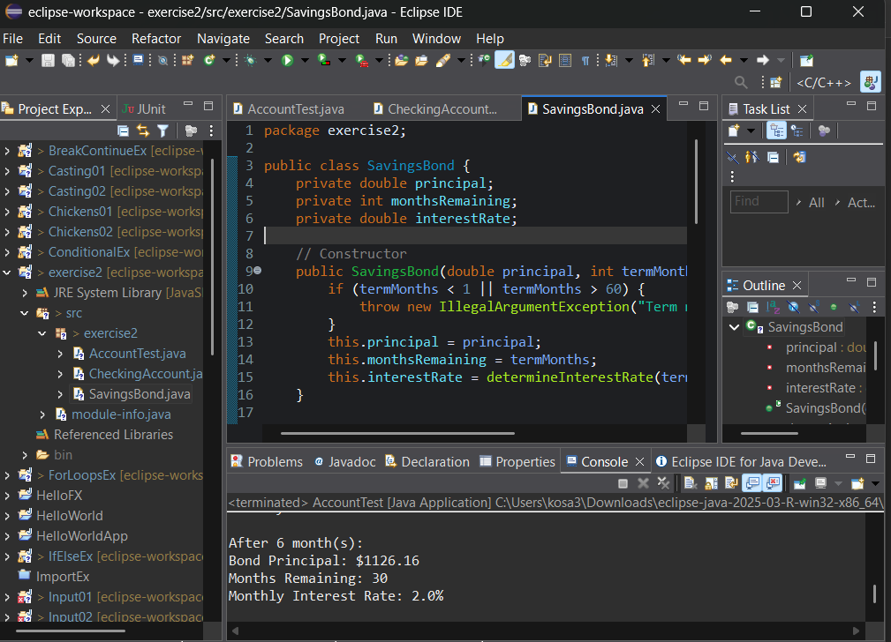

JFo7-2:

Exercise 1, Part 1:

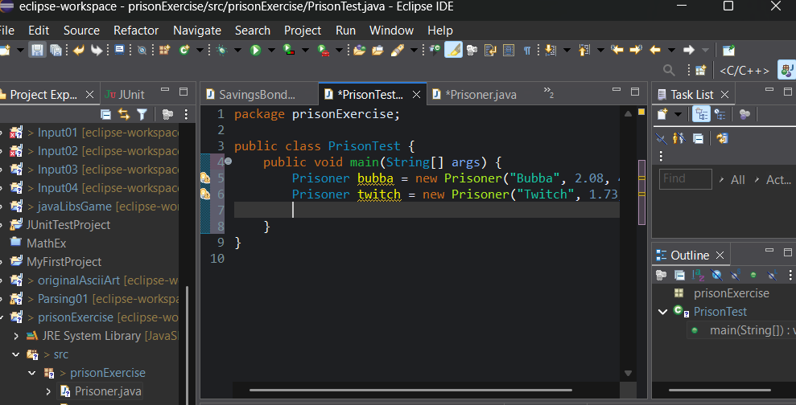

Exercise 1, Part 2:

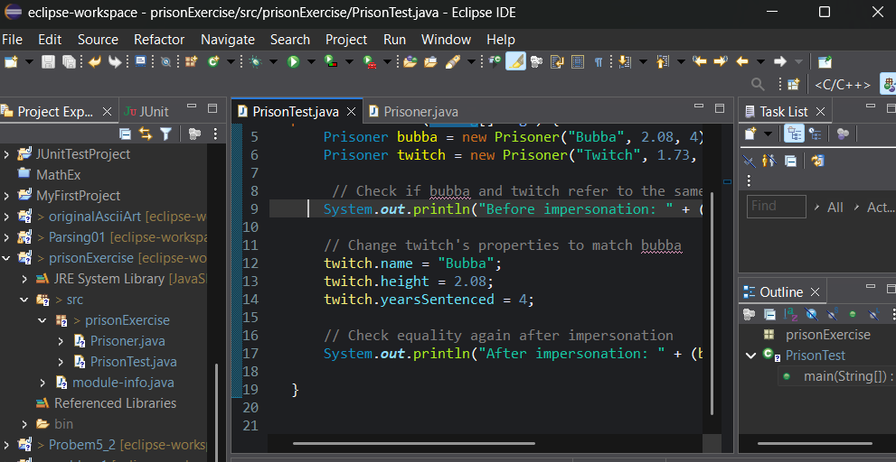

Exercise 2:

fooled

Exercise 3:

N/A

JFo7-3:

Exercise 1:

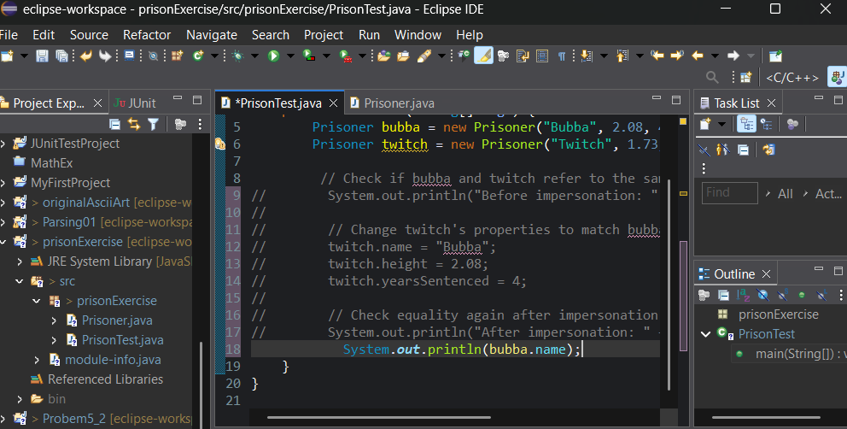

Exercise 2:

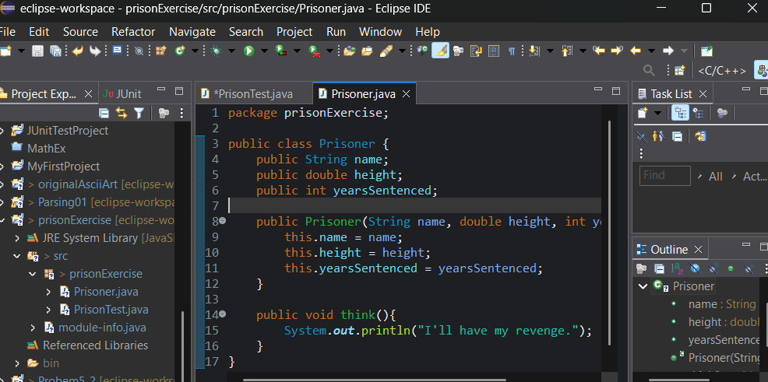

Exercise 3, Part 1:

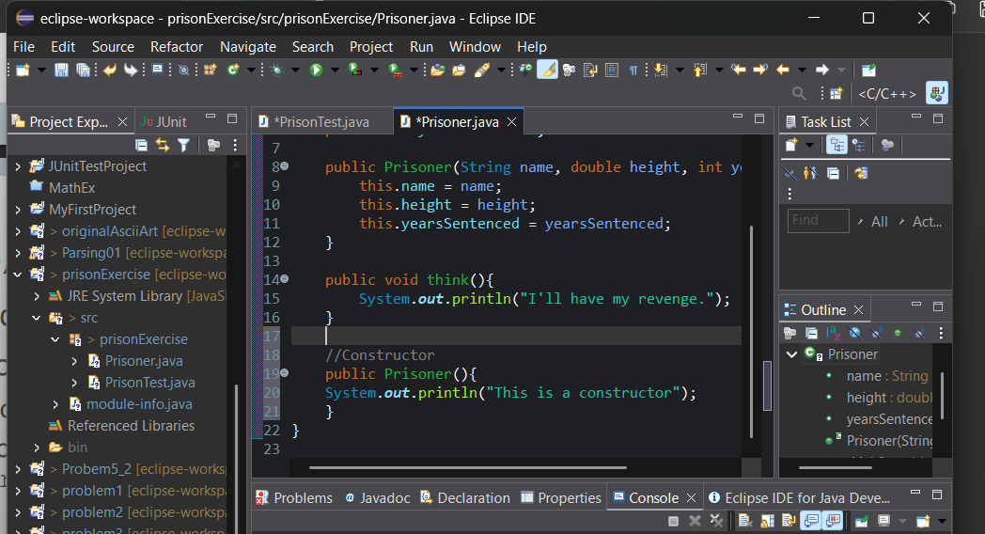

Exercise 3, Part 2:

Add in the parameters so it takes in the values for the name, height, yearsSentenced

Exercise 4:

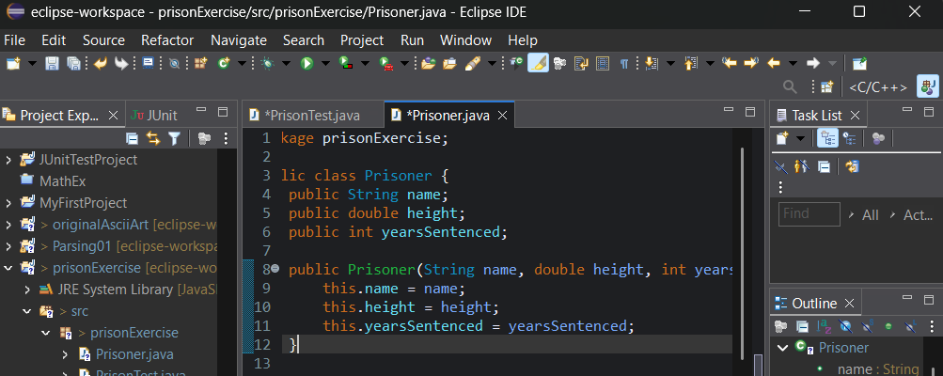

JFo7-4:

Exercise 1:

N/A

Exercise 2:

N/A

Exercise 3:

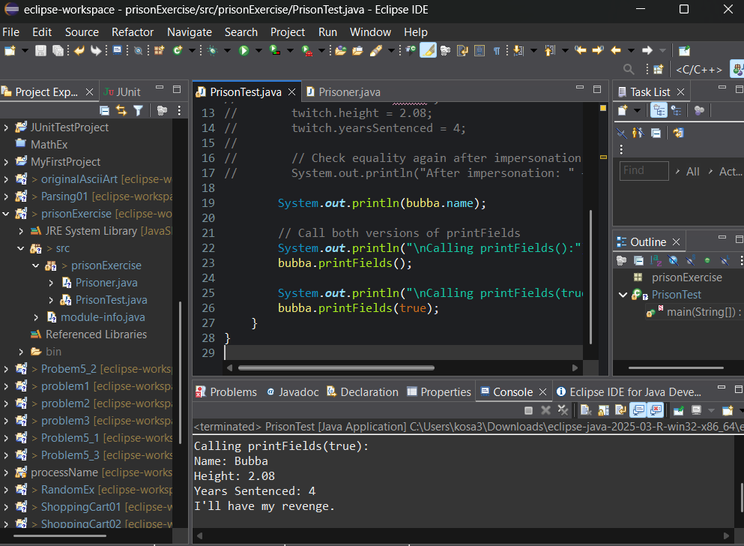

Exercise 4:

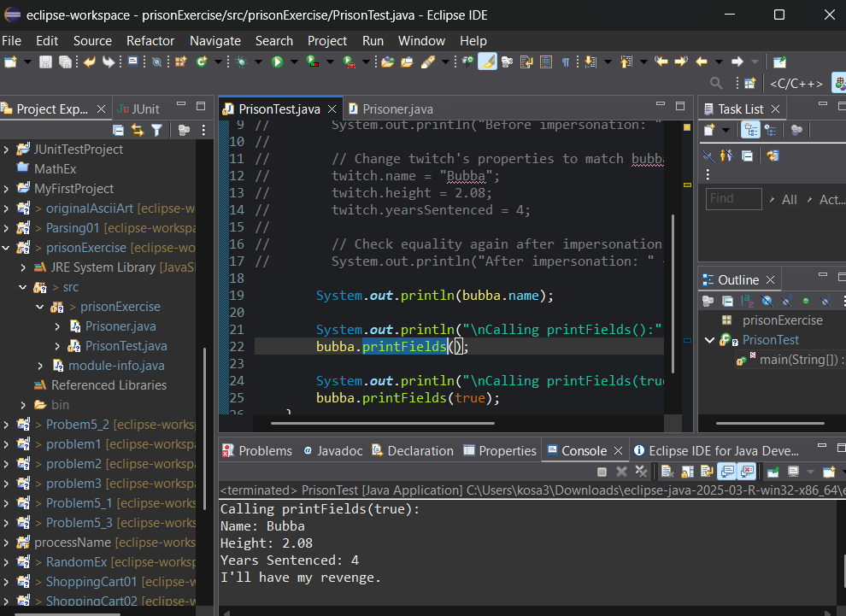

JFo7-5:

Exercise 1, Part 1:

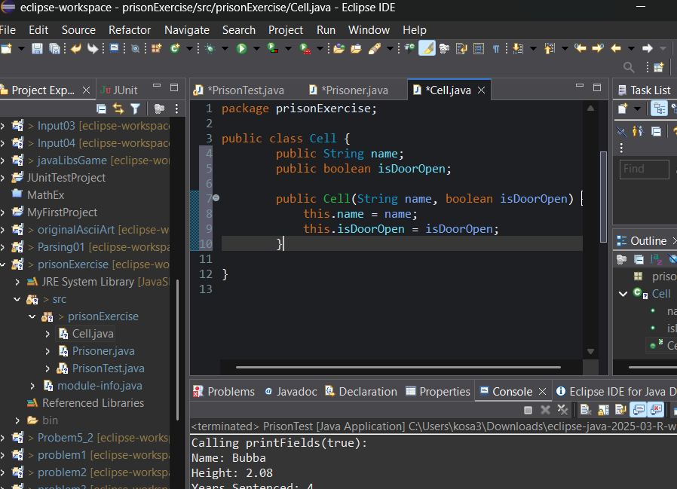

Exercise 1, Part 2:

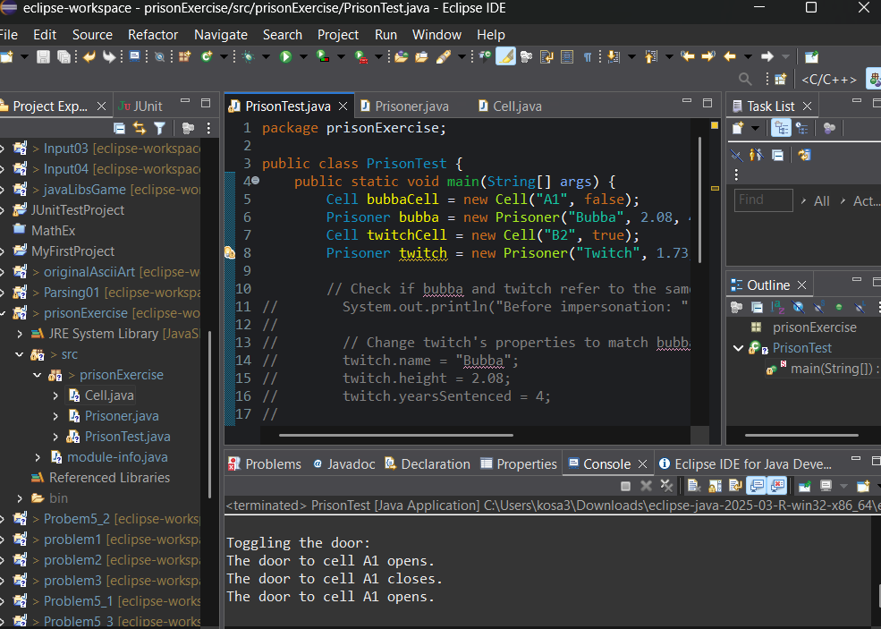

Exercise 2:

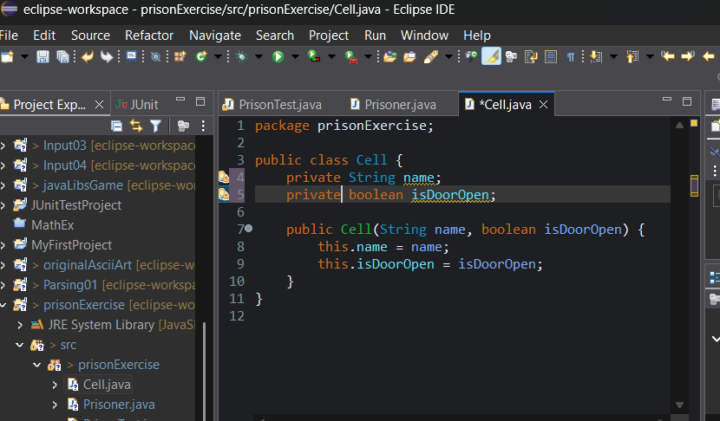

Exercise 3, Part 1:

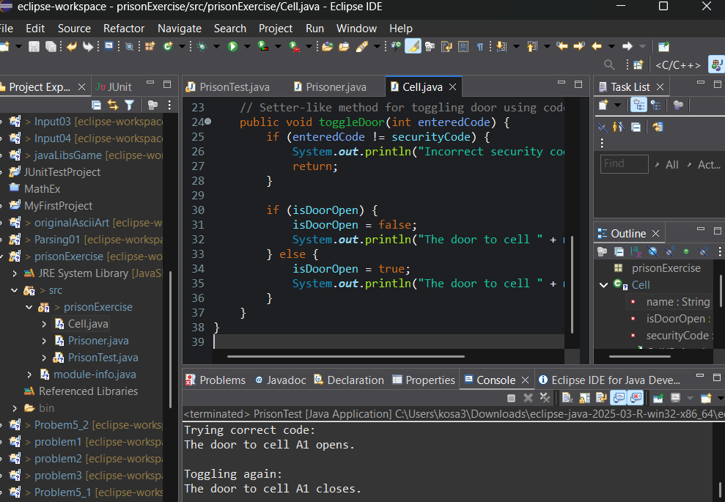

Exercise 3, Part 2:

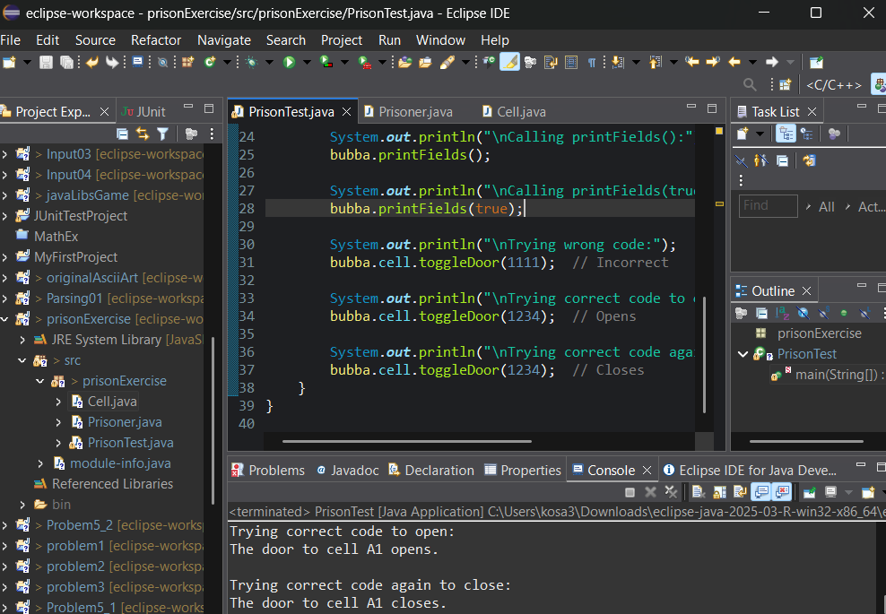

Exercise 4:

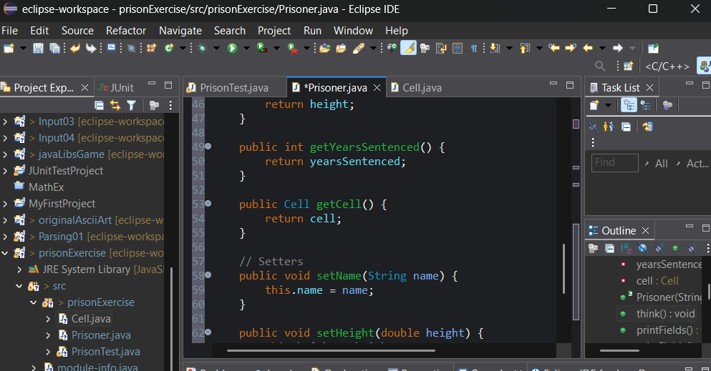

JFo7-6:

Exercise 1:

N/A

Exercise 2:

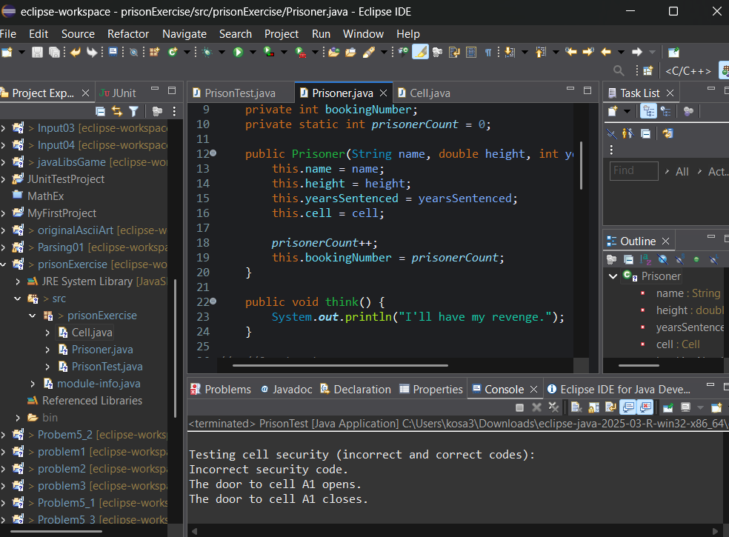

Exercise 3:

