JFo8-1 to JFo8-4

JFo8-1:

Exercise 1:

* Identify data type, name and size

int[] myArray; → data type is int, name is myArray and size is undefined

myArray = new int[20]; → data type is int, name is myArray and size is 20

char[] sentence = new char[100]; → data type is char, name is sentence and size is 100

double[] teamPoints = new double[5]; → data type is double, name is teamPoints and size is 5

Exercise 2:

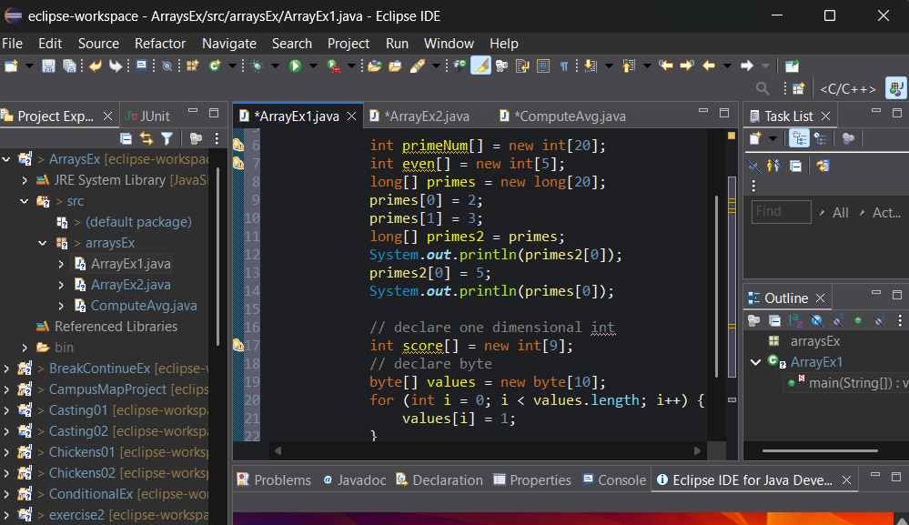

Exercise 3:

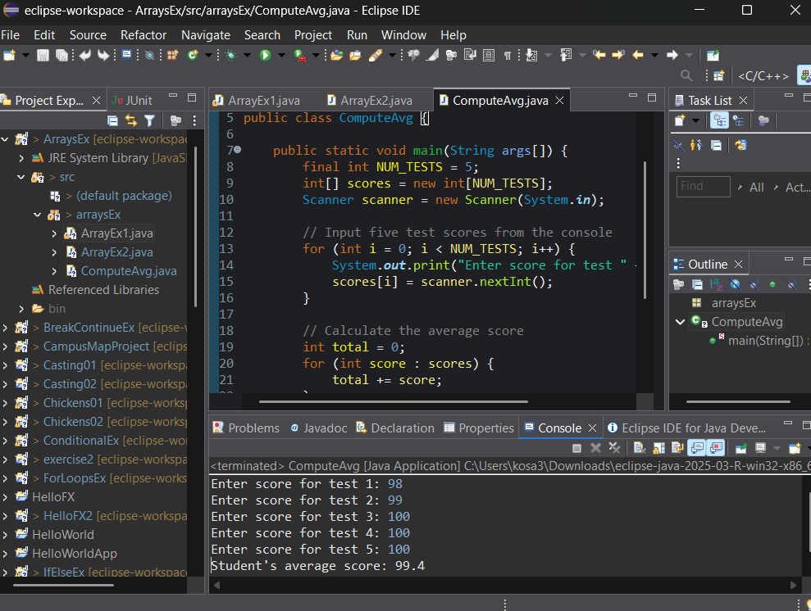

Exercise 4:

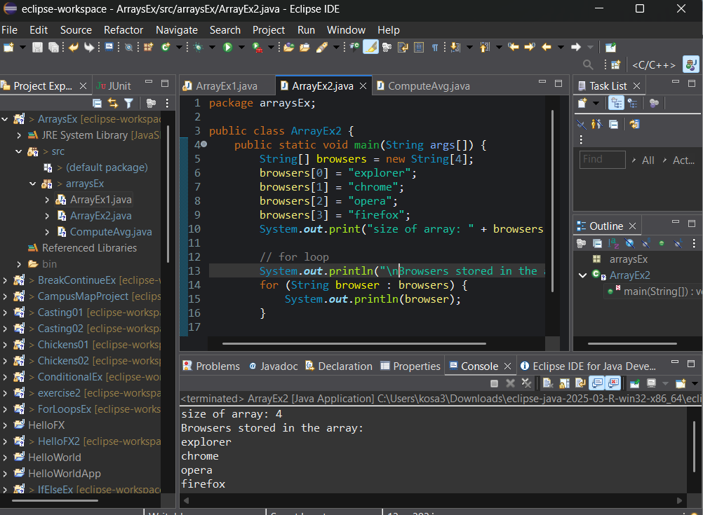

JFo8-2:

Exercise 1, Part 1:

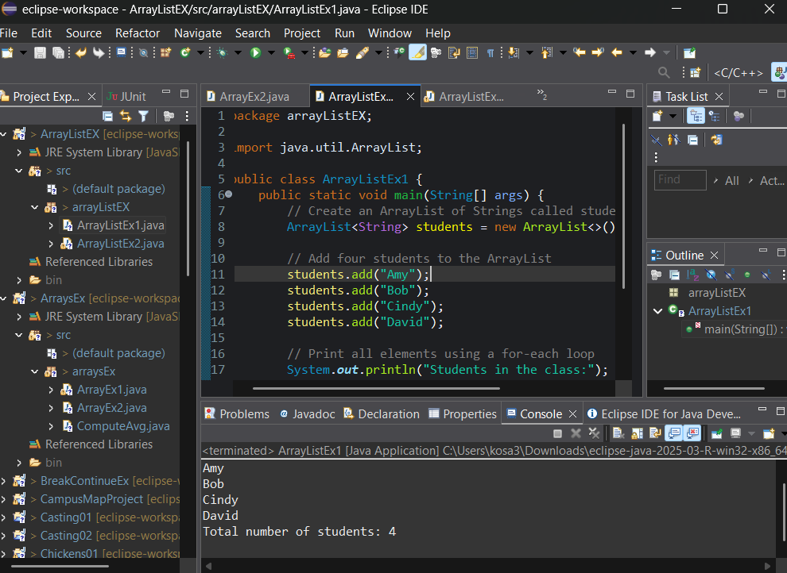

Exercise 1, Part 2:

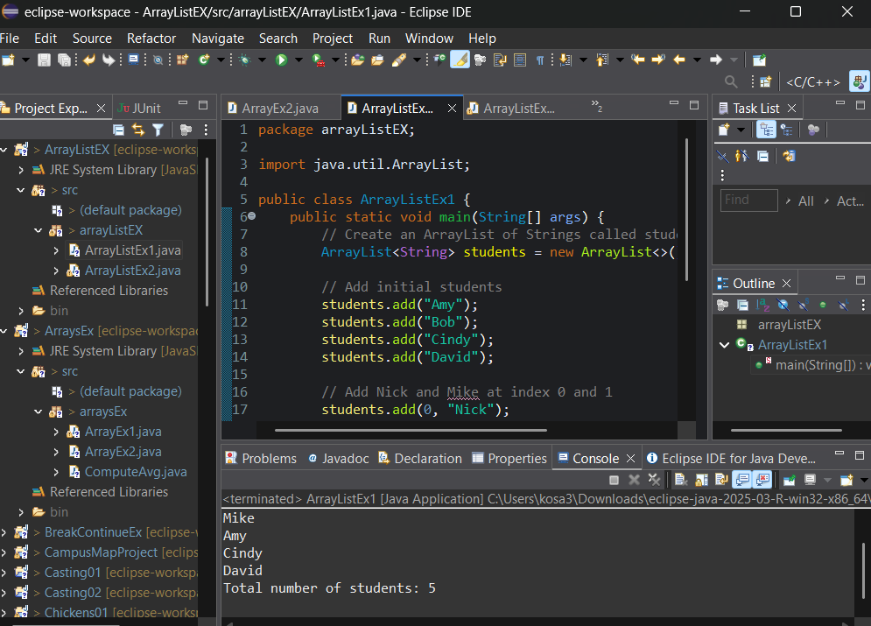

Exercise 2:

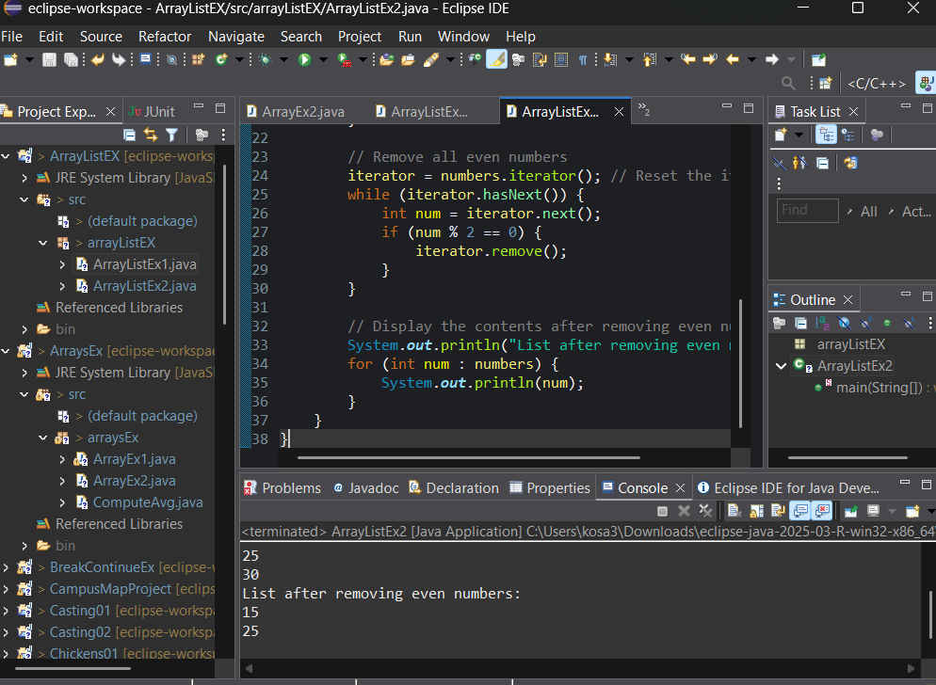

JFo8-3:

Exercise 1:

N/A File not attatched

Exercise 2:

N/A File not attatched

JFO8-4:

Exercise 1:

N/A File not attatched

Exercise 2:

N/A File not attatched

Exercise 3:

N/A File not attatched