* Problem 1: Simple ASCII Art
  + 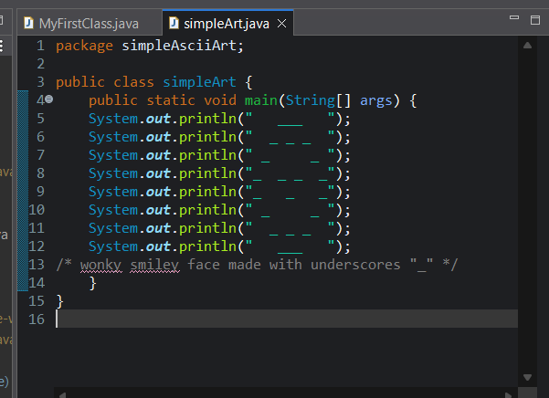
  + 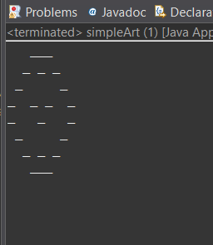
* Problem 2: Original ASCII Art
  + 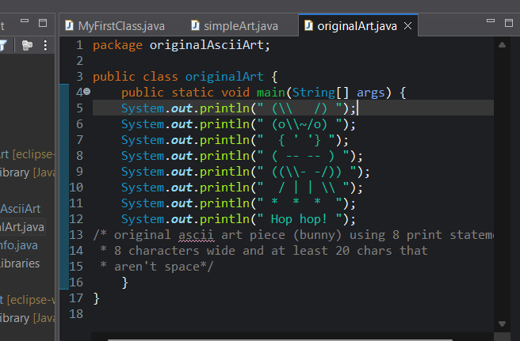
  + 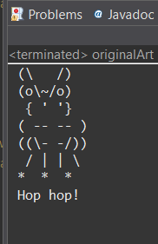
* Problem 3: The Snake Box Factory
  + Object: Snake box
    - Properties: Size, material, snake type
    - Behaviors: Package snake, seal box, track box
  + Object: Carrier Snake
    - Properties: Species, speed, current location
    - Behaviors: Pick up order, deliver order, return to base
  + Object: Order Management System
    - Properties: Order number, customer details, order status
    - Behaviors: Process order, assign delivery, update status