JFo4-Practice

Problem 1: Writing methods

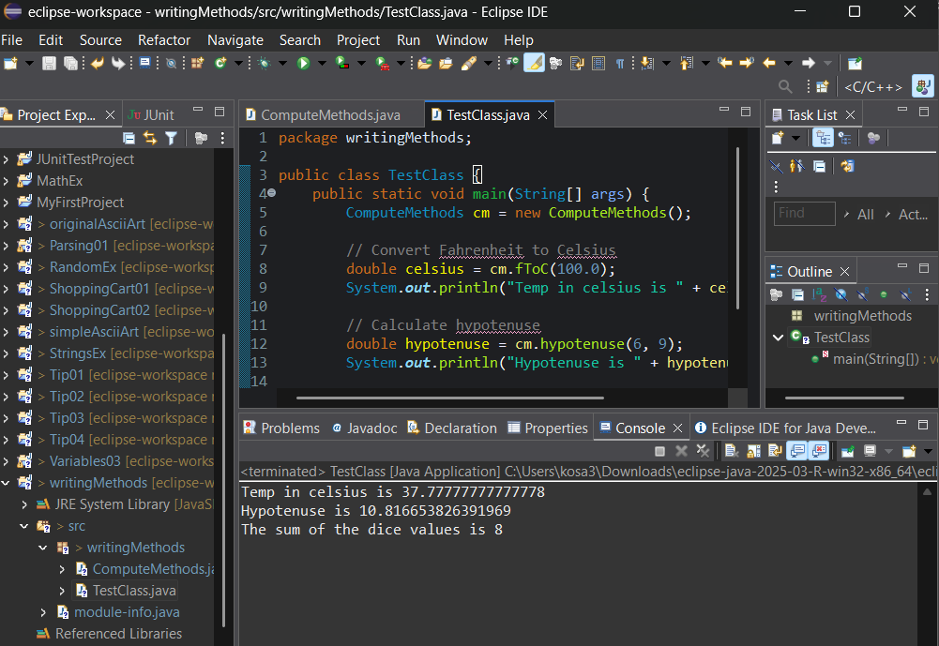

Problem 2: Process a name

