# Section 1, Part 1 -

## Step #1:

## Step #2, #3:

# Section 1, Part 2 -

## Step #1:

## 

## Step #2:

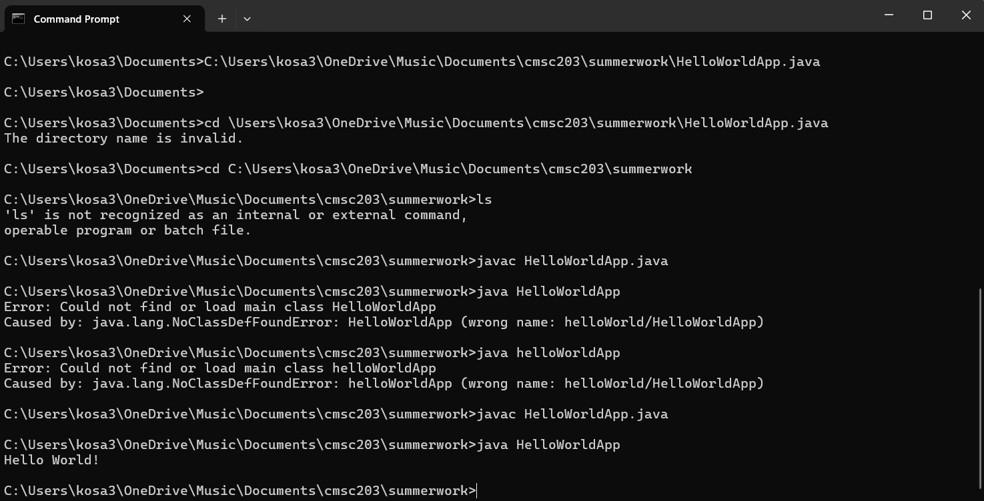

# Section 1, Part 3 -

## Step #1:

## Step #2:

## 

# Extras:

