ClinicCare-Lite
System Architecture Documentation
Prepared by: Member 1 — Project Manager, Architecture and Security Lead

1. Purpose
This document defines the system architecture of ClinicCare-Lite: the relationships between its core data entities, the layers the application is built from, and the interfaces through which the four team members' modules communicate. It is the shared reference for how the application is structured, so that each member's work fits together without conflicting assumptions.
Scope reminder: ClinicCare-Lite is an administrative and communication tool. It schedules, collects, and routes information between patients and clinicians. It does not diagnose, interpret symptoms, or generate treatment recommendations.

2. Entity Relationships
The application is built around six core entities. Their relationships are as follows:
- User — the base account for both roles (Clinician and Patient), distinguished by a role field.
- Clinic — belongs to one Clinician and has many registered Patients.
- HealthTask — created by a Clinician, assigned to one Patient, and associated with one Clinic.
- TaskSubmission — a Patient's response to one HealthTask, reviewed by the assigned Clinician.
- Message — sent between a Clinician and a Patient, or broadcast from a Clinician to all patients in a clinic.
- Appointment — scheduled between a Clinician and a Patient.

3. Class Diagram
The class diagram below shows the six core entities, their key attributes and methods, and the relationships between them.
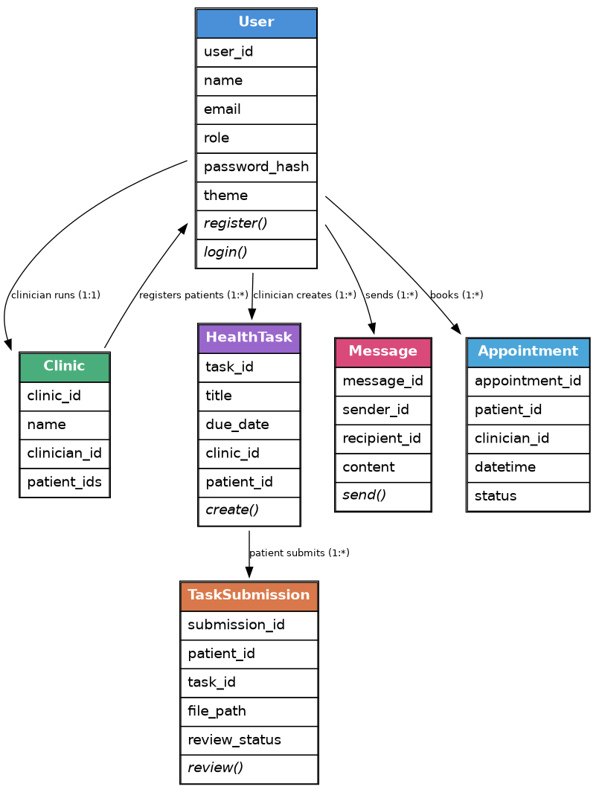
Figure 1 — Class diagram of ClinicCare-Lite's core entities.

4. System Architecture Diagram
The application is organised into four layers. The browser client sends requests to Flask routes, which use the model layer to read and write data, which in turn persists to JSON files. Email notifications are triggered as a side effect of certain model operations (e.g. a new submission or a completed review).
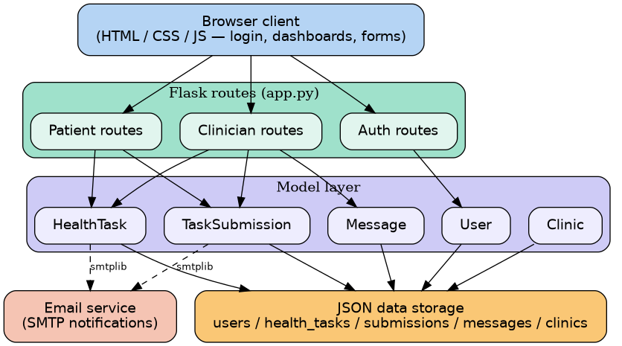
Figure 2 — System architecture, showing the four application layers.

5. Data-Flow Diagram
The diagram below traces a representative flow through the system: a patient submitting a file for a health task. This flow touches every layer of the architecture and illustrates how the pieces work together end to end.
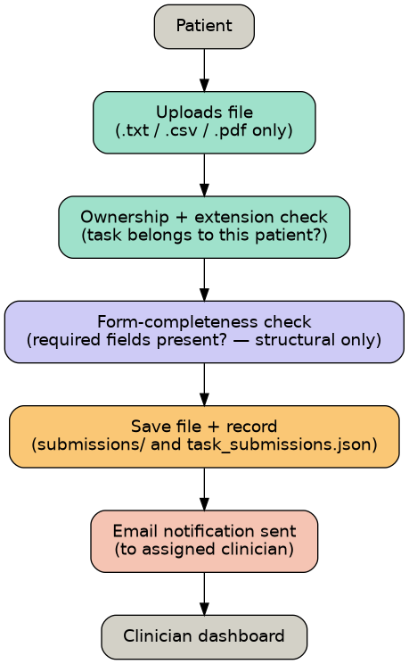
Figure 3 — Data flow for a patient task submission.

6. Use-Case Diagram
The diagram below groups the system's use cases by actor. Both actors share registration, login, and logout; the remaining actions are specific to each role.
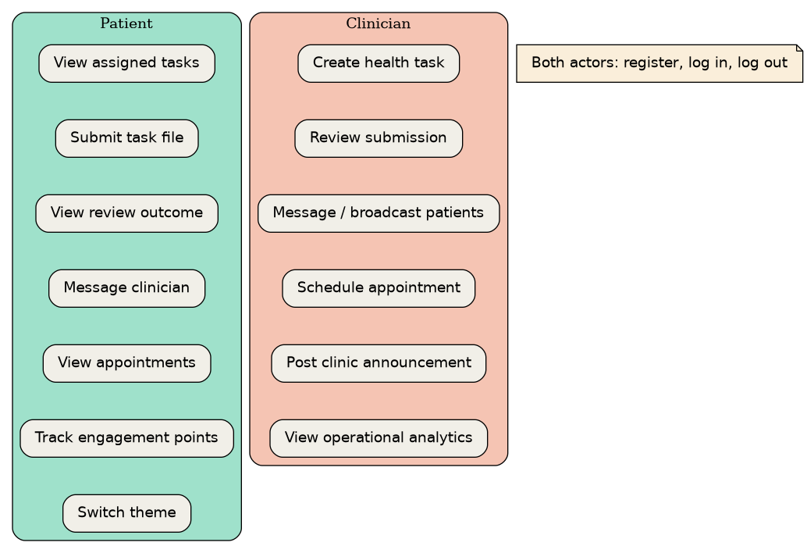
Figure 4 — Use cases grouped by actor (Patient and Clinician).

7. Navigation Map
The navigation map below shows how a user moves between screens after logging in, branching by role into either the Patient dashboard or the Clinician dashboard.
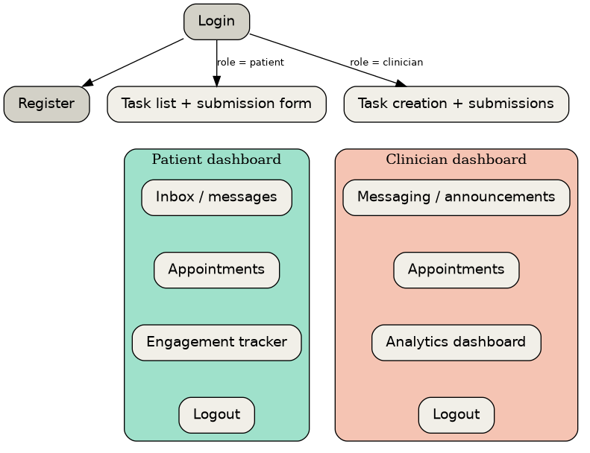
Figure 5 — Screen navigation map.

8. Module Interfaces
To let all four members build independently without breaking each other's code, the following interfaces are defined as shared contracts between modules:
Interface | Provided by | Used by | Contract
Session / auth state | Member 1 (Auth) | All routes | session["user_id"] and session["role"] identify who is logged in and their role
TaskSubmission object | Member 2 (Patient) | Member 3 (Clinician) | Member 2 creates submissions; Member 3 reads and updates review_status
HealthTask object | Member 3 (Clinician) | Member 2 (Patient) | Member 3 creates tasks; Member 2's dashboard reads them to display what's assigned
login_required() check | Member 1 (Access control) | All protected routes | Shared gatekeeper function; every dashboard/route calls this before rendering
JSON data files | Model layer (all members) | Member 4 (Analytics) | Member 4 reads all JSON files to build charts; never writes to them directly

9. Summary
This architecture keeps each member's work isolated to its own layer and module, while defining clear, minimal contracts (session state, shared model objects, and a common access-control check) for where those modules must agree. Any change to a shared interface listed in Section 8 should be discussed with the team before implementation, since it affects more than one member's code.

