Dbms – lab9

Arshia Azeem 24k-0012

Task 1:
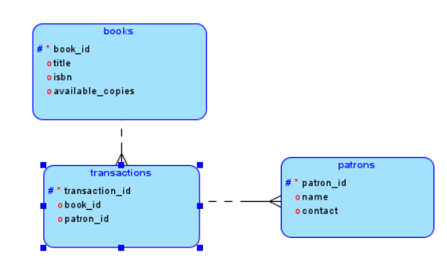

Task 2
a)
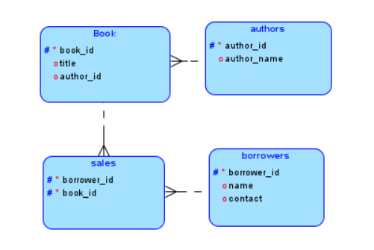
b)
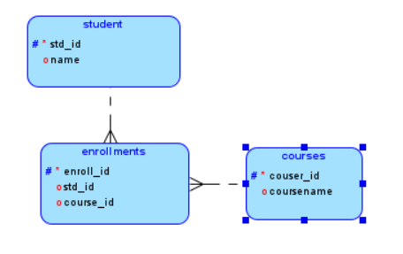
Task 3:
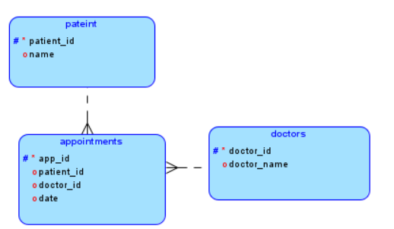
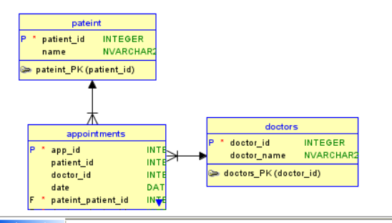

CREATE TABLE doctors (
doctor_id INT NOT NULL,
doctor_name NVARCHAR(100)
);

ALTER TABLE doctors
ADD CONSTRAINT doctors_PK
PRIMARY KEY CLUSTERED (doctor_id);

CREATE TABLE pateint (
patient_id INT NOT NULL,
name NVARCHAR(100)
);

ALTER TABLE pateint
ADD CONSTRAINT pateint_PK
PRIMARY KEY CLUSTERED (patient_id);

CREATE TABLE appointments (
app_id INT NOT NULL,
patient_id INT,
doctor_id INT,
date DATE,
pateint_patient_id INT NOT NULL,
doctors_doctor_id INT NOT NULL
);

ALTER TABLE appointments
ADD CONSTRAINT appointments_PK
PRIMARY KEY CLUSTERED (app_id);

ALTER TABLE appointments
ADD CONSTRAINT appointments_doctors_FK
FOREIGN KEY (doctors_doctor_id)
REFERENCES doctors (doctor_id)
ON DELETE NO ACTION
ON UPDATE NO ACTION;

ALTER TABLE appointments
ADD CONSTRAINT appointments_pateint_FK
FOREIGN KEY (pateint_patient_id)
REFERENCES pateint (patient_id)
ON DELETE NO ACTION
ON UPDATE NO ACTION;

Task 4:
(done in task 3)

Task 5:
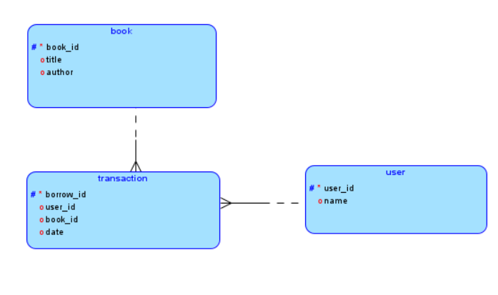

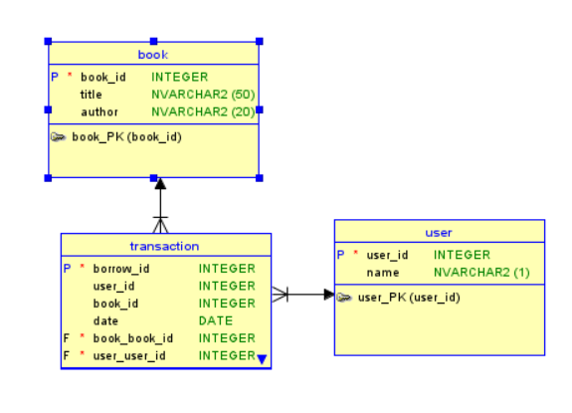
CREATE TABLE book (
book_id INT NOT NULL,
title NVARCHAR(50),
author NVARCHAR(20)
);

ALTER TABLE book
ADD CONSTRAINT book_PK
PRIMARY KEY CLUSTERED (book_id);

CREATE TABLE [user] (
user_id INT NOT NULL,
name NVARCHAR(100)
);

ALTER TABLE [user]
ADD CONSTRAINT user_PK
PRIMARY KEY CLUSTERED (user_id);

CREATE TABLE [transaction] (
borrow_id INT NOT NULL,
user_id INT,
book_id INT,
date DATE,
book_book_id INT NOT NULL,
user_user_id INT NOT NULL
);

ALTER TABLE [transaction]
ADD CONSTRAINT transaction_PK
PRIMARY KEY CLUSTERED (borrow_id);

ALTER TABLE [transaction]
ADD CONSTRAINT transaction_book_FK
FOREIGN KEY (book_book_id)
REFERENCES book (book_id)
ON DELETE NO ACTION
ON UPDATE NO ACTION;

ALTER TABLE [transaction]
ADD CONSTRAINT transaction_user_FK
FOREIGN KEY (user_user_id)
REFERENCES [user] (user_id)
ON DELETE NO ACTION
ON UPDATE NO ACTION;

Task 6:
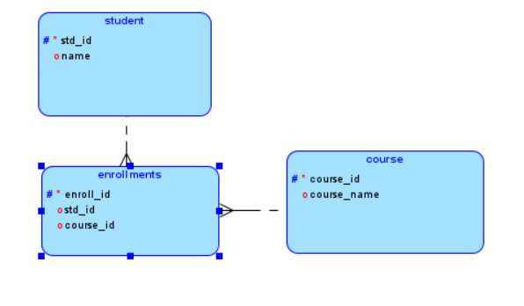

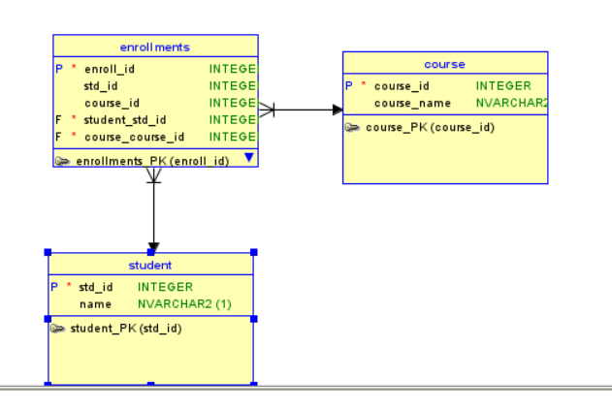
-- Generated by Oracle SQL Developer Data Modeler 24.3.1.351.0831
-- at: 2026-04-25 22:21:42 PKT
-- site: SQL Server 2012
-- type: SQL Server 2012

CREATE TABLE course (
course_id INT NOT NULL,
course_name NVARCHAR(100)
);

ALTER TABLE course
ADD CONSTRAINT course_PK
PRIMARY KEY CLUSTERED (course_id);

CREATE TABLE student (
std_id INT NOT NULL,
name NVARCHAR(100)
);

ALTER TABLE student
ADD CONSTRAINT student_PK
PRIMARY KEY CLUSTERED (std_id);

CREATE TABLE enrollments (
enroll_id INT NOT NULL,
std_id INT,
course_id INT,
student_std_id INT NOT NULL,
course_course_id INT NOT NULL
);

ALTER TABLE enrollments
ADD CONSTRAINT enrollments_PK
PRIMARY KEY CLUSTERED (enroll_id);

ALTER TABLE enrollments
ADD CONSTRAINT enrollments_course_FK
FOREIGN KEY (course_course_id)
REFERENCES course (course_id)
ON DELETE NO ACTION
ON UPDATE NO ACTION;

ALTER TABLE enrollments
ADD CONSTRAINT enrollments_student_FK
FOREIGN KEY (student_std_id)
REFERENCES student (std_id)
ON DELETE NO ACTION
ON UPDATE NO ACTION;

Task 7:
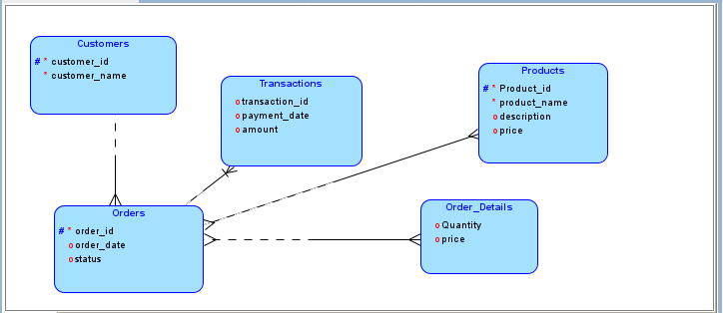
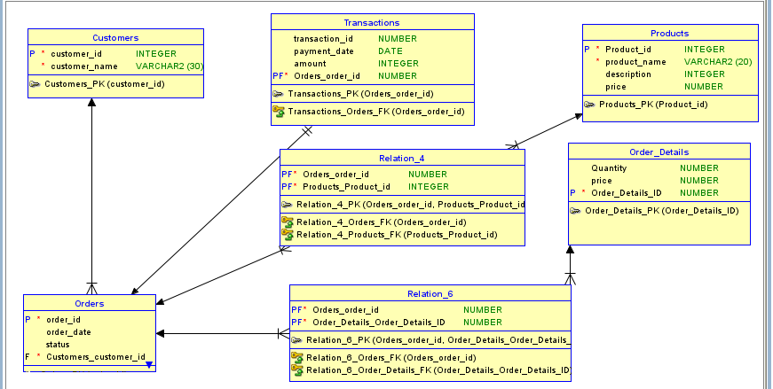
CREATE TABLE Customers (
customer_id INTEGER NOT NULL,
customer_name VARCHAR2(30) NOT NULL
);

ALTER TABLE Customers
ADD CONSTRAINT Customers_PK PRIMARY KEY (customer_id);

CREATE TABLE Order_Details (
Quantity NUMBER,
price NUMBER,
Order_Details_ID NUMBER NOT NULL
);

ALTER TABLE Order_Details
ADD CONSTRAINT Order_Details_PK PRIMARY KEY (Order_Details_ID);

CREATE TABLE Orders (
order_id NUMBER NOT NULL,
order_date DATE,
status VARCHAR2(10),
Customers_customer_id INTEGER NOT NULL
);

ALTER TABLE Orders
ADD CONSTRAINT Orders_PK PRIMARY KEY (order_id);

CREATE TABLE Products (
Product_id INTEGER NOT NULL,
product_name VARCHAR2(20) NOT NULL,
description INTEGER,
price NUMBER
);

ALTER TABLE Products
ADD CONSTRAINT Products_PK PRIMARY KEY (Product_id);

CREATE TABLE Relation_4 (
Orders_order_id NUMBER NOT NULL,
Products_Product_id INTEGER NOT NULL
);

ALTER TABLE Relation_4
ADD CONSTRAINT Relation_4_PK PRIMARY KEY (Orders_order_id, Products_Product_id);

CREATE TABLE Relation_6 (
Orders_order_id NUMBER NOT NULL,
Order_Details_Order_Details_ID NUMBER NOT NULL
);

ALTER TABLE Relation_6
ADD CONSTRAINT Relation_6_PK PRIMARY KEY (Orders_order_id, Order_Details_Order_Details_ID);

CREATE TABLE Transactions (
transaction_id NUMBER,
payment_date DATE,
amount INTEGER,
Orders_order_id NUMBER NOT NULL
);

ALTER TABLE Transactions
ADD CONSTRAINT Transactions_PK PRIMARY KEY (Orders_order_id);

ALTER TABLE Orders
ADD CONSTRAINT Orders_Customers_FK
FOREIGN KEY (Customers_customer_id)
REFERENCES Customers (customer_id);

ALTER TABLE Relation_4
ADD CONSTRAINT Relation_4_Orders_FK
FOREIGN KEY (Orders_order_id)
REFERENCES Orders (order_id);

ALTER TABLE Relation_4
ADD CONSTRAINT Relation_4_Products_FK
FOREIGN KEY (Products_Product_id)
REFERENCES Products (Product_id);

ALTER TABLE Relation_6
ADD CONSTRAINT Relation_6_Order_Details_FK
FOREIGN KEY (Order_Details_Order_Details_ID)
REFERENCES Order_Details (Order_Details_ID);

ALTER TABLE Relation_6
ADD CONSTRAINT Relation_6_Orders_FK
FOREIGN KEY (Orders_order_id)
REFERENCES Orders (order_id);

ALTER TABLE Transactions
ADD CONSTRAINT Transactions_Orders_FK
FOREIGN KEY (Orders_order_id)
REFERENCES Orders (order_id);

CREATE SEQUENCE Order_Details_Order_Details_ID
START WITH 1
NOCACHE
ORDER;

CREATE OR REPLACE TRIGGER Order_Details_Order_Details_ID
BEFORE INSERT ON Order_Details
FOR EACH ROW
WHEN (NEW.Order_Details_ID IS NULL)
BEGIN
:NEW.Order_Details_ID := Order_Details_Order_Details_ID.NEXTVAL;
END;
/

Task 8:
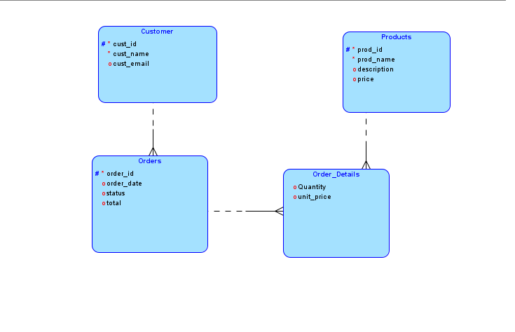

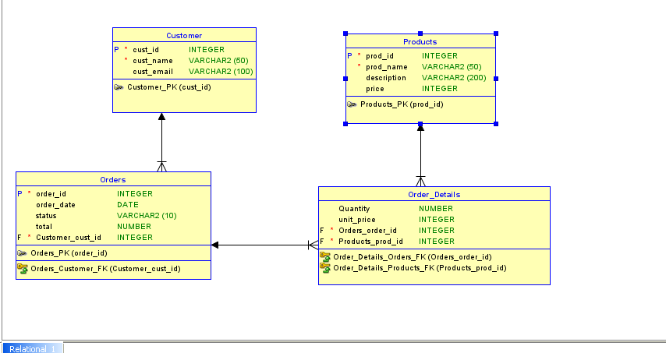

CREATE TABLE Customer
(
cust_id INTEGER NOT NULL ,
cust_name VARCHAR2 (50) NOT NULL ,
cust_email VARCHAR2 (100)
)
;

ALTER TABLE Customer
ADD CONSTRAINT Customer_PK PRIMARY KEY ( cust_id ) ;

CREATE TABLE Order_Details
(
Quantity NUMBER ,
unit_price INTEGER ,
Orders_order_id INTEGER NOT NULL ,
Products_prod_id INTEGER NOT NULL
)
;

CREATE TABLE Orders
(
order_id INTEGER NOT NULL ,
order_date DATE ,
status VARCHAR2 (10) ,
total NUMBER ,
Customer_cust_id INTEGER NOT NULL
)
;

ALTER TABLE Orders
ADD CONSTRAINT Orders_PK PRIMARY KEY ( order_id ) ;

CREATE TABLE Products
(
prod_id INTEGER NOT NULL ,
prod_name VARCHAR2 (50) NOT NULL ,
description VARCHAR2 (200) ,
price INTEGER
)
;

ALTER TABLE Products
ADD CONSTRAINT Products_PK PRIMARY KEY ( prod_id ) ;

ALTER TABLE Order_Details
ADD CONSTRAINT Order_Details_Orders_FK FOREIGN KEY
(
Orders_order_id
)
REFERENCES Orders
(
order_id
)
;

ALTER TABLE Order_Details
ADD CONSTRAINT Order_Details_Products_FK FOREIGN KEY
(
Products_prod_id
)
REFERENCES Products
(
prod_id
)
;

ALTER TABLE Orders
ADD CONSTRAINT Orders_Customer_FK FOREIGN KEY
(
Customer_cust_id
)
REFERENCES Customer
(
cust_id
)
;

