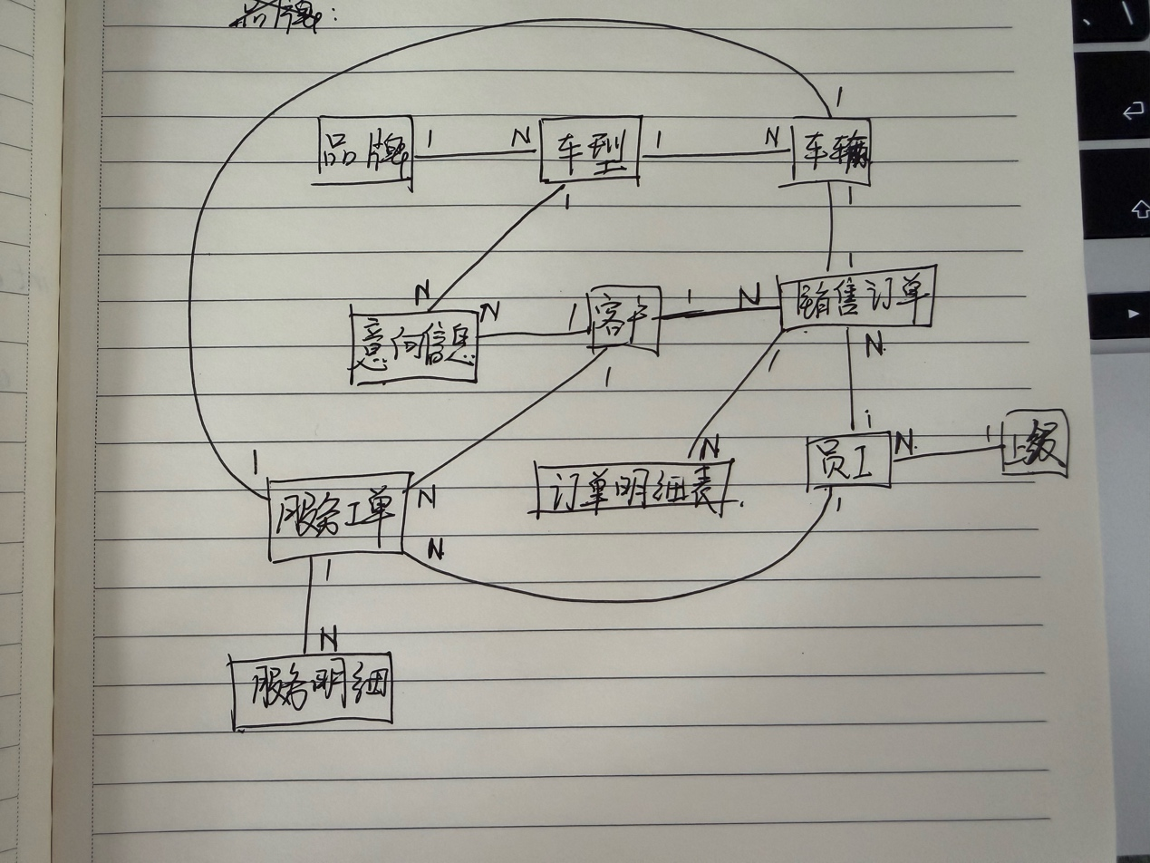
逻辑设计与规范化：
满足3NF需要消除依赖，要求非主属性只能依赖主键，不依赖其他非主属性。
关系模式设计如下：
brand (brand_id INT PK, brand_name VARCHAR(40));

model (model_id INT PK, brand_id INT FK, model_name VARCHAR(80), model_year INT, trim_name VARCHAR(80), msrp NUMERIC(12,2), engine_displacement NUMERIC(4,1), model_type VARCHAR(30), safety_stock_threshold INT);

customer (customer_id INT PK, customer_name VARCHAR(50), gender VARCHAR(10), phone VARCHAR(20), id_card VARCHAR(32), address VARCHAR(200), first_visit_date DATE, source_channel VARCHAR(30));

staff (staff_id INT PK, staff_no VARCHAR(30), staff_name VARCHAR(50), role VARCHAR(30), department VARCHAR(30), hire_date DATE, manager_id INT FK);

vehicle (vehicle_vin CHAR(17) PK, model_id INT FK, engine_no VARCHAR(32), color VARCHAR(20), manufacture_date DATE, inventory_in_date DATE, purchase_cost NUMERIC(12,2), suggested_retail_price NUMERIC(12,2), current_status VARCHAR(20));

customer_intent (intent_id INT PK, customer_id INT FK, model_id INT FK, intent_level VARCHAR(20), remark VARCHAR(500), staff_id INT FK, next_contact_time TIMESTAMP, created_at TIMESTAMP);

sales_order (order_id INT PK, customer_id INT FK, staff_id INT FK, vehicle_vin CHAR(17) FK, total_amount NUMERIC(12,2), deposit_amount NUMERIC(12,2), order_status VARCHAR(20), created_at TIMESTAMP, delivery_time TIMESTAMP);

order_item (item_id INT PK, order_id INT FK, item_type VARCHAR(20), item_desc VARCHAR(200), amount NUMERIC(12,2));

service_order (service_order_id INT PK, customer_id INT FK, staff_id INT FK, vehicle_vin CHAR(17) FK, service_type VARCHAR(20), created_at TIMESTAMP, expected_finish_time TIMESTAMP, total_fee NUMERIC(12,2), status VARCHAR(20));

service_item (item_id INT PK, service_order_id INT FK, item_name VARCHAR(80), quantity NUMERIC(12,2), unit_price NUMERIC(12,2), amount NUMERIC(12,2));

vehicle_status_log (log_id INT PK, vehicle_vin CHAR(17) FK, from_status VARCHAR(20), to_status VARCHAR(20), changed_at TIMESTAMP, staff_id INT FK, reason VARCHAR(200));

业务规则A：
- 封装存储过程 sp_create_sales_order
- 在事务中对目标车辆执行 SELECT ... FOR UPDATE 行级锁
- 校验 vehicle.current_status='IN_INVENTORY'，否则抛错并回滚
- 插入 sales_order 后，立即更新车辆状态为 LOCKED
- 提交事务，保证“校验+下单+锁车”原子性

业务规则B：
- 在 sales_order 表上创建 AFTER UPDATE 触发器。
- 当 order_status 从非 COMPLETED 变为 COMPLETED 时：更新 vehicle.current_status='SOLD'；若 delivery_time 为空则写入当前时间。

业务规则C：
- 建立状态日志表 vehicle_status_log，记录 vehicle_vin、from_status、to_status、changed_at、staff_id
- 在 vehicle 表上创建状态变更触发器：新增车辆时记录初始状态；更新车辆时若状态发生变化，自动写入日志。
- 建立库存汇总视图 v_inventory_summary，按车型实时聚合 IN_INVENTORY/LOCKED/IN_TRANSIT/SOLD 数量。

