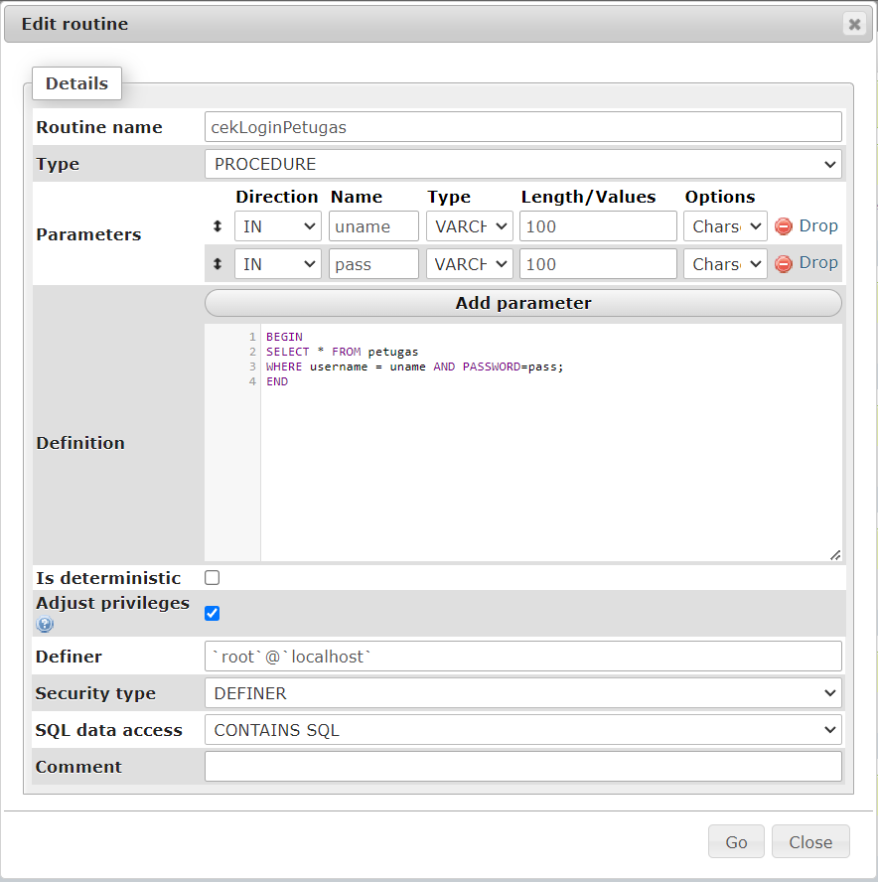

BEGIN

SELECT * FROM petugas

WHERE username = uname AND PASSWORD=pass;

END

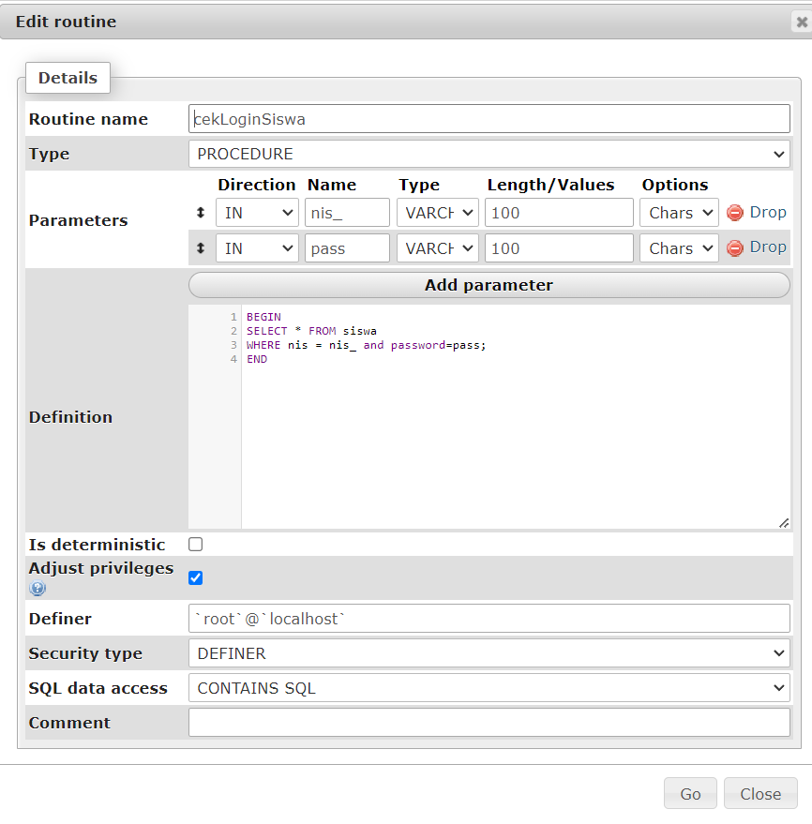

BEGIN

SELECT * FROM siswa

WHERE nis = nis_ and password=pass;

END

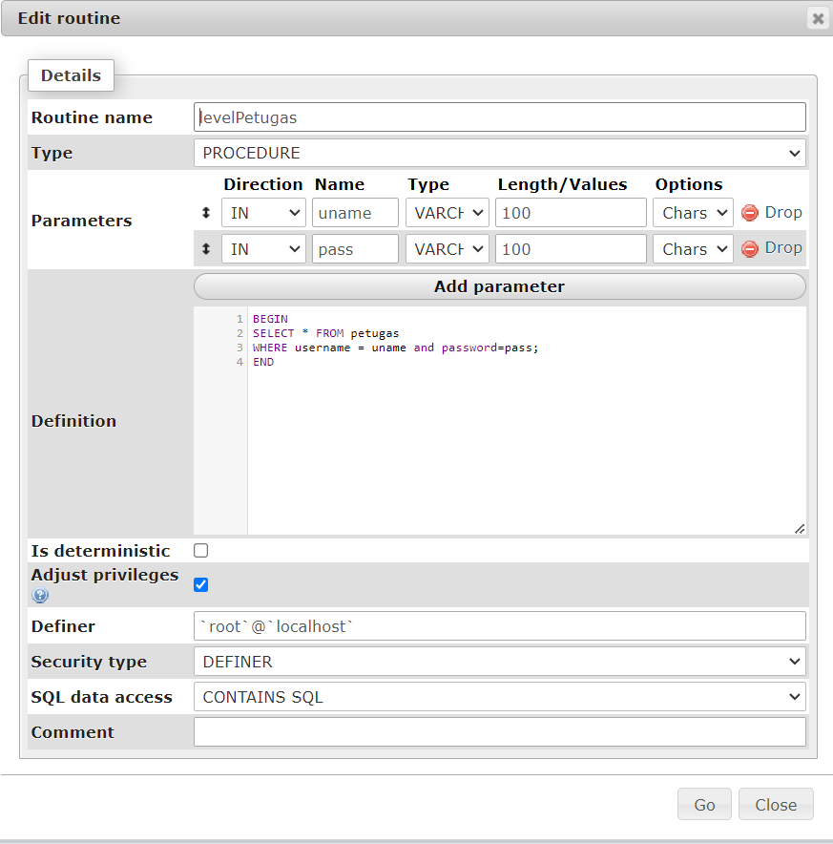

BEGIN

SELECT * FROM petugas

WHERE username = uname and password=pass;

END

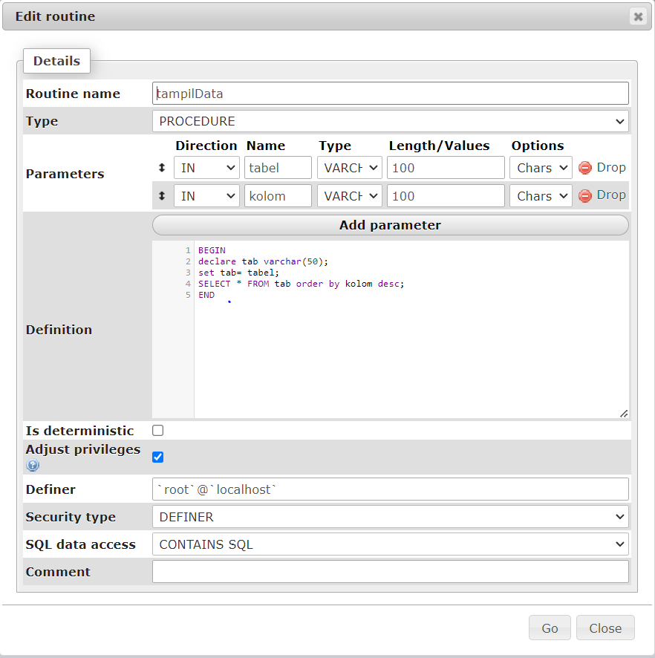

BEGIN

declare tab varchar(50);

set tab= tabel;

SELECT * FROM tab order by kolom desc;

END

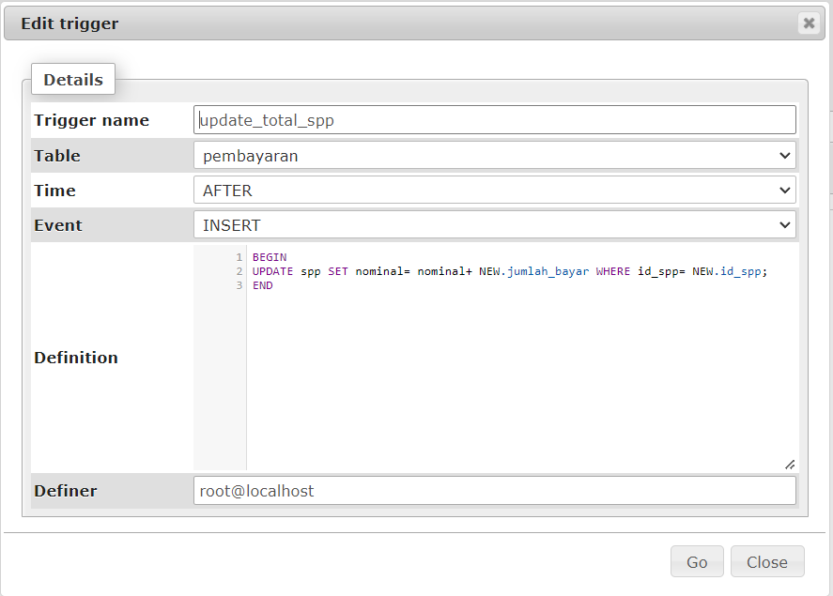

BEGIN

UPDATE spp SET nominal= nominal+ NEW.jumlah_bayar WHERE id_spp= NEW.id_spp;

END