25mml002 Edge intelligence lab 1 LOG
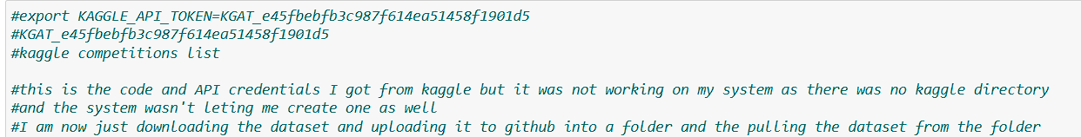
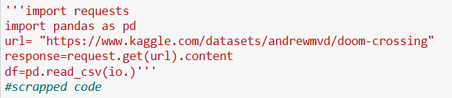
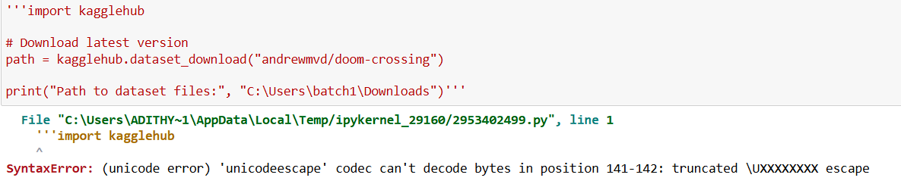
I did not know what this error was until I realised it was referring to the the slashes. Windows uses backslashes ’\’ to define paths and this was maybe an error because of that… it was not.
Scrapped.
Decided to just take it simple. No using url. Just download the image dataset and use it on device.
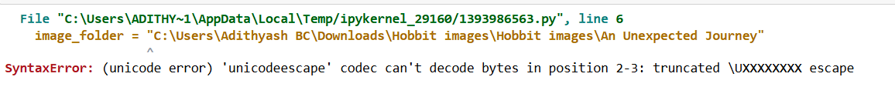
Ran into Unicode error…Again! Although simple to fix. Just put lowercase r in front of the path image_folder = r"C:\Users\Adithyash BC\Downloads\Hobbit images\Hobbit images" . The addition of ‘r’ tells python to treat it as a raw string wherein the slashes don’t mean anything as they are treated like normal charecters.
I ran into another problem such as reading the files. The image files. I scurried on over to my trusty friend (chatgpt) which told me to use the pillow library. I was only using the os library before, which in hindsight was not the most useful library for reading images. Using the pillow library (PIL) I am able to open, read, resize and modify images.
The rest of the code mostly went by error free until I ran into a slightly bigger problem. The dataset I downloaded was cleaned. I did not know that as I had downloaded it from Kaggle after searching for “dirty” and “uncleaned”. But nevertheless, the code works and these are the outputs received from it.
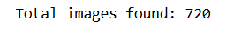
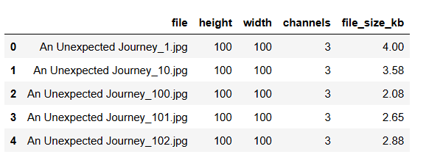
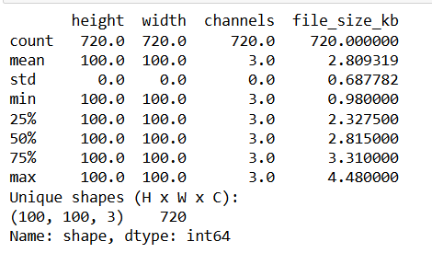
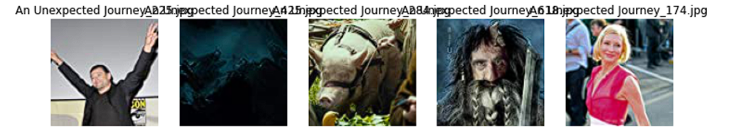
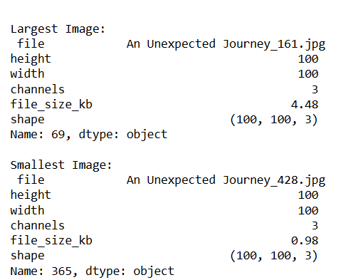
I did have my reservations about the data being “uncleaned” when I inspected it viasually but after investigating the dataset the similarities became apparent. Now that I am technically working out of my personal computer I can just change the path and run the code again on my folder of saved images.
I ran the code once again this time with a different path. I ran head first into some PIL problems. There were text files in the folder and that threw some errors.
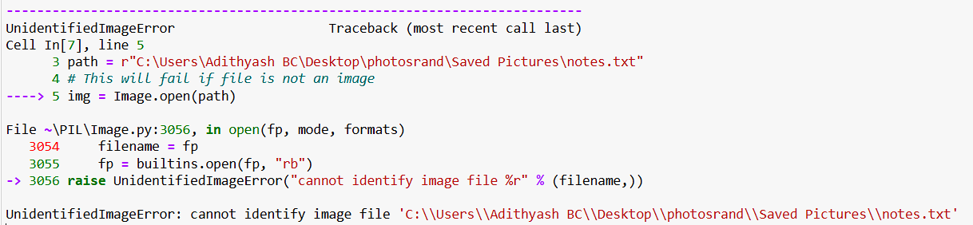
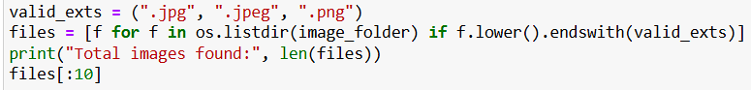
Added this block of code that filters out any other formats other than jpg or png.
The outputs from referencing the new folder are as follows
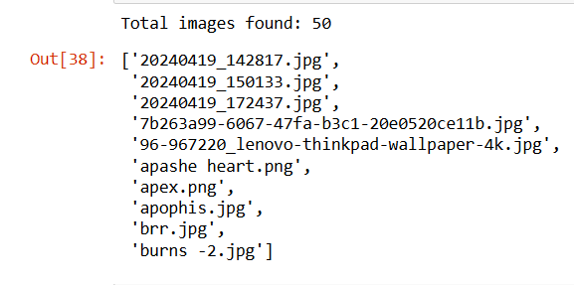
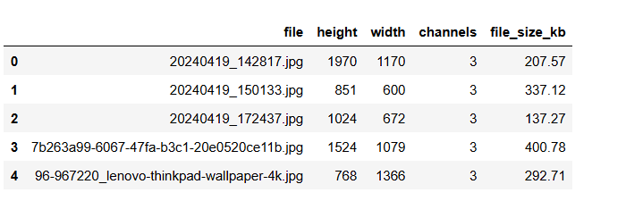
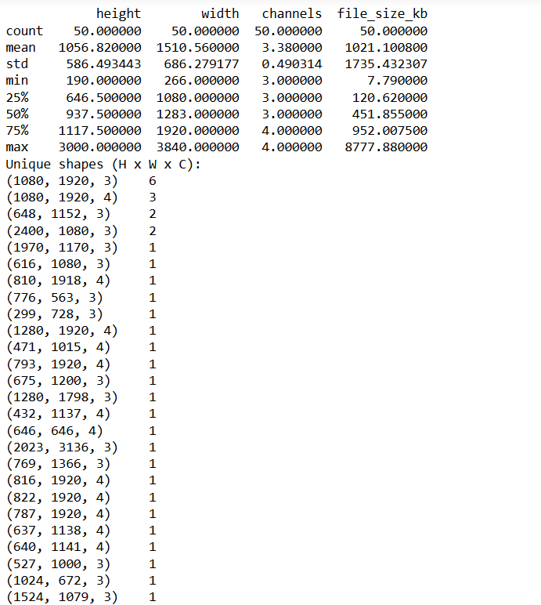
Basically every image was a unique shape.
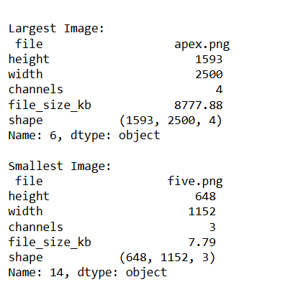
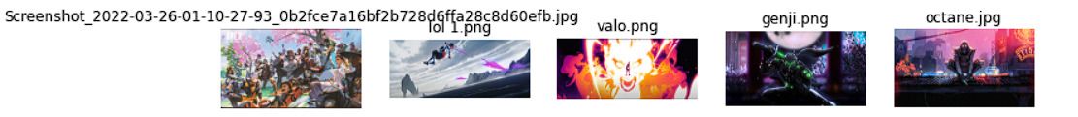

Most issues came from the path, wrong file types and just plain old quotation marks errors. The fixes included making the file path a raw string, filtering only valid image extensions, error and exception handling with a try/catch block and using the right quotes “”, ‘’. These small changes and fixes ensures that the code runs smoothly every time and with various image datasets.

