**Applied Deep Learning - Homework 3**

**Tasks 1**

The following graph shows the test and train errors after each epoch our model did while training. The model consistent of two fully connected linear layers with the ReLU function.

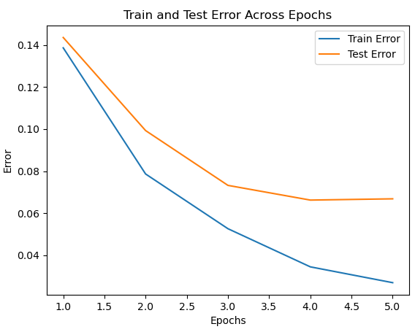

Test error of final network on the 10000 test images: 0.0668.

Accuracy of: 97.97%

Both errors are decreased with each epoch and the decline is slowing down the longer the model trains. We can also see the train error is lower than the test error as expected.

The following are images that our final model has misclassified. Above each image we have the actual Label, followed by the misclassification the model did.

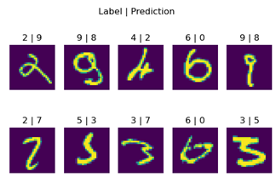

We can see that the images the model failed on are somewhat hard to label even as a human and for almost all of them we can see the similarity between the image and the prediction the model gave.

**Task 2**  
the following graph shows the same earlier model’s test error per epoch, for each seed between 1-5.

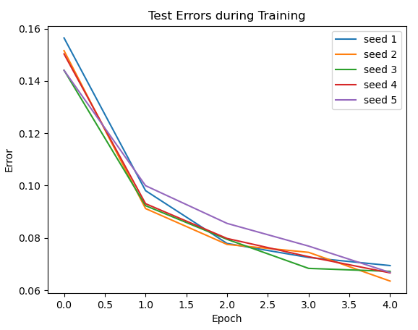

Mean final Error is 0.0667.

Standard deviation of final Errors is 0.00212.

The final errors exhibit very low standard deviation, and the graph illustrates that even though the different graphs aren’t exactly the same, the errors have comparable patterns among various seed values.

Judging by the variance and the graph provided, it appears that the model's performance is relatively stable and not too sensitive to the initial seed number chosen. To definitely say the model is robust to the choice of a seed number, more tests with more seed numbers should be conducted, but based on these results we would say the model is robust.

**Task 3**

**Task 4**

|  |  |  |  |
| --- | --- | --- | --- |
| **Hidden Size** | **Batch Size** | **Learning Rate** | **Test Error** |
| 100 | 100 | 0.01 | 0.0321 |
| 100 | 100 | 0.001 | 0.0329 |
| 100 | 100 | 0.0001 | 0.0804 |
| 100 | 1000 | 0.01 | 0.0297 |
| 100 | 1000 | 0.001 | 0.066 |
| 100 | 1000 | 0.0001 | 0.1389 |
| 500 | 100 | 0.01 | 0.0279 |
| 500 | 100 | 0.001 | 0.0229 |
| 500 | 100 | 0.0001 | 0.0608 |
| 500 | 1000 | 0.01 | 0.0222 |
| 500 | 1000 | 0.001 | 0.0466 |
| 500 | 1000 | 0.0001 | 0.1032 |

**Task 5**

