Assignment 4

**Task 1**

Example images from the training set and their labels -

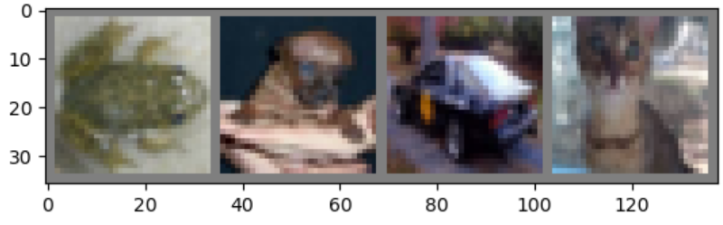

GroundTruth:  frog  dog   car   cat

Model training –

[1,  2000] loss: 2.221

[1,  4000] loss: 1.826

[1,  6000] loss: 1.668

[1,  8000] loss: 1.584

[1, 10000] loss: 1.557

[1, 12000] loss: 1.488

[2,  2000] loss: 1.426

[2,  4000] loss: 1.401

[2,  6000] loss: 1.391

[2,  8000] loss: 1.358

[2, 10000] loss: 1.323

[2, 12000] loss: 1.345

We can see the loss is getting lower the further into training we go.

Testing the model –

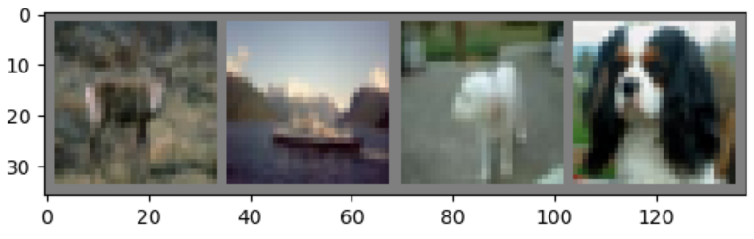

GroundTruth:  deer  ship  dog   dog

Predicted:  frog  ship  dog   dog

Accuracy of the network on the 10000 test images: 52.8 %

Accuracy for class: plane is 46.9 %

Accuracy for class: car   is 74.1 %

Accuracy for class: bird  is 29.3 %

Accuracy for class: cat   is 21.0 %

Accuracy for class: deer  is 29.3 %

Accuracy for class: dog   is 57.9 %

Accuracy for class: frog  is 74.4 %

Accuracy for class: horse is 59.5 %

Accuracy for class: ship  is 82.8 %

Accuracy for class: truck is 52.8 %

**Task 2**