Understanding Space
S01 What is Space
Space, it can be argued, is a natural physical entity that is based upon the human perception of existence and observable experience. Thus much of how space is perceived is how the human mind constructs a model of what is observed with the senses of the human body, and in particular, through vision via the eyes. It is therefore possible for space not to be as it is perceive to be by the human mind, and what is seen may also be an illusion or projection based upon what the human mind can comprehend.

A physical space can be defined by a set of rules which entities and phenomenon can exist, and the behavior that entities and phenomenon must follow. The definition of what space is, is based upon the human observation and comprehension which is the only way that it can be done. Any other method requires imagination and conjecture that goes beyond the human perception, which may also lead to the more correct answer of what physical space truly is. Such methods have lead to the theories of quantum mechanics and general relativity.

One definition of what physical space is
Definition S1a
Space is the stage upon, or in which interactions of physical entities take place.
This definition implies that space is separable and apart from the entities and phenomenon that exits and are observed. This implies that space is a physical entity in itself and thus has properties without the existence or need to exist of physical entities such as particles of matter or electromagnetic radiation, that is light. This definition implies space is like a sheet of paper where entities are placed on it and interact with each other, and perhaps the space itself.
From the human perspective, distances and angles of rotation are used to create a coordinate system to define a mathematical description of space and in which to perform mathematical calculations. This has worked for most of the time, but even this may not be enough as there are limits on what mathematics can describe. Also, mathematics is a human invention that is used to describe and model in abstract terms what occurs in the natural world, such that the meaning or what is truly occurring can be lost or be completely wrong.
One consideration is that what is perceived as space as a physical entity is that the entirety of the universe is just a space, and that the entities and fields that are observed to be present in the universe are a manifestation of the physical space interacting with itself such that matter “condensates” out of those interactions to form the building blocks and foundations of matter itself, along with the interacting fields that accompany matter such as electromagnetism and gravity.
Another consideration is that space is created by the interacting fields of matter, and that space is thus not a physical entity in its own right. In other words, the interacting matter and the interacting fields associated with them creates an illusory perception of a space, and that space does not really exist as the human mind has built a model of.
Never the less, a set of basic definitions of the space of the physical world can be more formally defined by what is observable and projected to be true. Using the human perception and experience in the universe we exist in as a basis, a set of rules can be set out for defining space.

Definition S1
Space is a domain where all entities and phenomenon reside and exist in and such that the following properties hold in all situations.

i : Be infinite in extent, but be finite such that there is no starting or end location.
ii : Have no central origin or coordinate reference.
iii : Be scalable to a minimum or maximum extent that can not be exceeded.
iv : Can have any “shape” that satisfies i: -> iii
v : Have no fixed rigid structure that cannot be altered.

S02 Degrees Of Freedom
Space has as a property, a defined a mathematical construct of dimension which is the number of spacial coordinate degrees of freedom in which an entity can be defined to move within, and have a physical form constructed of. Any physical space with any dimension must adhere to all of Definition S1 properties as any mathematical description.
The human perception of space is restricted to the three dimensions that the human sensors can interact with, and thus the human mind has built a model of. However, that does not mean that the universe does not exist in reality within a space of a different dimension. Speculation and conjecture has been proposed that the universe may exist as a hologram like structure with the three dimensions of space that is perceived is actually a projection from a two dimensional surface.
Another leap of imagination and conjecture can propose that the space that the universe exists in is of a higher dimension, and that the three dimensions that humans perceive is analogous to that of the book flatland, where two dimensional beings exists, and cannot comprehend or perceive of an existence of a higher third dimension. Thus, like a two dimensional being living on a two dimensional surface that makes up the space that it exists within, the same similar condition could be present for that of the universe that humans exist within. The three dimensional space that makes up the perceived space of the universe could be considered as a three dimensional surface existing upon a four dimensional volume of space.
To fit in with Definition S1, such a space that the universe exists within needs to be a closed surface. Such a surface must exist on top of a space of one dimension higher. A zero dimension space considered as a point is an exception to this. A line is considered as a form of a one dimension space, that to be closed such as a circle needs a two dimension space to exist within, or indeed creates a two dimension space. A closed line forming the circumference of a circle can be considered as a surface of a two dimensional space. A spherical surface can be considered as a form of a two dimensional closed surface that exists on, or creates a three dimensional volume. Analogous to this is that a three dimensional space can be considered as being a surface of a four dimensional space or hyper sphere.
Thus it can be considered that since no higher dimensions of space that the three dimensions that the human mind can perceive and exist within, no higher dimension of space than four exists, with the three dimensions that is observed of existing upon a four dimensional surface. If Definition S1 is valid in defining a physical space for the universe to exist within, then a new way of thinking of what is the structure of space is can be conceived so as to build a model of the workings and understanding of the universe.
Space as an aether
One concept of space is that it has a structure analogous to that of a fluid or crystalline solid which is commonly referred to as an aether. Such a concept of space is not new, and for an in depth discussion and conjecture of such a proposal for the structure space to be found elsewhere.
However for such a proposal, a need of explaining this aether structure of space is required. An aether model of space would be that space has a cell like structure. These “cells” of space interact with their neighbors in an analogous way to that of water, gas, or crystalline solids via the electromagnetic bonding forces between them. Each has a surface of some description with their neighbors, and through this surface of interaction, a tension force exists that bonds them together exists. To maintain each cells integrity, an internal restoration force exists to maintain a shape and volume of that cell.
Given that there exists two forces of interaction that is common in the universe that effect matter and energy, such an aether needs to have these properties that give rise to these forces. Force can be considered as an expression of energy, and the force or energy involved in observation of all physical phenomenon are the electromagnetic and gravitational forces. Electric charge and gravitational mass are the properties that are attributed to these forces, and therefore it is concluded that any aether of space must have an electromagnetic and gravitational component that exists within each aether cell of space. These properties give rise to the properties of the tension and restoration forces that exist within and between each cell.
These cells are not particles as such, but are a form of pure energy, and exist as a kind of ocean of energy that has a flat undisturbed zero energy state. Disturbances of this zero energy state give rise to physical phenomenon and behaviors such as photons of energy and particles of matter.
To exist within an aether is not a difficult concept. By considering the Aether as a fluid, disturbances of the aether can propagate throughout the aether giving rise to the propagation of energy, and within that energy, information of the source of that disturbance at a distance from any entity that interacts with that source, be it of a being able to comprehend such a disturbance via a sense such as light interacting with the retina of an eye, or a particle of matter under going an interaction of movement.
Part of this interaction of space as an aether is the possibility that the aether can interact in such a manner as to form a self interacting region of cells that condense out of aether to form particles of matter.
If such interactions are possible, then a strong consideration needs to be given that space is an aether.
S04 : More Space Properties

A further investigation into 1D and 2D space properties that extend into 3D space will help with understanding space .
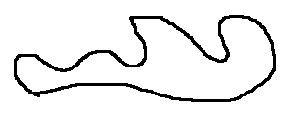
Fig MSP-01

1: Shape
Considering from definition S01:iv that a space can have any “shape”, an “observer” in any space cannot determine the true “shape” of that space. That is, a space can take on any “shape”. One hypothetical shape could be as in fig MSP-01 for a 1D space. An “observer” only “sees” the “signals” “transmitted” by another entity that travels along the 1D space line. Unless information relating to the 1D space shape is given in this signal, then no determination of the 1D space shape can be made. Topologically though. any 1D space shape can be in its simplest form a circle.

Expanding this argument to 2D and 3D space, the shape of the 2D and 3D surfaces can be of any shape.

2: “Transmitted” “signals” can travel in any space in two possible modes
A: instantaneously:
There is no delay between “transmission” from an “emitter” entity and an “observation” made by an “observing” entity any where in the physical space.=> instantaneous self “observation” is possible.

If the “transmission” and “observation” can be considered as a physical processes, then an infinite number of these physical processes can occur simultaneously with no concept of time existing. That is, can have a system where all possible physical processes in a physical system all occur in one instant. Such a system is where there is no delay between one or more “transmission”-”observation”, “observation”-”transmission” pair processes. That is, no change in the physical state of the entities existing in a physical space.

If have a delay between “transmissions” of “signals” or interaction from an entity to an “observer” entity such that the state of the entities changes by the “transmissions” and “observation” process, then a perception of time can be created in respect to each entity individually.

B: Delay:
Compared to the instantaneous condition given in 2A, a delay exists between a “signal” transmitted by entity O and “observed” by entity Q. This signal travels a unit length l in a given unit time interval. A definition of time is given in the chapter Understanding Time This delay creates a situation where physical processes in a physical space are dependent upon the separation between entities, and the perceived time it takes for the “transmitted” “signal” to reach the “observing” entity. If a “transmitted” “signal” were to reach the “observing” entity before an earlier transmitted” “signal” along the same physical path of space, then some further process must have caused this.

A concept of time can be developed for the entire physical space as a “signal” can be considered as being in between entities, and even as an entity itself. The state of the whole physical space changes as a change in the location of the “signal” can be considered as a change in the state of the physical space.

“Signals” transmitted in opposite directions arrive at the “observer” not simultaneously if the “observer” is not directly opposite to the “transmitter”, and no interruption of the traveling “signals” occur. That is, if on a circumference of a circle for example, the “observer” was at location π = -π radians away from a “transmitter” located at 0 radian origin coordinate transmits a signal in all directions simultaneously, then the “observer” would receive the signal simultaneously from all directions.

3: Continuity:
1D space can be considered as continuous if there is no interruption between a “signal” being transmitted and “observed”. If there were, a gap in 1D space will exist and there will be no “joining”, or rather a hole or gap on the physical space surface .

4: Homogeneity:
Any space can be considered as having the same constant properties that govern all physical processes at all locations. If this is not so, then an inconsistency will exist allowing or disallowing one or more physical processes to occur in one or more sections of physical space, or to have one or more physical processes undergoing some form of different transformation such that there is an inconsistency of physical behavior and outcome of results.

5: Physical processes occur at the same rate at all locations in all spaces in respect to an “observer” at that location. This follows from the homogeneity of space.

However, if it is considered that physical processes can occur at different observed rates away from an observers local location in space, but the end result of a physical process is always constant, then it can be argued that homogeneity of physical process still exists, but not the rate of physical processes.

6: A physical Space can change its “shape” or size, but all the properties 1-5 above must hold in this changed “shape”.

Consequences of space properties.
1: Change of shape of physical space can be considered as a change in spacial “density”, and is possible and can be noticed as such by a “stretching” or “squeezing” of a physical space by “observing” an apparent change in a section the spacial properties regarding the time it takes for a “signal” to traverse that section of space, and the observed time any physical processes that occur to take place by an observers clock. The travel times and changes in the physical state of entities take less or more time to occur in one region of space when compared to that in a different region of space with a different spacial “density”.(see about time for a more detailed discussion)

2: If space is “stretched” (“dilated”) in a region of physical space, the physical processes in that “stretched” region must still have the same properties as expressed above. Thus time to complete a physical process, and for a “signal” to traverse this region is the same as if it were in a relatively “un-stretched” region. This would then infer that a “stretched” region will have time progressing at a faster rate than that in a relatively “un-stretched” region, and the converse would be the case. ie a relatively “squeezed” (“contraction”) region will have time progressing at a slower rate than the regions around it.

Considering that all processes occur at the same rate in all physical spaces, the rate that a “transmitted” “signal” causes a change in the state of an entity remains constant in all regions of space => velocity of “transmitted” “signal” is constant => time slows down in “contracted“ regions and speeds up in “dilated” regions of space.

3: The result of this gives another emerging property that space and time are inter woven, and that no definite time clock exists for a physical space, and that an “observer” cannot tell if the region of space they exist in, or if any region of space exists in a natural, un-stretched, or squeezed state. In fact there may not ever be a “natural” state for space.

The discussion in the above sections gives a definition of physical space as if it were a separate physical entity that exists separate to the entities and physical phenomenon. The discussion above is also partly derived from observation of physical phenomenon of the universe and that certain behavior is never observed. Eg instantaneous transmission of electromagnetic waves and the constant velocity of light in all reference frames.

S05.0 Space as a Surface on a Higher Dimensional Space
Consider that there are three points O,P,Q that make up a triangle on a 2D surface lying on a sphere in 3D space (Fig WP 2b). Consider that there are “2D Beings” that “live” on this surface that would observe the distance OP,OQ and PQ as straight lines, where as a “3D being” that lives in 3D space would observe these as curved lines that depend upon the curvature of the sphere that the 2D surface being exist upon. Ie the radius of the sphere r_{s}.
The distance in OP 2D space is the same distance as measured in 3D space over the curvature of the sphere, which is determined by the angle subtended between point P and O (Fig WP 2a) (or the angle of rotation to translate point P to point O) and the radius r_{s} of the sphere.
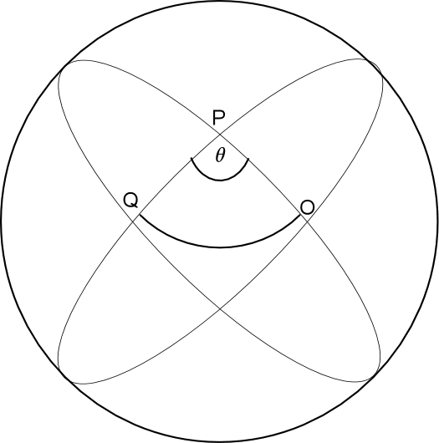
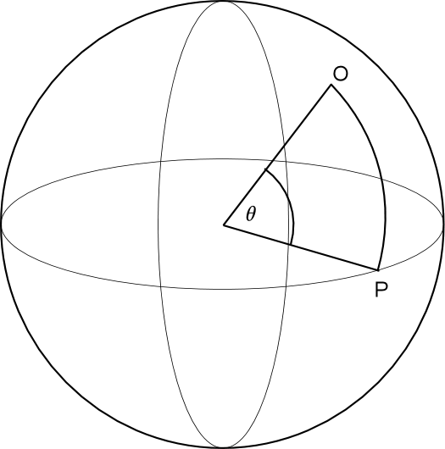
Fig WP 2a Fig WP 2b
If have spheres of different size but the distance is OP to be constant, then as
r_{s}→ ∞ then θ → 0
or as
θ → 2π then r→
assuming the angle subtended in 3D space cannot > 2π otherwise it folds onto itself and this violates the property of 3D space. So for a given distance in OP 2D space has in 3D space, the distance for OP curvature of 2D space in 3D space of curvature determined by (r_{s},θ) being
WP 3-1
Extrapolating this to a 3D surface in a 4D space, then the distance is OP not the distance on a 3D sphere as above in 3D, but the straight line from P to O in 3D space that gives the shortest distance between P and O.
In 4D space li OP is on a 4D hyper sphere where 3D space is its surface. The distance in OP 3D space = the distance OP on a 4D hyper sphere. For an observer that exists in 4D space, that observer will see OP as a curved line, where point O, P are separated by a hyper sphere angle Φ for a hyper sphere of radius r_{h}.
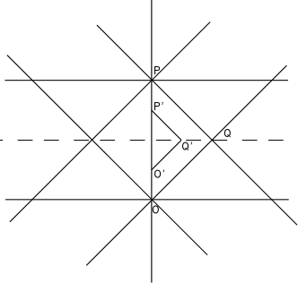
Fig WP 3
To find the radius of curvature, use a property that every point in 3D space is a point where traveling in any direction from it will lead back to that point, which means that for any two points separated by distance OP they will have these paths crossing over each other even if they start traveling in same direction “parallel” to each other. The distance it takes for this cross over of parallel lines will give a measurement of r_{h} as the point of cross over or meeting will be
or for a 2D surface on a 3D sphere
For a very large r_{s}, this measurement may be impractical.
For a 3D surface on a 4D space, the line of travel can be any line on a given parallel plane, or rather have planes intersecting each other. For this property to occur, all directions of travel from O and P travel away on lines forming a “great circle” or geodesic. Easy to assume since the shortest distance between any two points on a spherical surface must have the line joining them be a “great circle” or geodesic
Consider this to measure curvature of a flat 2D surface on a 3D spherical space. The distance from O to Q on a line of a geodesic midway between those of P and O has the distance OQ = distance PQ such that have the angle at Q = 90º or π/2 (fig WP 3). Then by Pythagoras theorem

=
Now on a spherical surface and
Thus because Pythagoras theorem does not hold for a spherical surface

On all spheres for distance PQ = OQ have angles <POQ = <OPQ = π/4 the angle <OQP > π/2 and ≠ . Illustrated in fig WP 3 from a 2D surface to a 3D sphere is as in fig WP 4.
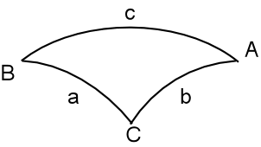
Fig WP 4
The distance a = b and the angle A =B = π/4. Angle C > π/2 and the distance C >
For a spherical surface, have the relationship
WP 3-2
and also
cos (c) = cos (a)cos(b) + sin(a)sin(b)cos(C) WP 3-3
By the use of these relationships, can use numerical methods to find a radius of the curvature of a sphere that this triangle lies on. To do this for a given distance a=b and measured c and C, relationship WP 3-2 is compared to these values to see if there is a violation. If no violation is found then use of WP 3-3 is used to see if this relationship is also violated. Ie
cos (c) = cos² (a) + sin²(a)cos(C) WP 3-4
since a=b.
By use of computer program code, finding values of a,A a and C that honor relationship WP 3-2 for various spherical surfaces and in turn also honor WP 3-4, it is found that for large spheres, a and c must become smaller and smaller in value otherwise WP 3-2 and WP 3-4 are never honored => for a very large sphere, then a and c must be exceedingly small and perhaps so small that they cannot be measured and thus have the wrong conclusion that the observer is in a flat space. This is counter intuitive until one considers Girands theorem which states the area for a triangle on a sphere is
A = r²(a+b+c-π) WP 3-5
or
WP 3-6
which = 0 on a plane. As one takes smaller and smaller areas on a sphere of radius r, it is found that WP 3-6 → 1/r²
Equivalent in 4D space curvature most likely would be that
WP 3-7
where f(a,b,c,d) are angles of a tetrahedron or some function that defines the rules of the angles of a tetrahedron shape or other 3D shape and volume. Similarly expect that
WP 3-8
for smaller and smaller volumes.
S05.1
If in 4D space have 3D space analogous to a 2D space on a 3D sphere, then 3D space exists on a 4D “hyper sphere”. In 2D space the triangle is the simplest 2D shape. In 3D space the tetrahedron is the simplest 3D shape. In 2D space on a 3D sphere the sides of the triangle each lie on a geodesic of a 3D sphere. In 3D space lying on a 4D hyper sphere the sides of a tetrahedron lay on a 4D geodesic of a 4D Hyper sphere.

S06.0 Most fundamental coordinate system between entities
For any two entities P & Q on a surface of a sphere (or any surface) that can interact to each other only on this spherical surface, are separated by a distance OP. This distance is measured by a 3D observer (fig QS 1a) as
- EQS-0
These entities on their own have no preferred orientation in terms of any coordinate system employed. Once one entity is in communication of interaction with another, then a coordinate system can be employed by simply specifying an axis of a coordinate system that passes through the centers of each, establishing a straight line. Ignoring all but the segment of line connecting the these two entities, have only two variables that defines the system as far as coordinates are concerned. Ie a distance of separation and a reference of a coordinates of what is positive and negative in respect to each entity. (fig QS1b). Ie each entity shares a distance of separation

Entity Q can consider that positive direction of coordinate system is in a direction towards P, and vise versa for entity Q.
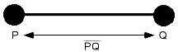
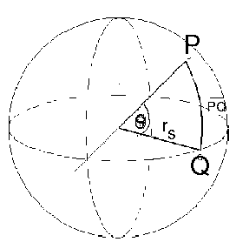
Fig QS 1a Fig QS1b
Since Q “sees” or is in communication with P, and P “sees” Q only and no other entity, then no other than one coordinate system is necessary to consider. Ie have one dimensional action Q on P, and P on Q, and thus have a one dimensional coordinate system for this system.
For such a system, any action or influence of Q on P or P on Q would be the same function f of the distance in one dimension. Ie proportional toand and Such a function would have an opposite or negative value in respect from the direction of the measured distance from the perspective of the other entity location to the location of the entity at which the observer is located. That is if the observer was located at entity located at P, then PQ = -QP, and if if the observer was located at entity located at Q, then QP = -PQ. Similarly for function f, if the observer was located at entity located at P
- EQS-1
and
In regards to if an observer was located at entity located at Q
- EQS-2
Or more general expression for a 3D observer have
- EQS-3
ie each entity sees the other entity as having a negative direction in any coordinate system in respect to itself if the origin of the coordinate system was moved to the other entities perspective, or location in respect of its own.

