The Aether Model of Space
The Concept
The basic aether model of space is that the space of the universe has a structure, and that this structure is as a concept, one of space being constructed of small fundamental cells of space that can not be sub divided into smaller cells of space. Each sub space cell has a number of other sub space neighbour cells surrounding them, where they interact with each other at what can be considered as a kind of surface of interaction. These surfaces and shape of each cell, as it were conceptualised, have no gaps of space where no sub space cell exists.
A conceptualisation of such a structure can be envisioned by looking at a grid of hexagons for a 2D space, where each hexagon is a cell of space surrounded by six hexagons of equal size, side length and distance from each other,. Such a space is depicted in Fig AM01 and Fig AM02
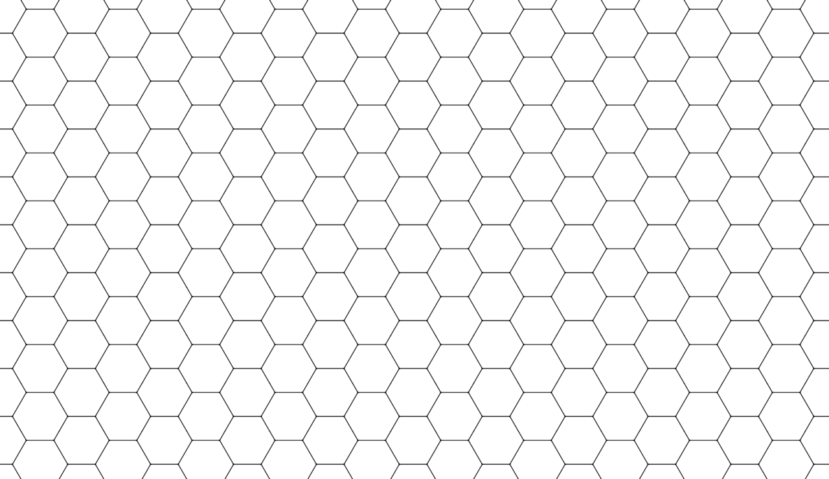
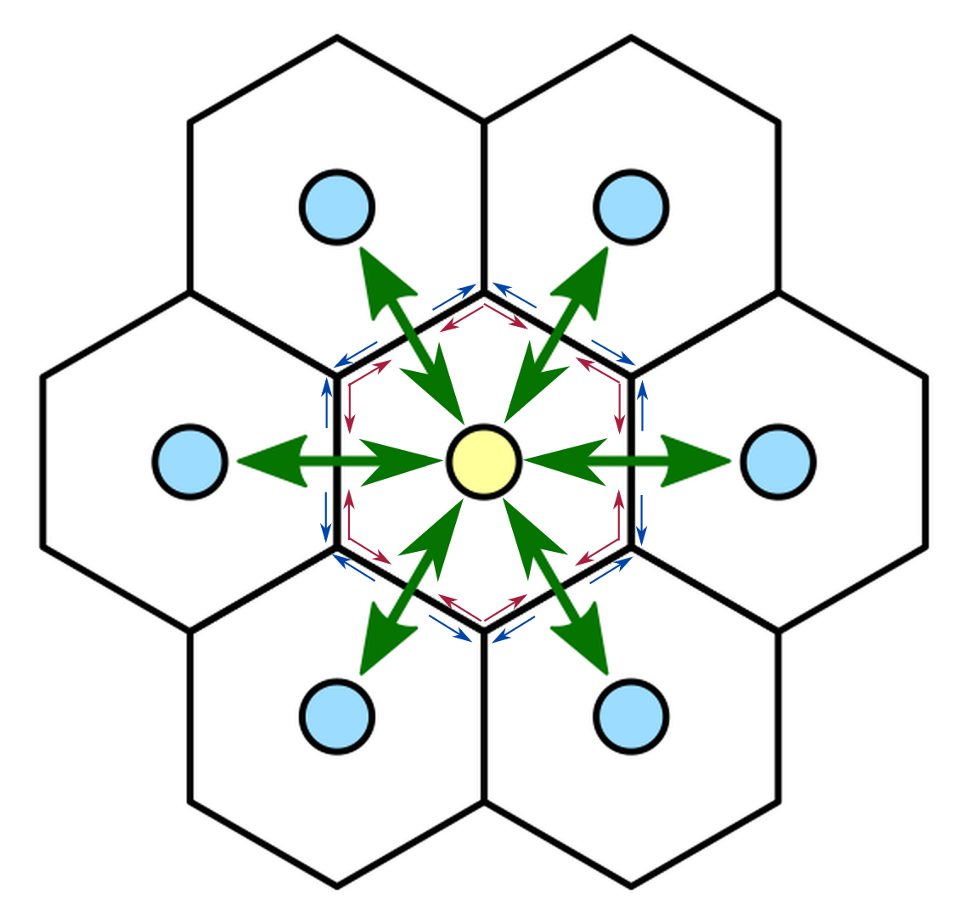
Fig AM01 Fig AM02
If it can be considered that in 3D, the area of each cell is a substitute for the volume of a 3D cell, and the length of each side being a substitute for the surface area of a 3D cell, then building an aether model can proceed.
Such a structure of space for an aether model can be considered as being either of a fluid or crystalline. A fluid structure would be like that of water or gas where these cells through interaction move about one another. A crystalline structure would be one where these cells are fixed and cannot move.
Which one to choose?
Given the observation and theories of physics, space as an aether would favour it being a fluid as will be discussed in what follows. the reasoning being that if matter existed within a crystalline structure, to undergo motion, it would have to be propagated through the crystalline structure by means of interaction that swaps or changes one or more of these cells internal properties. It is easier to consider that a propagation of matter through space interacts with the surrounding cells in such a manner as to push them aside or ride a wave of energy.
Axiom AMA01: Space as an aether can be considered as a structure like that of a fluid that has a fundamental structure of sub space cells that has a shape and number of interacting regions.
Given that in this 2D aether model, this hexagonal grid space of an aether exists, consider that this grid is a surface of space. Consider next that this surface needs to satisfy Definition S1 of the chapter understanding space, then this surface needs to exist upon a 3D volume that can be considered topologically as a sphere.
Axiom AMA02:The aether is a spherical surface that exists upon a volume of a spherical space of dimension one order higher than itself
Consider that this spherical volume is a physical state of being that is considered as its natural physical state of zero energy. Consider that what maintains this natural zero physical state is the interactions between all of the hexagonal cells that make up the surface of this sphere. These interactions in effect are depicted by the green arrows in Fig AM02, where the interactions seem to be between the centers of each cell across each cells boundary and can be reciprical. That is, both grid cells interact in respect and in tandem to each other such that an action of one cell A upon another cell B invokes a reaction back upon itself from B. But this effect can be considered as an emergent behaviour of where the real interaction between the space cells occurs, which is between the surfaces that each each cell is in contact with each other.
Consider that the interacting surfaces have a minimum zero state size, but can change size to be larger. In the chapter Understanding energy, it is discussed that a one dimensional string has within it tension and restoration energies and forces that sustain its shape and integrity of structure. These energies and forces exist between the segments of the sub string structure that make up the 1D string. It was also stated that these same forces can exist in 2D and 3D structures as well.
The same energies and forces is considered to be present with the 2D hex cell structure, and such energies and forces can be considered to exist along each side of each hex cell. These tension and restoration energies and forces are depicted by the blue and red arrows in Fig AM02.
Axiom AMA03: The aether interactions are considered to occur in regions that have an internal energy that can be thought of as a tension and restoration energy and forces that are attributed to these regions. The tension is an energy that distorts the region above its zero energy state, and a restoration energy that works to keep the region in its zero energy state and against the distorting tension energy.
Models of interaction
There are three model options to model such an Aether space.
Model option AMM01
To have the changes in the shape of any hex cell from its zero energy state being attributed to an energy added to one or more that cells sides so as to enlarge its length. As discussed in the chapter Understanding energy, this acts on the tension and restoration forces to deform the shape of the surface that the hexagonal grid exists upon away from its zero energy state. Such deformations can form ripples or waves of motion of energy on the surface of the 3D volume which the hex grid exists upon.
Adding energy to any side of the sub space hex cell as depicted in Fig AM02 can be modelled to have that increase in that side being transmitted through all of the sides of the hex cells that that side is apart of. In effect, changing the size of the hex cells sides that the side being deformed by energy is a part of, and in effect changing the size of the sub space hex cells. In effect, any energy deformation to a sub space cell by adding energy to one of its interacting sides creates a cascade of interactions along the cell sides so as to then deform and change the overall shape, and hence energy state of the individual hex cells around that hex side being deformed with energy.
This model of hex cell side interaction implies that the hex cell shapes are deformed in a non-uniform manner, with a designated hex cell able to have one or more of the cell sides of different sizes, and hence energies. (Fig AM-03A)
Model option AMM02
The sub space hex cell as a whole is able to have energy added to it which then means that the length of the hex sides all have an equal length and hence energy of interaction, and all sides of the hex cell change in equal proportion to the energy added to the cell. This deformation of hex cell size is then transmitted to all neighbouring hex cells in a 2D version of the 1D string discussed in the chapter Understanding energy.(Fig AM-03B)
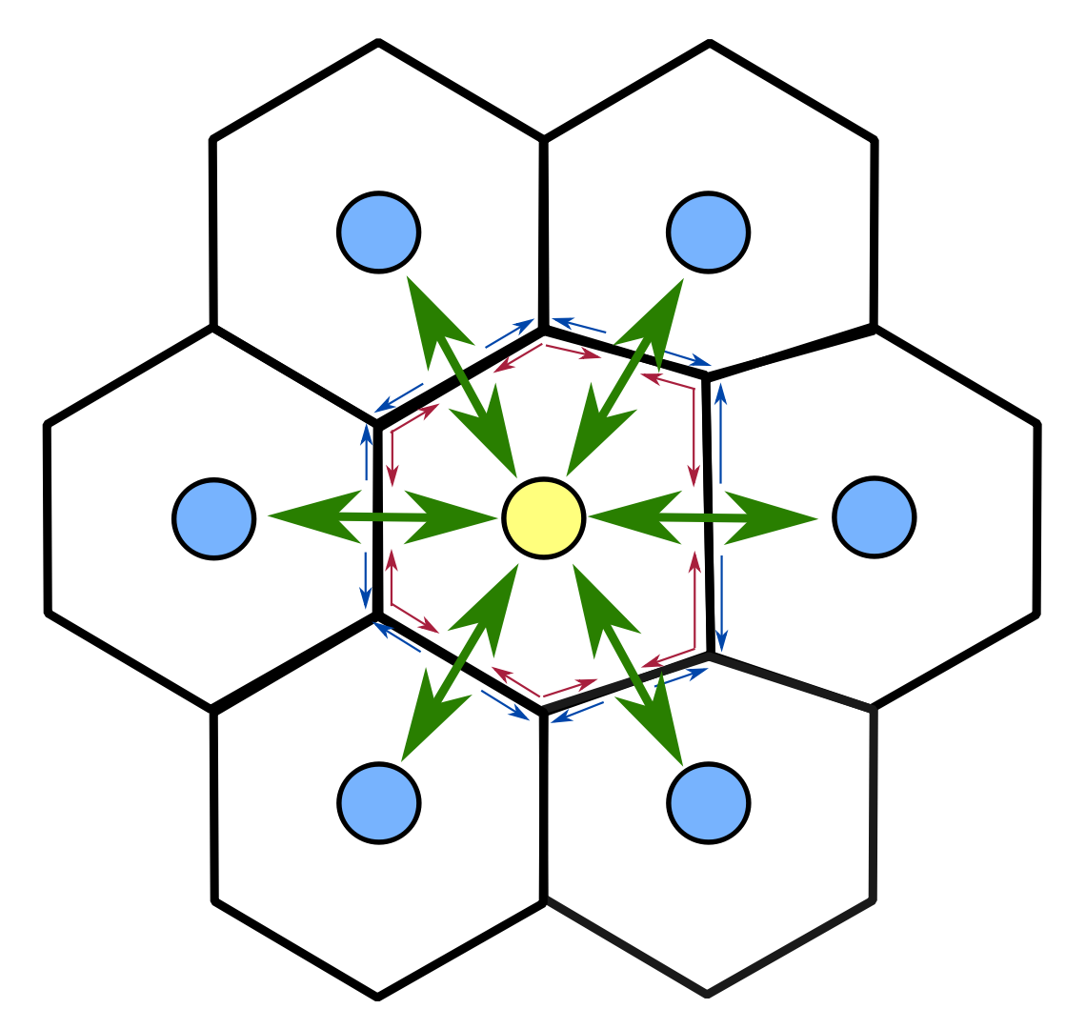
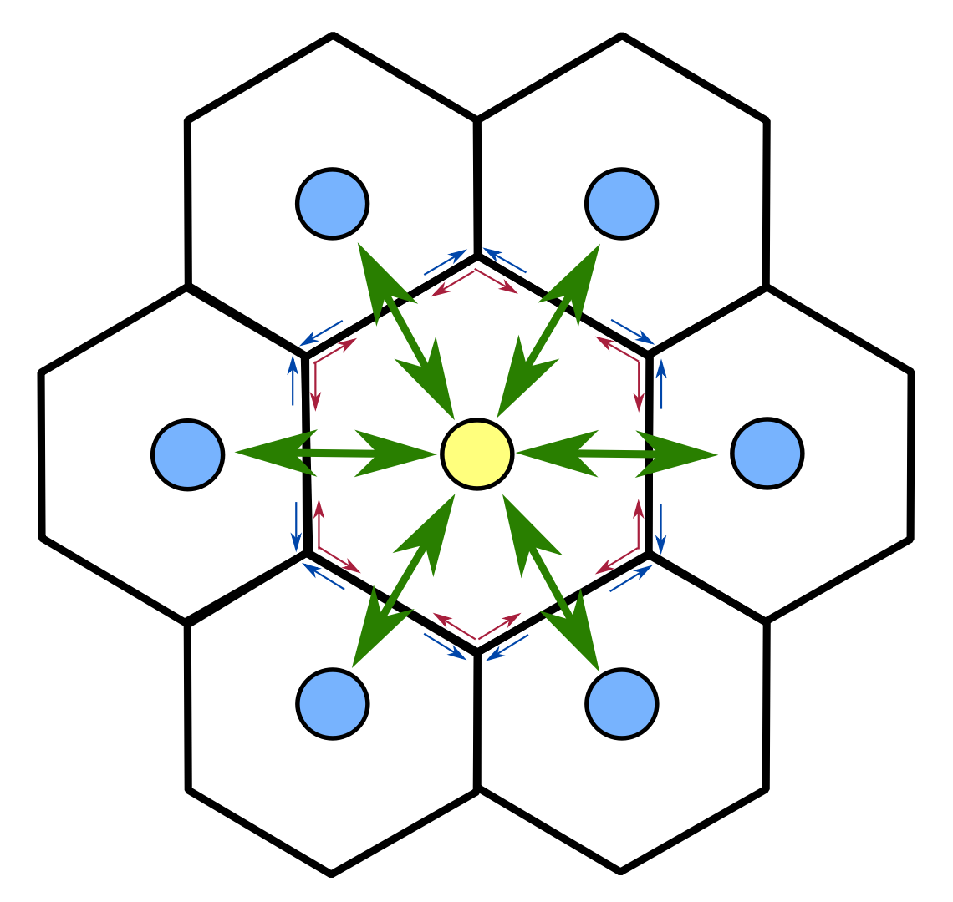
Fig AM-03A Fig AM-03B
Aether sub space cell side interaction Aether sub space cell interaction
What this means is that one aether model of a sub space hex cell can be considered as one of the energy effecting the hex cell as a whole, not its individual sides of contact of interaction. In this case the hex cell as a whole will interact equally with all its neighbours simultaneously as indicated by the green arrowed lines in Fig AM02.
Model option AMM03
A combination of AMM01 and AMM02 where an energy interaction can deform the hex sub space cell in either form of interaction. This is the model form that will be chosen as it gives the greatest flexibility as an energy interaction can interact with one or more of a hex grid sub space cells sides.
Mode of interaction
The mode of interaction can be considered to be governed by the premise that the physical process of interaction is of an iterative nature. As outlined and discussed in the chapter Understanding Time, time is a measurement of the process of interaction to change a physical entity or system of entities from one physical state A to another physical state B. The aether models AMM01 to AMM03 outlined above is such a process of changing the physical state of an aether sub space hex from a physical state of zero energy state to another physical state by the addition of energy.
To model this process, it is considered that it occurs in a single step of interaction, and is not continuous with an infinite number of sub steps. Quantum mechanics with its evidence that have the energy interactions being of a discrete magnitude can also be extended that these interactions occur in discrete number of steps, if not a single step.
In this model of an aether existence of space, interactions of energy is considered to take place as a single step of interaction. That duration of interaction is measured, as outlined and discussed in the chapter Understanding Time, relative in terms of a time clock that also has an iteration step of changing its physical that is used as a unit of time.
Axiom AMA04: All processes of interaction of changing the physical state of a sub space of the aether from one physical state A to another physical state B with no intermediate steps possible occurs in a single step of iteration.
The Aether Space and its interactions
Axiom AMA02 above states that the aether is a spherical surface that exists upon a volume of a spherical space of dimension one order higher than itself. For the example used as a concept to understand such a statement, the aether of a space is a 2D surface that exists upon a 3D sphere. This can be visualised simply as a sphere in 3D space. The surface of such a sphere being perfectly flat and smooth, and undistorted can be considered as the aether space in whole being in its zero energy state. Any deviation from this undistorted zero energy state in any region of the 2D surface can be considered as an energy excitation of that region which can propagate throughout the aether surface from that location of interaction.
That energy excitation may result in an increase of the surface area of the aether space. If it is considered that the volume of the space that the aether surface exists upon is to be kept constant in all situations of physical states, then any deformation of the aether surface that increases that aether surface must also have a decrease of equal proportion in the aether surface area in some other region of the aether surface. Such a scenario is illustrated in Fig AM-04. The green color represents the zero energy state of the aether sub space cells, the red the regions of increase in surface area, and blue the regions of decrease in aether surface area.
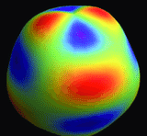
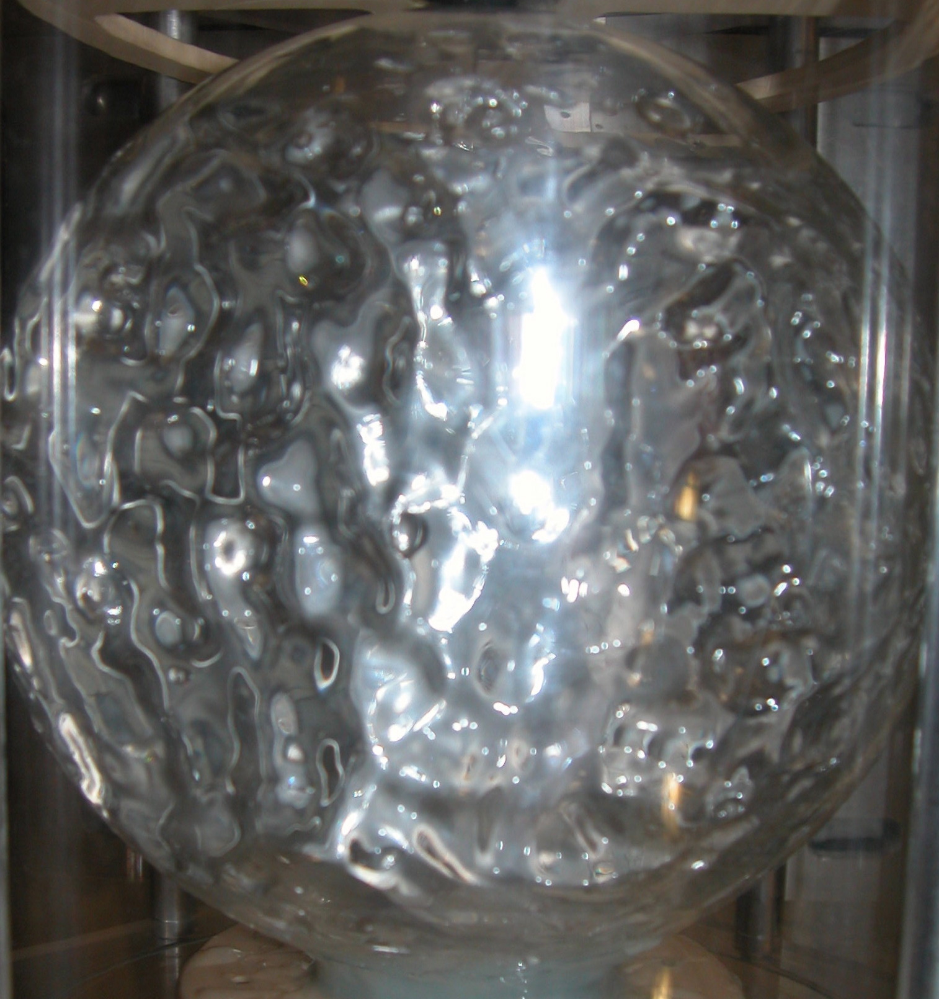
Fig AM-04 Fig AM-05
Such an interaction would imply that the aether space volume remains constant and that the aether space is capable, and has an intrinsic property of interacting with itself, and that the total energy of the aether space is constant at all times. This would also imply that any distortions and energy to create those distortions originates from the aether space itself. By envisioning that an aether space like this, the energy of the aether space to create distortions of it originates from and is representative of the volume of that aether space.
Any external energy added from outside this space through an interaction, either in a region or as a whole, can expand the aether space area and hence volume. Similarly, extracting energy can decrease the aether space area and volume. This external interaction is not entirely satisfactory to consider, and will be largely dismissed.
However, if it is considered that the volume of an aether space has an energy density that is not constant, but is varying from region to region, or is a function of the volume radius, the aether space distortion and change of volume can occur by a change in energy density expanding or contracting the aether volume in a region or overall, and hence changing the surface area of a region or overall of the aether space. Once an equilibrium of energy density is achieved to reach a certain zero energy density, the expansion or contraction of the aether space will cease.
In either of these two scenarios, the axioms AMA05 and AMA06 can be stated.
Axiom AMA05: It can be considered that the total energy of an aether space representative of the volume of it is constant in all situations,
Axiom AMA06:The aether space has an energy density that can vary, giving rise to changes or distortions in the aether volume and surface area.
What axioms AMA05 and AMA06 states is that if the volume of aether space has an energy density that increases either from the center or on the surface, and that energy density is not the minimum, there is a kind of energy gradient that exists that is like a form of energy pressure pushing the surface area to expand as a kind of flow of energy outwards from the surface increasing its area. A speculative mechanism for an expanding aether space that can be a kind of inflation and expansion that is considered and accepted as what is the situation of observation for the universe.
Whether an external or internal excitation of energy is responsible for the fluctuations and distortions of an aether space, the result can be visualised as being of waves of propagation as the energy of distortion is interact and is distributed about the aether surface. Such a representation is given in Fig AM-5 of spherical waves of a sphere or water in zero gravity.

Extension of the aether model to 3D
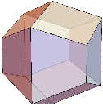
Fig AM06
The above generalisation and description of a 2D aether space can be extended to the situation of an aether 3D space. The 2D hexagonal grid of a surface for 3D volume is of a structure that has the same space filling characteristics of equal distant 3D geometry of constant shape. That 3D shape is that of a Trapezo-rhombic dodecahedron which forms the basis of a 3D aether cell. (Fig AM06) These cells may also be labelled as voxels in this document to distinguish them from a 2D hex surface cells.
A trapezo-rhombic dodecahedron has 12 faces, 24 sides and 14 vertices. If it is considered that it are the sides upon which the interactions occur, then there are 24 sites of interaction per voxel. However unlike the 2D hex cell in illustrated in Fig AM02, the direct lines of interaction between cells indicated by the green arrows are through the 12 faces of the 3D voxel. Thus a 3D aether model may need to account that it is the faces where the interactions occur between 3D aether voxels, even if it is the sides in which energy interactions occur.
It may well be that in a 3D aether model, it is the faces in which energy interactions occur, and that these interactions have a tension and restoration on each face that effect the face as a whole, and not the individual sides of each face. This would be the first line of thought as the lines on each face do not have a direct path going through them from the center of one voxel to that of its neighbours.
So what such a 3D aether model of space is that there is either 12 sites of energy interaction according to a face interaction model, or 24 according to a line interaction model.
As with the 2D aether, another option is that similar to model option AMM02, the energy interaction is upon the voxel as a whole.
Thus the interaction models for a 3D aether Trapezo-rhombic dodecahedron voxel can be stated as.
Voxel Models of interaction
Model option AMM 3D 01
Adding energy to any side of the sub space Trapezo-rhombic dodecahedron voxel can be modelled to have that increase in that side being transmitted through all of the sides of the hex cells that that side is apart of. In effect, changing the size of the voxel sides and faces that the side being deformed by energy is a part of, and in effect changing the size of the sub space voxel. In effect, any energy deformation to a sub space cell by adding energy to one of its interacting sides creates a cascade of interactions along the cell sides so as to then deform and change the overall shape, and hence energy state of the individual voxels around that voxel side being deformed with energy.
This model of voxel side interaction implies that the voxel cell shapes are deformed in a non-uniform manner, with a designated voxel cell able to have one or more of the cell sides of different sizes, and hence energies. Thus the following models can be proposed.
Model option AMM 3D 02
Adding energy to any face of the sub space Trapezo-rhombic dodecahedron voxel can be modelled to have that increase in that face being transmitted through all of the faces of the hex cells that that face is apart of. In effect, changing the size of the voxel faces and faces that the face being deformed by energy is a part of, and in effect changing the size of the sub space voxel. In effect, any energy deformation to a sub space cell by adding energy to one of its interacting faces creates a cascade of interactions along the cell faces so as to then deform and change the overall shape, and hence energy state of the individual voxels around that voxel face being deformed with energy.
This model of voxel face interaction implies that the voxel cell shapes are deformed in a non-uniform manner, with a designated voxel cell able to have one or more of the cell faces of different sizes, and hence energies.
Model option AMM 3D 03
The sub space voxel as a whole is able to have energy added to it which then means that the length of the hex sides all have an equal length and hence energy of interaction, and all sides of the voxel change in equal proportion to the energy added to the cell. This deformation of voxel size is then transmitted to all neighbouring voxels in a 2D version of the 1D string discussed in the chapter Understanding energy.(Fig AM-03B)
What this means is that one aether model of a sub space voxel can be considered as one of the energy effecting the voxel as a whole, not its individual sides of contact of interaction. In this case the voxel as a whole will interact equally with all its neighbours simultaneously as indicated by the green arrowed lines in Fig AM02.
Model option AMM 3D 03
A combination of AMM 3D 01 or AMM 3D 01 with AMM 3D 03 where an energy interaction can deform the voxel sub space cell in either form of interaction. This is the model form that will be chosen as it gives the greatest flexibility as an energy interaction can interact with one or more of a voxel sub space cells sides.
The mode of interaction for a voxel 3D aerther space is the same as that for an aether hex grid model. And that Axiom AMA04 also holds true for any voxel interaction.
The concept of the Aether space for a 2D hex surface also holds up for a 3D voxel model of the aether. The 3D voxel aether is a 3D surface that exists upon a 4D volume and the axioms AMA05 and AMA06 also hold up for a 3D surface upon a 4D volume.
If one were to envisage a 3D surface upon a 4D volume, disturbances or excitations of that 3D surface would be an expansion of that 3D surface away from its zero energy or undisturbed state. Such a disturbance can be detected in the 3D space as an expansion or contraction of some density of a physical parameter or characteristic. Such a parameter may be the measured mass or energy of an entity. Such parameters may exhibit such a density in a spherical shape that is similar to a manifestation of a 4D spherical object intersecting with and being observed on a 3D surface. This being similar to a 3D sphere intersecting with a 2D plane surface being observed in a 2D space as a circle.

Aether Model Considerations
Shape of aether hex and voxel cell represented as vectors of interaction
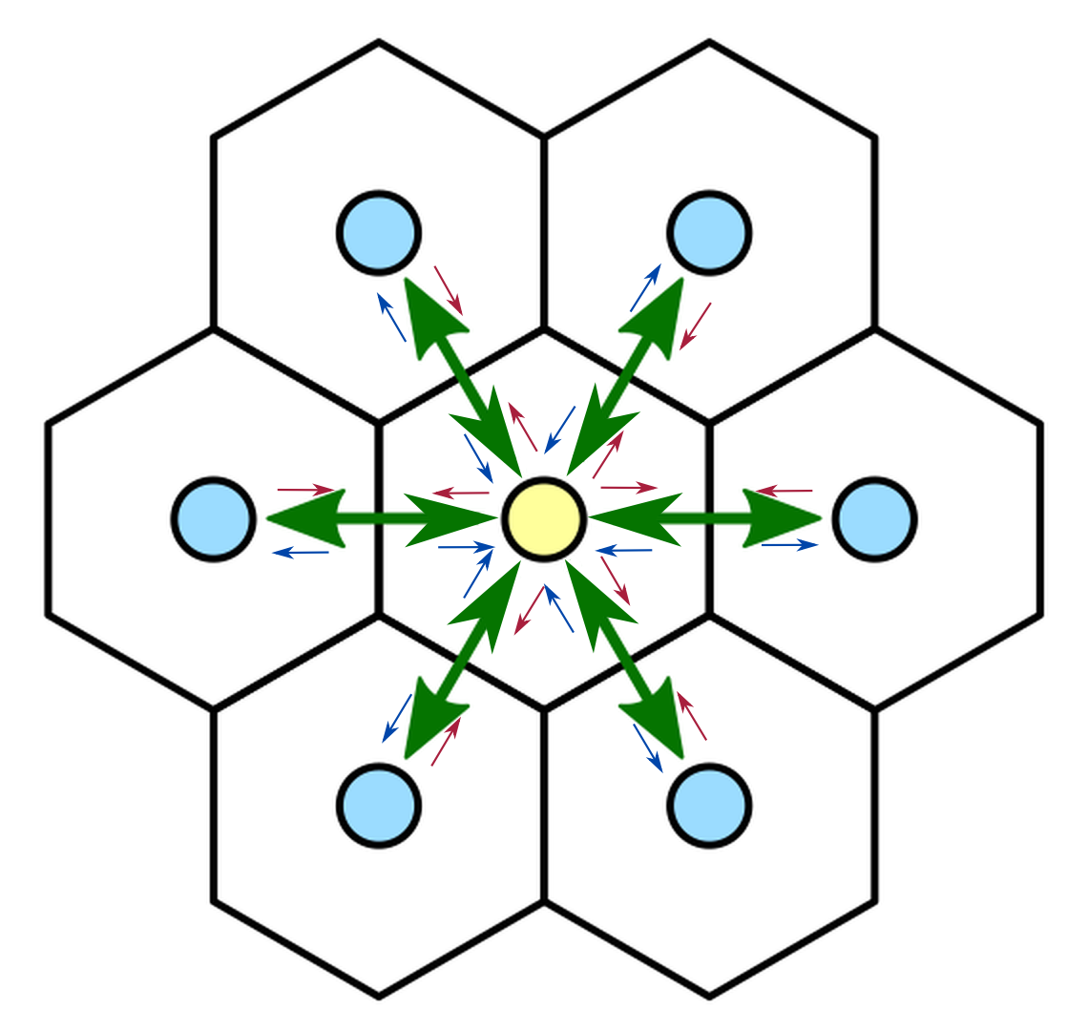
Fig AM07
The aether 2D and 3D model shape described above represent a space filling shapes that are derived and emerge from a structure of evenly spaced circles and spheres of equal radius that have their centers at the center of the hex and trapezo-rhombic dodecahedron. If it is assumed that the interactions between neighbouring aether cells occur effectively at a point on a line joining the centers of the aether cells, then whether that interaction is along a line common to the two cells, or a geometric face, or the aether cell as a whole, the tension and restoration forces described in the sections above can be represented by a line joining the centers of neighbouring aether cells. Such a line for a 2D hex cell is represented as the green double arrow lines of Fig AM07 for a 2D hex surface. As described above, the blue and red arrows represent the effective tension and restoration energies and forces acting between the neighbouring 2D aether hex cells. Changes in the length or magnitude of these lines represent changes in the shape of the 2D aether hex cell.
Thus an aether model of the structure and interactions of an aether space need only to consider in the model parameters for the aether cell, and vectors representing the energies and interactions between each neighbouring cell. This applies to both a 2D hex surface model, and a 3D trapezo-rhombic dodecahedron surface model of an aether space.
Tension and restoration energies and forces modelling
In the chapter Understanding Energy, the tension and restoration forces of a 1D string undergoing a deformation from its zero energy state in the most simple form is of a function similar to a spring with a mass at its free end. This function being
F(i) = k(x_{i},y_{i},z_{i}) ƒ(x_{i},y_{i},z_{i}) EQ-ES04
where F(i) is the force of deformation acting on the ith sub string segment, ƒ(x_{i},y_{i},z_{i}) is a function of the disturbance of the ith sub string segment from its undisturbed zero energy state, and k(x_{i},y_{i},z_{i}) the function of proportionality of the ith string segment. This same expression can be used for an aether sub space cell.
An aether modification of this equation for the ith aether subspace cell and jth vector of interaction gives for
F(i,j) = a(i,j)m_{i,j}
where a(i,j) is the acceleration of the ith aether subspace cell and jth vector of interaction and m_{i,j} a mass like parameter attributed to the ith aether subspace cell and jth vector of interaction.
Rearranging, obtain
a(i,j) = k(x_{i,j},y_{i,j},z_{i,j}) ƒ(x_{i,j},y_{i,j},z_{i,j})
and using vector calculus notation can be expressed as
u_{tt}(i,j) = Δu_{i,j}
which is an expression for a wave equation.
u_{tt}(i,j) = c_{i,j}² Δu_{i,j}
A simple first pass function of interaction for restoration energy or forces is to have k(x_{i,j},y_{i,j},z_{i,j}) equal to a constant. This would then create a simple model of an ether space be similar to that of a surface of equally spaced springs where the green line depicted in Fig AM07 are representative of springs that have an intrinsic restoration force k, and a displacement of distortion ƒ caused by an interaction of each spring or the aether cell as a whole with energy.
This is the set up for a first pass aether model of space that in many respects represents a crystalline solid.
To represent a fluid, this model would need to be modified such that the aether cells are able to change size and move about by having these springs or interaction vectors changing size. Such changes in size can allow the centers of the the aether cells to change location according to how the restoration energies and forces are applied.
This is the set up for a first pass that will be used as a basis for constructing an aether model of space.

Real World Considerations
The above generalisation and description of an aether space is, as stated, a model that can be used to describe and build a concept of an ether space in the real world.
These models do have a flaw in that a real universe aether structure may not work in a geometric manner of structure of interactions as described for a 2D hex grid surface, and a 3D trapezo-rhombic dodecahedron surface. The geometric shapes of a hex and a trapezo-rhombic dodecahedron are space filling shapes that are derived and emerge from a structure of evenly spaced circles and spheres of equal radius that have their centers at the center of the hex and trapezo-rhombic dodecahedron. A real world aether structure may incorporate an entirely different structure of interaction and thus may have fewer or more modes of interactions, or even a varying number. If a real world aether space does have a shape, it may be one of non straight lines and/or resemble a voronoi shape and structure.
For any model of the physical space of the universe, there is the factor of what order of magnitude of scale does the model need to be to mimic the real universe. The mathematical tools of calculus used to create the current theories and models and calculate results seem to work very well for every day applications, and even at the quantum level.
This infers that any size of any aether sub space cell would be very small on the atomic level so as to allow calculus limits for derivatives and integrals trending towards a zero value to be valid to give accurate results. Use of irrational numbers would be invalid and cause major problems at the level of a quantum space that any aether model would be at, and to be able to use irrational numbers on a quantum scale further indicates that any aether sub space cell is extremely small.
What this means is that any aether model of space is of a cell structure of so fine that it may be very difficult to create models on a large scale utilising computational resources. It may also mean that if any aether sub space cell does in fact exists and make up the structure of physical space, it can not directly be observed and measured.
Another consideration is the interactions may not be that of a simple spring as described in Tension and restoration energies and forces modelling of the section aether model considerations. If may be that real world interactions of an aether may be that the restoration fores are not spring like at all, but have a function dependent upon the amount of deformation or separation of centers of the aether cells from each other. Other possibilities are that the restoration forces are non linear and vary according to some exponential relationship.
Despite these concerns, if the universe is of a structure of an aether space, it is unknown what the structure of this space is as with much of physics. But this is not the goal here. The goal is to create a possible model of an aether space, and from that model see if there are behaviours, structures, and physics that reflect or resemble real world physics. If there are, then a better understanding and knowledge of the inner workings of the universe at a fundamental level can be achieved. If necessary and/or achievable, refinement and modification can then be applied to obtain better results of that understanding and knowledge.

