The Standard Model

The standard model of particle physics is often acclaimed as one of, if not, the most comprehensive and successful theories of modern physics. It is a theory that claims to model on the most fundamental level of the physical universe, the most basic processes and behaviours that make up the building blocks of matter and energy. From the standard model, an understanding and basis can be formed to describe and model higher level physical forms of matter and energy, from the fundamental particles, to atoms, molecules and the observed physics of each level.
The standard model is anything but simple in its construction and the mathematical models that are used to describe it. It is assumed the reader will have a basic understanding of the standard model of particle physics, and if not, many a youtube videos are available to view and obtain a basic understanding of it. Some links are given below.
The map of particle physics

The Standard Model-Fermilab

The Standard Model
The standard model: what's the evidence for the quark?
Evidence of colour charge
What is a Neutrino - the Most Mysterious Particle in Modern Physics?

Quarks, QCD, and the Rise of the Standard Model

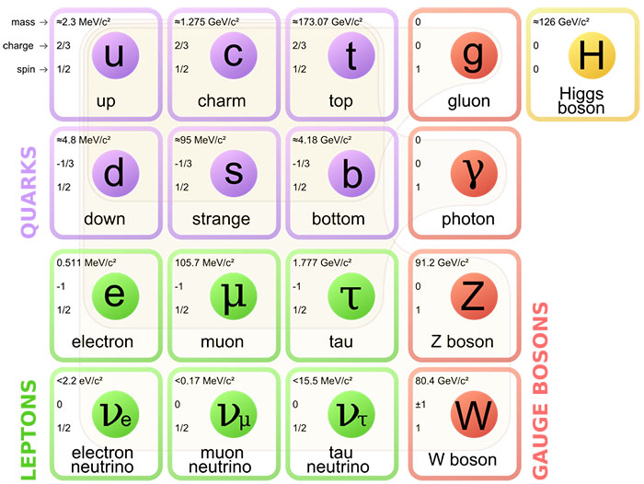
Fig SM01 : Standard Model of Particle Physics particles
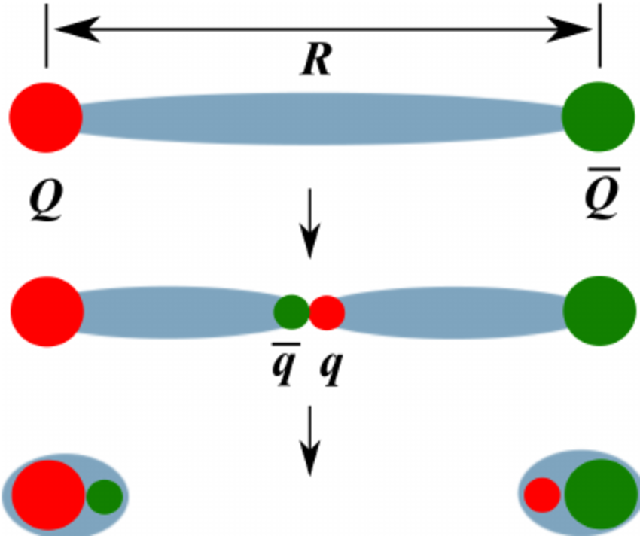

Fig SM02 : gluon string breaking.
Quark anti quark pair seperation distance R increases with added energy until energy creates new anti quark- quark pair that then form two new particles
And a search of standard model of particle physics on youtube will give more.

The standard model has at its core, the assertion that all matter consists of two groups of sub nuclear particles, given the names of quarks and leptons, that form the basis of all matter.
Quarks combine together following certain rules of quantum field theory to form the observed nuclear matter that makes up the universe, such as protons and neutrons. It is asserted that all nuclear matter of protons and neutrons are not fundamental and are made up of different types of quarks that have certain properties and are held together by an interacting charge carried by a charge carrier called gluons.
Evidence of the existence of this nuclear substructure is in the form of particle accelerators accelerating electrons and nuclei at high velocities to collide together, and observe the results of the scattering of these electrons. In an analogy to Rutherford's experiment of discovering the atomic nucleus by observing helium alpha particles directed onto a gold foil, it is assumed that a similar process will happen in the nucleus of an atom, and in particular for a proton or neutron to scatter high energy electrons in a non elastic fashion if the nucleus is not a fundamental single entity.
Observations gave this impression, and it was then given that the interpretation was that protons and neutrons were not fundamental, but were made of more fundamental entities given then name quarks.
No quark can be directly observed as an individual entity, but can only be inferred of their existence from theory and observations of decaying particles (mesons) that are proposed to be composed of quarks. Theory states that quarks have a binding energy that increases with increasing distance between them. In other words, as the quarks are attempted to be separated from each other, the interaction of attraction between them increases, unlike with gravity where the interaction of attraction increases as the distance of separation between two entities with mass with mass gets smaller.
The standard model stipulates that as quarks are attempted to be separated from each other with supplied energy, the added energy creates particle streams or jets from the gluon energy in the form or new quark-antiquark pairs particles that are coupled together with gluons.(fig SM02) The theory explains the observed jet streams of created particles in accelerator experiments by this process.
The electron is itself postulated as being a most basic form of matter along with other observed electron like particles called muons, and theoretical non observed photon like particles called neutrinos. These particles are grouped together that form the matter that is observed in the universe are called Leptons.(Fig SM01)
Quarks and leptons that form the matter that is observed in the universe are grouped together as set of particles that are called Fermions.
Each of these fundamental particles in the standard model have an associated field with them, and it is fluctuations in the field associated with a particular particle that define that particle. These interactions have yet another particle of a specific type that carries or conducts the interaction between the fields of the Fermions and Leptons with each other or between them. These interaction carrier particles are grouped together and are given the named of bosons.
It can be said that the standard model defines any observed particle as an excitation of the field that the particle is associated with, and that a particle is not some entity that exists as some kind of self contained independent entity. Interactions of particles can be said therefore to be an interaction between the fields that define that particular particle and that of another. In other words, the standard model states that at the fundamental level, all observed physical phenomenon are the interactions of fields that define matter. Thus the standard model can be stated that it is a quantum field theory of matter.
A concept that has brought forward, through very complex mathematics, a model that describes to within acceptable accuracy, the workings and explanation of how matter of the universe comes into existence, and the behaviour of such. However, the standard model has a flaw in that it cannot include within it, gravity. As with the boson particles of the model to conduct the interactions between matter of the universe, a proposed boson for gravity, the graviton, causes the model to fail and collapse. Gravity cannot be included in the standard model, and thus this may give an indication that the standard model, if gravity and all the other fields of interaction are to be merged into a grand unified field theory, needs a major modification, is incorrect, or that gravity is indeed a separate property that cannot be incorporated into the standard model.
Assume that gravity is a property that along with electromagnetism, the strong and weak nuclear interactions, forms the basis of the physical universe and all are unified and derived from a more fundamental field, then a task and method or new way of thinking needs to be formulated to find a solution to such a universal field theory.
One such beginning is that the Standard Model has the electron as an entity that is not made up of a substructure of fundamental entities, quarks, as the standard model postulates that a proton or neutron does. An electron is in itself, a fundamental entity, but not a quark, yet it has many of the same properties as a hadron that is made of three or more quarks.
The question of why the electron exists as not being, or consisting of quarks may be a clue that the standard model is not correct in that the postulate of the existence of quarks is illusory, and do not exist except as a mathematical entity within a mathematical model of the structure of matter. In other words, there may well be a physical process at play in what is observed that is facilitated by the existence within a model, the standard model, of a mathematical quantity called a quark. A process and understanding that is beyond current human knowledge, but which is facilitated by the standard model. If such a physical process is present, then the standard model is a clue in itself to that true and real knowledge and understanding of what is the fundamental nature of matter and the universe.
Consider that except for mass, an anti electron, the positron and a proton can be considered essentially of having the same physical properties. They both have the same electric charge and spin, which suggests that the same process of electromagnetic interaction that each experiences and undergoes is the same. The quark model that has the proton consisting of two up quarks and a down quark of fractional +2/3 and -1/3 electric charge which indicates that if quarks do indeed exist, they also for consistency and uniformity. must experience and conform to the same electromagnetic interactions that any entity with electric charge undergoes. That is because the two positive quarks have a net repulsive electric field greater than the net negative attractive field, a proton should be unstable and thus decay into individual quarks and never exist?
The answer to this is, of course, given by the standard model, the gluon. Another field that has the properties of having three charges, that when combined become neutral or zero. And in addition, has the field strength increase as the distance between quarks increase, thus confining the quarks to exist within a confined space.
All this creates a complexity that leads to other questions that need to be asked and explored.
One such question.
If individual quarks make up protons and neutrons, then should not protons and neutrons have the quarks of like charge separated into a molecule like structure where the bottom quark is centred between the two up quarks within a proton, and the up quark is centred between the two down quarks within a neutron? If this is the case, would then be the result that both would not thus have a uniform electric field, and a neutron be slightly more positive on one axis, and thus not be a particle of zero uniform net electric field in all directions?
Then there are the questions that beseech any entity that has a substructure such as the net shape, rotation, and mass distribution of such entities that are made of substructure entities that are not of uniform mass or electric, and perhaps gluon colour charge. How do these individual quarks govern and evolve the behaviour of matter in the quantum world above their level such as what is considered as matter waves etc?
Another change of thinking and method of inquiry may be in the electron-positron pair production and annihilation.
A method to find a model of physics to unite and merge the standard model with gravity could be found by considering first that by theory, experiment and observation, an electron positron pair can be generated by the gauge boson of a photon of sufficient energy interacting with the nucleus of an atom. Such an interaction in the presence of a nucleus and the constituent electrons that make up an atom may give one clue to a grand unified field theory. It may also give a clue as to an explanation and how the numerous unstable particles that are generated by cosmic rays and within particle accelerators known as the particle zoo come into existence.
A consideration with the standard model is that it is a highly mathematical and abstract theory that has in its construction, several fields that define the physical properties of matter which then interact with each other through hypothetical particles that carry the interaction. Hypothetical particles that are inferred to be created from energy and exist based upon the observation of proposed decay processes and not direct observation. It may be suspected that the standard model is not a true physical model of the processes and workings of the universe on a nuclear and sub nuclear level, but is a representation in a mathematical form of the physical processes. Gluons and quarks as given by the model may be a representation of a process of energy interaction, as do the gauge boson particles. The separate fields of electromagnetism, color charge, spinor, Higgs etc may be just a reduction or separation of physical elements of a single form energy interaction that can also generate emergent physical properties, processes, and behaviours.
In the end, it may not matter whether or not if the standard model is a model that accurately describes the processes of the nuclear and sub nuclear realm. Like with Einsteins general relativity superseding Newtons theory of gravity, general relativity is not required for most gravitational calculations that exist in low gravitational fields and velocities much smaller than the speed of light. It the main, it works in all practical applications. However, to gain a true understanding of the universe for the purpose of gaining a greater knowledge and to advance further in more general and extreme situations, the physical model needs to reflect in a direct fashion as possible the processes of nature without any abstract mathematics that is so far removed from the reality that it losses context and meaning.
Never the less, the standard model, like many models of the physical universe, gives acceptable and even highly accurate models of prediction of physical phenomenon of the universe. However, these models are limited in that even with the process given, the most fundamental understanding of how a photon of sufficient energy in the presence of a nucleus can produce an electron-positron pair is not present. To have this understanding and knowledge would, in the opinion of this author, unlock the secrets of how all the physics of the quantum world and gravity can be united into a single field theory, and even dispel or modify the standard model into a more complete and perhaps simplified form. If it can be understood and discover the process of electron-positron production, then all other forms of matter production and processes of transformation can be understood as a variance of a single process.

Finding an alternative to the Standard Model
To find any alternative model to the standard model into a unified field theory of physics, a recourse and review of all physical phenomena and behaviour would need to be undertaken. This undertaking needs to reduce all physical processes and behaviours down to the lowest and most basic fundamental level such that no further physical process can be used to model and explain the observed and measured phenomena being examined.
A simple example of the temperature of any physical entity and its state as being a solid, liquid, gas or plasma, can be attributed to one physical process, and that being the exchange of energy. This exchange of energy can be attributed to the interactions of electromagnetic fields of individual atoms causing them to be set into motion. These interactions of electromagnetic fields in turn is the result of photons being generated or absorbed within the individual atoms or the electromagnetic bonds between them causing the electromagnetic fields to fluctuate, and in turn the atoms and the electrons of atomic structure themselves to be set in motion. Thus Temperature being measured by whatever means, be it the change of volume of a liquid, gas, or the resistance of a metal, is a measurement of the exchange of energy, and in particular electromagnetic energy that alters the physical state and structure of matter.
In many instances, many observed physical phenomena is at its most basic level, in an interaction of electromagnetic fields that result in an exchange of energy that gives rise to changing the motion of observed entities such as atoms and molecules. Even in the macro world of the human scale, collisions of objects such as billiard balls can be reduced to the interactions of electromagnetic fields of the atoms that make up those objects.
Thus the most fundamental and primitive level of all physical phenomena that is seen in the universe from which all other emergent physics is derived from is the interaction and process of one or more fields such as the electromagnetic field. The other observation attributed to a field is gravity.
Gravitational fields are governed by the physical property of matter of mass. Einstein created a model for gravity that is geometric and has the spacial field that surrounds matter being distorted and changed by the presence of mass. This distortion of space guides how all matter moves.
In a kind of feedback loop, a net gravitational field is generated or forms from the interaction of the individual mass of all entities, which in turn interacts with all entities of the universe creating a path of motion for all to follow. In following this path of motion, the gravitation fields of each mass then defines a new net gravitational field which then sets the environment for further motion of all entities.
Gravity not only effects entities with mass, but also the electromagnetic fields such that photons that are defined not to have mass, also have their path of motion defined by gravitational fields. With the path of photons that are essentially a disturbance of the electromagnetic field being influenced by gravity, this would suggest that an electromagnetic field either rides in the gravitational field and is separate of it, or interacts with the gravitational field and is part of it.
If the electromagnetic field and gravitational fields interact, then each should be able to influence or change the other. Indeed this is the case. Photons escaping from a gravitational field lose energy and measured wavelength suggesting that the electromagnetic field that make up a photon interact with the gravitational field in a manner that couples the electromagnetic field to that of a gravitational field. The converse may be true, that an electromagnetic field can influence or generate a gravitational field.
The convention is that a gravitational field is associated with space, and that gravity distorts space. Thus and explanation to how and why photons change energy or observed interpreted wavelength is due to riding on this distorted space, and thus being distorted by it. This then brings up the question of what is space, and what is its composition and properties. The section Understanding Space is an attempt to grapple with this question.
In any field theory that links or merges electromagnetism with gravitation, one requisite is perhaps that the link between them is the physical property of the concept of space. If this is so, then it may then be considered that the 3D space that makes up the observed universe is not the space that makes up the physical universe, but that it is a projection from a higher level of dimension, and most notably a forth dimension that defines the physical phenomena that is observed. By taking such a leap of perspective, and exploring this possibility, a solution may be found to the origin and even emergence of a uniform theory of gravitation and electromagnetism.
Electron-proton consideration:
In the standard model, the proton is modelled to be constructed from three sub-nuclear particles named as quarks, and the electron given as a fundamental particle in its own right.
If an electron exists in its own right as a fundamental particle, then what is this fundamental particle?
The standard model may partially answer this in that the standard model considers all particles as excitations or disturbances of the electromagnetic field. Consider that the electron is such an excitation or disturbance that is in a self interacting and stable form of the electromagnetic field. The charge, mass, spin and other properties is an emergence of this stable electromagnetic field that is governed by certain universal limitations that are set. How such a self interacting and stable form of the electromagnetic field is constructed if it is the correct process, would be a codex to how the universe operates as a whole for a description and understanding of all matter.
Consider that if one observes the physical properties of the electron and proton, besides the mass, they are essentially a mirror copy of each other. The anti electron, or positron can be considered to be equivalent to a proton in all but mass. So the question can be, why do protons exist, and how. Protons are not necessary for pure symmetry of the physical conservation laws of physical properties to exist in the universe?
The answer may be as to the mass of the proton. If there is a connection of electromagnetic fields to gravitational fields, it may be in the mass of the electron to that of the proton. Consider as a possibility that the electric fields of the proton to that of the electron is different in their densities, but not in their overall charge. Consider that the charge density is related to the mass, and a greater mass gives a higher charge density. That is, a proton may have the same electric charge as an electron, but it has that charge confined to a smaller 3D volume related to its mass. Similarly, the electron. has a charge density related to its mass but since it has a lower mass, it has a lower charge density, and thus has a larger volume in which the electric field is confined to.
If electrons, protons and their antiparticles are stable, and all other known particles transform, ie decay into particles of lower mass energy and photons etc, then it may be that these particles are excitations of the electromagnetic or other field that are in an unstable state such that the excitation changes form to the most stable state that is dictated by an unknown processes of the natural physical universe. That is, particle transformation or decay can be viewed as a kind of path of least action or energy within a field of energy that defines all particles.
Speculation of Relativity in the quantum world
If as proposed as a speculation that the mass of a particle is related to a charge density, and assuming that the physics of of Einstein’s relativity is applicable art the quantum scale, then where there is mass, there is relativistic physics present. One consideration may be that the particles of the universe such as protons and electrons may be a form of minuscule black holes. If a mass is present, and if particles can be considered as a singular fundamental particle, then a speculation can be proposed that a black hole like surface can exist which has a volume of area comparable to the size of the particle that it is associated with.
A particle that has an electric field could have that electric field coupled with the gravitational field, and if is speculated that a particle is a result of an excitation of the electromagnetic field into some stable or semi stable self interacting state, then a mass and the gravitational field associated with it is a product or emergence of that self interacting state of the electromagnetic field.
This would then lead to the speculation that space itself is a field which harbours the electromagnetic field as an intrinsic property that exists is within it, and that defines space itself. Speculation is to propose that a self interacting electric field confines part of this electromagnetic field within a confined volume of space that then results in a property of mass, and hence an emergent gravitational field. This confined volume of space has a charge density proportional to the mass of the particle which also defines the size of the particle in terms of an electromagnetic field.
It may be that the gravitational field determined by the mass of a particle, has the mass determined by the stable electromagnetic field of the particle have the same surface area and volume. Speculation that unstable particles perhaps are an imbalance of gravitational and electromagnetic fields causing that particle to transform, ie decay to a more stable balance of electromagnetic and gravitational fields.
If the speculation that particles are defined by an excitation of the electromagnetic field in a stable, self interacting form within a physical entity of space, and that this interaction in turn defines a confinement and density of this space and it electric charge into a form that is measured and defined as a mass, then a unification between the emergent gravitational field and the electromagnetic field can be developed.
The as yet wild speculation would be that a gravitational field would be the emergence of space being a product of the electric field density, and that gravity is an interaction of the charge density of space. Higher charge density, higher mass, greater is the gravitational interaction. However, this charge density or mass interaction is much weaker and is easily overcome by electromagnetic interactions.

Speculation of the neutron and the strong nuclear force
The standard model explains the decay of a free neutron via the weak force as such.
A free neutron interacts with the weak nuclear force via one of the two down quarks that are modelled to be sub-particles that make up the structure of the neutron by interacting with a W¯ particle, which then transforms or decays into an electron and an electron antineutrino.
However, if an electron with sufficient energy can be captured by a proton to produce a neutron in a process of electron capture. The standard model explains this capture as a reverse process where an electron interacts with a W⁻¯particle, which then interacts with and changes one of the a protons up quarks into a down quark, and transmits an electron neutrino.
This part of the standard model has evolved so as to have energy, momentum and spin conserved of the electron and proton to that of the neutron.
If one considers that a neutron is not a fundamental particle, but is a combination of a proton and an electron such that the two are in a physical state of being where the proton electromagnetic field is surrounded by that of the electron electromagnetic field, and the resultant net electric field of this interaction of electromagnetic fields beyond some radius of this proton-electron interaction is zero. Considering the hypothesis outlined in the section Electron-proton consideration, such a proposal would have the smaller proton with greater mass and charge density surrounded and enveloped by an electron of larger size with lower charge density, but equal total electric charge overall.
This would then suggest that the structure of a fundamental particle would be primarily, if not totally of a surface in nature, and that any interior to this surface does not conform to any concept of being solid. That is, impermeable and impenetrable. The fact that a neutron has greater mass than that of a combination of a free proton and electron can be explained that extra energy is gained and needed in such a proton-electron system to form a neutron. This extra energy is more than likely gained by the electron which modifies its physical state so as it can interact with a proton and form a neutron.
A proposal for the neutron to be emergent from a proton-electron bonding interaction was made about century ago soon after its discovery, but was quickly dismissed. The reasons for this rejection was based upon, as it is since, on the basis that such a model would conform to the same physics and model of the electron cloud of an atom.
However, speculating the physics on a nuclear scale is of the model of a proton-electron interaction is possible, then the strong nuclear force binding the protons and neutrons together will be a sharing or exchange of electrons between neutrons and protons, switching a neutron into a proton, and a proton into a neutron. Such an exchange would need to be performed synchronously within the nucleus in a small enough time step to have the electric repulsive forces of the electromagnetic fields of all particles balanced. Such a balance should be present where there are small numbers of proton-neutrons present in equal numbers where the distribution of nucleons are in a symmetrical or ordered configuration so as to remain stable. Eg Helium, carbon, oxygen etc.
The standard model has a similar but different mechanism for the explanation of the strong nuclear force by using an argument of neutral charged pion mesons are exchanged between protons and neutrons. The neutrally charged pion mesons acts as a kind of force carrier of quantum chromodynamic charge to exchange colour charge between protons and neutrons. In the standard model, hadrons are composed of quarks that each have a colour charge, and similar to atomic structures being held together by electromagnetic interaction, are held together together by means of a colour field interaction. This colour field interaction is mediated by hypothetical gluons in a similar reasoning that the electromagnetic interaction is mediated by the photon. Since protons and neutrons cannot directly interact with each other through colour charge interaction, they need an intermediary neutral colour charged particle to exchange this colour charge between the proton and neutron, and perform the colour charge interaction between the proton and neutron. That intermediary neutral colour charged particle is the pi° meson.
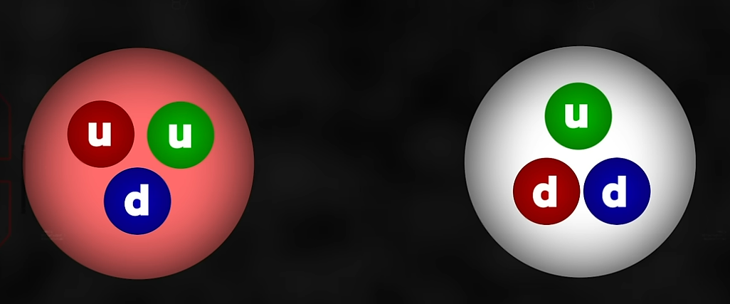
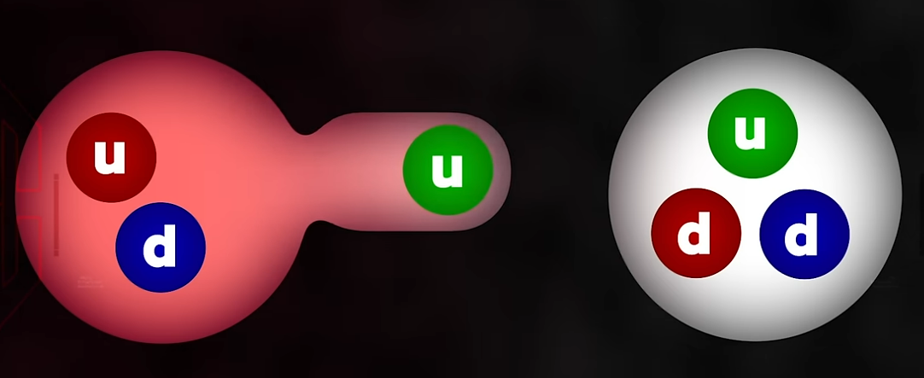
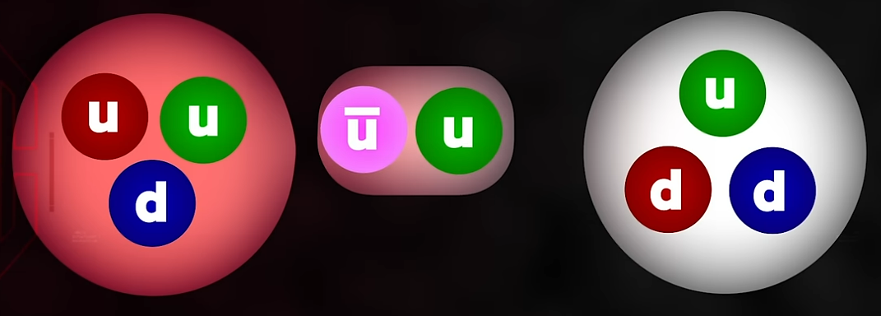
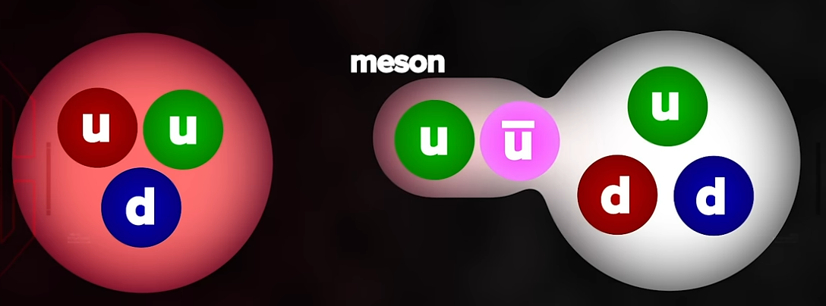
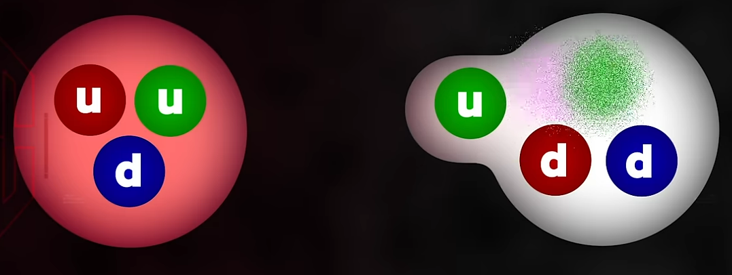
Fig SMA01 Standard model of strong nuclear force
This youtube https://www.youtube.com/watch?v=E8hyodMhbRw video gives a description of this process that is illustrated in Fig SMA01
The standard model also thus has the requirement that the strong nuclear force is conducted in a small enough time step to overcome the electromagnetic forces present in the nucleus and is most stable of the nucleus being small and having an even number of protons to neutrons where the distribution of nucleons are in a symmetrical or ordered configuration.
The standard model has an indirect mechanism to explain the process of a strong nuclear force holding a nucleus together, whereas the electron-proton interaction utilising an electromagnetic process of interaction is more direct, and hence one would suspect, more simple.
One aspect to consider with the neutron being constructed from a proton-electron pair is the conservation of physical properties of mass-energy, spin, charge and momentum that must be present in any transformation of the neutron to a proton-electron. For a neutron decay, the observed equation of the decay process is.
n → p⁺ + e¯ + γ - SMAE01
Charge is conserved,
mass-energy is conserved with the conversion of mass to energy represented by the photon γ.
Momentum can be considered conserved through the momentum of the exiting photon γ.
Spin is apparently not conserved as it is considered that a neutron is not a single fundamental particle. However, if it may be considered and acceptable that an electron that interacts with a proton to form a free neutron is not to be considered as two separate entities acting independent from one another, but is a single entity born of the supposition of two entities that do not occupy the same physical quantum state, and hence are able interact with each other to form a single entity that is a free neutron. Consider that as a single entity, the neutron thus has a spin given to it as a result of its formation as a single entity that is a result of its construction, and not a spin that is a function of the electron and proton pair from which it was formed. That is, a resultant neutron is made up of more than the individual parts that constructed it. Such a proposition would also be valid for any other observed phenomena of a single particle decaying into separate individual particles.
To explain nuclear decay is similar to the standard model. An imbalance of the configuration of proton distribution creates a state or situation within the nucleus that the exchange of electrons between protons cannot overcome the electromagnetic repulsive interactions between protons, and the nucleus splits or fragments into smaller, more stable nuclear parts releasing energy in the form of photons and the kinetic energy of the fragmented parts. Free neutrons may also be released which in time through a sensitive and unstable nature of the interaction between the proton and electron pair, decays into its constituent parts as in SMAE01.
Thus this model of nuclear and neutron decay need no intermediary W particle that the standard model demands for nuclear decay, and defines the weak nuclear force.
Thus an alternative basis for a model of the nuclear processes and interactions is defined. This is a model of speculation and consideration. To validate any such a proposal needs to have some mathematical modelling to be performed to back it up.
Speculation of the particle zoo
The particle zoo is a reference to all of the additional particles that are observed that are not the stable variety of protons, electrons or neutrons. Given that a particle is defined as a state of excitation within the electromagnetic field that permeates throughout the universe, then these additional particles can be defined as an excitation of this electromagnetic field, but because they only briefly exist, this excitation state can be defined as unstable.
Speculating with logic, any unstable state of excitation with no additional input, will through the concept of a physical process following a path of least action, and according to its physical state of being and its local environment, transform or decay to a lower state of excitation. Such a process would infer that this would be a transformation to an excitation state of lower energy as one or more particles of lower mass, and or emissions of photons of energy.
It would be expected that such transforming decay processes could have several steps for particles of large mass or energy decaying into particles of lower mass until a stable particle(s) of a proton, electron, their anti particles or photons of energy are produced.
Speculating that a neutron is one of a unique physical state that has a proton and an electron in some system of interaction and that is unstable, then other observed “particles” may also share such an unstable system of interaction that give a similar form of decay.
With this model of speculation and definition, then all the particles that are observed in nature that make up what is called the particle zoo that has been observed in particle accelerators and cosmic ray interactions can be explained as being in a state of stable or non stable of excitation within the electromagnetic field that exists and makes up the universe.
The production of these observed unstable particles that make up the particle zoo is a result of interactions of the electromagnetic fields of colliding particles naturally as cosmic rays with the nucleus of gas molecules in the atmosphere, a cloud or bubble chamber, or via particle accelerators colliding a beam of electrons, or a charged nucleus of a certain atom with a target or another beam of charged nucleus. The result is the same. A production of unstable particles that posses certain properties that is a result of the interactions of the collision of electromagnetic, and as is perceived, nuclear fields.
The standard model of physics is built upon the basis of what observations are made, and interpreting these observations as new particles acting within a detector that commonly has electromagnetic field to measure properties such as electric charge and mass. Observed are the products of the decay process that each unstable particle undergoes, producing even more particles until no more decay products are produced, or are dissipated as energy in the form of one or more photons. It is from the observation and measurement of these decay products that the standard model is formed to create and explain the observed experimental results. The theory then was extended to make predictions and attempt to unify the observed forces, ie fields of nature. Unfortunately for the standard model, gravity has not been able to be included as part of it.
With all that the standard model has accomplished, it may also be incorrect in that what is interpreted as quarks being further fundamental entities on their own right, that are bound together through a trifecta called colour charge. It may be that the quark-gluon model is a complex version of some underlying process of field interaction that is as yet not conceived and unknown. Much like that the Ptolemy model of planetary motion gave acceptable results of prediction, but was fundamentally wrong in that a sun centred model gave the same results with that lead to a higher level of knowledge and understanding leading to more accurate predictability of planetary motion and a theory of gravity. This revelation then also progressed the human mind into new corridors of knowledge understanding and thinking.
The speculation proposed is that the observed particle zoo of unstable particles is that they are all formed and composed of a process of a form of an unstable self interacting electromagnetic field that has not the required energy or physical properties in the required quantity or configuration to remain stable. The only particles that are known to be stable are proton and electron plus their anti particles. To be able to discover and model why these are the only stable particles that are known to exist should lead to a wider and simpler model to understand and explain all the other unstable particles that are known as the particle zoo.

More videos on the standard mode of particle physics

Resonances and Strangeness
Resonances and Strangeness
Resonances and Strangeness
Resonances and Strangeness
Resonances and Strangeness

Standard Model Notes :
Decays due to weak force evidenced by lepton production.
Decays due to EM force evidenced by photon production.
Decays due to strong force evidenced by pion production.

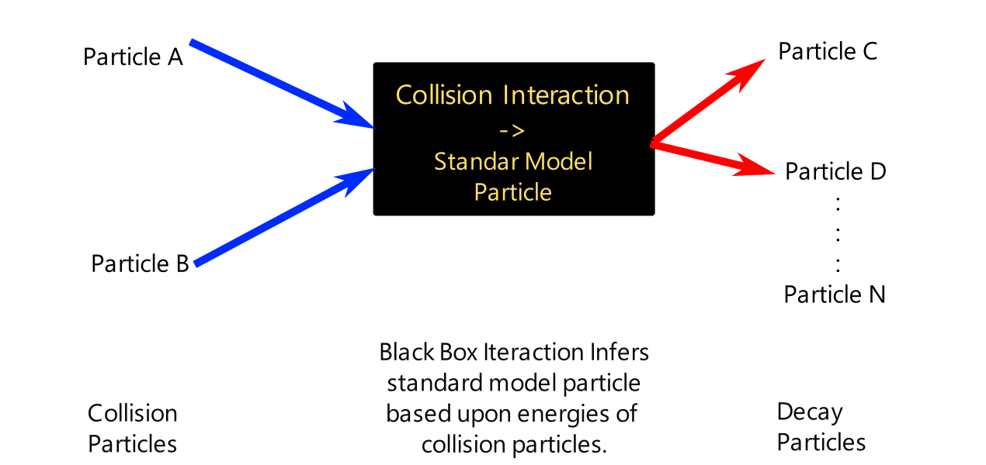
Fig SMN01.
How standard model deduces existence of non observable particles

Most of particles that the standard model states that exist are not directly observed as they are calculated to have time periods of existence so small that they cannot be observed by experiment. This then has the consequence that the standard model particles are inferred to exist by the assertion that the experimental observation of production of the above decay processes from the interaction of two colliding accelerated particles such as beams of electrons, protons or atomic nucleus with a target or another beam give evidence of the existence of a high energy particle. A schematic of this method to prove the existence of a standard model particle is as in Fig SMN01.
In other words the existence of many of the standard model particles is asserted to exist from the standard model giving a theoretical prediction of the production of decay particles rather than a direct observation of interaction or detection of the standard model particles themselves. This can leave the door open that a black box process of particle interaction is occurring to produce the resultant observable particles that does not need the existence of such non observable particles.
In observed experiments where the existence of such short lived particles are proposed, a measurement of energy is plotted against the production of decay particles, and where there is a peak of production of particles, this is defined as a resonance of energy for that proposed particle. From this peak a defined energy range and mass for the proposed particle is calculated. A further consideration is that these resonant energies are measured at scattering angles of the colliding beam(s), target configuration.
Given that many of these collision beams are accelerated to a significant fraction of, or near light velocities, it is assumed that relativistic physics is taken into consideration of the observed results and mathematical calculation and modelling so as for interpretation of the physics that may be occurring is considered as valid and correct.

