Reference Frames

To perform any type of physical analysis, or create a model of a physical process, the concept of a frame of reference needs to be introduced so as to model and explain the observations of physical systems and the interactions of physical entities that are in motion relative each other. Reference frames are important in that what one observer or entity perceives as one form of physical process or interaction would be different to another when the two observers are in motion, and that the transmission of information by which the interaction or observation is made not instantaneous.
To explain any differences of observations between two observers in motion relative to each other requires a consideration to see things from the perspective of the other observer or entity in respect to ones own. Eg that of a perspective of a fixed location on the surface of the earth vs an object look the moon in a motion of orbiting around it, to that of a location stationary on the axis of the earths rotation. Each have a different observation of perspective of the motion of entities as each will be in a different reference frame of motion.
Thus without taking into context of the reference frame that a human observer is in, a very incorrect and misleading conclusion of what is the true physics that is taking place can be deduced. Examples of defined pseudo forces in certain frames of reference can lead to the wrong models of physical systems being created, and thus leading to a cascading of misunderstanding and incorrect conclusions of the physics that is taking place. The example of the Ptolemaic model of the solar system with the earth as the centre of the universe being one.
And this can even be true in modern physics. Current models of the universe on the macro or micro level may be incorrect if the perspective that the model that is being used is in a reference frame that is incorrect or even not known. Some theories of physics require dimensions of space greater than the three that Is perceived by the human mind. Even the geometry used within a reference frame to create the models may not be sufficient.
With the limitations of what reference frames can be modelled or thought of by the human mind to model and explain the universe, they are thus important and need to exist to do so.
Below is perhaps a different take on an interpretation and model of what reference frames represent and a perspective of how the physics of a moving object may be observed and measured. Some of the results do look different and unexpected. Perhaps the maths and approach may be the reason. No claim that what follows is correct, just that the results of the mathematics gives is what it gives.

01 : Definitions

Definition : DRF01 : Observational frame of reference
In physics, an observational frame of reference is defined, in essence, as the observational properties that are present and “observed” from the perspective of an entity that is in a state of motion and does not interact with other entities, or have physical properties of interaction.

What this means is that more than one entity can share, or be in the same observational frame of reference. Such a shared observational frame of reference is where the physical state of all entities within it do not change. Any entity that has a state of motion continues with that sate of motion. Such as if two entities E_{A} and E_{B} are moving with constant velocity in any unchanging direction with respect to each other, and that the direction does not change, then those two entities are in the same observational frame of reference as an “observer” O entity that “observes” their path of motion. If the observer is entity E_{A}, then from E_{A} perspective, E_{A} is stationary and E_{B} is observed to have motion that does not change. Such an observational frame of reference is defined in physics as an inertial frame of reference

Definition : DRF02 : Observational inertial frame of reference
An observational frame of reference in which the observational physical properties, such as motion, of all entities that are present and “observed” from the perspective of an entity are static and do not change.

The opposite of an observational inertial frame of reference is a non observational frame of reference where changes to the physical state of one or more entities that are “observed” to occur. Such changes are attributed to a force, which most often is attributed as changes in motion such as direction or rate of motion that is defined as acceleration.

Definition : DRF03 : Observational non inertial frame of reference
An observational non inertial frame of reference is a frame of reference in which the observational physical properties, such as motion, of all entities that are present are “observed” from the perspective of an observer to continually change in motion. Observational non inertial frames experience a change of physical properties due to what is perceived as an acceleration that is attributed to some form of perceived force.

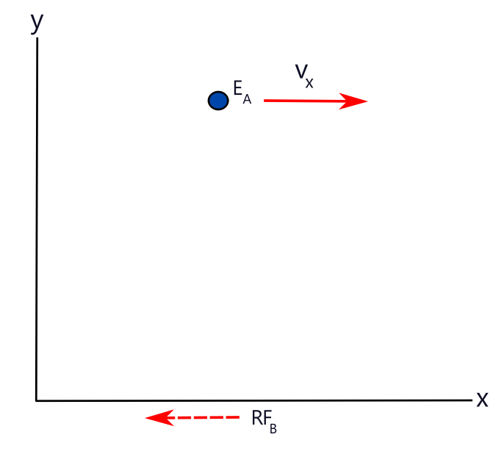
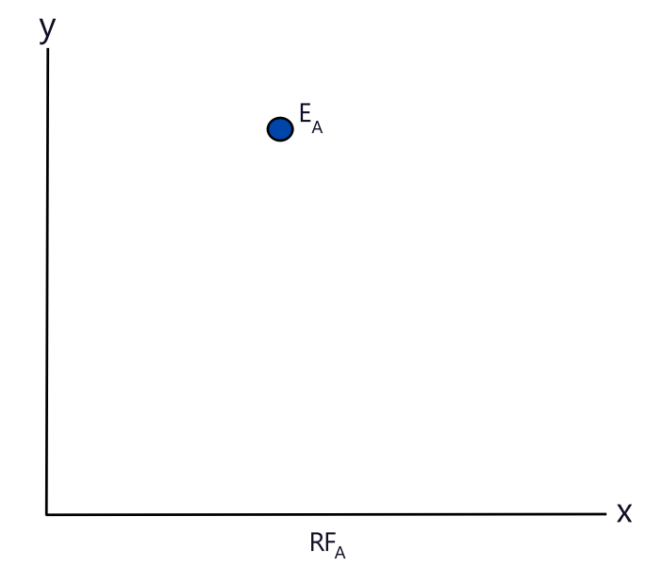
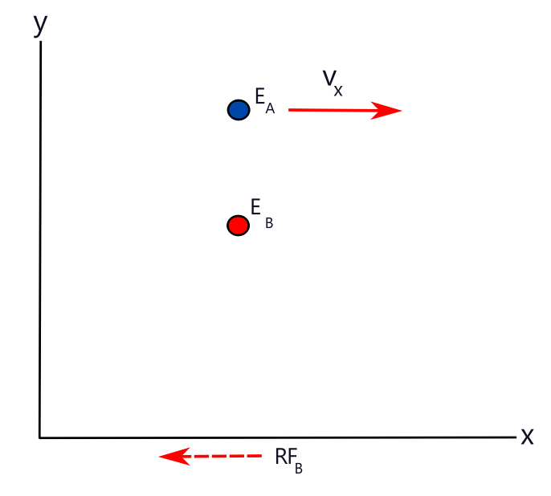
Fig RF01a Fig RF01b Fig RF01c
Entity E_{A} in RF_{A} perspective Entity E_{A} in RF_{B} perspective Entity E_{A} and E_{B} in RF_{B} perspective

Scenario A
Consider an observer O_{A} in a reference frame RF_{A} that releases an entity E_{A} in this reference frame at a location P in that reference frame such that E_{A} is observed by O_{A} to be motionless in respect to that reference frame. Consider that the entity inherits the physical properties that RF_{A} has such as motion. The observer O_{A} sees or observes no change in the entity E_{A} properties that it had prior to being released. E_{A} can be considered as being in a zero energy state of motion in this reference frame RF_{A}. Fig RF01a
Consider and observer O_{B} in a reference frame RF_{B} that is moving in the -x direction in relation to RF_{A}, and observes the entity E_{A} released in RF_{A} is having motion and properties of that entity that are not observed by O_{A} . O_{B} has designated that the entity E_{A} is changing its coordinates with each period of time in RF_{B}, and thus has a velocity v_{x} and other properties such as energy of motion that O_{A} does not observe or measure. Fig RF01b
Consider that in reference frame RF_{B} an entity is released by observer O_{B} at some location in O_{B} reference frame such that it is designated to have no motion in RF_{B} by O_{B} before it is designated to have passed the entity E_{A} in reference frame RF_{A}. Both observers O_{A} and O_{B} note that the entities in their respective reference frames do not change in any way, either in motion or any other properties they may have. Fig RF01c.
This situation is defined as RF_{A} and RF_{B} being independent of one another such that RF_{A} and RF_{B} do not interact or influence the physical properties of an entity or events of another reference frame. This can be defined that every entity in a system has it own reference frame, and that the reference frames of each entity does not influence or interact in any way with an entity in any other reference frame such that the properties of that entity in a differing reference frame does not change in that reference frame.
An analogy can be considered as a large flat object lying on a moving platform relative to it, where the platform and object have no friction of contact between them. Each has a frame of reference that can be considered as in motion to each other, but there is no interaction between these reference frames to cause any change in the motion or properties of the object or platform.

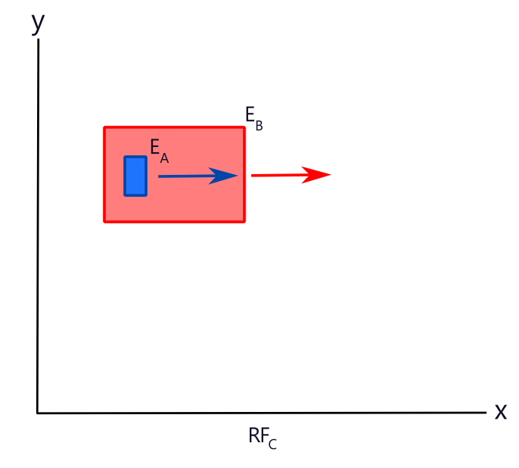
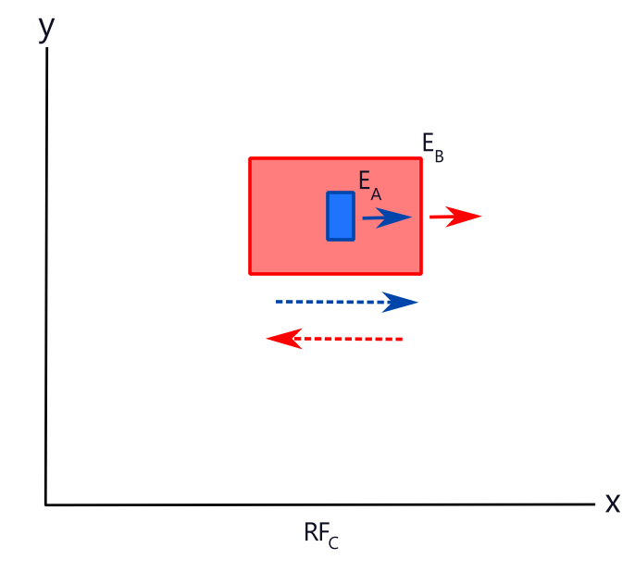
Fig02a Fig02b
Scenario B
Consider that have a reference frame RF_{C} that does influence and change the properties of an entity and/or events in RF_{A} above. Then the observer O_{A} described above will see a change in the entity properties and thus suggest that some kind of hidden force is at hand. In this scenario, the reference frames are coupled together and that RF_{A} is embedded as being a part of RF_{C} . Conversely RF_{A} must also influence entities and events in RF_{C} as part of a feedback loop. That is if RF_{C} has an effect on entities in RF_{A},then RF_{A} needs to be able to have an effect on entities in RF_{C}.
This situation is as if RF_{A} and RF_{c} are being coupled to one another in a way such that RF_{A} and RF_{c} interact with each other with some kind of frictional like bonding force between them that kind of sticks the reference frames together such that the events or entity properties appears to change in such a way that each reference frame is part of a single base reference frame RF.
Eg a box on a moving truck that makes up a reference frame of the box RF_{A} . The moving truck is in a reference frame RF_{B} and is observed by an observer O_{C} in RF_{C} to be moving with the box on the trucks platform that is in the same motion as the truck. (Fig02a) The truck changes its velocity of motion and O_{C} observes that the previously stationary box moves in the direction that the truck was travelling in, but slows down and eventually stops, reaching an equilibrium with the reference frame of the truck. (Fig02b) The only reason this can occur is if there is some kind of frictional force between the platform inertial frame and that of the truck as it changes its motion, and this frictional force is exerted on the box so as to change its motion. In turn the box exerts a frictional force on the truck trying to prevent it from changing its inertial state of motion from that of the box. These are illustrated as the dashed lines in Fig02b where in this case a slower truck velocity results in the box frictional interaction with the truck (blue dashed line) is wanting to push the truck forward, while the truck frictional interaction with the box (red dashed line) pushes on the box to slow its motion.
This truck - box interaction is an analogy. In a real physical scenario, such an interaction would be between entities that have what may be considered as an interacting field between them, and that these fields are tied to the entities and the entities to a reference frame. In other words, it may be considered that a physical entity, an interacting field associated with it, and the reference frame of that entity are of one, and possibly same single physical property.
Which Scenario
Which of these two scenarios is the correct one to use ?
Or could it be that both are correct and that natural phenomenon involves Scenario A for certain situations, while Scenario B is valid in others.?
If Scenario A is correct and valid for all physical phenomenon, then all forces observed in the universe may very well be one of being in different reference frames and observing the motion of straight lines of motion of entities existing within a universal zero reference frame. Through some form of existence of entities being in a reference frame of some form of complex motion, what appears to be a force is not a force at all.
If Scenario B is correct, then when the reference frames that entities exists in, or when they change reference frames, a force is observed as an interaction of the properties of two entities reference frames. This leads to two possibilities.
i : That there may well be a single field present of which every entity is connected to by a property it has to that field, which each entity interacts with and modifies through its motion.
ii: That each entity generates a field by a field property that generates a net field of that property which it interacts and modifies through its motion.
Both seem valid in a logical sense, but will not be conjectured here if either, both or none will be considered, just yet.
02 : Observation of Reference Frames

02-01 All reference Frames

All observations in all reference frames require an interaction of some kind between the entities of each reference frame so as to register a measurement of some quantity between then. For the following it is considered that the form of interaction is one of photons as at the most basic level of interaction, even of gravity. It is assumed, and from actual experimental observation, that interaction of all kinds occur at the velocity of light. Thus all interactions and physical measurements of all kinds such as distance, energy, and time, has the speed of light at its core, and that from Einsteins’ postulate, is always measured to be constant in all frames of reference, be it inertial or non inertial.

Thus any thought experiment or theory needs to take into account this constant measured velocity of light and that it is finite. This means that measured events that any observer in any reference frame will observe and/or interact with an event that, unless the observer is at the same location of that event, is in the past. There is no real simultaneity of events that can be measured as occurring simultaneously with the same time clock that one is observing with. This is unless that event is at the location of that of the observers’ clock, or the transmission and interaction with an event is infinite in velocity, and thus requires a zero interval of time for an event of interaction, and interaction to that event to occur by the measurement of all clocks. In this case, there is only one reference frame which all entities exist.

In order to conduct thought experiments so as to gain an understanding of the physical phenomenon that different observers in different reference frames observe, the idea of a universal overview needs to be established Such a universal overview requires a universal observer that can observe all physical phenomenon as if there is only one single reference frame in which all physical properties of all physical entities is known at any instant. That is, there is an instantaneous, zero time, infinite velocity of transmission of information to the observer of all physical phenomenon and properties. This is not physical reality, but a tool for the thought experiments in this documents that require certain definitions to be stated.

Definition : DRF04 : Universal Frame of reference
A universal single frame of reference RF_{U} where all physical properties of all physical entities can be known at any instant. That is, there is an instantaneous, zero time, infinite velocity of transmission of information from which measurements can be made or deduced from.

Definition : DRF05 : Universal Observer
An observer O_{U} that can observe in a universal reference frame RF_{U}, defined in definition DRF04, the location, movement, and interactions of all entities and of all physical phenomenon of a universe.

Definition : DRF06 : Universal Time
Universal time T_{U} is the time that a universal clock measures of the universal frame of reference defined in definition DRF04 that can measure the passage of all motions within the universe that the universal frame of reference as if there is no delay in observing any entities or physical phenomenon. That is as if the transmission of information in a physical system has infinite velocity.

Definition : DRF07 : Universal Clock
Universal clock C_{U} is a clock that measures the universal time that a universal observer would observe in a universal fame of reference as defined in DRF04, DRF05, and DRF06.

With these definitions DRF04, DRF05, DRF06, and DRF07 a construction of thought experiments can be made to postulate and understand the observed physical phenomenon of the real universe.

An important postulate and concept is one of a situation where all entities and their physical properties within a system does not change. Such a system can be said to have a stationary frame of reference and can be defined as in Postulate : PRF01.

Postulate : PRF01 : Principle of a stationary inertial frame of reference.
All entities, physical properties and physical phenomenon that are in the same inertial frame of reference such that at all instances of measured time, all observers measure no movement of entity coordinates or changes to an entity or its properties.

Another postulate and concept is one of a situation where all entity locations within a system does not change, but that there are certain events or phenomenon that may or may not be in action or in motion . Such a system can be said to have a stationary frame of reference and can be defined as Postulate : PRF02.

Postulate : PRF02 : Principle of a zero inertial frame of reference.
All entities that are in the same inertial frame of reference such that at all instances of measured time, all observers measure no movement of any entity coordinates, but there exists events or physical phenomenon that may or may not be in action or in motion.

02-02 Zero Velocity
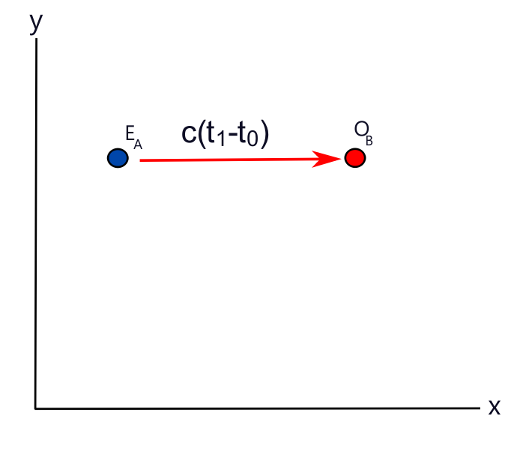
Fig ZRF-01

Consider that the clocks in reference frame FR_{A} and FR_{B} have been synchronised in some way that they register the same time value as a universal clock C_{U} when at some location x_{i}. Entity E_{A} emits a photon directly at O_{B} at a time t₀ equal to the universal time T₀.( t₀ = T₀) If both FR_{A} and FR_{B} were of the same reference frame such that observers O_{A} and O_{B} in both observe each other to be motionless, the time measured by O_{B} in receiving this photon knowing it is measured as t₁, which is equal to the universal time T₁. and the interval would be Δt where Δt = t₁-t₀.
Knowing that the emitted photon is at time t_{0 ,} Δt can be calculated. Knowing the velocity of light, c, a distance s_{AB} between E_{A} and O_{B} can be determined to be
s_{AB} = cΔt = c(t₁-t₀) = c(T₁-T₀) ZV-E01
Similarly, if the converse was initiated where the observer O_{B} emits a photon towards E_{A}, then ZV-E01 would hold from an observer at the location of E_{A}.
This is a situation satisfying the postulate of a zero inertial frame of reference Postulate : PRF02. Entities initially do not interact with each other or with any other physical property present and universal time intervals and observer measured time intervals and clocks all match with one another. ie universal time equals observer times if all clocks are simultaneously synchronised by a universal observer in a universal frame of reference.

02-03 Constant velocity

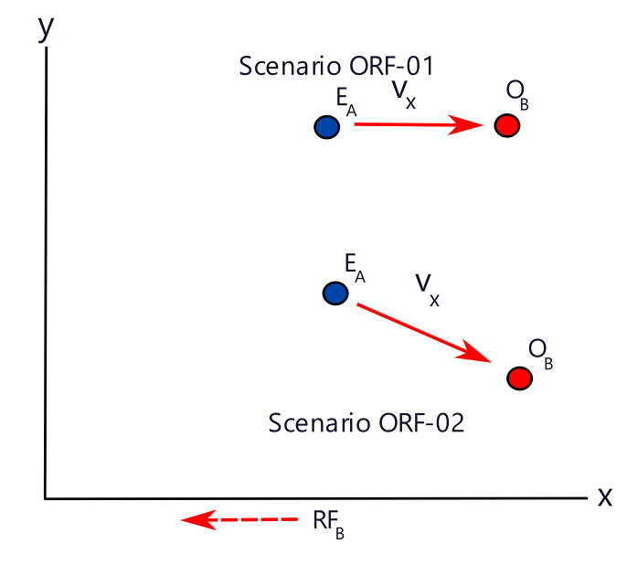
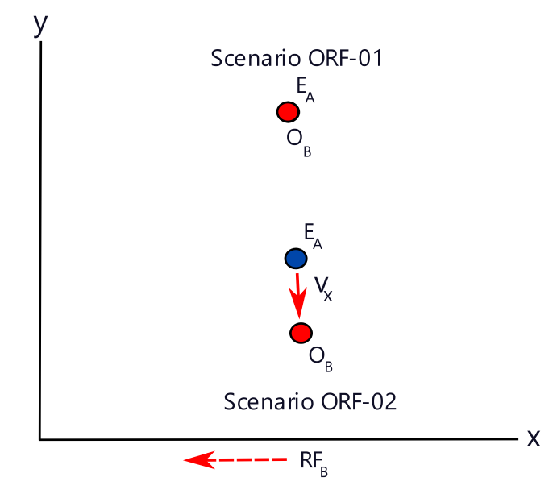
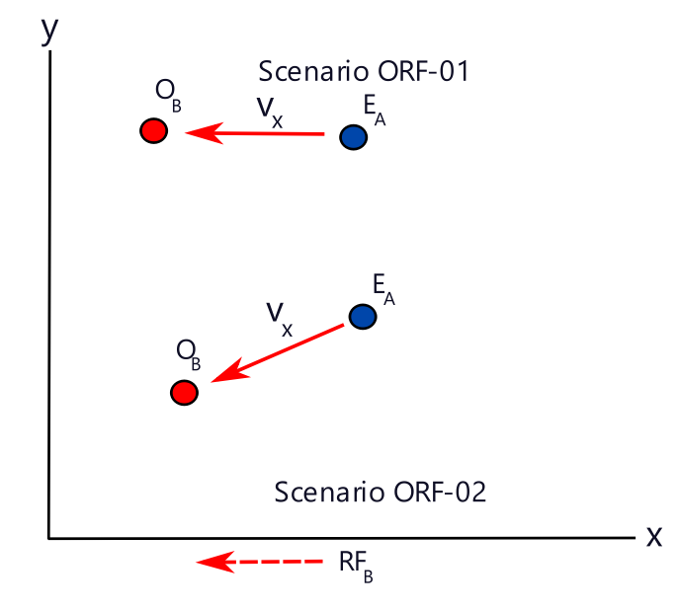
Fig ORF-01a Fig ORF-01b Fig ORF-01c
O_{B} Observes E_{A} approaching O_{B} Observes E_{A} at minimum distance O_{B} Observes E_{A} receding

Consider that the situation of Scenario A as presented in section 01 definitions above is present, and that observer O_{B} is taking measurements of the distance, velocity and other physical properties of entity E_{A} from the reference frame FR_{B}. E_{A} approaches in a straight line trajectory towards O_{B} until it reaches a location designated as a measured minimum distance, and then recedes in a straight line trajectory from O_{B} in the opposite direction from the perspective of FR_{B}. Consider that O_{B} “observes” E_{A} from the interaction of photons emitted by E_{A} interacting with a photon detector in O_{B} reference frame.
There are two possible scenarios for this situation as illustrated in Fig ORF-01a, Fig ORF-01b and Fig ORF-01c
Scenario ORF-01: O_{B} motion is such that it has a zero minimum distance. Ie the location of O_{B} and E_{A} coincide at one instant of motion.
Scenario ORF-02: O_{B} motion is such that it has a non zero minimum distance. Ie the location of O_{B} and E_{A} never coincide at one instant of motion.

Analysis of Scenario ORF-01
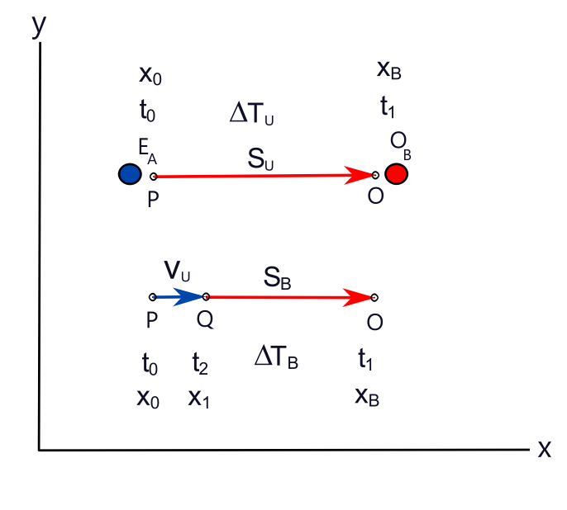
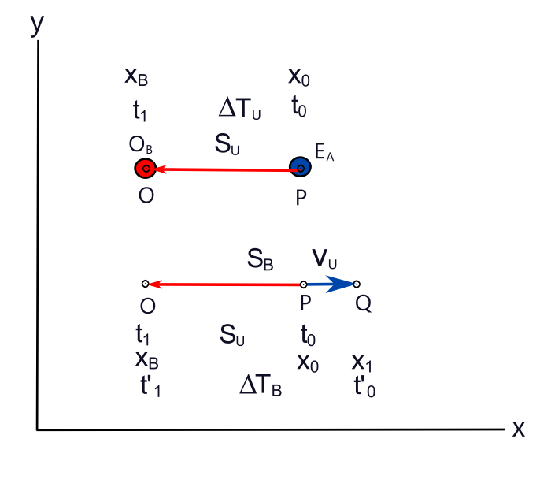
Fig ORF-02a Fig ORF-02b
O_{B} Observes E_{A} approaching head on O_{B} Observes E_{A} receding head on
Motion of approach ORF-01.1
Consider that the clocks in reference frame FR_{A} and FR_{B} have been synchronised in some way that they register the same time value as a universal clock C_{U} in the universal reference frame RF_{U}, when at some location P = x_{i}. Entity E_{A} emits a photon directly at O_{B} at a time t₀ equal to the universal time T₀.( t₀ = T₀).(Fig ORF-02) If E_{A} was motionless in respect to an observer O_{B}, then the time t₁ that O_{B} would measure to receive the photon would be given by ZV-E01 to be
s_{AB} = cΔt = c(t₁-t₀) = c(T₁-T₀) = cΔT_{U} CV-E01
However, if E_{A} is travelling directly at O_{B} at a universal frame of reference measured velocity of V_{U}, then when the photon is emitted, by classical physics it will have a net velocity of c+V_{U}. But according to Einsteins postulate and accepted experimental evidence that the speed of light is constant in all reference frames, this photon measured velocity must not change when measured by observer O_{B}. From the definition of velocity v being
v =

In the universal frame of reference RF_{U} , x₀ is the coordinate in the universal reference frame when the photon was emitted by E_{A} at location P. But in the reference frame of O_{B} , x₀ is the coordinate in RF_{U} of E_{A} when it observes the emitted photon if it is to measure its velocity to be that of light c, and not c+v. Designate this coordinate x₁ in the reference frame of O_{B} to be
x₁ = x₀ + v_{x}ΔT_{U} CV-E02
where v_{X} is the velocity of entity E_{A} in the universal reference frame RF_{U}.
=> distance measured s_{B} by O_{B} when the photon was emitted to be
s_{B} = (x₀ + cΔT_{U}) – x₁ CV-E03a
=> s_{B} = (x₀ + cΔT_{U}) - (x₀ + v_{x}ΔT_{U}) CV-E03b
=> s_{B} = cΔT_{U}– v_{x}ΔT_{U} CV-E03c
=> s_{B} = s_{U} – v_{x}ΔT_{U} CV-E03d

If the distance s_{U} that the light travelled in RF_{U} is measured in the reference frame RF_{B} that O_{B} measures of a photon emitted from E_{A}, then to have the distance s_{B} as measured by O_{B} from which E_{A} emitted the photon travelling at a constant velocity v_{x} towards O_{B} needs to be equal to s_{U}. (Fig ORF-02)

Let x₀ be the location P in RF_{U} of E_{A} when the photon was emitted by E_{A}.
Let x_{B} be the location O in RF_{U} of E_{B} when the photon emitted by E_{A} was received by O_{B}.
Let x₁ be the location Q in RF_{U} of E_{A} that it had translated to through travelling in a direct pat towards O_{B} at a constant velocity v_{x} when the photon emitted by E_{A} was received by O_{B}. ie

Let ΔT_{U} be the time interval measured in RF_{U} that the photon emitted by E_{A} at location x₀ was received by O_{B}.
Let ΔT_{B} be the time interval as measured in RF_{U} would be if the photon emitted by E_{A} was at location Q=x₁ and was received by O_{B}.

By Einstein’s postulate that the velocity of light, c, measured in all reference frames is constant at all instances. Then the velocity of light emitted at x₀ and observed by O_{B} at x_{B} would be equal to the velocity of light emitted at x₁ and observed by O_{B} at x_{B}. Thus

c == CV-E04a
=>
ΔT_{B} = ΔT_{U} CV-E04b
=> substituting x₁ = x₀ + v_{X}ΔT_{U} where v_{X} is the velocity of entity E_{A} in the universal reference frame RF_{U}.
ΔT_{B} = ΔT_{U} CV-E04c
=>
ΔT_{B} = ΔT_{U} CV-E04d
=>
ΔT_{B} = ΔT_{U} CV-E04e
=> since = c and = = 1/c have
ΔT _{B} = ΔT_{U} CV-E05

CV-E05 gives a measurement of time, ΔT_{B}, that the photon took to reach O_{B} from x₀ in the reference frame that O_{B} exists in with respect to that which a moving E_{A} exists in. This is equivalent to as if the photon was emitted at location x₁, in the reference frame of O_{B}. Because O_{B} exists in the same reference frame as the universal reference frame as it is motionless in the universal reference frame, then it can be said that RF_{B} = RF_{U}.

For a measurement of length to be measured by O_{B} in respect to that of the moving entity E_{A}, a second photon is emitted by E_{A}, and is emitted at the location x₁ as observed by a universal observer O_{U} in RF_{U}.

A time t₁ is recorded by O_{B} of the arrival of the first photon at the location O of O_{B}.
A time t₂ is recorded by O_{B} of the arrival at the second photon at the location O of O_{B}.

The measurement of length s_{B12} between these two photons by O_{B} is thus measured as
s_{B12} = c(t₂ - t₁) = cΔt_{B12} CV-E06a
where Δt_{B12} is the measured time interval that O_{B} observes between photon arrivals.

Given that O_{B} is in RF_{U}, and that in RF_{U} , s_{U12} = v_{x}ΔT_{U}, where ΔT_{U} is the time interval as measured by a universal observer O_{U} in RF_{U}. then
s_{B12} = c(t₂ - t₁) = v_{x}ΔT_{U} CV-E06b
t₁ = ΔT_{U}, t₂ = ΔT_{U} + v_{x}ΔT_{U}/c
=>
s_{B12} = cΔt_{B12} = v_{x}ΔT_{U} CV-E06

What this indicates is that measurements of length by O_{B} is the same as that of the universal reference frame. This should be expected as O_{B} is in the universal reference frame, and RF_{B} = RF_{U}.

Motion of receding ORF-01.2
If the opposite of the above situation described where E_{A} was receding from O_{B}, rather than approaching O_{B}, then it is not difficult to see that given a negative direction of velocity for E_{A} in respect to the location of O_{B}, CV-E05 would become
ΔT_{B} = ΔT_{U} CV-E07
and CV-E06 would be
s_{B12} = cΔt_{B12} = -v_{x}ΔT_{U} CV-E08

if one considers that length is a vector and is in the same direction as the motion of E_{A}.

Instant of coincident location ORF-01.3

Consider that on approach of E_{A} to O_{B}, at some instant, the location of E_{A} and O_{B} coincide and they overlap upon each other. At this instant, it can be considered that there zero time of transmission of any physical properties between them, and as a consequence, zero length of any physical properties such as space measurements. It may be said that either nothing happens between E_{A} and O_{B}, or that any interaction of transmission and reaction to transmission of physical phenomenon is truly simultaneous and occurs in zero time. It could be said that at this instance that both reference frames converge into being one common reference frame where all space and time between E_{A} and O_{B} coalesce into one state of physical being.

Interval of physical Process – approaching reference frames ORF-01.4

Consider that a physical process, such as the emission of a photon is not instantaneous and takes a period of time Δt_{P} = t₁ – t₀ to complete, which is constant as measured in all reference frames. t₀ being the time of initiating the process, t₁ being the time of completing the process.

Consider that this process begins at as performed by an entity E_{A} and is stationary in the reference frame of O_{B}. It is quite trivial to deduce that O_{B} will measure the interval of the process of emission of the photon through measuring its perceived wavelength as Δt_{P}.

Consider that E_{A} is in motion on a direct straight line path towards O_{B} at a velocity v_{X}, that E_{A} begins the process of emitting a photon at a location x₀, and as E_{A} continues moving towards O_{B}, it continues to emit the photon until it completes the emission process at location
x₁= x₀ + v_{X} Δt_{P}. CV-E09
At all times, the process of photon emission, the photon components are emitted at the velocity of light, c, within the reference frame of E_{A}.

In the reference frame of O_{B}, O_{B} observes the photon at the velocity of light, c and all of its components. The head of the photon travels a time t₀ = Δt_{U} as described above. The end of the photon travels a time t₁ = Δt_{U} + Δt_{B} as described above in deriving CV-E05. Consider that Δt_{P} which is constant as measured in all reference frames.

=> Δt_{P} = t₁ – t₀ = ΔT_{U} + ΔT_{B} - ΔT_{U} = ΔT_{B} = ΔT_{U} CV-E10
Which is a contraction of the time measured time in the reference frame RF_{B} that O_{B} exists within, in respect to the time measured in the reference frame RF_{A} that the entiry E_{A} exists within. It is the same as CV-E05 measuring two instances of motion of E_{A} travelling at velocity v_{X} directly towards O_{B}.

If it is considered that the measurement of length of a photon emitted by E_{A} travelling at velocity v_{X} is cΔt_{P} which is equivalent to its physical property of a wavelength λ_{P}, then using CV-E10 the measured wavelength of the photon can be deduced to be
Δλ_{P} = cΔt_{P} = cΔT_{B} = cΔT_{U} = ΔT_{U} CV-E11
Which is a contraction of the measured wavelength in the reference frame RF_{B} that O_{B} exists within, in respect to the time measured in the reference frame RF_{A} that the entiry E_{A} exists within.

Interval of physical Process – receding reference frames ORF-01.5

Consider that E_{A} is in motion on a direct straight line path receding away from O_{B} at a velocity v_{X}, that E_{A} begins the process of emitting a photon at a location x₀, and as E_{A} continues moving towards O_{B}, it continues to emit the photon until it completes the emission process at location
x₁= x₀ ₋ v_{X} Δt_{P}. CV-E012
At all times, the process of photon emission, the photon components are emitted at the velocity of light, c, within the reference frame of E_{A}.

In the reference frame of O_{B}, O_{B} observes the photon at the velocity of light, c of all its components. The head of the photon travels a time t₀ = Δt_{U} as described above. The end of the photon travels a time t₁ = Δt_{U} + Δt_{B} as described above. Consider that Δt_{P} which is constant as measured in all reference frames where velocity is in the negative direction, and thus tB is that of CV-E07, obtain

=> Δt_{P} = t₁ – t₀ = ΔT_{U} + ΔT_{B} - ΔT_{U} = ΔT_{B} = ΔT_{U} CV-E13
Which is an expansion of the time measured time in the reference frame RF_{B} that O_{B} exists within, in respect to the time measured in the reference frame RF_{A} that the entiry E_{A} exists within. It is the same as CV-E07 measuring two instances of motion of E_{A} travelling at velocity v_{X} directly towards O_{B}.

If it is considered that the measurement of length of a photon emitted by E_{A} travelling at velocity v_{X} is cΔt_{P} which is equivalent to its physical property of a wavelength λ_{P}, then using CV-E13 the measured wavelength of the photon can be deduced to be
Δλ_{P} = cΔt_{P} = cΔT_{B} = cΔT_{U} = ΔT_{U} CV-E14
Which is an expansion of the measured wavelength in the reference frame RF_{B} that O_{B} exists within, in respect to the time measured in the reference frame RF_{A} that the entiry E_{A} exists within.

Analysis of Scenario ORF-02
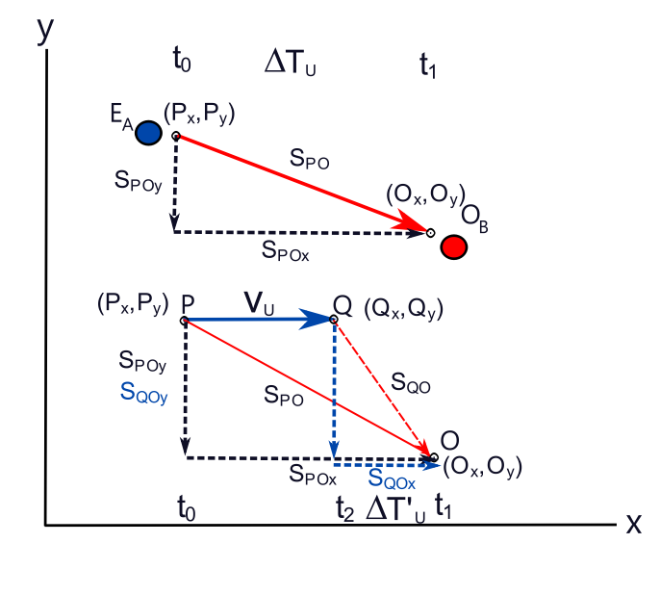
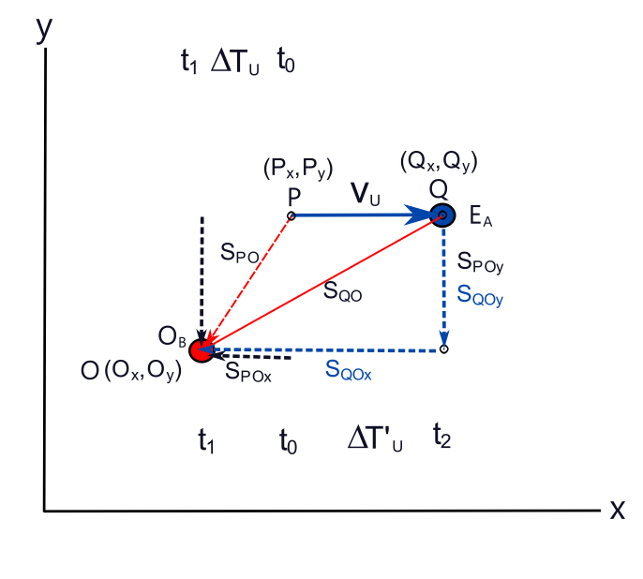
Fig ORF-03a Fig ORF-03b
O_{B} Observes E_{A} approaching obliquely O_{B} Observes E_{A} receding obliquely

Motion of approach ORF-02.1
Consider that the clocks in reference frame FR_{A} and FR_{B} have been synchronised in some way that they register the same time value as a universal clock C_{U} in the universal reference frame RF_{U}, when at some location x_{i}. Entity E_{A} is travelling in a straight line towards and oblique to an observer O_{B} that does not intercept the location O of O_{B}, and at a location P emits a photon directly at O_{B} at a time t₀ equal to the universal time T₀.( t₀ = T₀). If E_{A} was motionless in respect to an observer O_{B}, then the time that O_{B} would measure to receive the photon would be t₁, and the interval of time between emitting the photon by E_{A} and O_{B} receiving it would give a distance of travel from P to O as given by ZV-E01 to be
s_{PO} = cΔt = c(t₁-t₀) = c(T₁-T₀) = cΔT_{U} CV-E15

Where T₁,T₀ are the universal time that a universal observer wou;d measure and ΔT_{U} the universal time interval.
Designate t₁ to be the measured time t_{B} of the reference frame RF_{B} that O_{B}, exists within.

Now consider that in the time interval ΔT_{U}, E_{A} is moves at a constant velocity v_{X} to a location Q where
Q = P + v_{X} ΔT_{U} CV-E16
and emits a photon at a universal time T’₀ in a direction that the observer O_{B}, first detects the emitted photon at a time T’₁, then the universal time interval of transmission and observation would give a distance from Q to O as
s_{PO} = cΔt’ = c(t’₁-t’₀) = c(T’₁-T’₀) = cΔT’_{U} CV-E17
if it is considered that the velocity of light as measured by O_{B} of this photon is c. This would then imply from CV-E15 and CV-E17 that
c = = CV-E18
=>
ΔT’_{U}= CV-E19
Assuming that trigonometry in the universal frame of reference can be used, then
(S_{PO})² = (S_{POx})² + (S_{POy})²
Where S_{POx} and S_{POy} are the x and y components of the distance S_{PO}. And since S_{PO} = cΔt then
(cΔt)² = (c_{x}Δt)² + (c_{y}Δt)² CV-E20
Where c_{x} and c_{y} are the x and y components of c.
Similarly for S_{QO},
(S_{QO})² = (S_{QOx})² + (S_{QOy})²
Where S_{QOx} and S_{QOy} are the x and y components of the distance S_{QO}. And since S_{QO} = cΔt’ then
(cΔt’)² = (c_{x}Δt’)² + (c_{y}Δt’)² CV-E21a
S_{QOx} = O_{x} – Q_{x} = O_{x} – (P_{x} + v_{x}ΔT_{U}) CV-E21b
S_{QOy} = O_{y} – Q_{y} = O_{y} – (P_{y} + v_{y}ΔT_{U})
and since v_{y} = 0
S_{QOy} = O_{y} – Q_{y} = O_{y} – P_{y} CV-E21c
=>
(S_{QO})² = (O_{x} – (P_{x} + v_{x}ΔT_{U}))² + (O_{y} – P_{y})² CV-E21d
expanding out the right hand side becomes
(O_{x})² + (P_{x} + v_{x}ΔT_{U})² - 2(O_{x}(P_{x} + v_{x}ΔT_{U})) + (O_{y})² + (P_{y})² - 2O_{y}P_{y}
(O_{x})² + (P_{x}²) + (v_{x}ΔT_{U})² + 2(P_{x}v_{x}ΔT_{U}) - 2(O_{x}P_{x} + O_{x}v_{x}ΔT_{U}) + (O_{y})² + (P_{y})² - 2O_{y}P_{y}
(O_{x})² + (O_{y})² + (P_{x}²) + (P_{y})² - 2(O_{x}P_{x} + O_{y}P_{y}) + 2(P_{x}v_{x}ΔT_{U} - O_{x}v_{x}ΔT_{U}) + (v_{x}ΔT_{U})²
(O_{x})² + (O_{y})² + (P_{x}²) + (P_{y})² - 2(O_{x}P_{x} + O_{y}P_{y}) + (v_{x}ΔT_{U})² + 2v_{x}ΔT_{U}(P_{x -} O_{x})
((O_{x})² + (P_{x}²) - 2O_{x}P_{x} )+ ((O_{y})² +(P_{y})² - 2O_{y}P_{y})) + (v_{x}ΔT_{U})( v_{x}ΔT_{U} + 2(P_{x –} O_{x}))
(O_{x} - P_{x})²+ (O_{y} - P_{y})² + (v_{x}ΔT_{U})( v_{x}ΔT_{U} + 2(P_{x –} O_{x}))
and O_{x} – P_{x} = S_{POx} and O_{y} – P_{y} = S_{POy} =>
S_{POx}²+ S_{POy}² + (v_{x}ΔT_{U})( v_{x}ΔT_{U} + 2(P_{x –} O_{x}))
and S_{POx}²+ S_{POy}² = S_{PO}² => CV-E21d can be written as
(S_{QO})² = (S_{PO})² + v_{X}ΔT_{U}(v_{X}ΔT_{U} + 2Δx_{PO}) CV-E21
where Δx_{PO} is (P_{X} – O_{X}), the difference in the x coordinate of the initial emission of a photon from entity E_{A} at location P, and the observer x coordinate receiving that photon at location O.
Note : CV-E21 is valid for a photon emitted from P and taking a period of time ΔT_{U} to reach the observer. Substituting CV-E21 into CV-E19, obtained
ΔT’_{U}= =
= CV-E22
and since S_{PO} = cΔT_{U} CV-E22 becomes
ΔT’_{U}= = CV-E23
and = -v_{x} =>
ΔT’_{U} = CV-E24a
= CV-E24
Which matches the Lorentz transformation.

Receding motion ORF-02.2
For a receding entity E_{A} moving away from O at a velocity v_{x} (Fig ORF-03b) , the location of P of the initial emission of a photon is closer to O than the emission of a photon when E_{A} has moved to location Q at the same time that a photon emitted at P is measured by at O. For this situation with the same arguments leading to CV-E21d an expression for the distance S_{QO} becomes
(S_{QO})² = ((P_{x} + v_{x}ΔT_{U}) - O_{x} )² + (P_{y} – O_{y})² CV-E25
Which when expanded out and evaluated similar to deriving CV-E21 above gives
(S_{QO})² = (S_{PO})² + v_{X}ΔT_{U}(v_{X}ΔT_{U} + 2Δx_{PO}) CV-E26
which is CV-E21 for an approaching entity emitting a photon, and which will give the same result of a relationship between ΔT_{U} and ΔT’_{U} as CV-E24.
Incidence at minimum distance ORF-02.3
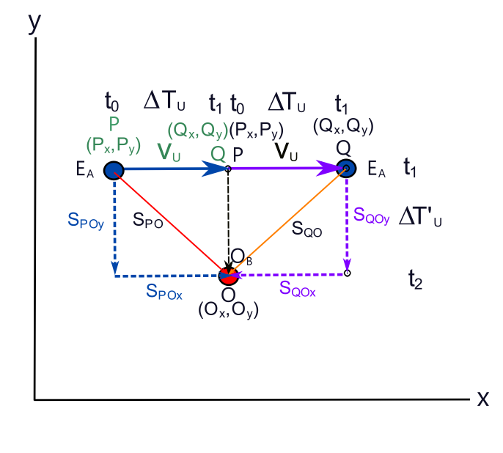
Fig ORF-04
O_{B} Observes E_{A} at minimum distance
For the instance of a photon emitted at a minimum distance, an approaching scenario would have Q_{x} = O_{x} , and a receding scenario would have P_{x} = O_{x}. For Q_{x} = O_{x}, S_{QO} = S_{QOy} and for P_{x} = O_{x},S_{PO} = S_{POy}
This would imply that on approach, a minimum distance of Q would give an expression of relationship between ΔT_{U} and ΔT’_{U} as a Pythagorean trigonometric problem. Distances S_{QO} = S_{QOy} = cΔT’_{U} ,S_{PO} = cΔT_{U} and S_{PQ} = v_{x}ΔT_{U}. =>
S_{QO}² = S_{PO}² - S_{PQ}² CV-E27a
=> (cΔT’_{U})² = (cΔT_{U})² - (v_{x}ΔT_{U})² CV-E27b
=> ΔT’_{U} = CV-E27c
=> ΔT’_{U} = CV-E27
Which agrees with the previous derivation given by CV-E24
For entity E_{A} receding from O at a constant velocity v_{x}, have
S_{PO}² = S_{QO}² - S_{PO}² CV-E28a
=> (cΔT’_{U})² = (cΔT_{U})² - (v_{x}ΔT_{U})² CV-E28b
which is the same as CV-E27b and which therefore CV-E27 also holds for an Entity receding away from an observer O.
Interval of physical Process – approaching reference frames ORF-02.4
For an entity E_{A} emitting a photon oblique to its motion, if the emission process occurs in a given interval such that as it moves the photon is generated, then it has to be assumed that somehow the direction of emission of the photon is always orientated to be in the direct direction towards the observer O. That is, the emission direction changes as the entity moves, otherwise the observer O will only sense the head of the photon unless the absorption process to measure the photon can encapsulate the photon over an area or volume and not at a single point. Whatever process can be made for observer O to observe an incoming photon, it is assumed that for the purposes of this exercise, an observation of a photon that has been generated in a given interval can be made.
Consider that a physical process, such as the emission of a photon is not instantaneous and takes a period of time Δt_{P} = t₁ – t₀ to complete, which is constant as measured in all reference frames. t₀ being the time of initiating the process, t₁ being the time of completing the process.
Consider that this process begins at as performed by an entity E_{A} and is stationary in the reference frame of O_{B}. It is quite trivial to deduce that O_{B} will measure the interval of the process of emission of the photon through measuring its perceived wavelength as
λ_{U} = cΔt_{PO} = cΔT_{U} CV-E29a
Consider that E_{A} is in motion on an oblique straight line path towards O_{B} at a velocity v_{X}, as illustrated in Fig ORF-03a, and that E_{A} begins the process of emitting a photon at a location P, and as E_{A} continues moving it continues to emit the photon until it completes the emission process at location Q. The distance
S_{QO} = cΔT’_{U} = λ’_{U} ==== CV-E29
is thus given as the measured wavelength at O of the emitted photon. By the same method, for a receding entity E_{A}, the same result would occur and CV-E29 would apply.

Incidence at equal distance ORF-02.5
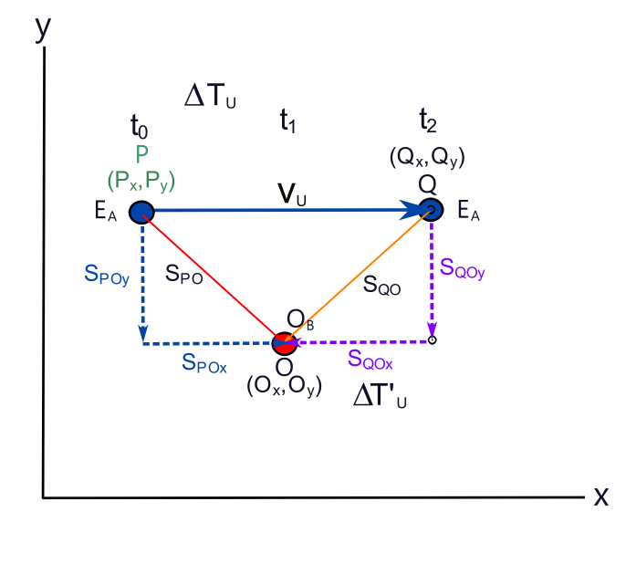
Fig ORF-05
Consider the situation where a photon has emitted from and entity E_{A} at location P as it approaches an observer O_{B} at location O at velocity v_{x}, and it takes a universal measured time ΔT_{U} to reach O_{B}. Then consider that a second photon is emitted at location Q where Q = P + v_{U} ΔT_{U} as E_{A} recedes away from O_{B}.(Fig ORF-05). The distance from P to O, S_{PO} is
S_{PO}² = S_{POx}² + S_{POy}² = (O_{x} – P_{x})² + (O_{y} – P_{y})² = (cΔT_{U})² CV-E30a
and The distance from Q to O, S_{PO} is
S_{QO}² = S_{QOx}² + S_{QOy}² = (Q_{x} – O_{x})² + (Q_{y} – O_{y})²
= ((P_{x} + v_{U}ΔT_{U}) – O_{x})² + (Q_{y} – O_{y})² = (cΔT’_{U})² CV-E30b
=>
(cΔT’_{U})² = (P_{x} + v_{U}ΔT_{U})² + O_{x}² - 2 O_{x} (P_{x} + v_{U}ΔT_{U}) + (Q_{y} – O_{y})²
= P_{x}² + (v_{U}ΔT)² + 2 P_{x} v_{U}ΔT + O_{x}²- 2 O_{x} (P_{x} + v_{U}ΔT_{U}) + (Q_{y} – O_{y})²
= P_{x}² + O_{x}² - 2 O_{x}P_{x} + (v_{U}ΔT_{U})² + 2P_{x} v_{U}ΔT_{U} – 2O_{x}v_{U}ΔT_{U} + (Q_{y} – O_{y})²
= ( P_{x} – O_{x})² + (Q_{y} – O_{y})² + (v_{U}ΔT_{U})² + 2v_{U}ΔT_{U}(P_{x} - O_{x})
and (Q_{y} – O_{y}) = (P_{y} – O_{y}) =>
(cΔT’_{U})² = ( P_{x} – O_{x})² + (P_{y} – O_{y})² + (v_{U}ΔT_{U})² + 2v_{U}ΔT_{U}(P_{x} - O_{x})
= S_{PO}² + (v_{U}ΔT_{U})² + 2v_{U}ΔT_{U}(P_{x} - O_{x}) CV-E30d
Consider that (P_{x} - O_{x}) = -(O_{x} - P_{x}).=>
(cΔT’_{U})² = S_{PO}² + (v_{U}ΔT_{U})² - 2v_{U}ΔT_{U}(O_{x} - P_{x}) CV-E30e
Consider that where ΔT_{POx} is the universal time it takes for the entity E_{A} to travel from location P_{x} to location O_{x}. Expressing ΔT_{POx} as a percentage or fraction term in the range of 0.0 to 1.0 of the time ΔT_{U} for the entity E_{A} to travel from location P_{x} to location Q_{x}.as T_{POx}% gives ΔT_{POx} = T_{POx}% ΔT_{U}.=> (O_{x} - P_{x}) = v_{U}T_{POx}% ΔT_{U} and CV-E30e can be written as
(cΔT’_{U})² = S_{PO}² + (v_{U}ΔT_{U})² - 2v_{U}ΔT_{U} v_{U}T_{POx}% ΔT_{U}
=> (cΔT’_{U})² = S_{PO}² + (v_{U}ΔT_{U})² – 2(v_{U}ΔT_{U})² T_{POx}% CV-E30f
and since S_{PO} = cΔT_{U} then have
(cΔT’_{U})² = (cΔT_{U})² + (v_{U}ΔT_{U})² – 2(v_{U}ΔT_{U})² T_{POx}%
= (cΔT_{U})² + (1 – 2T_{POx}%)(v_{U}ΔT_{U})² CV-E30g
=> ΔT’_{U} = CV-E30
What CV-E30 indicates is that depending upon the location of P and Q in respect to the observer at location O as a fraction of the distance that the entity E_{A} travels in time T_{U}, the relative measured time of a signal emitted at Q is not constant if P an Q are in opposite coordinate sectors. That is, if P is negative and Q positive or P is positive and Q negative. If P and Q are of the same coordinate sector of being both positive or negative, then T_{POx}% would be equal to one at all instances, and ΔT’_{U} would become as CV-E24, the normal relativistic expression with a Lorentz transformation.
This is also a very specific and exceptional case where the emission of a photon by E_{A} at location P travelling at a velocity v_{U} is such that it is observed at location O at the same universal time another photon is emitted at Q that is of an opposite coordinate sector. In most instances for a single entity this may not be the case and could be quite rare. Consider that T_{POx}% = 0.5 meaning that distance S_{PO}= S_{QO} are equal, and hence ΔT’_{U} = ΔT_{U} which is expected. This is a potentially even more rare occurrence of such an event where velocities of an entity E_{A} are not high enough to cross to an opposite coordinate sector in respect to the observer location O.
Along with the derivation of motion of an entity E_{A} that is on a path incidental to the location of an observer given by CV-E05 and CV-E07, different measurements of relative times and lengths may be made that are not of the Lorentz transformation type, but are of a modified Lorentz transformation as given in CV-E30.

03 : Rotational Reference Frames
03.1 Stationary rotational motion
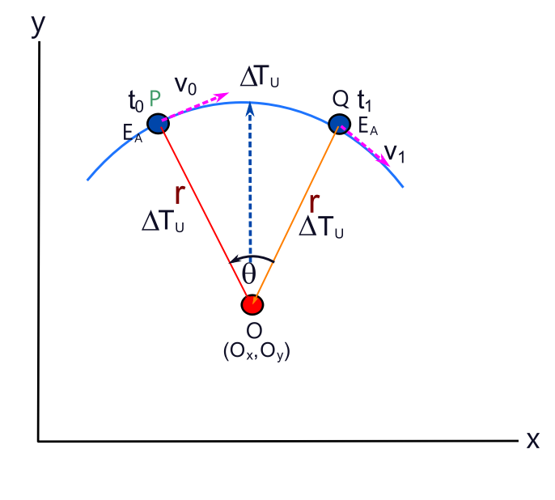
Fig 03-01
Frame of reference as observed by
a rotating observer.

Consider that an observer O exists within a universal reference frame RF_{U} and is stationary in RF_{U}. Consider that an entity E_{A} is also present and is stationary in respect to the reference frame of O. That is, E_{A} can be considered to be also within the universal reference frame RF_{U}. Consider that O has a form such that it can observe a rotation about an axis that is perpendicular to a plane between it and E_{A}, and that it is observed that O that is at the centre of this rotation, and that it is O that is rotating.(fig 03-01)
Consider that the measured distance between O and E_{A} is r, and that E_{A} emits a photon at a constant time interval of T_{U} within its reference frame, and that O rotates at a constant angle θ between emission and observing each photon.
From the perspective of O, if the facing of an observer is fixed and is rotating about an axis, E_{A} is perceived to be in a rotational motion about O at a constant distance r and angular velocity ω. The entity E_{A} is thus also perceived to have a changing linear velocity that is tangential to the perceived rotational motion about the observer O. Thus from the perspective of O, O observes a force acting on E_{A} centred at the location of O.
As illustrated in Fig 03-01, consider that at time t₀, E_{A} emits a photon that is observed by O after a universal time ΔT_{U}. After a time interval of ΔT_{U}, observer O perceives E_{A} to be at location P, at at this same instant in the universal reference frame that both observer and entity exist within, E_{A} emits a second photon that is observed by O after a universal time ΔT_{U}, and during observing the first photon and this second photon, O rotates by an angle θ and perceives that E_{A} is at location Q. Observer O is rotating anti clockwise in the universal reference frame. If Observer O deduces that E_{A} had travelled on a circular path as illustrated in Fig03-01, then in a time interval of ΔT_{U}, E_{A} has travelled a distance of θr = cΔT’_{U}, and has undergone a change in velocity according to the perceived velocity vector addition of Δv = v₀ + v₁. That is this reference frame of O observes an acceleration of E_{A} despite both having no motion in the reference frame that E_{A} exists in and which is the universal reference frame RF_{U} .
What this means is that a rotating entity in itself mathematically, if not physically may have intrinsic relativistic characteristics.
Observer O perception of E_{A} would be that the distance travelled by E_{A} would be
θr = cΔT’_{U} RRF-E01
and r = cΔT_{U} => θ cΔT_{U} = cΔT’_{U} RRF-E02a
=> θΔT_{U} = ΔT’_{U} RRF-E02
which would give a perception that the angle θ is an expression of the ratio of relative times between E_{A} and O. Expressing RRF-E02 in terms of an angular velocity ω = θ/ΔT_{U} of O => θ =ω ΔT_{U} have
=> ωΔT_{U}² = ΔT’_{U} RRF-E03
The perceived magnitude of rotational velocity of E_{A} by Observer O would be as defined rotational motion be
v = rω
and r = cΔT_{U}, and from => RRF-E03 ω = ΔT’_{U}/ΔT_{U}² =>
v = = RRF-E04
or rearranging obtain
ΔT’_{U} = RRF-E05
What RRF-E05 seems to be indicating, is that a rotating observer can observe an entity to travel at speeds faster than that of light, and that any rate of rotation is possible. An implication is that with a fast enough rotation, an observer can observe E_{A} in a periodic pattern that is dependent upon the distance of O from E_{A} and rotational velocity ω.
However this is considering that O is a point object. If O is not a point object and is not an entity that can be of some structure that is impervious to rotational motion without limits, then it can be considered that RRF-E05 has a limit according to Einstein's postulate that v < c, and that all observers have a limit on their rotational motion.
Change in velocity Δv of E_{A} is expressed as
Δv = v₀ + v₁ = (v cos θ₁ + v sin θ₁) - (v cos θ₀ + v sin θ₀)
where v is the velocity magnitude which is constant and =>
Δv = v₀ + v₁ = v (cos θ₁ - cos θ₀ + sin θ₁ - sin θ₀) RRF-E06
Consider That θ₀ = 0 and using RRF-E04 then have
Δv =(cos θ₁ - 1 + sin θ₁)
=(cos θ₁ + sin θ₁ – 1) RRF-E07

Discrepancy between head on and oblique motion of entities
There seems to be a difference in the measurements that an observer O_{B} would measure of time and length that an entity E_{A} would emit as a photon if the motion of E_{A} was oblique, as opposed to a direct path that would have E_{A} and O_{B} “collide” with each other.
CV-E05 and CV-E24 are expressions of the same quantity of measurement of the ratio of the time measurement that a moving entity would measure compared to a “stationary” entity. However they give different results as CV-E05 looks more Doppler like, and CV-E24 more special relativity like. Looking the derivations of CV-E05 and CV-E24, this can only be explained that in deriving CV-E05, it has no y component of the velocity of light compared to CV-E24 that does.
But it may also be considered that CV-E24 is not realistic in that for a photon to be observed, the emission direction needs to rotate, at just the right angle so as to keep its form, and not have its components skim past the observer as the entity moves at a velocity v_{x}.
An analogy would be a bomber having all its bombs dropped one at a time having each bomb hitting the ground in a straight line and not all at one single location.
For all the bombs to hit at a single location, each successive bomb would need to have its velocity upon release reduced in a constant deceleratory manner. That would mean successive components of the photon need to travel as lower x component velocities. To maintain an overall constant speed of light, the y component would need to increase in the reference frame it was emitted in which would just simply re create the initial problem.
Thus an observer measuring such a photon would only observe the first bomb, as it were, and not any of the others as they pass by.
Does this mean that measurements of physical phenomenon differ not only in what reference frame that one is in, but also the relative direction of interaction, and that an observer is taking measurements of physical phenomenon?

Reference Frame as a source of observation of a Physical Force

non-embedded reference frame
Consider an observer O_{r} is rotating about a central axis at a radius r from an axis of rotation z, and rotates about this central axis with a constant angular velocity ω. The observer O_{r} can be considered to be in a rotational frame of reference RF_{R}. Consider that the observer O_{r} does not experience any restraint or “force” of movement away from, or towards the central axis, and r does not change. In other words, O_{r} is in a rotational reference frame RF_{R} that is an inertial frame of reference, and if an object was freely placed in this frame of reference by an observer O_{r}, it would be seen not to have any motion. Such a frame of reference can thus be considered as self contained and exist as an independent and non embedded reference frame RF_{ne}. It can be considered that such a reference frame is a universal reference frame RF_{U}.
embedded reference frame
Consider that O_{r} does experience a restraint or “force” of movement away from, or to the central axis and r does change in time. O_{r} is in a rotational reference frame RF_{R} that is a non inertial frame of reference, and if an object was freely placed in this frame of reference by an observer O_{r}, it would be seen to have motion. Such a frame of reference RF_{e} can thus be considered as non self contained and exists embedded within a lager reference frame RF_{U}.
Thus if the observer releases an object o at some instant that is free and not bound to the rotational motion reference frame that the observer is bound to. (ie there is no frictional force between object o and system that the observer is bound to.) it would be observed that the object o has its own inertial frame of reference RF_{o}, and gains the properties of motion based upon the location and motion of inertial frame RF_{R} of the observer when it was released.
Eg consider that the object was released at radius r from the center of rotation. It would then gain the properties of linear velocity of the point of rotation at the moment it was released and move at a constant velocity and direction relative to the reference frame that the rotational reference exists within. In other words, it travels in a straight line in the reference frame that the rotational reference frame exists in. From the point of view of the rotating reference frame, the released object moves away from the center of rotation according to the following.
At time of release at radius r from center of rotation, object o has linear velocity
v₀ = rω
consider that in the external reference frame that RF_{e} is embedded in, the direction of motion is in the +y axis.
Thus as the object moves in the +y direction, the observer will see it move in a spiral like motion away from point of release around the axis of rotation.
In time t, the object has moved distance v₀t in the +y direction and the change in radius at which the object is seen to change in the rotational reference frame is given by

since Δy = v₀Δt

and v₀Δt = r₀ω

ERF-01
And thus from the perspective of the observer in the rotational reference frame, the object moves in a spiral motion away from the center axis of rotation and radius given by ERF-01.

Spherical Surface Field

Consider the concept of a field S that is defined to originate from some location in space that is designated as a point of origin such that the field is of a spherical shape, and that it can be modelled and represented as a surface or volume of vectors. At any given distance from the central point of origin, the individual vectors representing the field are all of the same magnitude and pointing outwards from the central point of origin, and thus are perpendicular to a spherical surface at a given radius r from this central point. Consider that the number of vectors represents a density or flux of the field, and that the total number of these vectors over a given spherical surface at radius r from the origin is constant. Thus over a given area of the spherical surface, a representation a field intensity or strength can be defined as the number of these field vectors per unit area. If evenly distributed, this would mean that as the area increases, the field intensity decreases as fewer field vectors per unit area are present, and that this intensity or flux of the field at radius r from the origin σ_{r} is decreased by a factor of

for a sphere where r is the radius of the surface of a surrounding sphere, and for a given total flux or charge Q over the entire surface

Consider a Cartesian coordinate system of axis designated as i, j, k forms the basis of the spherical coordinate system such that the coordinates of a sphere is defined as

where represents the radius unit vectors that define the direction of the radius in the i, j , k axis.
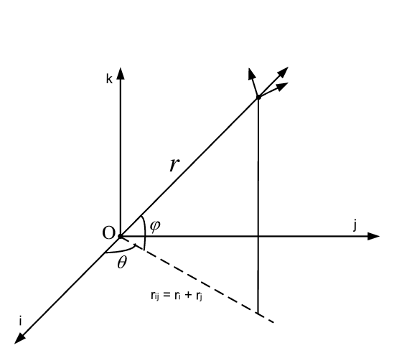
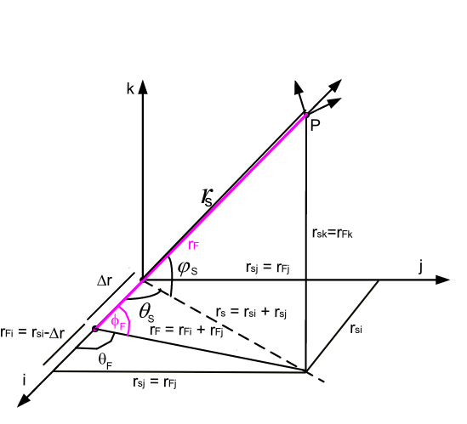
Fig SSF-01 Fig SSF-02
The spherical coordinate convention used here are of the form as given in fig SSF-01 where θ is the angle on the i-j plane from the positive i direction axis in an anti clockwise direction looking perpendicular to this plane from above or in the direction of the -k vector. Φ is the angle from the i-j plane to the +k axis. This convention is used to have consistency and common to the i-j plane having its angle of rotation or vectors expressed as θ and to have angles Φ measured from this plane.
Consider that this field model origin is displaced by an amount Δr_{i} in the designated i axis direction. Now consider that the vector field as described above of this displaced field F is now overlapped upon the surface of the previous field surface at some radius r_{s} from the origin. What is given below is a mathematical treatment and description of this field F on the surface of the original field S at some radius r_{s} from the origin.
To help with this mathematical description, refer to Fig SSF-02 that gives a description of the relationship of F with S. From vector mathematics, it can be seen that the location of the origin of field F is (Δri,0j,0k), and the radius or distance from this location to point P on the surface of the surface S is

Other relationships of angles and distances are given below.
Spherical surface vector
- SSF-01
Where
unit radial surface vector in the i, j, k vector axis direction such that unit radius of spherical surface
- SSF-02
the spherical coordinate surface angels that define a coordinate on the spherical surface
Spherical field vector F
- SSF-03
Where
unit radial spherical field vector in the i, j, k vector axis direction such that unit radius of spherical field is given by
- SSF-04
the spherical coordinate surface angels that define a coordinate on the spherical field.
Spherical field vector F coordinate relationship to spherical surface
- SSF-05a'
Which is the unit vector from the origin of the spherical field vector F in the i axis direction. r_{Si} is the spherical surface radial i component and Δr_{i} is the change in the radial component of the spherical surface origin in the i axis direction to the center of the spherical field vector F. | r_{S} - Δr | is the distance between the centers of S and F.
Now

and have Δr_{j} =0, Δr_{k} = 0 =>
- SSF-05
thus SSF-05a' becomes
- SSF-05a
Similarly
- SSF-05b'
- SSF-05c'
SSF-05b' and SSF-05c' are for r_{F} of a spherical field of radius . For r_{F} to be the radius to the spherical surface S from center location (Δr,0,0) in respect to the sphere S located at (0,0,0), by just looking at the geometric diagram, Fig SSF-02
- SSF-05b
- SSF-05c
From definition of a spherical surface
- SSF-06a
- SSF-06b
- SSF-06c
=>
- SSF-07a
- SSF-07b
and thus rF is related to RS by SSF-05a, SSF-07a and SSF-07b
in addition
- SSF-07c
From the rule of sines and using geometric diagram,

=>
and since from trigonometric relations have
- SSF-08
To find cos(θ_{F}), can use the vector relationship

now =>
- SSF-09
Similarly to deriving SSF-08
- SSF-10
To find cos(ϕ_{F}) need to consider that the projection from S onto the i-j plane has i_{s} defined by the vector rFi + rFj as in fig XXX thus from the definition of cos(angle) = adjacent/hypotenuse
- SSF-11
Divergence of F onto S Div_{F→S}
Div_{F→S} =
F●S = ●
= SDF-01
substituting for from SSF-08 to SSF-11 obtain
F●S
=++
= ++
and substituting SSF-05a, SSF-05b and SSF-05c, have
F●S =
+
+ SDF-02
and using SSF-05 for r _{F} have
=
+
+ SDF-03
and by using relationships SSF-06a, SSF-06b, SSF-06c and SSF-07c and substituting them into SDF-03, the divergence of the spherical vector field F through the spherical surface can be expressed in terms of the spherical surface coordinate and the displacement Δr_{i} . These substitutions are not expressed here as the resultant expression would be very long and complicated and rather unnecessary as SDF-03 is enough to be able to see this. By use of a simple computer program, the result of F●S can be obtained and graphically displayed.
If Δr_{i} = 0 SDF-03 reduces to
F●S =
+ +
And since , and have
F●S = ++= 1
As it should be
Curl of F onto S Curl_{F→S}
Curl_{F→S} = F x S = = - SCF-01a
= - SCF-01
Substituting for Fi,Fj,Fk Si,Sj,Sk from SSF-01 and SSF-03 obtain
F x S =
-
+
substituting for from SSF-08 to SSF-11 obtain
F x S =
-
+ - SCF-02
and substituting SSF-05a, SSF-05b and SSF-05c, have
F x S =
-
+
=
-
+ - SCF-03
Now , r_{Fj} = r_{Sj} r_{Fk} = r_{Sk} and using SSF-05 for r _{F} have
F x S =
-
+
=
-
+ - SCF-04
If Δr_{i} = 0 SCF-04 reduces to
F x S =
-
+
now , = = , = 1
thus have
F x S =-
+
=
as it should be
Cartesian coordinates
Using Cartesian coordinates where x_{S}, y_{S}, z_{S} are the Cartesian coordinates on the surface of a sphere that the initial field vectors of a field S are defined from a field that has as its center the origin and a radius of this sphere r_{S} where
- SCF-05
where r_{Si} = x_{S}, r_{Sj} = y_{S}, r_{Sk} = z_{S} then the radius to this surface coordinate from a field F displaced by coordinate (Δx,0,0) as described above is r_{F} where
- SCF-06a
where r_{Fi} = r_{Si} - Δx and r_{Fi} = r_{Si}, r_{SFi} = r_{Sk} => r_{Fi} = x_{S} - Δx and r_{Fi} = y_{S}, r_{Fk} = z_{S} and radius r_{F} from center of field F to surface of field S at radius r_{S} from center of field S is
- SCF-06
Thus
Div_{F→S} = F●S = ●
= - SCF-07
And
Curl_{F→S} = F x S =
= - SCF-08a
= - SCF-08
As Δx → x_{S} or Δx → 0 Div_{F→S} = F●S → r_{S}² and Curl_{F→S} = F x S →
as they should.
Illustration of change in field location
(to be edited and modified)
In Fig SCF01a and Fig SCF01b is illustrated a resultant field on an initial spherical surface S of a field S centered at the origin (0,0,0), and the vector representation of this field given by the blue arrows. If the Field is displaced to a location (0.5,0,0) the field F on this surface at the same location on this surface is represented by the green arrows. The divergence of F on this surface S is given by SCF-07.

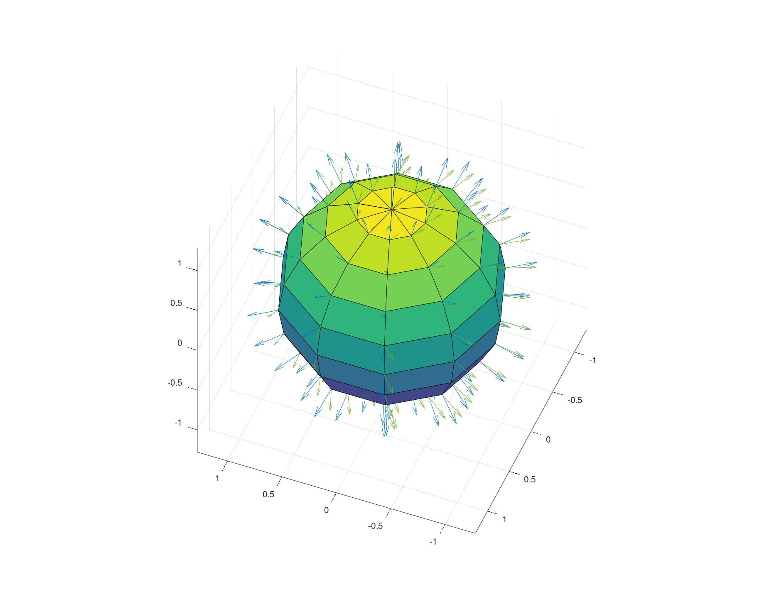
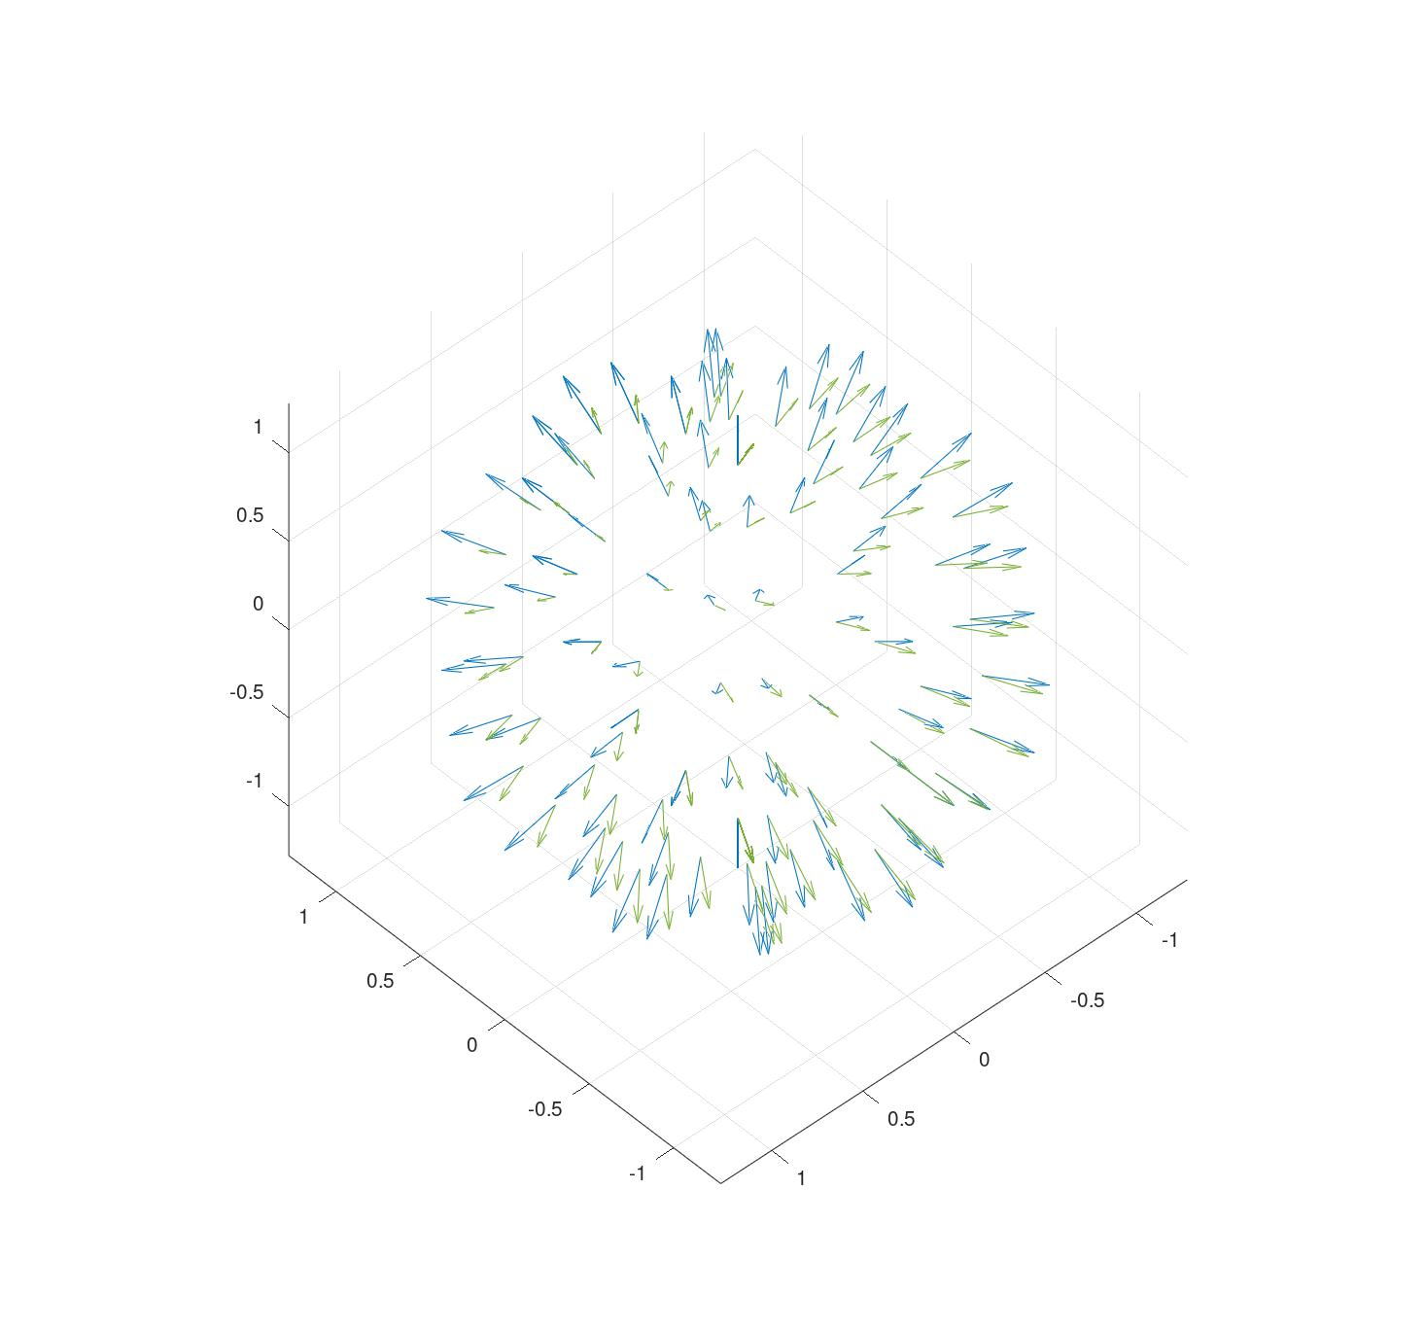
Fig SCF01a Divergence of field F from S Fig SCF01b

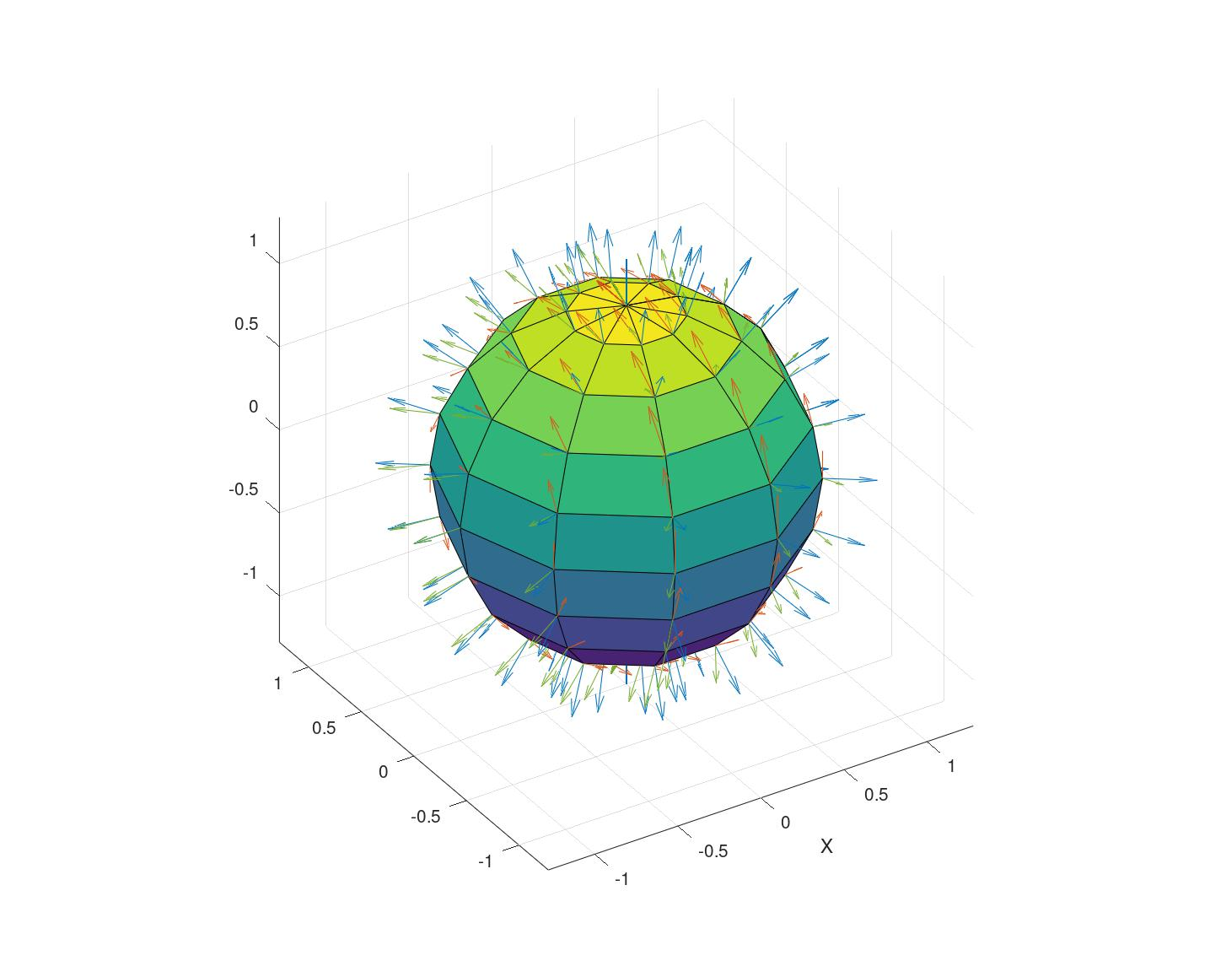
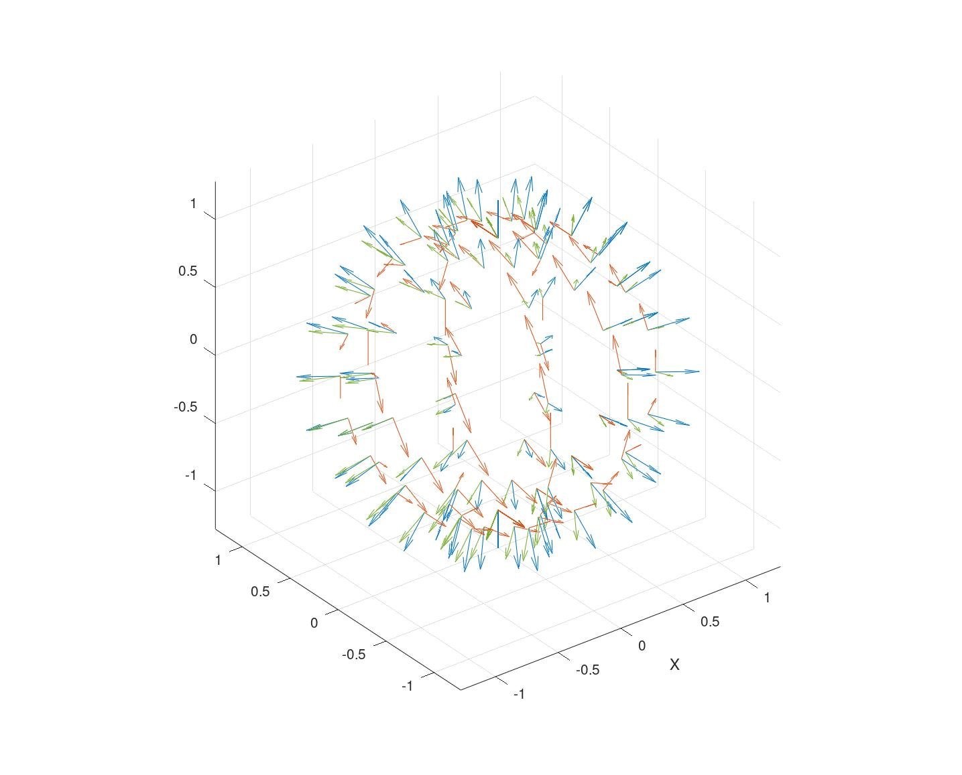
Fig SCF02a Curl of field F and S Fig SCF02b

In Fig SCF02a and Fig SCF02b has illustrated the resultant curl of the vectors representing the fields S and F as given by use of equation SCF-08, which are displayed as red colored arrows. As can be seen, and expected, these arrows rotate about the x axis and on the surface of the initial field S. The length of these vectors increases with the distance from the x axis that they rotate about and are not an indication of anything other than the direction of the vector cross product or curl operation. What this suggests is that all spherical fields have this curl property, at least as a mathematical product if it is in motion and the displaced field F can interact with the initial Field S.

