Building a model of the universe

Mathematics

Iteration
If it is considered that the universe physical processes proceed in iterative steps, then the mathematics that dominate the universe are of an iteration nature.
Define any general iteration step can be expressed in the form
I_{n+1} = I_{n} + ^{I}Δ_{n} I-01
where I is the iteration process property , n = iteration step, Δ is the iteration change of the iteration property. eg ^{I}Δ_{n} is the change of the I iteration property of the nth iteration step and I-01 expresses that the iteration property I of the n+1 iteration step is the addition of the same iteration property I on the n iteration step plus the change of the I iteration property of the nth iteration step.
Iteration of the motion of an entity E.
Location displacement :
Consider that an entity has a designated property of a location x in a physical space of dimension D.
x_{n} is the location in a physical space of the entity at an iterative step n in that physical space, and x_{n+1} is s the location in a physical space of the entity at the next iterative step n+1 in that physical space. Then using I-01
x_{n+1} = x_{n} + ^{x}Δ_{n} I-02
where ^{x}Δ_{n} is a displacement or change of the entity location taking place in the n iteration step.
I-02 represents an iteration step for the displacement or motion of an entity in nth iteration step.
Velocity:
The physics the definition of the displacement or change of location of an entity is the velocity v of an entity. Ie
v_{n} = x_{n} - x_{n-1} I-03a
= x_{n-1} - ^{x}Δ_{n-1}- x_{n-1}
= ^{x}Δ_{n-1} I-03
or
v_{n+1} = ^{x}Δ_{n} I-04
Consider expressing a change in velocity for an iterative n+1 step as
v_{n+1} = v_{n} + ^{v}Δ_{n} I-05
where ^{v}Δ_{n} is a displacement or change of the entity velocity taking place in the n iteration step.
Using I-03 obtain
v_{n+1} = ^{x}Δ_{n-1} + ^{v}Δ_{n} I-06
By definition ^{v}Δ_{n} is a change in velocity for the nth iteration step, and as such implies
^{v}Δ_{n} = v_{n+1} – v_{n} = (x_{n+1} – x_{n}) - (x_{n} – x_{n-1})
= x_{n+1} – 2x_{n} – x_{n-1}
using I-02 for x_{n+1} gives
= x_{n} + ^{x}Δ_{n} – 2x_{n} – x_{n-1}
= ^{x}Δ_{n} – x_{n} – x_{n-1} I-07
Substituting I-7 into I-06 gives
v_{n+1} = ^{x}Δ_{n-1} + ^{x}Δ_{n} – x_{n} + x_{n-1}
= (^{x}Δ_{n} – x_{n} ) + (x_{n-1} + ^{x}Δ_{n-1} )
utilising I-02 x_{n} = x_{n-1} + ^{x}Δ_{n-1}
= (^{x}Δ_{n} – x_{n} ) + x_{n}
= ^{x}Δ_{n}
which confirms I-04
Thus displacement of an entity location expressed by I-02 can be rewritten if not already obvious as
x_{n+1} = x_{n} + v_{n+1} I-08
What has been demonstrated here are the iterative equivalence of the classical equations of motion for velocity where the time interval is reduced to one single iterative step. The displacement or change of location of an entity in an iterative step is the velocity of that entity in that step, and is also the gradient or derivative of the motion of an entity in that iterative step.
Per iteration step
Change of location = velocity = gradient = derivative of motion of entity.
Acceleration:
The classical definition of acceleration of an entity is defined as the change in velocity of that entity over a time period. For a single period of an iteration, that time period is one and acceleration a for the n+1 iteration can be defined as
a_{n+1} = v_{n+1} – v_{n} I-09
using I-05
= v_{n} + ^{v}Δ_{n} – v_{n}
= ^{v}Δ_{n}
and using I-07
= ^{x}Δ_{n} – x_{n} – x_{n-1} I-10
= ^{x}Δ_{n} – (x_{n-1} + ^{x}Δ_{n-1}) – x_{n-1}
= ^{x}Δ_{n} – ^{x}Δ_{n-1} I-11
= v_{n} – v_{n-1} I-12
Which by I-11 gives and expression for the acceleration of an entity of the n+1 iteration as a function of the displacement of that entity in the n and n-1 iteration. The displacements that are the gradients or derivatives of the n and n-1 iteration.
Jerk (Jolt) :
Definition of change of acceleration of an entity is called the jerk or jolt (j) of that entity. For a single period of an iteration, that time period is one and the jerk j for the n+1 iteration can be defined as
j_{n+1} = a_{n} + ªΔ_{n} I-13
The definition of a change in acceleration of an entity defined as the change in acceleration of that entity over a time period is designated as the word jerk or jolt j. For a single period of an iteration, that time period is one and jerk j for the n+1 iteration can be defined as
j_{n+1} = a_{n+1} – a_{n} I-14
The acceleration a for the n+1 iteration can be expressed as
a_{n+1} = a_{n} + ªΔ_{n} I-15
where a_{n} is the acceleration of the entity in the nth iteration step, and ªΔ_{n} is a change of the entity acceleration taking place in the nth iteration step.
Reasons for considering and exploring changes in acceleration of an entity is simply that all forces of electromagnetism and gravity have changes in acceleration of entities due to these forces that is dependent upon their distance from each each other.
Substituting a_{n+1} from I-15 into I-14 gives
j_{n+1} = a_{n} + ªΔ_{n} – a_{n}
₌ ªΔ_{n} I-15
The differential of the jerk or jolt j of the nth iteration.
Breaking ªΔ_{n} down
ªΔ_{n} = a_{n+1} – a_{n}
by using I-11 becomes
=( ^{x}Δ_{n} – ^{x}Δ_{n-1} ) – ( ^{x}Δ_{n-1} – ^{x}Δ_{n-2})
= ^{x}Δ_{n} – 2 ^{x}Δ_{n-1} + ^{x}Δ_{n-2} I-16
= v_{n} – 2v_{n-1} + v_{n-2} I-17
Which by I-16 gives and expression for the jerk or jolt of an entity of the n+1 iteration as a function of the displacement of that entity in the n, n-1 and n-2 iteration. The displacements that are the gradients or derivatives of the n, n-1 and n-2 iterations.
Total displacement or distance:
Generally, the total displacement or distance S travelled by an entity over n iteration steps is the summation of all of the entity displacements for each i iteration step, ^{x}Δ_{i}. ie
S = = I-18
Velocity:
^{x}Δ_{i} can be considered by utilising I-04 as a velocity of an entity within the ith iteration and thus I-18 can also be written as
I-19
where v_{i} is the displacement or velocity of the entity within the ith iteration.
Consider that ^{x}Δ_{i} = v_{i} are of a constant value or velocity for all iterations i. ie ^{x}Δ or v. Then have
S == (n-1) ^{x}Δ I-20
which gives in classical physics the total number of iteration steps (n-1) as time and ^{x}Δ is a constant velocity, which gives
S = vΔt
Acceleration:
A changing entity displacement ^{x}Δ_{i} or velocity v_{i} for each iteration is defined as an acceleration over two iterations as given by I-09 to I-12. However, the total displacement or distance S travelled by an entity undergoing acceleration is still defined by I-18 or I-19. Acceleration is defined by classical physics as a change in velocity per interval of time. For an iteration, acceleration can be thought of as also a change in velocity per iteration. However, acceleration, like velocity, at its most fundamental level, is still an expression of change of an entity’s location per iteration, only that the rate of change of an entity’s location per iteration is not constant from the nth iteration to the n+1 iteration.
Consider that in the nth iteration, an entity location is displaced by ^{x}Δ_{n} from its initial location x_{n} to give a location x_{n+1} in the n+1 iteration. Consider that in the n+1 iteration, an entity location is displaced by ^{x}Δ_{n+1} from its initial location x_{n+1}, to give a location x_{n+2} in the n+2 iteration. ie
x_{n+1} = x_{n} + ^{x}Δ_{n} I-21a
x_{n+2} = x_{n+1} + ^{x}Δ_{n+1} I-21b
The displacement or distance from the nth iteration to the n+2 iteration is the sum of I-21a and I-21b. Since it is only a displacement and no initial location is required for calculating a distance, x_{n} can be considered as equalling to zero.
s_{n+1} = x_{n+1} + x_{n+2}
= (x_{n} + ^{x}Δ_{n}) + (x_{n+1} + ^{x}Δ_{n+1})
= 2(x_{n} + ^{x}Δ_{n}) + ^{x}Δ_{n+1} I-21c
Since it is only a displacement and no initial location is required for calculating a distance, x_{n} can be considered as equalling to zero, =>
s_{n+1} = 2(^{x}Δ_{n})+ ^{x}Δ_{n+1} I-21
By extending this sequence to the s_{n+2} iteration, it becomes apparent that the displacement of an entity undergoing acceleration is a feedback loop, where the total displacement up to any iteration step requires the processes of all of the previous iteration steps to be performed. Summing all individual iteration displacements of I-21 will give a total displacement S or distance of an entity undergoing acceleration.
S = = I-22a
Consider that x_{i} = s_{i-1} for i > 0
If it is considered that s_{i-1} is a displacement of the previous iteration, and that the definition of a displacement of an entity for one time period is a velocity, then s_{i-1} can be defined as an initial velocity of an entity for the ith iteration period and is a displacement of the entity that is to occur in the current iteration if no change to this iteration initial velocity takes place. ie v_{i} = s_{i-1}
If such a change in displacement in the ith iteration were to take place compared to the i-1 iteration, then ^{x}Δ_{i} is a change in the displacement of an entity in the ith iteration above that of its initial velocity given for that ith iteration by s_{i-1}, which is also a change in velocity of the current iteration. ie s_{i-1}+ ^{x}Δ_{i} is an expression of the acceleration a_{i} of the entity in the ith iteration step in terms of displacement of the entity. ie v_{i} = s_{i-1}+ ^{x}Δ_{i} = s_{i}. To avoid confusion with earlier declarations, ^{x}Δ_{i} needs to be replaced with ^{s}Δ_{i} to indicate that this is a change in the displacement of an entity in the ith iteration compared to the previous i-1 iteration. Thus have
S = s₀ + = x₀ + ^{x}Δ₀ + I-22
and considering that it is displacement only that is being summed, x₀ = 0 =>
S = ^{x}Δ₀ + I-23
Acceleration of an entity can thus be stated as a change in rate of displacements between one iteration and the next. ie acceleration a_{i} = s_{i –} s_{i-1} = ^{s}Δ_{i}.
Expanding I-23 a recursive pattern emerges as
S = ^{x}Δ₀ + (^{x}Δ₀ + ^{s}Δ₁) +
= ^{x}Δ₀ + (^{x}Δ₀ + ^{s}Δ₁) + (^{x}Δ₁ + ^{s}Δ₂) +
= ^{x}Δ₀ + (^{x}Δ₀ + ^{s}Δ₁) + ((^{x}Δ₀ + ^{s}Δ₁) + ^{s}Δ₂) + (^{x}Δ₂ + ^{s}Δ₃) +
= ^{x}Δ₀ + (^{x}Δ₀ + ^{s}Δ₁)+((^{x}Δ₀ + ^{s}Δ₁) + ^{s}Δ₂)+(((^{x}Δ₀ + ^{s}Δ₁) + ^{s}Δ₂) + ^{s}Δ₃)+(^{x}Δ₃ + ^{s}Δ₄)+
= n(^{x}Δ₀) + (n-1)(^{s}Δ₁) + (n-2)(^{s}Δ₂) + (n-3)(^{s}Δ₃) + (n-4)(^{s}Δ₄) + …… + (1) (^{s}Δ_{n-1})
= n(^{x}Δ₀) + I-24
which can be interpreted as equivalent for iteration of equal time duration to
S = nv₀ + = v₀t + I-25
if have constant acceleration a = ^{s}Δ = ^{s}Δ_{i} for all i iterations, then I-24 becomes
S = n(^{x}Δ₀) +
and or =>
S = n(^{x}Δ₀) + I-26
Consider that ^{x}Δ₀ is the initial velocity of the entity, ^{s}Δ is the constant acceleration, and n is the time of duration then I-26 can be expressed as
S = v₀t + I-27
for very large number of iterations, n²-n ≈ n² => t²-t ≈ t² confirming that this iteration approach agrees with the classical equation of motion of an entity undergoing constant acceleration that has been derived using integral calculus
Thus to calculate the displacement or distance an entity traverses in n iterations, only the initial displacement or velocity in the first iteration is needed to be known, and the acceleration or changed displacements between each iteration, then the summation equation I-24 can be applied.
I-24 applies to all situations of motion, including entities experiencing jerk (jolt) changing acceleration, constant acceleration, or constant velocity. The location of an entity in any iteration i is an expression of the initial location x₀ of that entity plus the displacement given by I-22, and the end location after completing n iterations is
x_{n} = x₀ + s_{n} = x₀ +n(^{x}Δ₀) + I-28
which is equivalent to the classical equation of motion
x_{n} = x₀ + v₀t + I-29
for very large number, n, of iterations.
Jerk or Jolt:
All classical defined forces of electromagnetism and gravity have the force defied as
Force = mass x acceleration
or in algebraic form
F = ma
the force, and hence acceleration experienced on an entity for electromagnetism and gravity changes in proportion to the inverse of the square of the distance, r, an entity E of mass m is to another entity that it is interacting with, and which is attributed to as the source of the interacting force. For electromagnetism
F = ma =
and for gravity
F = ma =
=>
a =
Thus as r changes, so does the acceleration experienced by entity E, and this change in acceleration is defined and named as the jerk or jolt j that entity E experiences as its distance from the entity it is interacting with changes.
Consider that in any n+1 iteration, the jolt, j, experienced by an entity is defined as the change in acceleration of the n+1 iteration compared to the acceleration of the n iteration as given by I-14, which can be also written as I-15.
The displacement or distance s travelled for an acceleration in the n+1 iteration is defined by
s_{n+1} = s_{n} + ^{s}Δ_{n} I-30
if ^{s}Δ_{n-1} ≠ ^{s}Δ_{n} then entity E undergoes a jerk or jolt between iteration n and n+1 and that jolt j_{n} for the n iteration is
j_{n} = a_{n} – a_{n-1} = ^{s}Δ_{n –} ^{s}Δ_{n-1} = ªΔ_{n} I-31
=>
^{s}Δ_{n} = j_{n} + ^{s}Δ_{n-1} = ªΔ_{n} + ^{s}Δ_{n-1} I-32
Substituting I-34 into I-30 obtain the displacement or distance traversed by an entity in the nth iteration is
s_{n+1} = s_{n} + ^{s}Δ_{n-1} + j_{n} = s_{n} + ^{s}Δ_{n-1} + ªΔ_{n} I-33
Thus the total displacement or distance S traversed by an entity over n iterations is.
S = s₀ + = ^{x}Δ₀ + I-34
where s_{i-1} = I-34 is an altered expression of I-23.
Expanding I-34 is similar to expanding I-23.
S = ^{x}Δ₀ + (^{x}Δ₀ + ^{s}Δ₀ + ªΔ₁) +
= ^{x}Δ₀ + (^{x}Δ₀ + ^{s}Δ₀ + ªΔ₁) + (s₁ + ^{s}Δ₁ + ªΔ₂) +
= ^{x}Δ₀+(^{x}Δ₀ + ^{s}Δ₀ + ªΔ₁)+((^{x}Δ₀ + ^{s}Δ₀ + ªΔ₁) + ^{s}Δ₁ + ªΔ₂)+(s₂ + ^{s}Δ₂ + ªΔ₃) +

= n(^{x}Δ₀) + (n-1)(^{s}Δ₀+ªΔ₁)+ (n-2)(^{s}Δ₁ + ªΔ₂) + (n-3)(^{s}Δ₂ +ªΔ₃) + (n-4)(^{s}Δ₃+ªΔ₄) + …… + (1) (^{s}Δ_{n-2}+ªΔ_{n-1})
Any ^{s}Δ_{n} = (^{s}Δ_{n-1}+ªΔ_{n}) from I-33 =>
S = n(^{x}Δ₀) + (n-1)(^{s}Δ₀+ªΔ₁)+ (n-2)(^{s}Δ₀+ªΔ₁+ ªΔ₂) + (n-3)(^{s}Δ₀+ªΔ₁+ ªΔ₂ +ªΔ₃) + (n-4)(^{s}Δ₀+ªΔ₁+ ªΔ₂+ªΔ₃+ªΔ₄) + …… + (1) (^{s}Δ₀+ ªΔ₁+ ªΔ₂ + ªΔ₃ + …. + ªΔ_{n-1} ) I-35
= n(^{x}Δ₀) ++++ ..+
= n(^{x}Δ₀) ++ I-36
of which the first two terms is equivalent to I-26, and thus I-36 becomes
S = n(^{x}Δ₀) ++ I-37
of which, as for the distance traversed under a constant acceleration is equivalent to
S = v₀t ++ I-38
where ªΔ_{i} is the jerk or jolt value for the i iteration of a total of n iteration intervals.
Consider that the jerk or jolt is constant for all n iterations. ie ªΔ_{i} = ªΔ for all I, then all ªΔ_{i} in I-35 = ªΔ => have k ªΔ for each n-k summation of I-38. ie
S = n(^{x}Δ₀) + (n-1)(^{s}Δ₀+ªΔ)+ (n-2)(^{s}Δ₀+ªΔ+ ªΔ) + (n-3)(^{s}Δ₀+ªΔ+ ªΔ +ªΔ) + (n-4)(^{s}Δ₀+ªΔ+ ªΔ+ªΔ+ªΔ) +... + (1) (^{s}Δ₀+ ªΔ+ ªΔ + ªΔ + …. + ªΔ_{n-1} )
or
S = n(^{x}Δ₀) ++ I-39
= n(^{x}Δ₀) ++ I-40
and using summation relationships and with N = n-1, obtain

S = n(^{x}Δ₀) ++

= n(^{x}Δ₀) ++
= n(^{x}Δ₀) ++
= n(^{x}Δ₀) ++ I-41
Consider that ^{x}Δ₀ is the initial velocity and ^{s}Δ₀ is the initial acceleration at the first iteration period of the entity, and ªΔ is the constant change of acceleration or jerk, (jolt) j, and n is the time of duration, then I-41 can be expressed as
S = v₀t ++ I-42
For very large number of iterations, n²-n ≈ n² => t²-t ≈ t² and n³-n ≈ n³ => t³-t ≈ t³, confirming that this iteration approach agrees with the classical equation of motion of an entity undergoing a constant jerk that has been derived using integral calculus.
I-42 applies to all situations of motion, including entities experiencing jerk (jolt) changing acceleration, constant acceleration, or constant velocity. The location of an entity in any iteration i is an expression of the initial location x₀ of that entity plus the displacement given by I-22, and the end location after completing n iterations is
x_{n} = x₀ + s_{n} = x₀ +n(^{x}Δ₀) ++I-43
which is equivalent to the classical equation of motion
x_{n} ≈ x₀ + v₀t ++ I-44
for very large number, n, of iterations and constant change of acceleration, jerk j.

Conclusion:
In this section, it has been demonstrated that an iteration approach to defining the motion of an entity is viable, simple and agrees with the traditional approach of integral calculus. Acceleration and jerk have been demonstrated as a feedback process that is an accumulation of all previous changes of motion, or at least for a single iteration, is a feed back response from the most recent and previous iteration process.
In I-27 and I-42, the inclusion of the t²-t and t³-t is an indication that within a single iteration on its own, no acceleration or jerk can be defined or discovered, as t²-t and t³-t = 0 for a single period of iteration. This also gives an indication that if the universe operates as a series of iterative events, as the physics model approaches that of the physical process single iteration events, or at small time scales or distances that are of a scale of these events, iteration relationships like I-27 and I-42 become more prevalent. It is also an indication that the use of calculus that relies on a continuous number field is prone to increasing error and is no longer valid to use.
Through derivation of acceleration and jerk, the displacement or distance traversed relationships of I-25 and I-41 indicate that acceleration and jerk is a parameter of the history of an entity over more than one iteration. Velocity can be determined in a single iteration by a measurement of the difference of displacement of an entity within an iteration. Acceleration, and jerk requires a known history of entity displacement, and each has have within them, the accumulated history of of these displacements, as I-24 and I-38 shows.
In I-24 it can be argued that the acceleration a_{i} in any iteration i, is a measurement of the difference of the ith iteration velocity or displacement from an initial i=0 iteration velocity or displacement. Similarly,In I-38 it can be argued that the jolt j_{i} in any iteration i, is a measurement of the difference of the ith iteration acceleration from an initial i=0 iteration acceleration.
If a unified theory of the universe is to be found for all the interpreted observed forces at play, each force is in essence a process of acceleration and jerk. As demonstrated here, acceleration and jerk processes are feedback processes that can be expressed as a summation of iteration steps prior to the iteration step being measured, and as such, a unifying theory of forces will involve a physical process of feedback, which in turn can be a sign of self interaction from one period of iteration to the next.

An iteration model perspective:
Any model of the processes of the universe based upon an iteration step method would not have acceleration or jerk being a part of that individual iteration step as acceleration and jerk is a function of more than one iteration step, and is also a derived interpretation from the mathematics of calculus. Acceleration and jerk are thus observed emergent resultant behaviour of the physical process that increases an entities motion of displacement within that one iteration step in which it occurs.
It is often stated that Einstein’s field equation of general relativity being, without explaining it is
I-45
where the left side of the equation states the geometry of space that is determined or generated by the right side (the mass-energy of entities), and which then in turn reacts to this geometry to cause motion of the mass-energy entities, that in turn, then generate a new geometry of space to react to, and so on. This may just be such an iterative physical feedback process in which the motion from one iterative step to the next is determined by the conditions at any iterative step, and not by an equation derived from a set of observation measurements, such as Newton’s equation of gravitation.
Einstein’s field equation may be a mathematical expression of the underlying physical process of gravity that is taking place. This field equation gives a mathematical model that gravity is of a geometric nature and that entities that have a property of mass react from one moment to the next based upon the interpreted resultant geometry of space that the masses either modify, or create through interaction. In an iteration model, the action of an entity in any iteration is an action to the geometry surrounding the local vicinity of the entity at that iteration step. The geometry surrounding the local vicinity of the entity at that iteration step is determined by an accumulation of past iteration steps that has created that geometry of space.
With this in mind, what is interpreted as acceleration or jolt is a function of the geometry of space in the vicinity of the entity, not an action at a distance given by an equation such as Newtons law of gravity. That geometry of space at that location in space in that iteration step is a function of all past iteration steps of interaction, including that of a model of space interacting with itself.
An analogy would be dropping a pebble into a pond of calm water with a ball floating some distance from where the pebble was dropped. The ball does not react to the pebble, but to the disturbances of the water that the pebble has created by its interaction with the water. Being some distance from the location where the pebble was dropped, it takes some time, or number of iterations or physical processes to occur before any of those disturbances reach the ball, and for the ball to react to those disturbances. This is how an iteration model of the physical processes of the universe would be constructed. This is also a proposal of the underlying physics governing the universe and all its processes, and that such an iteration model is more relevant and accurate to give a greater understanding and knowledge of its inner workings than by the search for equations. Equations that rely on a mathematical approach that may break down at the most fundamental level at the heart of all physical processes and observation.

Iteration Model
Iteration step time :
It the universe processes progress as a series of iteration steps, then there should be a set minimum time duration that a single step can be performed in. Such a time step can be speculated by the one constant of the universe that does not vary in any reference frame, and is measured and proved to constant in all. That being the velocity of light.
Light, or photon, is prevalent in all physical processes of atomic interaction, and it has been theorised and proven that gravitational waves propagate at the velocity of light. Consider that the process of the propagation of light is an iterative process within an iteration step model of the universe. To find this iteration duration as a time value, consider that an iteration process is a change of physical state of a photon. Considering that the photon is an interpretation as a wave, this change of physical state is that from the assumed photon wave peak to the assumed photon wave trough, or from the trough to the peak . That is, half a wavelength λ.
Consider that the velocity of light c is defined as c == IM-01
where Δt is the duration that light takes to traverse one half of a wavelength, or one iteration.
The relationship IM-01 indicates that as the wavelength of a photon changes, the period of iteration changes in proportion. Many visible light wavelengths are in the range of 4x10⁻⁷ to 7x10⁻⁷ meters, which translates into possible iteration periods of Δt being in the range of 0.6666 x10⁻¹⁵ to 1.2666 x10⁻¹⁵ seconds.
In physics, there is a relationship between the energy E of a photon, and the measured interpreted wavelength λ, given by the equation
E = hf = IM-02
where c = velocity of light, h = Plank’s constant.
if it is assumed that the iteration for a photon to change its energy state is of a period from peak to trough of a single photon, then IM02 becomes.
2E = =
the velocity of light can be considered as the displacement or distance between peak and trough of a photon wave, c = λ/2 =>
2E = = IM-03
=>
EΔt = IM-04
and substituting the values for h, obtain.
EΔt = (6.62607015 x 10⁻³⁴)/2
= 3.31302557 x 10⁻³⁴ Joule-seconds
≈ 3.313 x 10⁻³⁴ Joule-seconds
Thus the iteration period of any photon from its wave peak to trough is ≈ 3.313 x 10⁻³⁴ Joule-seconds, which also by the speculation given here, is the iteration period in seconds for all photon processes.
This implies that from IM-04, that the duration of iteration process is in proportion to the inverse of the energy of the interaction, and that the process of energy changing the physical state occurs in one iteration.
Consider that an electron has a charge energy of ≈ 1.602 x 10⁻¹⁹ Joules, then an interaction involving an electron may have an iteration period of ≈ 3.313 x 10⁻³⁴ / 1.602 x 10⁻¹⁹ seconds ≈ 2.068 x 10⁻¹⁵ seconds.
This agrees in order magnitude with the possible iteration periods for the propagation of visible light that is emitted by electron transitions of atoms as given by IM-01.
The possible iteration periods given by IM-01 and IM-04 are not of the shortest duration as there exists higher energy and shorter photon wavelengths that may be more applicable to nuclear processes. What the shortest iteration duration is, and which other processes of the universe are derived or built from needs to found.
This could possibly be the theoretical plank time of ≈ 5.3912×10−44 seconds, but it is not advocated just yet.
Consider Einstein’s famous energy equation E = mc².
For an electron-positron pair production process,
E ≈ 2 x (9.1093837x10⁻³¹)x(2.99792458x10⁸)²
≈ 1.63742x10⁻¹³ joules
=> Δt for electron-positron pair production process is ≈ 1.63742x10⁻¹³ / 3.31302557 x 10⁻³⁴ ≈ 4.94235 x10⁻²⁰ seconds, if the process of proton-positron pair production is true for IM-04.
Such time periods are not possible to measure with the current technology and physics time clocks that use radioactive decay processes. Thus the iteration period being less than the current time clocks is not possible to be measured, only speculated and theorised.
However, what is being hypothesised by the examples given here is that if the fundamental physical processes of the universe occur in a single iterative step, the duration of that step for a particular fundamental physical process relative to another different fundamental physical process has at the core of both of their iterative duration, the speed of light, and Planks constant. Regardless of what is the duration, or if a fundamental smallest unit of duration exists, and what it is that forms a basis upon which all other iterative processes need to comply to, it is postulated that the velocity of light and Planks constant are at the core of any and all physical processes iteration duration.
Consider that E in IM-04 is of one unit of energy, then Δt, the smallest unit of time that an iteration can have is the Plank constant divided by 2. That is, the smallest duration of an iteration step in terms of a theoretical clock in any frame of reference is 3.31302557 x 10⁻³⁴ seconds, which is also close to the mathematical value of π x 10⁻³⁴ seconds, or h/(2π) seconds within 5.5%.
Therefore, it may be that an iteration model of the universe can have at its core, an iteration period or time in all reference frames of ≈ h/(2π) seconds according to the clock that is measuring time in the reference frame of the physical process that time is being measured.
That is, if a measurement of the wavelength of light is measured differently in two different reference frames of a constant velocity less than the measured velocity of light relative to each other, it is a sum of iteration intervals equivalent to the velocity differences of the frame of reference that contribute to this measured difference of wavelengths.
If a measurement of the wavelength of light is measured in two accelerating frames of reference, each iteration period would have a different velocity and hence reference frame between emission and interaction of a photon of light between source and receiver. The measured photon or interaction would be in the final reference frame(s) in which the photon finally reaches the recipient, which is an accumulation of iteration periods of differing velocities between the emission and receiving of the photon entities in their respective accelerating reference frames.
What this means is that depending what the total spacial distance travelled, the emission of a photon from the same source would be distorted by different proportions unlike from a non accelerating source which would be constant.
This distortion would be a measurement of increasing wavelength for a source and observer of increasing distance from each other accelerating from each other as the relative iteration duration of the photon physical state would be interpreted as increasing. At some maximum iteration period, no iteration period could be measured and no photon interaction or measurement could be made of the photon wavelength. Such an iteration period can be determined by the velocity of light. If the iteration period of change of the physical state of motion of an entity is equal to or greater than that of the photon, the photon would never be able to interact with an entity to change its physical state so as to be measured. That is, once any acceleration of motion reaches a velocity of that of light between two entities, no further interaction of light between them can take place, and hence no photons observed.
This distortion would be a measurement of decreasing wavelength for a source and observer of decreasing distance from each other accelerating towards each other as the relative iteration duration of the photon physical state would be interpreted as decreasing. If the smallest duration of interaction is given by h/(2π) seconds as suggested above, then the limit upon what measured wavelength an interacting photon can have is governed by this value and cannot be any lower. Taking the velocity of light as a limiter to the motion of a photon of light the shortest wavelength of light can be speculated to be of that comparable to the energies required for particles of mass to be created by Einstein’s famous equation E = mc². Taking the heaviest stable nucleon, the proton as a basis, this would have an energy of E = 1.67262192x10⁻²⁷ x (2.99792458x10^{8\})² = 1.5032776x10⁻¹⁰ joules. Substituting into IM-02 would yield a photon of 1.3214x10⁻¹⁵ metres. Thus photons of measured wavelength of the order of 10⁻¹⁵ metres is speculated to be the limit of the lowest or shortest wavelength a photon can have.
It can be speculated that entities accelerating towards each would only observe photons emitted from other entities accelerating towards them if the relative motion when the observation is measured is lower than the velocity of light. If the relative motion when the observation measured is at or greater than the velocity of light, then only an iteration of duration minimum is possible, meaning a photon of this minimal duration can be measured. But it can be considered that no entity can exceed the velocity of light as any emission of photons would be behind the entity motion, and thus the entity motion and change of physical state would be lower that the permissible minimum iteration period of duration, which is not allowed. If an entity is in motion at the velocity of light, any emission of light in the direction of motion would not progress beyond the entity location, and would be in motion with the entity, and have in essence a single iteration photon of wavelength of the lowest possible value.

Relationship of the velocity of light (electromagnetic radiation) to rate of iteration
By experiment and observation, the propagation, or measured velocity of light and Planks constant do not change in any reference frame, and since they both are vital to all fundamental physical processes that occur in the universe, and by inference, if every physical process in the universe is of an iterative process, then every iterative process of a particular kind must occur at a rate of duration that conforms to these two constants holding true.
As one example, light has a property that a receding or approaching light source has a Doppler shift observed, but an observer in the same reference frame observes no such effect. If it is considered that light is analogous to a wave, and the traversal of a transition at a fixed point in space is a change in the physical state of space at that location that changes at as the light wave passes through that location, (amplitude or energy state) that change of physical state is a physical process that by some fundamental physical property of the universe must be such that the duration of that physical process in relation to the motion of the source from which the light originated from is consistent, ie constant, at all times.
This is an explanation of Einstein’s hypothesis on the speed of light being invariant in all reference frames, and is also a fundamental hypothesis for the iteration of physical processes. All physical processes occur at an iterative rate such that the electromagnetic or gravitational interactions that form the basis of those interactions are at the velocity of light.
In the case of the Doppler effect, consider that the propagation of light changes the physical state of the measuring device at a fixed location in space relative to the observer such that it is interpreted as a maximum or highest positive value corresponding to the crest of an electromagnetic wave. Now consider that at some period progressing from this, the propagation of light changes the physical state of the measuring device such that it is interpreted as a minimum or lowest negative value corresponding to the trough of an electromagnetic wave. Consider for arguments sake, that the wave form is that of a step or square wave, where there is no intermediate value between the minimum and maximum physical states, this period of progression is the period of transition between these two physical states.
As such, the amplitude of the light wave does not change for any measured frequency of the waveform, only the duration of transition from the physical state of a crest to a trough. Thus if the energy of a photon of light as given by IM-02 is one of a relationship of that the duration of the transition from one physical state to the next, and not the amplitude of a photon. This counter to the physics of waves in a medium such as liquids or solids, where the energy of a wave is in the amplitude of a wave.
Consider that light is not a step or square wave of one single iteration between a crest and a trough physical state, but has a finite number of iterative steps between the crest and a trough physical state. Then each of these iterative steps has a duration in which to progress from one step to the next. What this means is that if the source of a photon of light is accelerating, then the photon will also be effected in such a way that it will be distorted as the progression of iteration periods to would be either increased or decreased depending on the observation of the source approaching or receding from the location of observation. This acceleration would need to be high for large observable distortions, as the velocity changes would need be of an order comparable to the period of iteration steps.
With the above in mind, what this means for electromagnetic radiation, is that all electromagnetic radiation can be considered as having a physical state of the same minimum and maximum magnitude, and that the only property of difference is the duration or rate of change of physical state of space between these two values. Thus can be implied that all photons are of the same, and that what constitutes a difference between them is a relative state of motion of the source from which each was emitted. Thus a photon of higher energy and shorter interpreted wavelength would have originated from a source of higher motion or acceleration.
Speculation : In atomic interactions where photons are interpreted to be absorbed by an electron to change its physical state from a lower to a higher energy state, the interaction is dependent upon a comparable rate of iteration of the photon changing its physical state to that of the electron. If the rate of photon iteration changing from a maximum to minimum physical state is somehow compatible with the electron changing its physical state in the same iteration period, then the interaction of the photon electromagnetic field property with that of the electron will cause the electron to change its physical state, perhaps even in the same period of iteration of that of the photon electromagnetic propagation.
Similarly, all physical interactions may have at the core of the interaction, that an interaction between two entities will occur if the duration of iteration of changes in physical state are compatible. It may be that either they have to be the same, or of some discrete multiple of each other.
Speculation : If it is accepted that the propagation of light electromagnetic radiation is of multiple iterative steps, then interruptions to the electromagnetic may be possible such that the electromagnetic pulse could be truncated or added to. That is, only part of the full cycle from crest to trough, or from trough to crest may be propagated. But this will probably end the propagation as the electromagnetic pulse would no longer be able to sustained as a full electromagnetic cycle is needed for the propagation process of the electromagnetic wave to succeed.
Question :
Through experiment, it is often theorised with evidence that light of the same or different wavelength can exist in a state of superposition, where the amplitudes of each photon can be added together to form a resultant single waveform. This being how telecommunication is possible. If the propagation of light is iterative in nature, then how is it possible for two photons of differing iteration duration, and hence being incompatible, able to be superposed upon each other? This can be a big issue and needs to be answered for this hypothesis to be fully successful!
Possible Answer :
1 Physical space is discrete and quantised such that in a physical process of a single iteration of the propagation of electromagnetic radiation, multiple segments of space change their physical state to the same value. Not satisfactory though as this would means all of 3D space is of an unchnaging 3D grid like structure.
2: The different electromagnetic iterative intervals interact with each other to form some kind of new iteration interval that has the resultant amplitude value of this interaction. Raises other questions about whether the larger iteration interval needs to be an exact multiple of the smaller iteration interval for this superposition model to be applied.
3: All electromagnetic radiation do not actually superpose upon each other to form a combined electromagnetic wave of a resultant summed up amplitude, but each interacts individually with the recipient entity in each individual interval of iteration that gives the illusion of a superposed waveform. This is analogous to multiple gas molecules hitting an area of a wall of a container of a vessel. Each individual molecule has only a small amount of energy and the electromagnetic interaction between one molecule and that of a wall gives off a small exchange of energy from the molecule to the wall. But many molecules hitting the wall a the same, or near instant, gives off a large exchange of energy to the wall creating an effect of noticeable pressure or force upon the wall from the superposition of the individual electromagnetic field interactions of the molecules with the wall.
Question :
If the superposition of electromagnetic radiation has the iteration intervals out of sync, either by the space the iteration occurs in if they are of the same or discrete multiples of each other, or by non discrete multiples of each other, how can they be superposed upon each other.
Possible Answer : See 3 : above.
Speculation : If two or more electromagnetic photons propagate in such a manner to each other that the iteration periods of both are in sync and are of the same duration, then those electromagnetic photons are able to interact with each other if their amplitudes overlap. This interaction can be the possible change in the resultant interpreted amplitude of the space that each photon overlaps with each other, or even a possible form of interaction that sets up a form of self interaction of the resultant electromagnetic field.
Iteration model of photon emission and the Doppler effect
Direct receding
Consider two entities that are in relative motion to each other such that they are directly receding from each other. Entity A is considered as motionless in its reference frame, while entity B is in a reference frame of motion moving away from it. Entity A emits a photon which has for argument sake, five iteration periods that define the photons waveform. In Fig IMI-01 is a depiction of the iteration model of this physical process of a photon transmission where there is a begin and end of photon transmission from a source Entity A that spans five iteration periods and defines that photon structure.

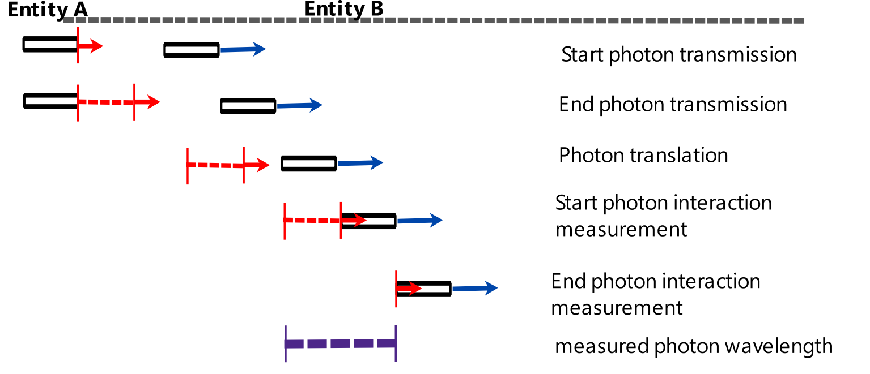
Fig IMI-01 Receding Entities

Entity B is in a motion of constant velocity moving away from Entity A in respect to its frame of reference to that of Entity A. This motion of velocity is considered to be a change in the physical state of Entity B in respect to that of Entity A, and at each iteration period progresses at a constant displacement of physical space away from Entity A. This velocity is less than that of the transmitted photon from Entity A, and thus the head or start of the photon transmission after some number n of iteration intervals, (ie time) reaches Entity B and interacts with a Entity B that can be considered as a measuring device. As Entity B progresses further in its motion, successive interactions with the higher velocity photon motion and its iteration steps occurs with each iteration of motion of Entity A until the end and last of the photon transmission iteration is incident and interacting with Entity B.
If Entity B takes a measurement of the total duration in respect to its own internal clock of iteration of all of the photon iteration steps from that of the first point of interaction to the last, it would find that this measurement is of greater number and hence duration or time than if it was in a stationary reference frame in respect to entity A. This is due to the motion of Entity B causing the end of the photon transmission to travel a greater distance, and hence requiring a greater number of clock iterations of entity B to be executed before the photon end to interact with entity B and be measured and interpreted as a wavelength of a photon of light.
In Fig IMI-01, at the top is a dashed line representing the iteration period of the reference frames measured by both entity A and Entity B. This is the same duration as the iteration periods of the photon. As the photon interacts with entity B, it takes 10 iteration periods before the end or last photon iteration period interacts with a moving Entity B in the same motion as an interacting photon, and is measured as the Photon wavelength. In this exaggerated example, the measured photon wavelength is twice of that if Entity B were to perform the same measurement from a stationary reference frame in respect to Entity A. Thus it is interpreted that the duration of iteration periods of the photon is twice that of Entity A, and hence the space of the photon has been stretched in at least the direction of motion of both the photon and Entity A.
This same result can be interpreted by considering that Entity B is stationary, and that the photon emitting Entity A is in motion away from Entity B. For each iteration period of moving Entity A, the begin and end of an iteration period of a photon is lengthened in spacial context of the reference frame of a stationary Entity A, and so is its measured duration compared to that of a clock of stationary Entity A.
Direct approach
Consider two entities that are in relative motion to each other such that they are directly approaching each other. Entity A is considered as motionless in its reference frame, while entity B is in a reference frame of motion moving toward it. Entity A emits a photon which has for argument sake, five iteration periods that define the photons waveform. In Fig IMI-02 is a depiction of the iteration model of this physical process of a photon transmission where there is a begin and end of photon transmission from a source Entity A that spans five iteration periods and defines that photon structure.
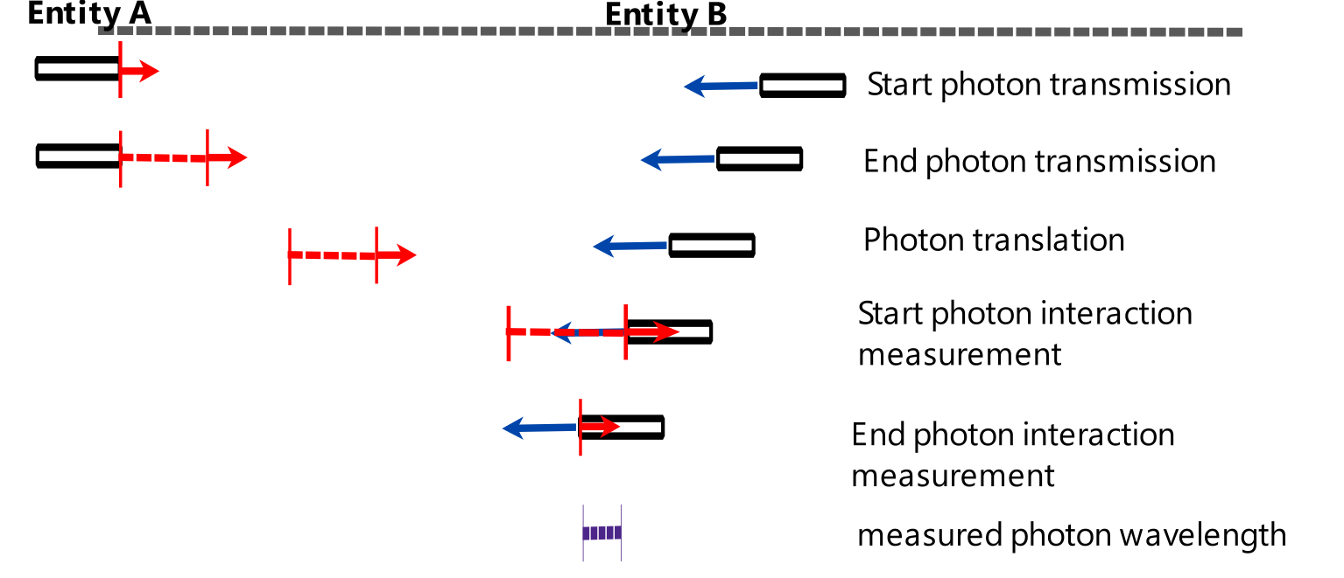
Fig IMI-02 Approaching Entities
Entity B is in a motion of constant velocity moving toward Entity A in respect to its frame of reference to that of Entity A. This motion of velocity is considered to be a change in the physical state of Entity B in respect to that of Entity A, and at each iteration period progresses at a constant displacement of physical space toward Entity A. This velocity is less than that of the transmitted photon from Entity A, and thus the head or start of the photon transmission after some number n of iteration intervals, (ie time) reaches Entity B and interacts with Entity B that can be considered as a measuring device. As Entity B progresses further in its motion, successive interactions with the higher velocity photon motion and its iteration steps occurs with each iteration of motion of Entity A until the end and last of the photon transmission iteration is incident and interacting with Entity B.
If Entity B takes a measurement of the total duration in respect to its own internal clock of iteration of all of the photon iteration steps from that of the first point of interaction to the last, it would find that this measurement is of lower number, and hence duration or time than if it was in a stationary reference frame in respect to entity A. This is due to the motion of Entity B causing the end of the photon transmission to travel a lesser distance, and hence requiring a lower number of clock iterations of entity B to be executed before the photon end to interact with entity B and be measured and interpreted as a wavelength of a photon of light.
In Fig IMI-02, at the top is a dashed line representing the iteration period of the reference frames measured by both entity A and Entity B. This is the same duration as the iteration periods of the photon. As the photon interacts with entity B, it takes 3 iteration periods before the end or last photon iteration period interacts with a moving Entity B in the opposing motion as an interacting photon, and is measured as the Photon wavelength. In this exaggerated example, the measured photon wavelength is almost about 3/5 of that if Entity B were to perform the same measurement from a stationary reference frame in respect to Entity A. Thus it is interpreted that the duration of iteration periods of the photon is 3/5 that of Entity A, and hence the space of the photon has been squeezed in at least the direction of motion of the photon.
This same result can be interpreted by considering that Entity B is stationary, and that the photon emitting Entity A is in motion towards Entity B. For each iteration period of moving Entity A, the begin and end of an iteration period of a photon is squeezed in spacial context of the reference frame of a stationary Entity A, and so is its measured duration compared to that of a clock of stationary Entity A.
Oblique approach
Consider two entities that are in relative motion to each other such that they are obliquely approaching each other. Entity A is considered as motionless in its reference frame, while entity B is in a reference frame of motion moving obliquely toward it. Entity A emits a photon which has for argument sake, five iteration periods that define the photons waveform. In Fig IMI-03 is a depiction of the iteration model of this physical process of a photon transmission where there is a begin and end of photon transmission from a source Entity A that spans five iteration periods and defines that photon structure.
Entity B is in a motion of constant velocity moving toward Entity A in respect to its frame of reference to that of Entity A. This motion of velocity is considered to be a change in the physical state of Entity B in respect to that of Entity A, and at each iteration period progresses at a constant displacement of physical space toward Entity A. This velocity is less than that of the transmitted photon from Entity A, and thus the head or start of the photon transmission after some number n of iteration intervals, (ie time) reaches Entity B and interacts with Entity B that can be considered as a measuring device. As Entity B progresses further in its motion, successive interactions with the higher velocity photon motion and its iteration steps occurs with each iteration of motion of Entity A until the end and last of the photon transmission iteration is incident and interacting with Entity B.
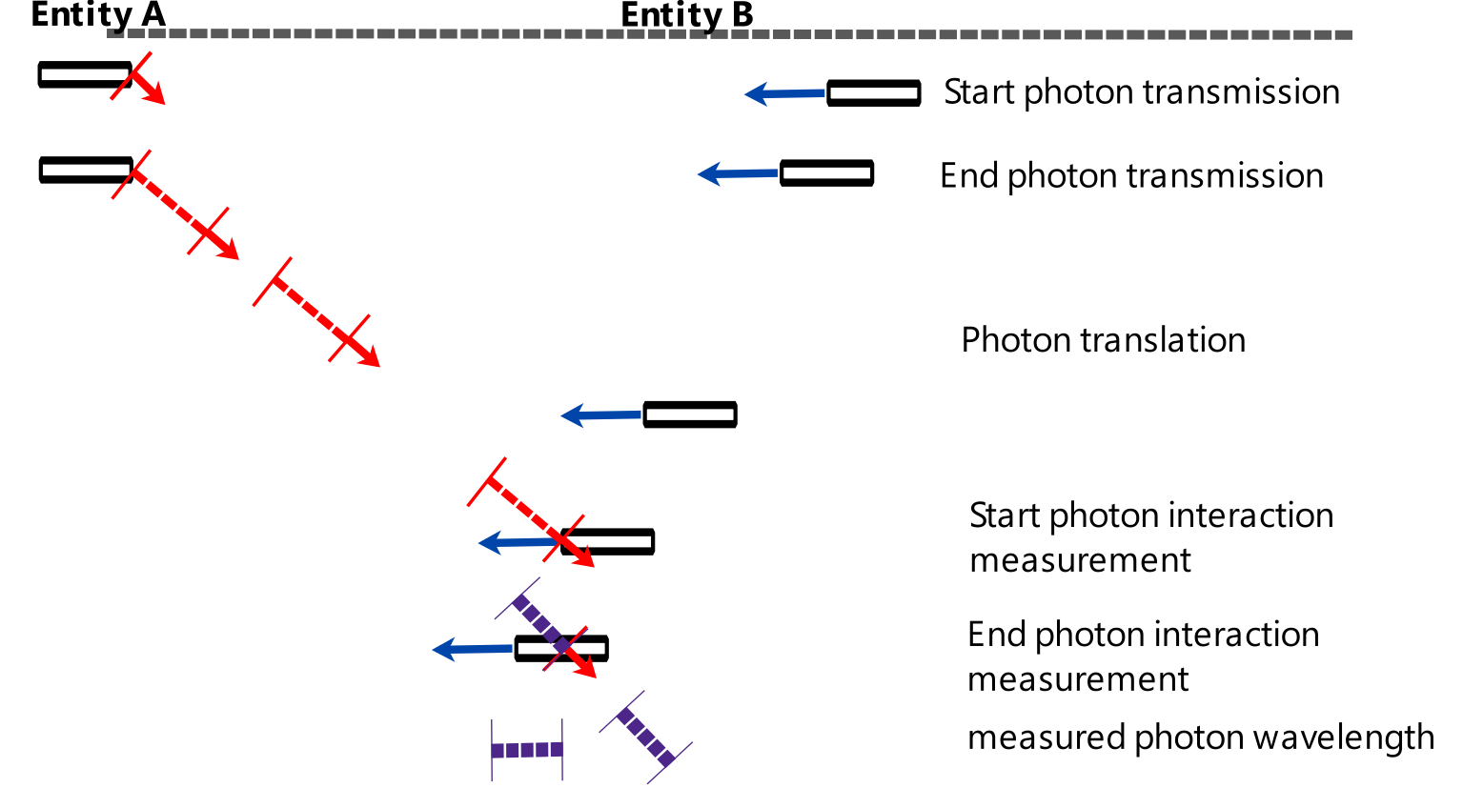
Fig IMI-03 Photon oblique interaction with oblique approaching entity
If Entity B takes a measurement of the total duration in respect to its own internal clock of iteration of all of the photon iteration steps from that of the first point of interaction to the last, it would find that this measurement is of lower number, and hence duration or time than if it was in a stationary reference frame in respect to entity A. This is due to the motion of Entity B causing the end of the photon transmission to travel a lesser distance, and hence requiring a lower number of clock iterations of entity B to be executed before the photon end to interact with entity B and be measured and interpreted as a wavelength of a photon of light.
In Fig IMI-03, at the top is a dashed line representing the iteration period of the reference frames measured by both entity A and Entity B. This is the same duration as the iteration periods of the photon. As the photon interacts with entity B, it takes about 3.5 iteration periods before the end or last photon iteration period interacts with a moving Entity B in the opposing motion as an interacting photon, and is measured as the Photon wavelength. In this exaggerated example, the measured photon wavelength is about 30% of that if Entity B were to perform the same measurement from a stationary reference frame in respect to Entity A. Thus it is interpreted that the duration of iteration periods of the photon is 30% that of Entity A, and hence the space of the photon has been squeezed in at least the direction of motion of the photon.
This 30% contraction is larger than if the photon was measured in a direct approach of motion as depicted in Fig IMI-02. This is due to the angle of incidence of the photon with the moving entity B, and that this measured wavelength will be different at different angles of incidence. The mathematics will not be derived here to calculate such measured wavelengths, but it can be deduced all photons measured in any reference frame that is deduced to be approaching a source of photon emissions will observe and measure those photons to be of a lesser wavelength than if within a stationary reference frame dependent upon both velocity of motion and the incident angle of the observed photon.
Oblique receding
Consider two entities that are in relative motion to each other such that they are obliquely receding from each other. Entity A is considered as motionless in its reference frame, while entity B is in a reference frame of motion moving obliquely away from it. Entity A emits a photon which has for argument sake, five iteration periods that define the photons waveform. In Fig IMI-04 is a depiction of the iteration model of this physical process of a photon transmission where there is a begin and end of photon transmission from a source Entity A that spans five iteration periods and defines that photon structure.
Entity B is in a motion of constant velocity moving away from Entity A in respect to its frame of reference to that of Entity A. This motion of velocity is considered to be a change in the physical state of Entity B in respect to that of Entity A, and at each iteration period progresses at a constant displacement of physical space away from Entity A. This velocity is less than that of the transmitted photon from Entity A, and thus the head or start of the photon transmission after some number n of iteration intervals, (ie time) reaches Entity B and interacts with Entity B that can be considered as a measuring device. As Entity B progresses further in its motion, successive interactions with the higher velocity photon motion and its iteration steps occurs with each iteration of motion of Entity A until the end and last of the photon transmission iteration is incident and interacting with Entity B.
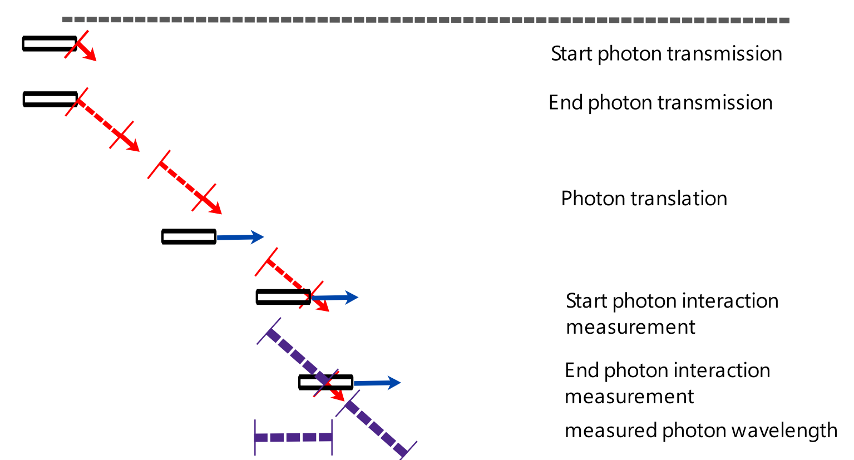
Fig IMI-04 Photon oblique interaction with oblique receding entity
If Entity B takes a measurement of the total duration in respect to its own internal clock of iteration of all of the photon iteration steps from that of the first point of interaction to the last, it would find that this measurement is of a higher number, and hence duration or time than if it was in a stationary reference frame in respect to entity A. This is due to the motion of Entity B causing the end of the photon transmission to travel a greater distance, and hence requiring a greater number of clock iterations of entity B to be executed before the photon end to interact with entity B and be measured and interpreted as a wavelength of a photon of light.
In Fig IMI-04, at the top is a dashed line representing the iteration period of the reference frames measured by both entity A and Entity B. This is the same duration as the iteration periods of the photon. As the photon interacts with entity B, it takes about 7 iteration periods before the end or last photon iteration period interacts with a moving Entity B in the opposing motion as an interacting photon, and is measured as the Photon wavelength. In this exaggerated example, the measured photon wavelength is about 140% of that if Entity B were to perform the same measurement from a stationary reference frame in respect to Entity A. Thus it is interpreted that the duration of iteration periods of the photon is 140% that of Entity A, and hence the space of the photon has been stretched in at least the direction of motion of the photon.
This 140% stretching is lower than if the photon was measured in a direct approach of motion as depicted in Fig IMI-01. This is due to the angle of incidence of the photon with the moving entity B, and that this measured wavelength will be different at different angles of incidence. The mathematics will not be derived here to calculate such measured wavelengths, but it can be deduced all photons measured in any reference frame that is deduced to be receding from a source of photon emissions will observe and measure those photons to be of a greater wavelength than if within a stationary reference frame dependent upon both velocity of motion and the incident angle of the observed photon.

Consideration
For all reference frames of motion, it needs to be considered if an oblique incidence of a photon can be measured. What is assumed is that a measurement can be taken as indicated in Fig IMI-03 and Fig IMI-04 where the end photon iteration is within the middle of entity B, and not at the head of entity B where the start of the photon iteration was incident with entity B.
If a measurement, and hence interaction with a photon needs to be always at one location in the reference frame of entity B, (that is as in Fig IMI-01 to Fig IMI-04 the head of entity B) then within a relative motion of obliqueness to the direction of the photon would mean this location changes, and thus the measurement and interaction of the photon would be lost or not possible at all.
Another consideration is that in an iteration model, an interaction of a photon iteration period may not be possible if the iteration period of the photon does not match, or is not a multiple of that of the entity it is incident with. That is, if the incident photon period of iteration relative to that of an entity through motion is not compatible, no interaction occurs, and the photon and entity simply pass through each other, as it were, without incident.
Such a hypothesis for an iteration model is not a hindrance or problem, but is a property that may be valid and advantageous to it. It is known that such real world physics phenomenon exist where photons of a specific measured wavelength or energy is required for certain physical processes to proceed. The photoelectric effect and atomic spectra being but two examples. Thus an iteration model where interactions can only occur if the interacting entities are of compatible iteration periods is a possible requirement of the model.
Another Consideration in an iteration model is a synchronisation factor in the iteration periods of potentially interacting entities. If two entities are within the same spacial zone of interacting with each other, but the iteration periods in which each entity undergoes a change of physical state do not overlap or coincide, then there is a potential for the iteration model to have a result of no interaction between the two entities.
In all situations of interactions, the logical conclusion is to assume that interactions between two or more entities can only occur if their respective iteration periods of change of state are of the same duration and are in synchronisation or phase. This assumption is based upon such an iteration model requiring that only a single change of physical state can occur in one single iteration period. This would mean that no change of physical state could be initiated, completed or modified by another change of physical state that does not have its period of iteration and change of state of the same duration and in synchronisation.
Such iteration conditions is illustrated in Fig IMI-05 where the dashed lines represent the iteration periods of two potential interacting entities.
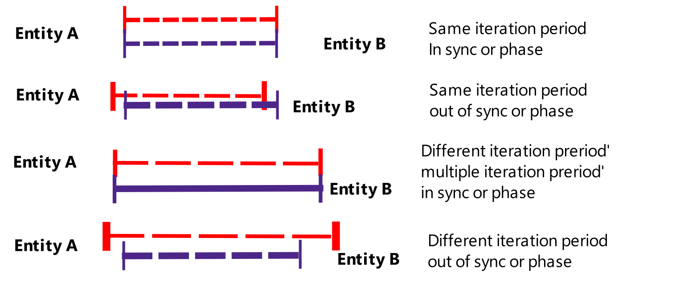
Fig IMI-05 Possible condition of iteration periods of interacting entities

Physical space as given in the examples of Iteration model of photon emission above has not been stipulated as being of a discrete nature. This is because physical space is considered to be a part of, and constructed from the entities that exist in the universe. Thus physical space and its measurements of its properties of length, area, volume etc is a kind of function or emergence upon the period of iteration of physical process of a change of physical state of an entity, which includes physical space itself, which is considered as an entity. (See Section Model Axioms: Space)
What this means is that physical space as observed and measured is governed by the physical processes that are used to observe and measure it, and thus if these physical processes have an iteration period that can vary depending upon the relative relationship such as motion as described in the Iteration model of photon emission above, then it is these iteration periods of these physical processes that define the properties of physical space and measured time.

