A Proposed Complete Model of the Universe

Introduction
Taking all of the definitions and axioms of the sections presented above, a speculated and proposed model of the universe can collated and summarised.
This is no way not an attempt to undermine current physics, or to declare a kind of flat earth conspiracy theory where current physical theories need replacement. It is, however as stated, a speculation of a model of a universe that can be compared to current theories so as to inspire new approaches or direction of current thinking of the workings and processes of the physical universe. Hopefully, in a similar context to the book flatland where an attempt is made to have a perspective of what a world with creatures whom have only two dimensions live, and which also help inspire this line of inquiry to speculate and search for alternatives.
The query of speculation however is bound to current understanding and observation and experiment of the physical universe. Thus no speculation of anything remotely supernatural is permitted.
The Model
The observable universe that the human mind exists within and it is witness to exists as a three dimensional surface upon a four dimension volume of physical space. This three dimensional surface is essentially an electromagnetic field that would, as a default state of being, exist in a neutral or zero state of disturbance or excitation. That is, the electromagnetic magnitude of zero charge or energy, giving a mundane existence equivalent to a flat 3D surface on a 4D sphere which has no features, and is homogeneous and isotropic throughout. (Equivalent to a flat featureless 2D surface on a 3D sphere)
Disturbances of the 3D surface are equivalent to the expansion or compression of the electromagnetic field that defines the space of the universe. (Equivalent to a 2D surface on a 3D sphere being deformed as bulges on the surface towards or away from the centre, or as increases and decreases in surface area)These disturbances set up a process of interaction of the regions or zones in which they occur and with their surroundings by creating a net resultant electromagnetic field that governs, and is the source of interactions which then define the change of physical state of the universe from one physical state A of disturbance to another physical state B of disturbance. This is a form of self interaction of the universe with itself and these disturbances are defined as photons.
Some of these disturbances become localised and interact in such a manner so as to form pockets of self interaction within a zone of space. Some of these become stable forms of pocket self interaction. These pockets of self interaction are what defines the observable particles of matter, which by their formation gain certain physical properties that are attributed them, and which interact with the net universal electromagnetic field that defines and is the physical space that they are a part of, and contribute towards.
As such, the physical properties of these observable particles are not isolated and excluded from their surrounding space, but are a part of it, defining it, which in turn then directs the particles and other forms of disturbances or excitations of space that is observed and interpreted as interaction of particles and energy with each other. Thus each particle in the universe exists not separate from the physical space that it exists within, but it is part of the universal physical space, and space is part of each and every particle. Therefore each and every particle and disturbance or excitation of space is a part of a whole universal entity that is the universe.
To picture and get a grasp of this concept, consider a plasma of ionised gas, where the electric charge of each ionised electron and nucleus creates a net electromagnetic field that all electrons and nucleons exist as part of. The net electromagnetic field is the space of the plasma and is analogous to the space that defines the universe.
1: Electron-nucleons interact to the net electromagnetic field that they generate in the form of motion to create a new physical sate of the plasma system of ionised gas.
2: This interaction causes net changes to the electromagnetic field that can be in the form of an electromagnetic disturbance that can be interpreted as a photon of energy.
3: If a photon of energy is of a sufficient quantity and under the right circumstances of interaction , can form one or more zones of self interacting pockets of electromagnetism that form one or more particles of matter, stable or unstable, and thus contribute to the overall net electromagnetic field of the system.
4: These changes to the net electromagnetic field sets up a new set of circumstances or physical state of the space in which the electron-nucleons are to interact with.
5: In perpetuity, repeat steps 1-4.
Utilising this analogy of a plasma gas with the beforehand description, a broad overall functionality of the process of the universe can be outlined as.
The Universal Process
- The universe exists as a 3D surface upon a 4D volume and the space of this 3D surface is in effect defined as an electromagnetic field that is in its default physical state flat and homogeneous and isotropic throughout.
- Deviations from the default physical state that are defined as disturbances or excitations of the electromagnetic field that defines space create a net physical state of the space of the universe.
- The deviations from the default physical state in ii interact with their immediate surroundings to form a new net physical state of the space of the universe and can be interpreted as being in motion and given the name of photons.
- The photons defined in iii can interact with each other and under the right circumstances form a pocket of a self interacting electromagnetic field that “condenses” out from the overall universal space defined in i and ii. This “condensation” can be of a stable or unstable forms and is interpreted and defined as particles of matter.
- The particles of matter defined in iv are part of the overall universal space and have properties of that space such as electric charge and emergent properties such as mass that change the physical state of physical space.
- The resultant net physical space that photons and particles of matter contribute to and create forms the basis upon which these photons and particles interact with and are interpreted as motion.
- In perpetuity, repeat steps ii to vi.

The universal process outlined above is an iterative process. Iterative processes occur in steps where each step takes a duration to complete and questions about synchronisation of these steps arise. Detailed discussion of this universal process is outlined and discussed in more detail in the section Physical Process Iteration of Physical Model. The process of changing a physical state is a process, as outlined and discussed in the section Time of Model Axioms, of the progression of the universe or system that in the human mind is a concept of time.
Within this iterative process is a step where the photons and particles define, by their very presence and physical properties, a state of physical space from which the photons and particles react to, and in that reaction form a basis of change of their own physical states such as what is interpreted as motion or energy. This change of physical state is interpreted and designated as a from of interaction, and in many circumstances, is interpreted as an interaction to the presence of other particles or photons . By interpreting the physical process as photons and particles reacting to the physical space of the local zone in which they exist in, the interaction is the direct response to the physical state of the local zone of space that has been defined by their presence, of which is an indirect interaction of any particle or photon with any or all other particles or photons. This is stated in Axiom API1of section Space of Physical interactions.
The Universal Process outlined above is thus a basic broad and simple top level model of the universe, and forms the basis from which more detail of the physics of the universe can be derived from. Much of current physics attempts to explain processes of the physical world through use of equations to give relationships between physical properties and behaviours and predictions of behaviour or phenomenon. Even with the success of this approach, these equations may have a more grounded basis as an expression of a more basic iterative process.
This model has not been plucked out of the air as it is based heavily upon current knowledge and understanding of universal physics with an added thought of what if.

The Physical Space
Overview
The physical space of the speculated and proposed model is that of a 3D physical space existing on the surface of a 4D volume as outlined by Axiom AS2 in section Space of Model Axioms. This is analogous to that of a 2D surface existing on a 3D volume, and such a 3D surface on a 4D volume would share similar properties to that of a 2D surface on a 3D volume.
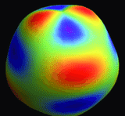
Fig PPS-01
2D spherical surface deformation to represent an analogy of a 3D surface deformation on a 4D surface
Red represents bulge of surface, Blue – violet depression or trough.

Properties of a physical space.
PPS01:A physical space of a volume would have an origin and a vector direction on a close surface of that volume would be one of being towards and from that origin, or a vector direction inside the volume on which the surface sits, or outside the volume on which the surface sits.
PPS02:A deformation of the surface as if it were made of some elastic material in the direction to or from the volume origin is an expansion of the physical space of the surface.
PPS03: If the volume of the physical space upon which a surface exists is to remain constant, any deformation of PPS02 that increases that volume must be matched with a deformation of equal proportion to lower the volume so as to maintain a constant volume for that physical surface space to exits on.
That is, if a deformation is made in the direction outwards from the volume surface increasing the overall volume of the space, another deformation in the direction inwards from the volume surface of equal proportion will need to be performed to maintain a constant volume of the physical space, and vise versa.
PPS04:A deformation of the surface as if it were made of some elastic material in the direction parallel or tangent to that of the surface, and being on the surface, and in all directions away from some location on that surface is an expansion of the physical space of the surface, but not that of the physical space of the volume that the surface exists upon.
PPS05:A deformation of the surface as if it were made of some elastic material in the direction parallel or tangent to that of the surface, and being on the surface, and in all directions towards some location on that surface is a contraction of the physical space of the surface, but not that of the physical space of the volume that the surface exists upon.
PPS06: If the surface of the physical space is to remain of a constant quantity, any deformation of PPS04 or PPS05 must be matched with a deformation of equal proportion so as to maintain a physical surface of a constant quantity.
PPS07: The physical space of the surface of a volume conforms to the geometry of that surface at all locations on that surface. That is measurements of characteristics such as distance, volume, geometry etc conforms to the curvature of the surface of the volume upon which the surface sits. What is measured as a straight line by an observer existing within the surface is a curved line for an observer making measurements and existing within the volume that the surface lies upon.
What this means is that if the surface is large enough such that the observer that exists within the surface is of a such a small relative scale, the measured values of the geometry at the same relative scale can be considered as being flat and non curved and Euclidean as errors in measurement are insignificant.
These geometric properties can be applied to Axiom AS1 and Axiom AS3 in section Space of Model Axioms, which then become properties of the physical space of the 3D surface that exists upon a 4D volume.
If physical space is considered to be constituted according Axiom AS4 in section Space of Model Axioms as some form of electromagnetic density, then the distortions of of this electromagnetic density as outlined in Axiom AS5 in section Space of Model Axioms can be considered as a form of the physical properties PPS02, PPS04, PPS05.
When mention is made of the models physical space or electromagnetic density or field, these terms can be referred to as interchangeable.
In this model, it is considered that the physical space of the universe is to be treated as one single entity that has many sub units or zones of self space interaction as outlined by Axiom AS6 and Axiom AS7 in section Space of Model Axioms. In its entirety, the physical space of the universe is considered as a single system or entity that is constructed of an innumerable number of subsystems of itself interacting within zones of self interacting space that is then as being a part of the whole, interacting with the whole.

If the physical space of the observable universe is that of a 3D surface on a 4D volume, then it can be conceived that for at least the zero or natural unexcited state of the 3D surface is that of a 4D hyper-sphere. What this would mean is that in all of the 3D surface, as for a 2D surface of a 3D sphere, the surface would be of a constant radius in of the higher dimension space.
Then the question arises, do the deformations in 3D space represent a penetration into a higher or lower surface of the higher dimension space if that deformation is in the direction of a higher or lower radial value from that space hyper-sphere radius?
Disturbances of a 2D surface on a 3D sphere that interact and form structures of peaks and troughs that constantly change and seemingly have motion can be considered as spherical waves. By use of an analogy, such disturbances of a 3D surface on a 4D volume can be considered as hyper-spherical waves, and thus a model of a physical 3D space on a 4D hyper-sphere can be one of such hyper-spherical waves being what forms, at least the photon and electromagnetic radiation propagation of the universe, if not stable and unstable self interacting forms of hyper-spherical waves the “particles”.
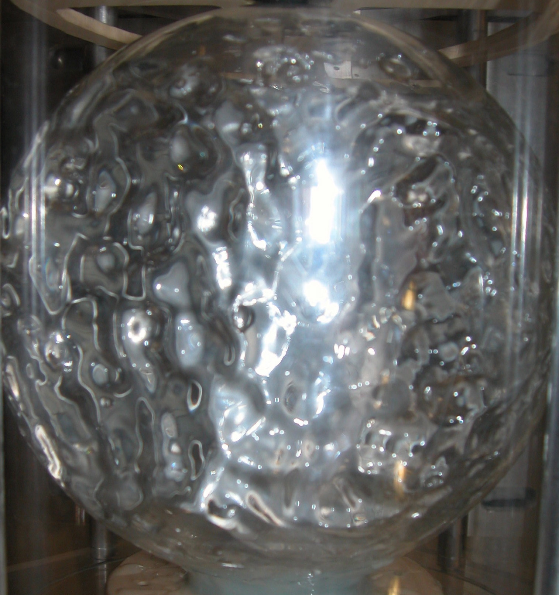
Fig PPS-01
Spherical waves of a sphere or water in zero gravity

