The Quantum Ocean

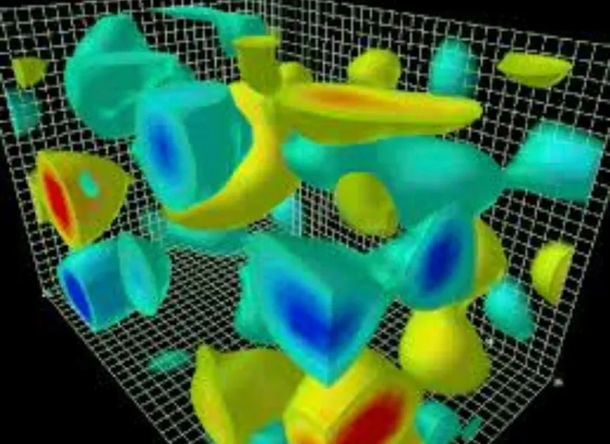
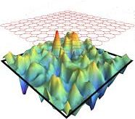
Fig QO-01 FIG QO-02

In defining a proposed model of the universal processes that govern the universe, on the fundamental level, being the quantum level, all the fundamental physical processes that shape the universe originate here. A proposed extension of the model given in the section A Proposed Complete Model of the Universe is outlined here so as to give an overview of a model of the quantum realm processes. The iteration aspect of the model is left out here as the concept of the underlying processes of quantum interaction between particles and photons is the focus, not the proposed iteration step process. The iteration step process can be thought of as being a part of the interaction process, not the interaction process itself.
The concept:
When a physicist talks about the micro or quantum world, where atoms and nuclei fill the landscape, discussion usually leads to discreteness of energy levels, probability wave functions, and weird things like tunnelling of particles through energy wells, and maybe even coupling of particles. What will be attempted here is to talk about what may actually be going on in the quantum level.
In the quantum realm, the entities that dominate are the fundamental particles, protons, neutrons and electrons, combinations of these to form atoms, and combinations of atoms to form molecules. These interact by electromagnetic fields that dominate over the gravitational field. Also present is electromagnetic radiation that at this level, has a significant effect on these three quantum level entities in such a way, that they can push around and change the physical state of these entities similar to the effects on a macro scale, how billiard balls react each other on a billiard table, or to objects of larger masses.
For the following discussion, it is considered that all the entities on the quantum level are free and unbound. ie as a gas or plasma.
All the electric and magnetic as well as gravitational fields seen on the human scale originate at the quantum level. The fundamental particles, atoms and molecules interact with each other largely via their electromagnetic fields, seemingly pushing and pulling each other around according to some random form of motion. This can be considered that this is due to to energy being exchanged, and the physical state of the interacting entities are thus modified. The electromagnetic radiation on the quantum level can be considered as also doing the same. It may be considered that electromagnetic radiation is a disturbance of the electromagnetic field carried in the form of a photon, and hence the interaction on the atomic and nuclear scale of photons with fundamental and atomic entities.
This gas or plasma like scenario has electromagnetic radiation and electromagnetic fields originating from near and far such as that a resultant universal electromagnetic field is generated. Consider that this resultant electromagnetic field is a physical form of a space, where like an ocean of waves, the energy of this space, with the peaks being high energy values, and troughs, low energy values of this space. The movement of waves represents the movement of energy within this quantum ocean. It may be considered that the electromagnetic radiation are the waves in this analog. However, unlike the waves of the oceans of water on earth which are disturbances of a 2D surface of a 3D volume, the quantum ocean waves are more of a 3D wave of energy densities within a 3D volume.
Fig QO-01 (cannot find source of image to give credit to) gives a schematic of such a concept. The green-blue blobs can represent regions of low energy densities, and the red-yellow regions of high energy densities. The intermediate energies in between, if displayed would obscure the illustration as a solid object where only a surface of colours would be visible at the limits of the surface of the volume being displayed. Fig QO-02 (How ubiquitous is entanglement in quantum field theory? : PHYSICAL REVIEW D 108, 085005 (2023) )can be considered as a 2D representation of this concept.
Consider that the entities of the fundamental particles, are like single balls floating in this 2D representation of a quantum ocean as illustrated in Fig QO-02 , and atoms and molecules are like groups of balls floating in this ocean. The inverse of the size of these balls represents the mass (ie heavier objects are small, and light large) and the displacement of ocean water around it, represents the electromagnetic field it contributes to the background electromagnetic fields. Consider that since an electron and a proton have the same electric charge, but different masses, they will displace the same electromagnetic field about each other in an opposing manner , but have a different density of mass.
Consider that these electromagnetic waves in this electromagnetic ocean pushes these masses about as the masses interact with the peaks and troughs in such a manner that they follow a path of least action. That is, a path to the lowest energy level in the local vicinity of space that the mass resides in. Consider that the rate or magnitude of interaction and motion is greatest where the gradient of the resultant electromagnetic field has the largest difference in the vicinity of a given entity.
Consider that a larger mass on the crest of one of these waves has an effect such as to lower that waves height or energy, then a higher mass creates a net electromagnetic field gradient around it to be lower than that of a lower mass entity. Also consider that the mass of an entity is a reflection of its size and electric charge density, where a larger mass has a larger electric field density making it smaller in size, but of an equal overall electric charge to that of one of a lower mass.
Thus an electron can be represented by say, a beach ball of lower mass and electric charge density can be pushed around more easily by a modest wave, whereas a proton, represented by a tennis ball of higher mass and higher charge density is not as easy to change its state of motion. (Fig QO-03) Higher waves, and hence energy, have larger effects on individual entities. Now consider a group of balls representing a molecule has one of its balls (atom) hit by a high energy wave. The ball is knocked away from the others and floats on is own.
In each of these scenarios of waves hitting elementary particles or atoms, the wave that hits the elementary particle or atom interacts with the wave by absorbing the wave in some manner such that it effects the particle regional electromagnetic field and the particle reacts to the resultant electromagnetic field around it causing it to change its motion or quantum physical .state.
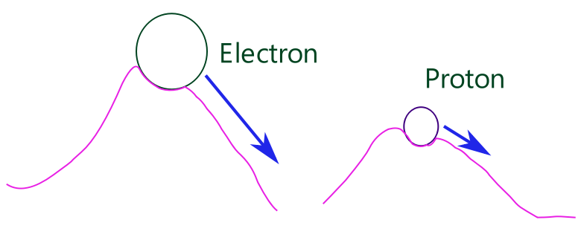
Fig QO-03 Electron of lower mass and electric charge density interacts with electromagnetic field less than proton of higher mass and higher charge density with an electromagnetic field of equal properties . Electron thus sits on an electromagnetic region with a higher gradient than that of a proton and thus changes its state of motion greater than that of a proton in a direction of highest rate of change or gradient of the electromagnetic field.
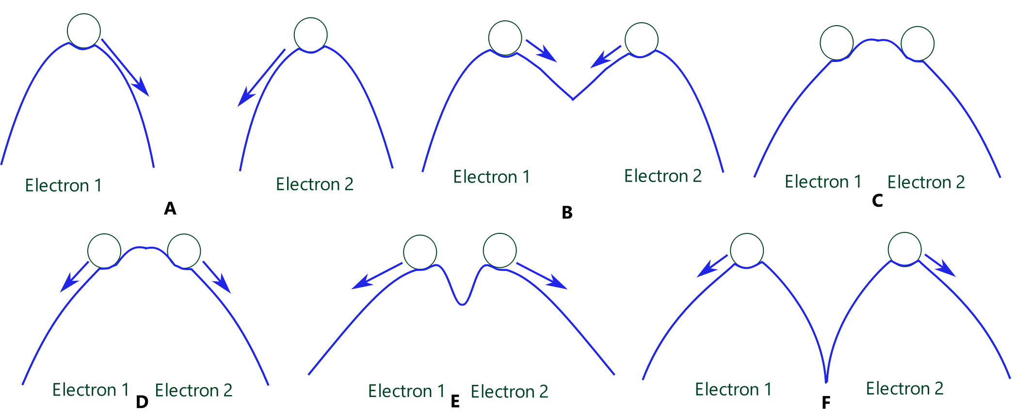
Fig QO-04 Interaction of approaching like charged entities : electrons
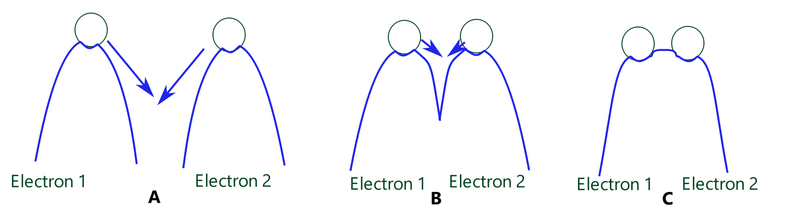
Fig QO-05 Interaction of approaching like charged entities with greater velocity that on closest approach are of a smaller spacial distance than at a lower initial velocity.
Entity Interaction:
Now consider two of these entities interacting with each other. Two electrons approach each other, their electromagnetic fields modify the electromagnetic ocean around them, but as they approach, they slow down, stop, and reverse direction, or are deflected away from each other. A collision has just occurred between two particles. The electromagnetic fields each particle interacting with each other in such a way that the modified electromagnetic ocean that results from their electromagnetic fields repels them from each other.(Fig QO-04) Consider that As each electron approaches each other (Fig QO-04 A), the electromagnetic field gradient that influences their motion decreases slowing their motion until the resutant electromagnetic field in the physical space between them is flat, equal to or greater than that of the physical space in any other direction, and in particular in a direction along a line away from a central point in between them(Fig QO-04 B – C). Thus the electromagnetic field of greatest magnitude and least action is in a direction away from this point between them, and each electron then has a motion on this gradient (Fig QO-04 D - F).
It is observed that the higher the velocity of the electrons, the closer they can approach each other in a process of interaction of the electromagnetic field that causes the electrons to be repelled from each other. Consider that such a process is that the electromagnetic field about each electron in motion is of a higher density, but smaller in the physical space that the electron occupies in its motion, including the electron itself, which then translates into a higher measured mass of the electrons. The same scenario applies as depicted in the steps of Fig QO-04, but before the electrons move apart, they are closer in proximity to each other (Fig QO-05) It may be that with sufficient energy of motion, entities of the same type and property of charge can overcome the repulsive electromagnetic field that repels them, and come into some form of contact or direct interaction with each other.
Entity- electromagnetic interaction :
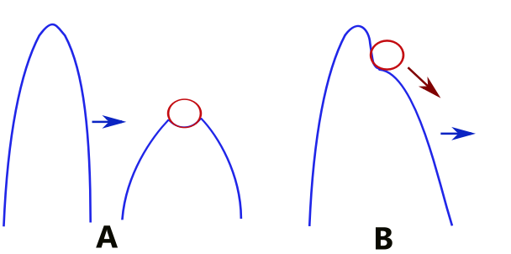
Fig QO-06 Entity EM interaction
A: EM field wave approaches charged entity.
B: EM field wave interacts with EM field of entity changing the overall EM field surrounding the entity such that a EM field gradient in the vicinity of the entity is greatest in the direction of the incoming EM field wave, causing the entity to interact with the resultant EM and have a motion in the direction of this gradient.
Consider that as one of these entities is hit by an electromagnetic wave (interacts with) the electromagnetic wave modifies the electromagnetic field about the entity such that the resultant electromagnetic field or wave around the entity changes the direction of its motion according where an energy gradient of the largest magnitude is located in space in the vicinity of the entity. This can be interpreted as an absorption of energy from the ocean that could be in the form of an electromagnetic wave that travels with the entity and being part of it. Perhaps analogous in some manner to a surfer riding a wave. (Fig QO-06)
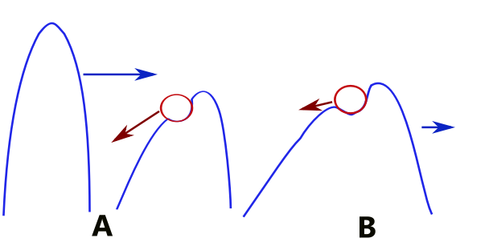
Fig QO-07 Entity EM interaction
A: EM field wave approaches a charged entity that is in a motion opposite to that of the direction to EM field wave.
B: EM field wave interacts with EM field of entity changing the overall EM field surrounding the entity such that a EM field gradient in the vicinity of the entity is greatest in the initial direction of the entity, but that the gradient of the resultant EM field is lower, thus the entity motion is at a lower rate.
Consider that as one of these entities hits a wave (interacts with) that is in the opposite direction of its motion and slows down. As the electromagnetic field of the incoming electromagnetic wave interacts with the electromagnetic field surrounding the moving entity, a resultant electromagnetic field emerges that then effects both the motion and physical states of the entity and the electromagnetic wave. The incoming electromagnetic wave can slow and/or redirect the motion of the entity by changing the net electromagnetic field gradient in the vicinity of the entity as it travels within the realm of the physical space surrounding the entity. A slow down will occur as the resultant electromagnetic gradient of the field decreases, and/or changes direction into the space of highest gradient of the electromagnetic field. (Fig QO-07)
Self interaction:
Consider now the interaction of the quantum ocean with itself.
Superposition:
In the natural world, it is found that the superposition of waves of water occur resulting in higher or lower amplitudes of water waves, and the energy of the wave of water is proportional to the amplitude that the water wave has. By superimposing several waves of water, regions of very high amplitudes can be attained where the waves amplitudes all are present in the same region of space at the same instance in time.
Similarly, for electromagnetic waves, this should also be the case where the electromagnetic wave is a disturbance and motion of the electromagnetic field of space. However, unlike a wave of water, electromagnetic waves, according to the Plank energy relationship, have the energy of a single photon of light proportional to the wavelength of a photon, not an amplitude of a photon of light as given by E = hf.
Using a water wave as an analogy could be a bad idea as a wave of water can be thought of as a disturbance of an incompressible volume of a density of mass that can only be added together to create a greater volume of mass that is expressed as an amplitude of a wave.
Consider that this would suggest that all photons of light exists and have the same amplitude of electromagnetic charge of disturbance of physical space in which they form a part of, but that a photon has an electromagnetic charge density that is proportional to its wavelength, such that as the measured wavelength of a photon decreases, this electromagnetic charge density increases. This electromagnetic charge density, being in a smaller region of physical space, would then have a larger gradient of change of the electromagnetic field of a photon as its wavelength decreases, thus creating higher rates of change of physical states, but occupying a smaller region of physical space.
These regions of electromagnetic disturbances that are photons then can be considered as from observation and experiment, able to superimpose upon each other to change the electromagnetic field in a manner similar to that of waves, but instead of amplitudes of a physical medium such as water, the amplitude of electromagnetic field is one of electromagnetic charge density. This electromagnetic field of charge density that can change the physical state of entities within it, can be considered as a field of electromagnetic energy, and the disturbances within it as waves of electromagnetic energy. Electromagnetic waves of different energy or charge density on this ocean, superimposed upon each other form a chaotic behaviour similar to the oceans of the earth and illustrated in Fig QO-02.
Particle / self interaction:
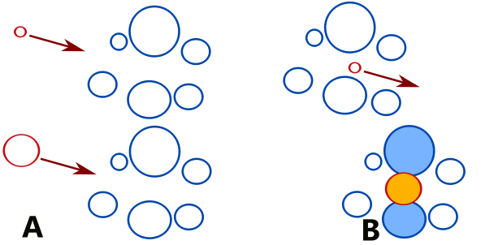
Fig QO-08 EM field - Particle interaction
A: EM field wave or particle approaches a group of EM field disturbances or particles Smaller size, larger the energy of the EM field wave or particle.
B: Smaller EM field wave or particle able to travel pass EM field disturbances or particles without interaction, but larger EM field wave or particle interacts with EM disturbances or particles
Consider on the quantum ocean, the individual waves of a 2D representation of the electromagnetic field look more like some kind of isolated bulge than a travelling wall of water as happens when dropping a rock into a pool of water. The diameter of this bulge represents a wavelength of the electromagnetic wave. Differences in wavelengths of electromagnetic waves in the real world are represented the same on the quantum ocean. Small wavelengths have large energies, and will have high amplitudes that represent the electromagnetic charge density in the quantum ocean. The small wavelength of the quantum ocean wave reflect a property of the wave that those with smaller wavelengths, though having a large energy, are more less likely to interact than a larger wavelength due to the smaller cross-section they occupy in space. This permits high energy electromagnetic waves to penetrate molecules without impediment as they pass through the gaps of lower electromagnetic field densities of the molecules or atoms, and not interact easily with the atoms that make up the molecule.(Fig QO-08) The smaller wavelengths or cross-section can also mean that a lower probability of interaction with individual fundamental entities such as electrons.
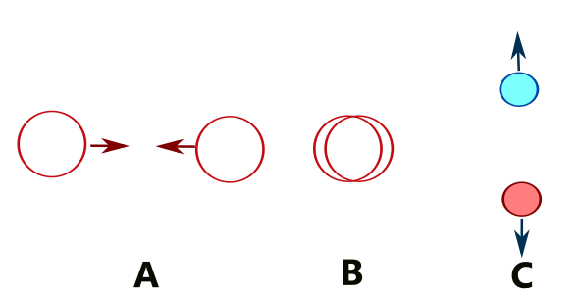
Fig QO-09 EM field – EM field interaction
A: Two EM field wave approaches each other.
B: Two EM field wave interacts with each other.
C: Two particles with mass and/or electric charge created.

Now consider two quantum ocean electromagnetic waves as described above interacting with each other by “colliding” head on. Consider that the electromagnetic waves in the quantum ocean have some form of self interaction where if a certain energy or wave density is present, the interacting electromagnetic waves produce a particle that has a property of mass. For two electromagnetic waves, if the energy density increases such that there is some form of self interaction one or a pair of particles are produced. If the resultant interaction results in a one or pair of particles, these particles would have mass and a possible charge. The resultant particle properties are added to the quantum ocean landscape, and the electromagnetic radiation that created them, subtracted.(Fig QO-09)
If however, there is an instability of the self interaction of a quantum ocean particle, it then transforms back into the quantum ocean either as a new particle of self interaction and/or a quantum ocean wave.
Thus the quantum ocean is not just about pushing particles and the interaction of particles with the electromagnetic waves and other particles, but also the creation, destruction and decay of particles of matter.
Consider the principles as outlined in the section, Quantum Maths. If the quantum ocean and space are at a level such that there is a smallest permissible wavelength that corresponds to the smallest permissible area or volume of space, then movement of all entities and electromagnetic waves would not be smooth in this ocean. It would be jerky and similar for any particle or electromagnetic wave governed by the graininess of the space that makes up the quantum ocean. This space would look like, say a hexagonal grid for a 2D space, and to move an appreciable distance would be similar to that of Brownian motion. Space would itself thus be quantised.
This all contributes to an overall unpredictability of the absolute behaviour of any individual or group of particles. Even if all of the initial conditions of all the particles and electromagnetic radiation in the universe were known, the exact paths and behaviours would not be known. The quantum maths that describes such a system is equivalent to the principles of chaos theory. Any small deviation in calculations or error in values will increase over time, causing divergence of prediction from observation to increase with each iterative step. Here small deviations in prediction can be due to such things as the superposition of electromagnetic waves creating a pair of particles, or the decay or annihilation there of. It may be that other properties exist on the quantum level as well that make this unpredictability and uncertain due to the sensitivity of outcomes opon the input parameters.
On the human level, living creatures modify the physical universe by the very act of living. Living creatures do not obey any laws of physics that govern mechanical behaviour, but by decision of choices. That is determined by mental thoughts, and these on the smallest scale of the universe can change the universe.
The quantum ocean described above results in a range of possible values for any entity or electromagnetic interaction to occur. This range of possible outcomes for a single interaction can have a certain probability of one particular outcome for all possible inputs. By building up a probability distribution function, this can be used to predict behaviour or results of directly related phenomenon or physical states. eg the spectrum of atomic atoms and nuclei.
What is important here is that on the quantum scale, interactions between entities and electromagnetic radiation are significant and often cause large step wise transitions from one physical state to the next.
A human wanting to measure a quantum value uses a probe to do so. In the case of an electron moving in this quantum ocean, a photon of sufficient energy is used to detect the electrons position, and then to, or to, observe a photon emitted from the electron. In doing so the photons physical state is modified, ie its motion. The observed photon will have taken a certain path to the observer through this quantum ocean, giving a certain degree of accuracy of the electrons location, but the motion is not known due to probe photon changing the electrons initial motion, either increasing or reducing its velocity, and even its direction.
In other words, by just simply trying to observe on the smallest scales the most fundamental of physical entities and properties of matter, the method of observation changes the conditions that are present in what is trying to be observed and measured, thus potentially interfering with the physical entity properties or processes that is being probed. Those physical entity properties or processes that exist on and in the quantum ocean on the quantum level of particles and the energy fields that they exist in and are a part of.
Quantum Ocean of Gravity.
It is common among Physicists that a theory on quantum gravity is difficult to postulate, formulate and merge with the quantum theory that describes the physics on the atomic and sub atomic level.
Consider that on the atomic and sub atomic level in which quantum physics deals with, that the quantum effects are due to, as described in the section the quantum Ocean above, the electromagnetic fields that exist and interact with those of the atomic particles. Consider that gravitational fields exist on this level also, and that there are fluctuations of the gravitational field that also exist due to the past locations and motions of mass charged particles.
Consider that the gravitational field on this level is much weaker than that of the electromagnetic fields present, and that the mass charge of particles is also much lower than that of the atomic particles. This creates a gravitational quantum ocean that acts just like that of the electromagnetic field, but is so weak in comparison so as to be drowned out by it, and in effect, not noticeable in experiment, or observable in any physical phenomenon. Even if electromagnetic fields did not exist at all, the mass charge of an electron or proton would generate a gravitational field that is so small that it would not interact with other gravitational fields of individual electrons or protons or small groupings thereof.
However, as the scale of physical processes becomes larger, and the net electromagnetic field becomes negligible and close enough to zero, and if there are a large enough number of individual particles such that the gravitational field and it fluctuations are large enough to be comparable to, or greater than that of the electromagnetic field, quantum like effects may be observed to occur on individual particles, though this effect would not be as observed in the atoms and molecules due to gravity being attractive only.
The observable quantum effects would be gravitational observable effects, not the observable effects involving electromagnetic radiation like the Heisenberg uncertainty principle to measure position and location of an atomic particle. The first kind of quantum effect would be something similar to Brownian motion, where an unpredictability of the location of a mass in a large enough fluctuating gravitational field would bounce around and be unpredictable.
But the greatest form of quantum gravity is within the realm of massively moving, and in particular, rotating bodies that create gravitational waves. Other bodies interacting with the gravity wave would interact in a manner that is similar to that of a particle interacting with an electromagnetic field.
But because such large bodies can have a very large and infinite range of configurations, this would again not resemble electromagnetic quantum physics in terms of having the same predetermined probabilistic outcomes, or the same consistent phenomenon occurring, such as an electromagnetic spectrum of an atom.
Consider that within a massive enough body like a star or neutron star, quantum gravitational effects would be things like the differentiation of masses of the elements.
In other words, Quantum gravitational effects only occur on the macro level, and even then are what we readily see. Such Quantum gravitational effects also would be of such a long duration for normal planetary and stellar masses, that they may only be observable on a time scale as large as years, centuries and even millions of years. To observe on a smaller time scale, super massive objects may need to be common and in close vicinity of each other.

Quantum States
Idea : It is commonly stated by many physicists and within many journals and texts that all forms of matter and of the fields that is associated with matter can exist in many different quantum states, or forms simultaneously until "observed" where upon it collapses into the quantum state that it is observed.
Consider that if in fact, the so called many physical quantum states of matter is in fact one unknown quantum physical state, and that by the act of observation, the conditions upon which this one single quantum state is changed to a new quantum state. That is, the act of observing changes the conditions by which the entity being observed was in, and that the act of observation in itself, does not always have the exact same observational conditions to obtain the exact same result, but by repeating the experimental observation, a range of results is recorded, and upon analysis, a graph or function of probability is obtained.
This is similar to the chaotic behaviour of a system in chaos theory where the final result is highly sensitive to the smallest of initial conditions, and like chaos theory, those initial conditions are largely unknown. This results in that any outcome from any initial input into a system is not precise and falls within a range of values, of which any measurement can be viewed as a probability of outcome. Eg the weather on a macro scale, or the location of an electron observed in an experiment.
Thus in quantum physics, because knowledge of the exact condition and quantum state of matter before a measurement by use of a probe such as a photon or particle is by and large, unknown, and cannot be known with a high degree of accuracy, a probability of distribution of initial quantum states needs to be incorporated to match the , distribution of results of observations.

