Quantum Mathematics

The term used here of quantum mathematics is to describe the mathematics of using numbers that can only be of whole or integer values. This is so, as in an attempt to describe the natural world or universe, no partial numbers are permitted. One cannot assign an electron a half an electric charge, or half its mass, nor any other particle.
By considering that mathematical calculations should not permit non integer values for physical quantities and constants, then a different modified mathematical model may be able to be found that describes the physical world in a more accurate and understanding way.
Consider the following assumptions that apply in the natural world.
Assumption A01: In the natural world at the most fundamental and quantum level, only integer (whole) entities and numbers representing these entities and characteristics are permissible. (Eg. can not have half an electron, or half an electron charge value)

Extending assumption A01 to abstract concepts used to model the natural world utilising mathematics, the mathematics must reflect assumption A01.

Assumption A02: In the natural world at the most fundamental and quantum level, only integer (whole) numbers can be used to describing the processes that occur in the mathematical modelling or calculations .

Assumption A03: In the natural world there is no infinitely large or small number that exists. That is, there is a fundamental limit or finiteness to the smallest or largest number of entities or the properties that exists.
Now applying these assumptions to the most basic mathematical functions of arithmetic, any arithmetic operation of any integer values must yield an integer value as a result.
Stating this as a mathematical thorem
Theorem MO-01
Let the set Z = { x : x = ....-2,-1,0,1,2,3, ...} be the set of all integer numbers.

Permissible operations that can be performed on or by any one or more numbers in Z must yield a number that also exists in the set Z .
h

From theorem MO-01 the basic arithmetic operations that can be performed are for any two integer numbers m and n giving resulting integer number p which exist in the set Z.

Addition
m + n = p EQ BO - 01

Subtraction
m - n = p EQ BO - 02

Multiplication
m x n = p EQ BO - 03

Multiplication of m x n = p can be represented as an addition of m to itself n times, or n to itself m times. Thus multiplication of two integer numbers can be represented as a finite series.

m x n = = = p EQ BO - 04

This leads to conclusion that in the natural world, what is defined as multiplication is really a summation. It may be obvious to any mathematician that this is the case in the most fundamental form, but the meaning can be lost when considering natural phenomena.

Division

Utilising Assumptions A01 and A02, then come to conclusion that no fractional or irrational numbers exist in the natural world, and as a result, numbers cannot be divided in calculations unless one number m, is a multiple of one or more other numbers a, b, ...., n.

This leads to definition for division as

= m if and only if p is in the set of integer numbers Z . EQ BO - 05

That is if p = m x n =

Assumption B01: In the natural world at the most fundamental and quantum level, EQ BO - 01 to BO-05 form the basis of all mathematical modelling of all natural phenomenon.

Other mathematical operations on integer numbers can be represented as a derivation of EQ BO - 04

Multiplication can be viewed as a body A of consisting of m entities each with property of interaction P, interacting with a body B consisting of n entities also each with property of interaction P . The result of this interaction is the addition of each of the entities m_{i} in body A interacting with each of the entities n_{k} in body B (P_{ik )} to produce a net interacting product value P. (Fig IN01) . The property of each of entities in body A that interacts with the property of each entity in body B to produce this net result is the addition of p_{ik}. which is the multiplication P_{i} x P_{k} = p
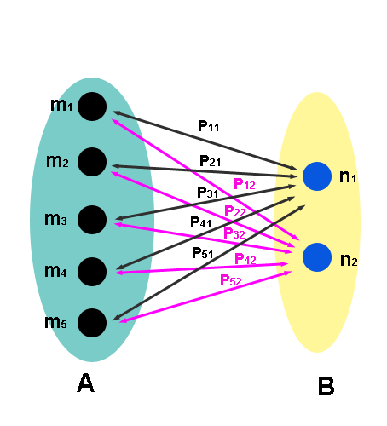
(Fig IN01)

P = P₁₁ + P₂₁ + P₃₁ + P₄₁ + P₅₁ + P₁₂ + P₂₃ + P₂₃ + P₂₄ + P₂₅
= 5P x 2p = = 10P

Example is net gravitational force where body A of mass Ma is equivalent to sum of z atoms interacting with body B of mass Mb with Z atoms of the same mass m.

ie Ma x Mb = z x Z =

It can be seen that It does not matter that mi or n_{k} are different values in body A and B when performing the multiplication above so long as the interaction P_{ik} is linear. ie directly proportional to m_{i}, n_{k} or
P_{ik} = Cƒ(m_{i},n_{k}) where C - constant and ƒ(mi,nk) is a function that produces the interaction between m_{i} and n_{k}.

Multiplication in such physical systems does not take into account the self interaction of each body with itself. ie the entities within each body with each other.

Power function:

A power function is defined different to conventional mathematics. It is defined as a summation of integers as follows for integer m raised to a positive integer power n to give an integer value p.
m^{n} = (m x m (n-1) times) = summation of summation n-1 times.
ie m^{n} = where is repeated n-1 times
eg

5⁴ = 5 x 5 x 5 x 5 = 5 x 5 x= 5 x=

ie have a recursive routine of summations of totals of summations.

Define for integer variable number m raised to the constant power n where n is a positive integer value

m^{n} = EQ PF - 01

whereis a iterative step of m_{j} equal to the previous summation of m_{j-1}.

eg m² = => 5² =

since j = 2 have 5² == 25

m³ = => 5³ =

for j = 2 have m₁ = 5 and summation step 1 of EQ PF-01 = 25

obtain for j=3 have m₂ = 25 and summation step 2 of EQ PF-01= 125

and therefore = 125

Similarly
Define for integer constant number n raised to the variable power m where m is a positive integer value

n^{m} = EQ PF - 02

whereis an iterative step of m_{j} equal to the previous summation of m_{j-1}.

What if have n defined as a negative number? This is the division of a number 1 by m^{n}. This is not possible by Assumption A01 to A03 and the definition of division.
Integer (Quantum) Number Mathematics : Differentiation

Differentiation is one of two cornerstones of mathematical analysis that is used in all of creating mathematical models of the physical world.

By definition differentiation is the change in function ƒ from coordinate (x) to ƒ(x+∆x) divided by the change in the coordinate value ∆x.

ie ƒ'(x) =

The limit as ∆x -> 0 gives conventional mathematical derivative for any continuous function for any value of x.

ƒ'(x) = - EQ D02

If have assumption A03 in effect, ∆x then definition of derivative is

ƒ'(x) = = - EQ D02

where δx is the minimum or infinitesimal value that can occur.

Thus calculating derivatives become more complicated and tedious using a quantum limit > 0 for ∆x.

For any integer value x raised to the integer power value n have x^{n}

ƒ'(x) = =

Let x0 = a multiple integer m of the minimum unit value L=δx that exists. ie x = mL then have

ƒ'(x^{n}) = = = =

Utilising the binomial theorem.

ƒ'(x^{n}) =

=

= where = - EQ D03

Thus polynomials can be easily differentiated.

eg ƒ(x) = x²,

ƒ'(x²) = = L[ 2x + 1]

Have Function ƒ(x) (foundations of infinitesimals)

ƒ(x+∆x) = ƒ(x) - EQ D04

ƒ(x+∆x) = δ - EQ D05

=> ƒ(x+∆x) - ƒ(x) = δ = ƒ'(x)δx + εδx - EQ D06

= ƒ'(x) + ε - EQ D07

Where f'(x) is zero limit derivative given by EQ D02, ε is function of xδx that forms rest of derivative formulation derived by EQ D02. eg for ƒ(x) = x³.

= 3x² + (δx [3x +δx ])
= 3x² + ε
where ε = (δx [3x +δx ])

ε is different for each different ƒ(x).

Derivative is rate of change between two values ƒ(x) and ƒ(x+∆x). Just because have derivative of ƒ(x), ƒ(x+∆x) does not mean ƒ(x') exists where x < x' < x+∆x. ie do not need continuous function for derivative to exist if ƒ(x) and ƒ(x+∆x) exist.

Multi variable differentiation

Have function of variables x1,x2, ..., xm, ..., xn. ie ƒ(x1,x2,.... xn)

Then partial derivative is

=

What all this means, is that there is a “residual” value, ε that is non zero when differentiating functions, and creates a different value for the differentiation than is currently in practice. This may not be of concern when dealing with differential equations where the variable x is or an order much greater than δx. Here the value ε is so small that it is so negligible that it is not detected. However when the variable being differentiated is of a certain order where ε is no longer negligible, the differentiation must take ε into account.

Such a situation in physics would be at the quantum level where physical quantities such as charge, mass, and even spacial of field values cannot be considered as a smooth continuous transition from one value to the next. Many differential equations in quantum physics and on the quantum, nuclear level use differentials assuming that the limit of the differential equation as defined in EQ-02 variable is zero. This would lead to incorrect results with large errors and as these equations are combined, a cascade of errors in the results.

There may also be a variation of ε between each physical parameter as well. For example, charge and mass may have a different value at which the limit δx for the space they are to be differentiated to. What needs to be determined is at what level do the differential equations begin to fail when using the limit Δx → 0 and thus find what to use for δx.

A similar situation arises for the second pillar of mathematical analysis and mathematical model of physical phenomenon, integration.
Integer (Quantum) Number Mathematics : Integration
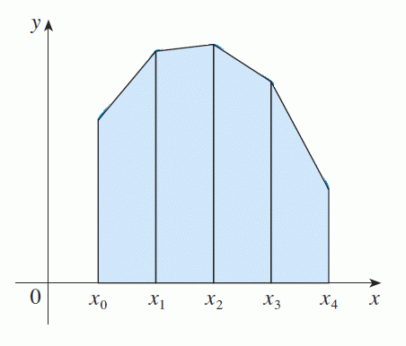
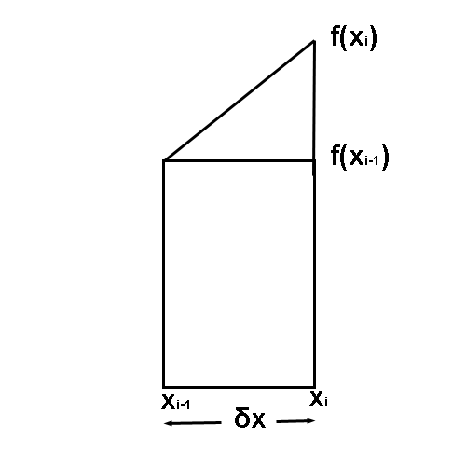
Fig QI01 Fig QI02

Consider that have function quantised with infinitesimal intervals of quantities (variables) only and that no infinitely smooth function is possible. this would give a function on the quantum scale illustrated in fig QI01. One of these infinitesimal intervals is given in fig QI02 where the function at value X_{i} and X_{i-1} are ƒ(x_{i}) and ƒ(x_{i-1}). The slope between X_{i} and X_{i-1} is the differential given in section on differentiation above at X_{i} . ie

= slope = ƒ'(x_{i})

The area under the curve of the function in this interval is given by

Area ƒ(x_{i-1})-> ƒ(x_{i}) = A_{i} = EQ QI-01

= EQ QI-02
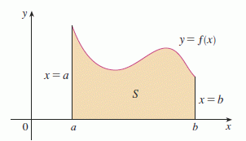
Fig QI03

Area of under curve for interval given in Fig QI03 is given by subdividing it into its infinitesimal intervals (Fig QI01 and Fig QI02) and summing them up. ie

Area under curve of y = ƒ(x) from a to b is given by.

=

=

=
= EQ QI-03

EQ QI-03 is equivalent to the trapezoidal method used in numerical integration in Cartesian coordinates. Here it is an exact value for infinitesimal intervals and not an estimation of infinitely smooth and zero intervals as given in conventional calculus.

By extending EQ QI-03, volumes in Cartesian coordinates can be also calculated.
As previously discussed in the section for differentiation, the mathematics of integration and the integrals derived depend heavily on assuming a limit of the interval of integration to be zero. Stipulated as before, this may give accurate enough results for values of y=ƒ(x) of an order much greater than b-a, but at a certain threshold, these integrals become inaccurate. This is due to the fact that y=ƒ(x) in the interval (x_{i-1}, x_{i}) is significantly different to the actual value and incurs an error to large to ignore.
Here it may even be found that a numerical integration using the trapezoidal method is incorrect and that a summation of a step function for y=ƒ(x) is required. This would yield the result of an integral.
= EQ QI-04
Which is a simple summation of y=ƒ(x) for each interval of δx.
Irrational Numbers
A mathematical definition of an irrational number is that a number p is irrational if it cannot be expressed in the form m/n. By Assumption A01, irrational numbers cannot exist. But mathematicians, and from everyday use, say they do as they are used successfully in engineering and other applications.
But consider that these irrational numbers need only be valid to a certain number of digits where they are used. There is a condition that they not need to used to an accuracy below, say 10⁻⁶ meters when constructing a spacecraft, or 10⁻¹² meters for a scientific instrument. if irrational numbers do not exist, they do not exist on a quantum level where no value smaller than a quantum integer value can exist.
In the macro world, we can construct these irrational numbers to a certain precision by the virtue of being able add a given number of quantum integer values together. eq say there is a quantum value of length of the value 10⁻¹⁵ meters that exists in nature (hypothetically). A value of the square root of 2 meters would be = 1.414213452373095 meters. or in other words 1414213452373095 quantum units of length. And since most of the mathematics used to calculate such irrational numbers are based on Euclidean geometry, perhaps a new look is needed in seeing what precision of mathematical numbers occurs on a quantum level.
Transcendental Numbers
A mathematical definition of a transcendental number is a number that cannot be written as a root of a polynomial equation. These are natural irrational numbers that occur such as the number π or pi representing the ratio of a circumference of a circle to its diameter. As described for irrational numbers, by assumption A01, transcendental numbers cannot exist on the quantum level.
The argument is the same as for irrational numbers why we perceive transcendental numbers to exist. for the case of π, we can measure the circumference of a circle to a certain accuracy, as its diameter, governed by the quantum value for the measurement. Dividing these numbers then gives a value of π, again governed by the quantum value of the length that exists. If a quantum value of length of the value 10⁻¹⁵ meters that exists in nature (hypothetically), then the physical value of pi for a circle of diameter one meter is 3.141592653589793 or 3141592653589793 quantum lengths.
A circle of larger diameter will have larger number of numbers after the decimal point, and a smaller number less. This is another difference between irrational and transcendental numbers. Transcendental numbers are not fixed. As the measurement of the circumference and diameter becomes smaller, the value of π becomes less and less of the value given above. This is due to the quantum length mentioned above. This is only an illustration of how the principle of using as an example, a hypothetical quantum length can vary the value of a transcendental number.

Conclusion
What is attempted to be pointed out in this section is that the mathematics derived and used on the macro scale should be examined, and perhaps modified for use in the quantum realm. In an effort to point out that to avoid errors in calculations and misunderstandings of the physics on the micro quantum level, a new look at the mathematics may in fact give an alternative and possibly more realistic method that can be used as a basis for progression to a new understanding of the physical world.
It may be that in the quantum world, like with Einstein’s theory or relativity bending space, Euclidean geometry and mathematics gives way to some other form of non linear, and hence non Euclidean mathematics.

