INCIDENT RESPONSE REPORT

Compromised Network Gateway Challenge
Date of Report: July 24, 2026
Prepared By: VincentBright
Classification: Confidential

1. Executive Summary
On July 24, 2026, a security incident was detected on the system vincentbright-Latitude-3340. An attacker successfully gained unauthorized access via a brute-force SSH attack, compromising the admin account. Post-exploitation, the attacker installed a persistent backdoor that communicates with a remote command-and-control (C2) server via ICMP beacons.
The investigation confirmed that the attacker made 54 failed login attempts before successfully authenticating at 09:29:02. The backdoor was installed as /tmp/.system_update.sh and configured to persist through a systemd service. The malware communicates with 8.8.8.8 via ICMP (ping) beacons every 60 seconds.

1.1 Incident Summary
Item | Detail
Incident Date | July 24, 2026
Time of Attack | 09:28:33 – 09:29:02
Attacker IP | 192.168.50.45
Compromised Account | admin
Attack Vector | SSH Brute-Force
Malware | Backdoor script (/tmp/.system_update.sh)
Persistence | Systemd service (backdoor.service)
C2 Communication | ICMP (ping) to 8.8.8.8
Status | Contained and Remediated

2. Attack Vector
The attacker launched a brute-force SSH attack against the system from IP address 192.168.50.45. A total of 54 failed login attempts were made against the admin account before the attacker successfully authenticated at 09:29:02.

Attack Pattern
Stage | Details
Initial Reconnaissance | Attacker identified open SSH port (22)
Brute-Force Attempt | 54 failed password attempts
Successful Authentication | Login at 09:29:02
Post-Exploitation | Backdoor installed with persistence

3. Forensic Evidence

3.1 Malicious Process Identification
A suspicious process was identified running as root. This process executed the backdoor script /tmp/.system_update.sh.
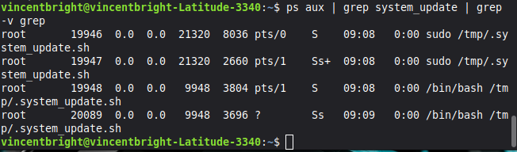
Process Details
Field | Value
PID | 19948
User | root
Command | /bin/bash /tmp/.system_update.sh
Working Directory | /home/vincentbright
Executable | /usr/bin/bash

3.2 Command Line
The full command used to launch the backdoor was:
text
/bin/bash /tmp/.system_update.sh
This confirms that the script was executed in a Bash shell with root privileges.

3.3 Persistence Mechanism
The backdoor persists through a systemd service located at /etc/systemd/system/backdoor.service.
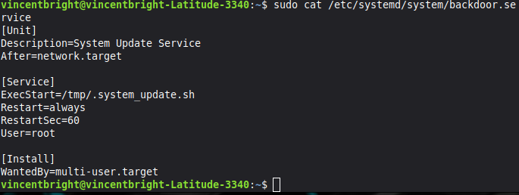
Service File Content
Directive | Value
Description | System Update Service
After | network.target
ExecStart | /tmp/.system_update.sh
Restart | always
RestartSec | 60
User | root
WantedBy | multi-user.target
This configuration ensures that the backdoor starts automatically on system boot and restarts if terminated.

Service Status
The service was confirmed to be active and running on the system.
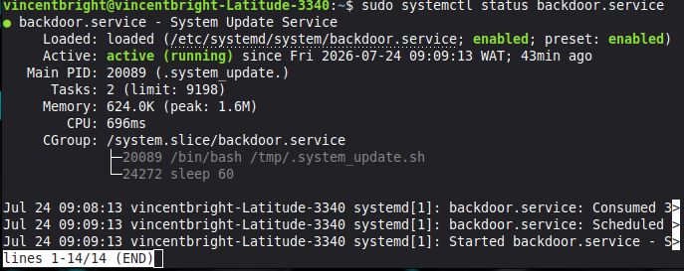

3.4 Backdoor Script
The backdoor script /tmp/.system_update.sh contains the following logic:
- Sends an ICMP (ping) beacon to 8.8.8.8
- Logs success or failure to /tmp/.system_backdoor.log
- Repeats every 60 seconds
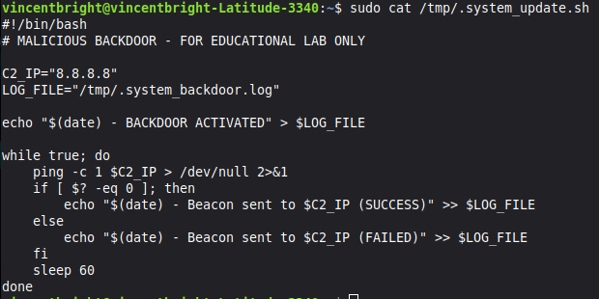

3.5 Network Communication (Wireshark)
Wireshark captured ICMP (ping) traffic from the compromised system to 8.8.8.8, confirming active command-and-control (C2) communication.
Network Evidence
Field | Value
Source IP | 10.114.119.174
Destination IP | 8.8.8.8
Protocol | ICMP (Echo Request)
Payload | 98 bytes
This traffic confirms the backdoor's C2 communication channel.
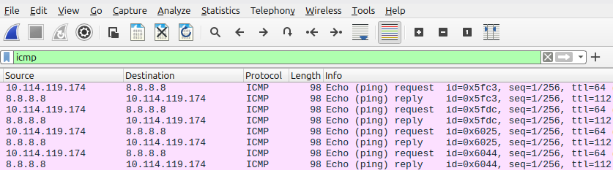

3.6 Brute-Force Logs
Failed Attempts
A total of 54 failed SSH login attempts were recorded against the admin account.
Count | Protocol | Target User | Source IP
54 | SSH | admin | 192.168.50.45
Successful Login
The attacker successfully authenticated at 09:29:02.
Timestamp | Event | User | Source IP
Jul 24 09:29:02 | Accepted password | admin | 192.168.50.45

3.7 Attack Timeline
Time | Event
09:28:33 | First failed SSH attempt from 192.168.50.45
09:28:33 – 09:29:01 | 52 rapid failed attempts (brute-force)
09:29:02 | Successful login for admin
09:29:02+ | Backdoor installed and activated

4. Technical Impact
Affected Asset | Impact
System | vincentbright-Latitude-3340
Compromised Account | admin
Malware Installed | /tmp/.system_update.sh
Persistence Mechanism | systemd service (backdoor.service)
C2 Communication | ICMP beacons to 8.8.8.8
Root Access | Yes (the backdoor runs as root)
The attacker's ability to install a persistent backdoor with root privileges indicates a successful compromise of the system.

Attack Timeline
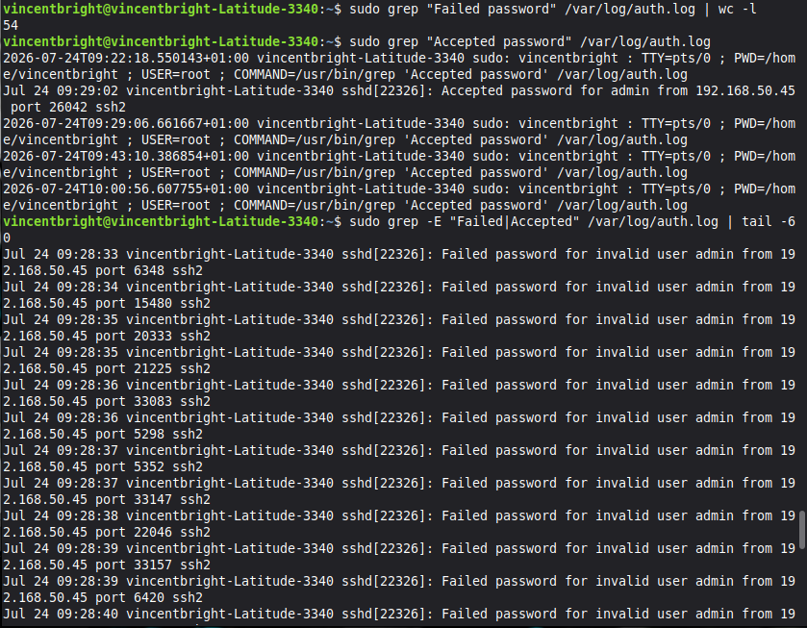

Successful Login

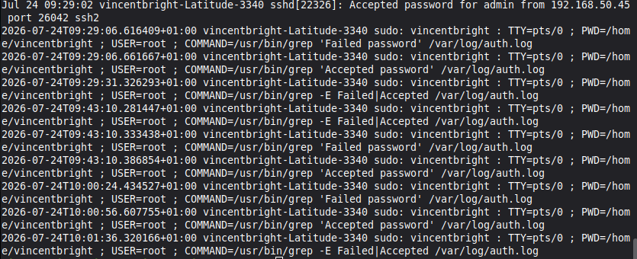

5. Remediation Steps

5.1 Immediate Containment
Step | Command
Kill the malicious process | sudo kill -9 19948
Remove the backdoor script | sudo rm /tmp/.system_update.sh
Remove the log file | sudo rm /tmp/.system_backdoor.log
Stop the systemd service | sudo systemctl stop backdoor.service
Disable the service | sudo systemctl disable backdoor.service
Remove service file | sudo rm /etc/systemd/system/backdoor.service
Reload systemd | sudo systemctl daemon-reload

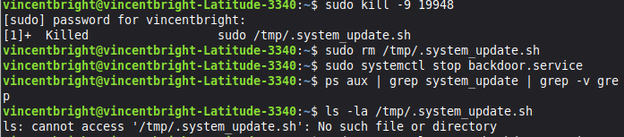

5.2 Account Security
Step | Command
Reset compromised password | sudo passwd admin
Force password change on next login | sudo chage -d 0 admin
Lock account if unused | sudo usermod -L admin

5.3 Network Security
Step | Command
Block attacker IP | sudo iptables -A INPUT -s 192.168.50.45 -j DROP
Save iptables rules | sudo iptables-save > /etc/iptables/rules.v4

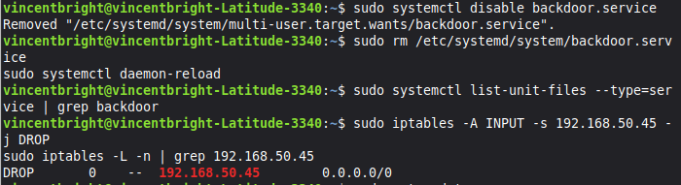

5.4 System Hardening
Step | Action
Install Fail2Ban | sudo apt install fail2ban -y
Enable Fail2Ban | sudo systemctl enable fail2ban && sudo systemctl start fail2ban
Disable root SSH login | Edit /etc/ssh/sshd_config: PermitRootLogin no
Use SSH key authentication | PasswordAuthentication no

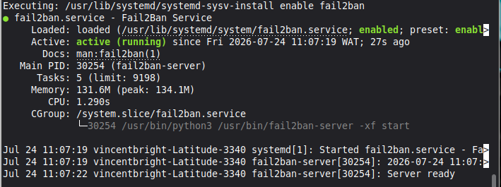

6. Recommendations
Priority | Recommendation | Rationale
High | Implement account lockout after 3 failed attempts | Prevents brute-force attacks
High | Enforce strong password policy | Reduces risk of credential guessing
High | Enable Fail2Ban | Automatically blocks suspicious IPs
Medium | Disable SSH password authentication | Use SSH keys for stronger security
Medium | Monitor /var/log/auth.log | Early detection of attacks
Medium | Review systemd services | Detect unauthorized persistence
Low | Harden SSH configuration | Reduce attack surface

7. Conclusion
The investigation confirmed a successful brute-force SSH attack leading to system compromise. The attacker installed a persistent backdoor with command-and-control capabilities, communicating via ICMP beacons to 8.8.8.8.
All evidence was collected, documented, and used to develop remediation and hardening recommendations. The compromised system has been contained, the backdoor removed, and the account secured.
This incident highlights the critical importance of:
- Strong password policies and account lockout mechanisms
- Continuous monitoring of authentication logs
- Regular reviews of systemd services and cron jobs
- Use of SSH key-based authentication
- Network-level blocking of malicious IPs
Report Prepared By: VincentBright
Date: July 24, 2026
Document Version: 1.0
Classification: Confidential

