Message

Message

**Sender**

**Ah18489a873**

**Receiver**

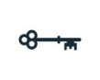

Encrypted Text after Appling algo and key

Message

Message

**Sender**

**Ah18489a873**

**Receiver**



**Shy29150194**

Encrypted Text after Appling algo and key



Message

**Receiver**