🛠️ Technical Requirements Document (TRD)
Production-minded architecture for the 24-hour implementation
HackNex 2026 • HNX26EPS03 • Live Translation for Indic Languages

1. Recommended Stack
Layer | Choice | Reason
Frontend | Next.js/React + TypeScript | Fast UI and deployment
Styling | Tailwind CSS | Rapid consistent UI
Realtime | WebSocket | Continuous audio/results
Backend | FastAPI + Python | Async and simple
Primary ASR | Sarvam Saaras realtime | Indic-focused partial transcripts
Translation | Sarvam translation API | Indic coverage
Fallback | Azure AI Speech | Realtime speech translation
DB | PostgreSQL | Sessions/segments/metrics
Cache | Redis optional | Session/rate-limit state
Deploy | Vercel + Render/Railway | Fast public deployment
Monitoring | Sentry + logs | Failure visibility

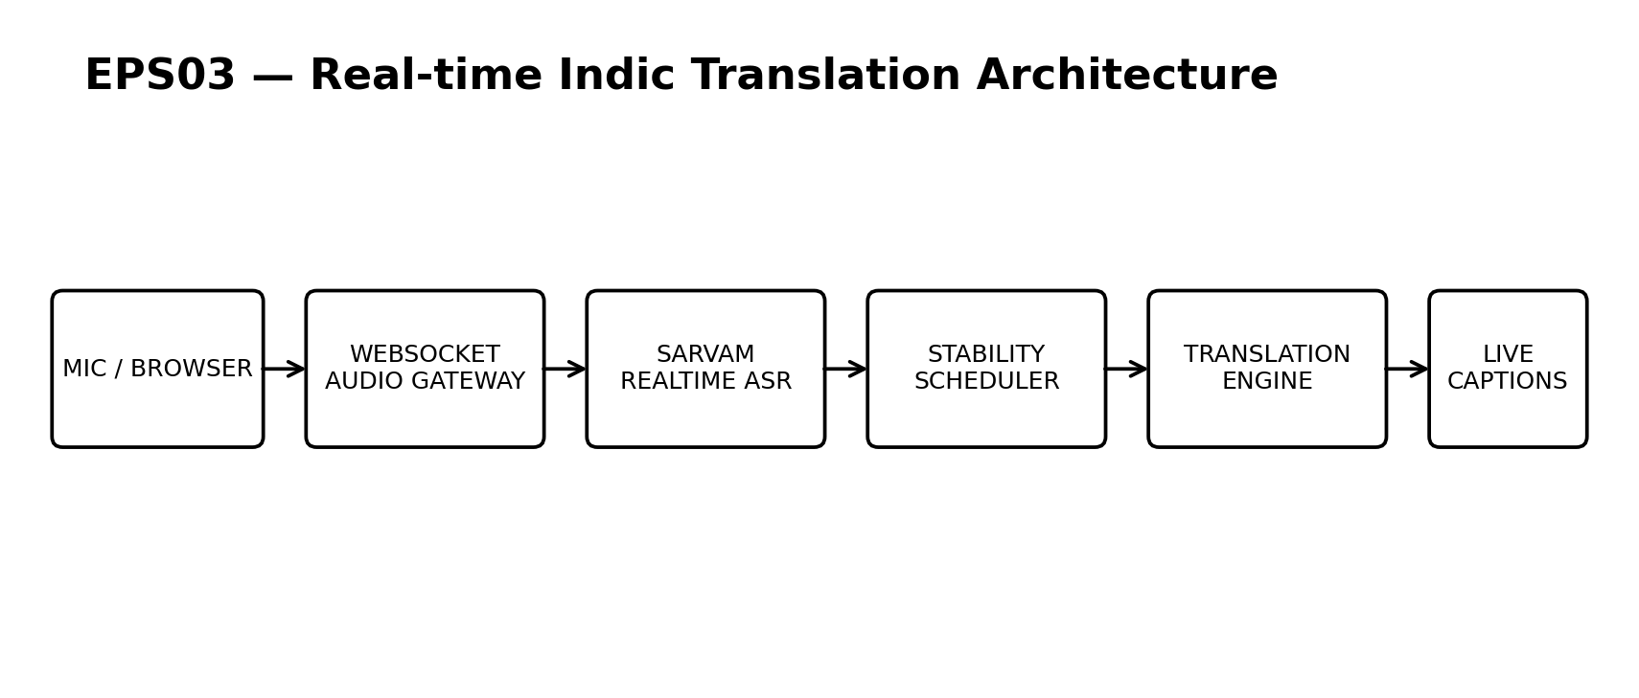

2. Realtime Protocol
Event | Payload
session.start | source_language,target_language,session_id
audio.chunk | binary PCM/WAV frame
transcript.partial | segment_id,text,timestamp,confidence
transcript.final | segment_id,text,timestamp
translation.partial | segment_id,translated_text
translation.final | segment_id,translated_text
session.status | state,latency_ms,provider
error | code,safe_message,retryable

3. Stability Scheduler
Start with k=3 recent hypotheses and commit the longest common prefix. Tune k and debounce/max-wait thresholds separately for each language.

4. Resilience
- Timeout → retry once then degrade
- Translation failure → source captions remain
- WebSocket drop → reconnect
- Quota failure → fallback provider
- Malformed event → safely ignore + log

5. Security
- Never expose API keys
- Validate origins
- Rate-limit session creation
- Do not persist raw audio by default
- Provide session deletion

6. Risks
Risk | Impact | Mitigation
Malayalam quality | High | Hour-5 bake-off and hard gate
Venue Wi-Fi | High | Reconnect + backup hotspot
Provider quota | High | Pre-check + fallback
Caption instability | High | Scheduler + metric
Browser audio | Medium | Chrome/Edge tests

Sarvam currently documents realtime streaming with true partial transcripts and support for Hindi, Tamil and Malayalam; Azure documents realtime speech translation as a fallback. citeturn0search7turn0search1turn0search8

