📱 Application Flow Specification
Screen-by-screen behavior and state transitions
HackNex 2026 • HNX26EPS03 • Live Translation for Indic Languages
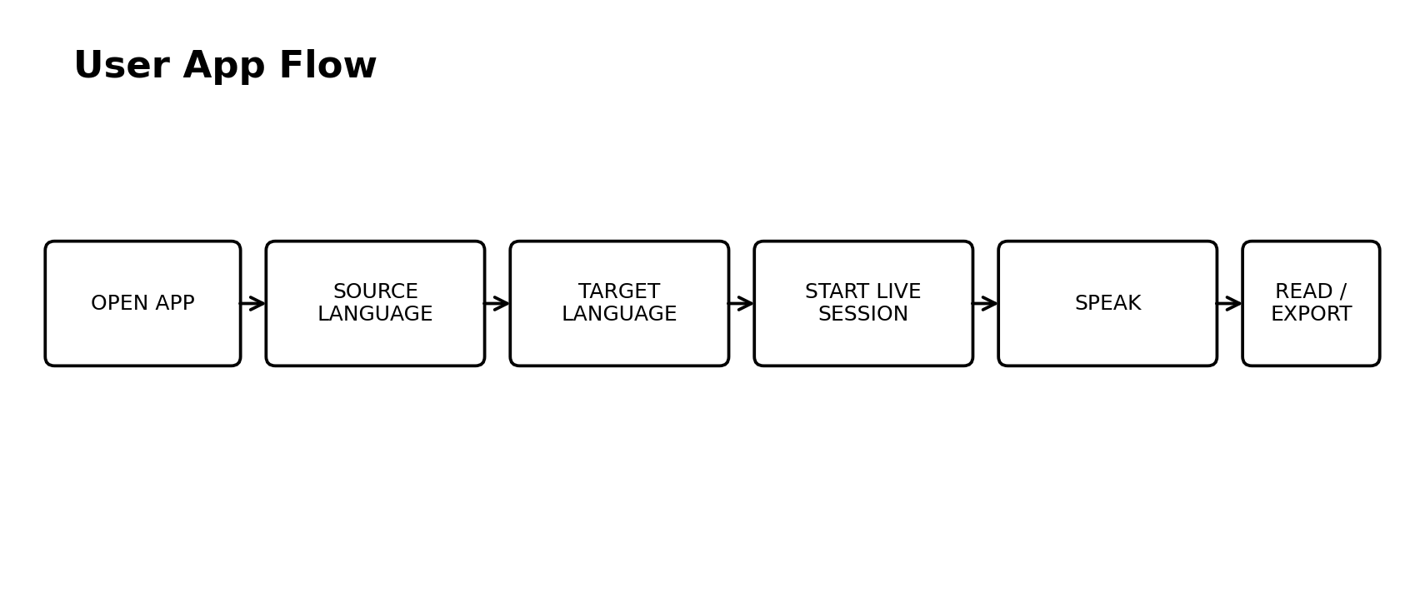

1. Screen Map
Screen | Purpose | Controls
Landing | Explain value | Start
Setup | Choose languages | Source,target,mic test
Live | Realtime captions | Pause,end,swap
Summary | Review/export | Transcript,translation,export
Settings | Demo controls | Provider,font,latency

2. State Machine
- IDLE → CONNECTING → LISTENING → TRANSLATING → LISTENING
- Any state → ERROR if unrecoverable
- ERROR → RECONNECTING → LISTENING if retryable
- LISTENING → ENDED → SUMMARY

3. Caption Behavior
- Partial text is visually lighter
- Committed text becomes stable
- Translate committed segments
- Newest segment stays prominent
- Show recent latency

4. Demo Journey
Open → Tamil source → English target → mic test → start → speak prepared sentence → show partial Tamil → show committed English → switch to Hindi → repeat → summary → export.

5. Failure Journey
If translation fails, continue source captions and show degraded mode. Do not freeze the whole app because a cloud endpoint decided to have feelings.

6. Test Cases
ID | Scenario | Expected
F01 | Mic granted | Starts
F02 | Mic denied | Recovery UI
F03 | Short sentence | Fast final
F04 | Long sentence | Max-wait finalization
F05 | Code-mix | Reasonable preservation
F06 | Network loss | Reconnect
F07 | Translation fail | Transcript remains
F08 | Malayalam below bar | Remove from scope

